Awesome-Sauce Game Site

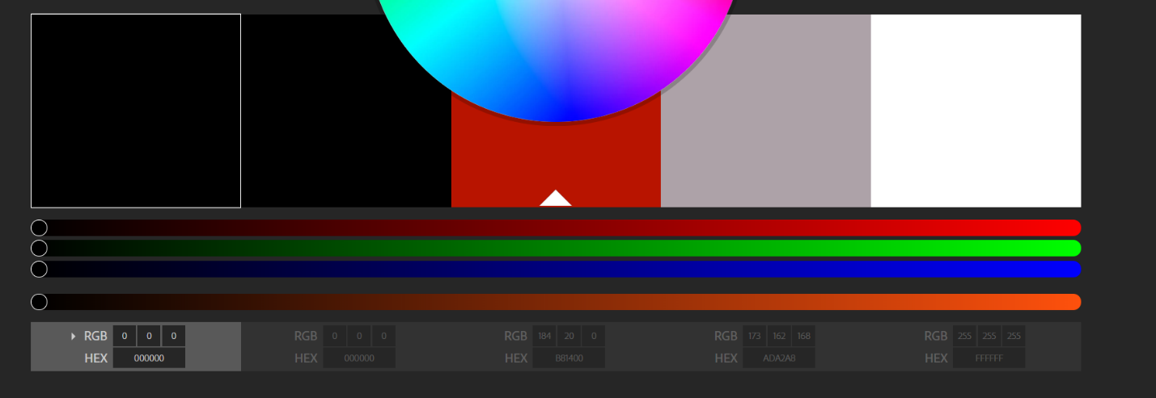

Color: #000 black, #B81400 red, #ADA2A8 grey, #FFF white.

Font: title=Spicy rice, body = Mali,

<link href="https://fonts.googleapis.com/css?family=**Mali|Spicy+Rice**" rel="stylesheet">

1. font-family: 'Mali', cursive;
2. font-family: 'Spicy Rice', cursive;

