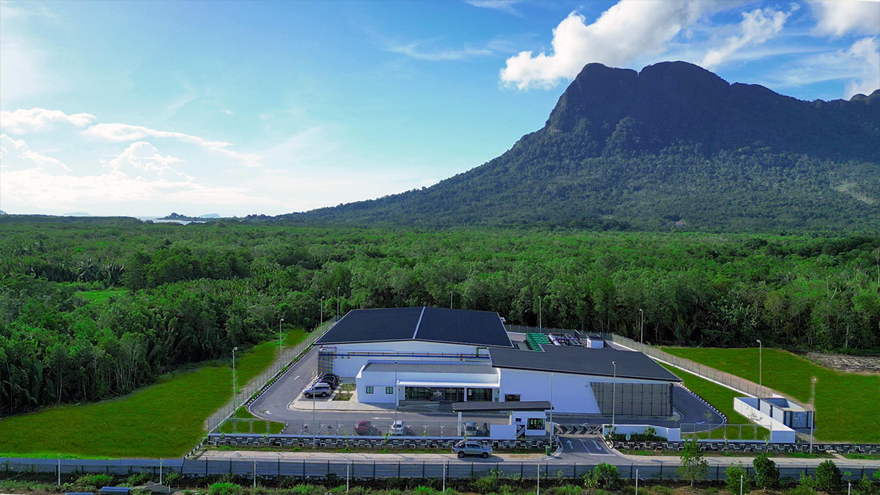

GRIDLINE

Financial Review Report
Irix DC-1 Asset Analysis

February 2026
CONFIDENTIAL

Executive Summary
GridLine has completed a high-level review of financial and operational information provided for Irix DC-1. Based on this initial assessment, the asset demonstrates a viable pathway for GridLine platform integration.
DC-1 aligns with GridLine's aggregation strategy due to the following key attributes:
- Cash-flow-positive operations with stable revenue base
- Significant underutilized capacity representing embedded growth potential
- Clear platform-scale upside through integration benefits

Platform integration shifts the valuation lens from asset-level cash flow toward scale, predictability, and capital efficiency—structural advantages that underpin GridLine's preferred transaction approach.

Asset Overview
Irix DC-1 is an operating data centre with established revenue streams and significant capacity headroom for future growth.

~$8.75M  REVENUE (FY2025) | ~22%  EBITDA MARGIN | 100%  OWNERSHIP | 1.20 MW  POWER CAPACITY

Capacity Utilisation
The facility currently operates at approximately 25% of designed capacity, representing 75% available headroom for future growth.

25% Utilised | 75% Available Headroom

Strategic Assessment

Asset Strengths
- Embedded growth capacity without new land or greenfield development
- Diversified end-market exposure across multiple sectors
- Anchor tenancy stability (SAINS – 11-year contract)
- Operating leverage at current margins
- Clean ownership structure enabling straightforward execution

Key Considerations
- Customer concentration – top three customers represent ~83% of revenue
- Lease expiries clustered over the next 2–3 years
- Revenue growth dependent on leasing execution

Platform Integration Value
Standalone data centres are typically valued on asset-level cash flow and concentration risk. Platform integration shifts the valuation lens toward scale, predictability, and capital efficiency.

FACTOR | STANDALONE | INSIDE GRIDLINE
Valuation basis | Asset-level EBITDA | Platform scale & predictability
Risk profile | Concentrated in one asset | Spread across portfolio
Capital raising | Asset by asset | Platform level
Contracts | Custom, harder to finance | Standardised, easier to finance
Exit options | Sell the asset | Multiple pathways

Valuation Enhancement
Integration into the GridLine platform positions DC-1 for institutional and public market valuations:
- Standalone Asset: 1x–3x Revenue multiple
- Platform Integration: 8–10x EBITDA multiple (Institutional/Public Market)

Partnership Options
The following options represent conceptual frameworks for discussion purposes only. They are subject to further negotiation, due diligence, and definitive documentation.

Option 1: Vendor Finance with Platform Equity (Primary)
- Agreed enterprise valuation
- Deferred consideration via vendor financing
- Interest accrual over time
- Repayment from free cash flow and/or platform-level liquidity events
- Minority equity participation in GridLine

Option 2: Partial Cash / Partial Equity (Alternative)
- Partial liquidity at close
- Increased execution complexity and longer timelines
- Reduced alignment compared to Option 1

Option 3: All Equity Contribution (Fallback)
- No immediate liquidity
- Full exposure to early-stage platform risk
- Limited alignment with GridLine governance objectives

Execution Track Record
GridLine has a related platform operating under a similar aggregation model. To date, that platform has achieved:

4  OPERATING DCs | ~$58M  MARKET CAP | ~$4M  ANNUAL REVENUE | 12x  POST-IPO

Portfolio Overview
- Asset 1: 1.0 MW capacity, ~$0.5M annual revenue
- Asset 2: 1.5 MW capacity, ~$1.2M annual revenue
- Asset 3: 2.0 MW capacity, ~$1.6M annual revenue
- Asset 4: 3.0 MW capacity, ~$1.8M annual revenue

Next Steps
To advance discussions and move toward a definitive agreement:

- Internal alignment on positioning and preferred transaction structure
- Exchange of additional financial and operational data for detailed due diligence
- Preliminary term sheet development based on Option 1 framework
- Engagement of legal and financial advisors for transaction structuring

GridLine remains committed to a collaborative process that delivers value for all stakeholders while building toward platform-scale infrastructure investment.

