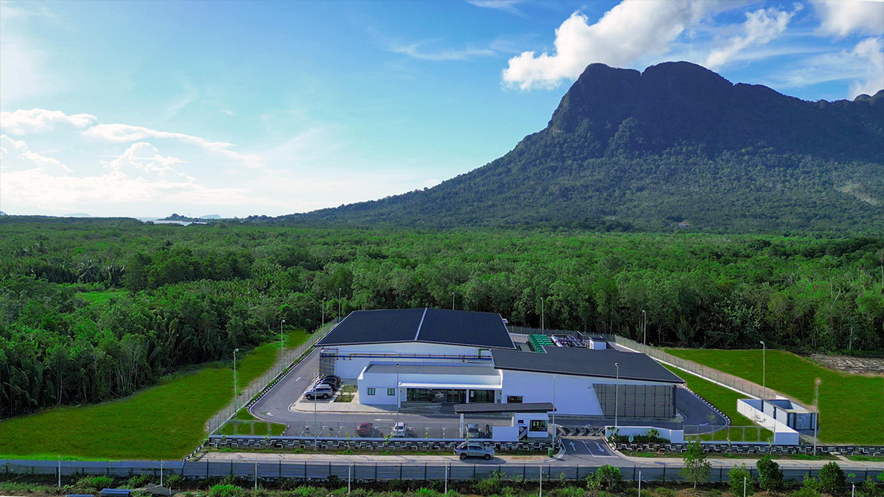

GRIDLINE
━━━━━━━━━━━━━━━━━━━━━━━━━━━━━━

Financial Review
Asset – Irix DC-1

February 2026 • Confidential

INITIAL ASSESSMENT
Overview
GridLine has completed a high-level review of financial and operational information provided for Irix DC-1. Based on this initial assessment, the asset demonstrates a viable pathway for GridLine platform integration.
DC-1 aligns with GridLine's aggregation strategy due to the following:
- Cash-flow-positive operations
- Underutilized capacity
- Clear platform-scale upside potential

FINANCIAL PROFILE
Key Financial Highlights

~$8.75M  REVENUE (FY25) | ~22%  EBITDA MARGIN | 100%  OWNERSHIP | 1.20 MW  POWER

~25%
CURRENT UTILISATION

GROWTH POTENTIAL
Capacity Utilisation
Designed capacity vs current utilisation

25% Utilised • 75% Available Headroom

INVESTMENT THESIS
Asset Strengths Identified
- Embedded growth capacity without new land or greenfield development
- Diversified end-market exposure
- Anchor tenancy stability (SAINS – 11-year contract)
- Operating leverage at current margins
- Clean ownership structure enabling straightforward execution

RISK FACTORS
Key Considerations
- Customer concentration (top three customers ~83% of revenue)
- Lease expiries clustered over the next 2–3 years
- Revenue growth dependent on leasing execution

INSTITUTIONAL ALIGNMENT MODEL
How GridLine Partnership Changes Value
Standalone data centres are typically valued on asset-level cash flow and concentration risk. Platform integration shifts the valuation lens toward scale, predictability, and capital efficiency.

WHAT CHANGES | ON ITS OWN | INSIDE GRIDLINE
How it's valued | Based on DC EBITDA today | Platform scale & predictability
Risk | Concentrated in one asset | Spread across multiple assets
Capital | Raised asset by asset | Raised at platform level
Contracts & reporting | Custom, harder to finance | Standardised, easier to finance
Exit options | Sell the asset | Multiple exit pathways

VALUATION RERATING
Why DC1 Is Worth More Inside GridLine
DC enhanced valuation within GRIDLINE platform

STANDALONE ASSET  1x – 3x Revenue  Discounted for illiquidity | →  PLATFORM | INSTITUTIONAL / PUBLIC MARKET  *8–12x Multiple  Portfolio-wide rerating

TRANSACTION FRAMEWORK
Partnership & Acquisition Options
Conceptual frameworks for discussion purposes only
Primary Option: Vendor Finance with Platform Equity
- Agreed enterprise valuation
- Deferred consideration via vendor financing
- Interest accrual over time
- Repayment from free cash flow and/or platform-level liquidity events
- Minority equity participation in GridLine

Alternative: Partial Cash / Partial Equity
- Partial liquidity at close
- Increased execution complexity; longer timelines

Fallback: All Equity Contribution
- No immediate liquidity; full early-stage platform risk

TRACK RECORD
Execution Credibility
GridLine has a related platform operating under a similar aggregation model. To date, that platform has acquired four operating data centers:

4  TIER II/III DCs | ~$58M  MARKET CAP | ~$4M  ANNUAL REV | 12x  POST-IPO

Portfolio Assets
- Asset 1: 1.0 MW, ~$0.5M revenue
- Asset 2: 1.5 MW, ~$1.2M revenue
- Asset 3: 2.0 MW, ~$1.6M revenue
- Asset 4: 3.0 MW, ~$1.8M revenue

PATH FORWARD
Next Steps
- Internal alignment on positioning
- Exchange of additional financial and operational data
- Preliminary term sheet development
- Engagement of advisors for transaction structuring

