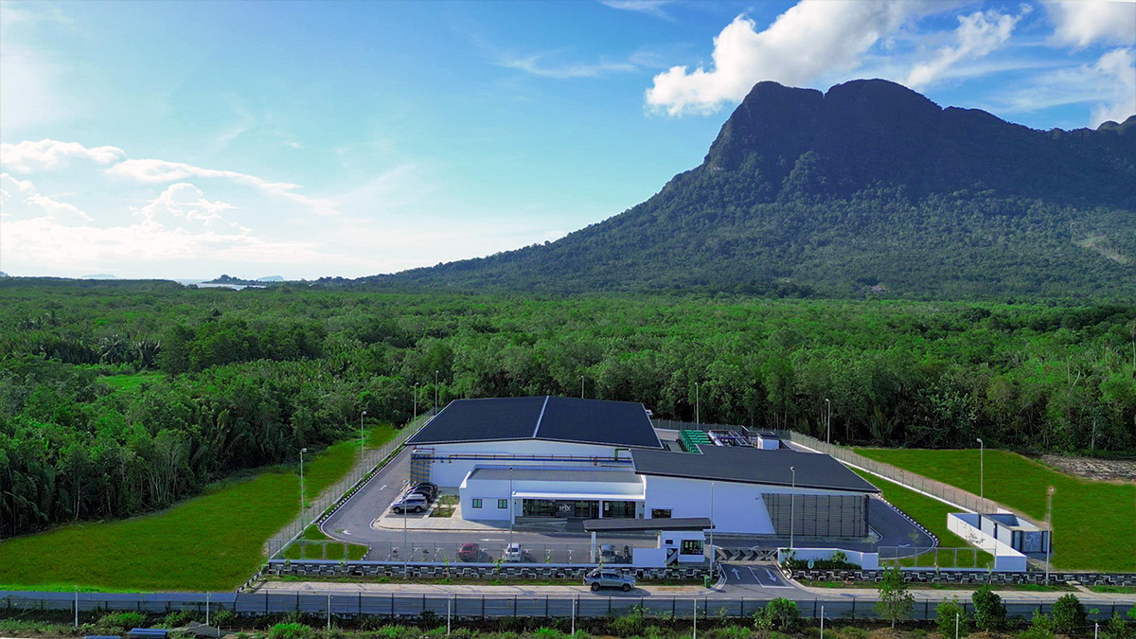

GRIDLINE
━━━━━━━━━━━━━━━━━━━━━━━━━━━━━━

Financial Review Report
Irix DC-1 Asset Analysis

February 2026 • Confidential

OVERVIEW
Executive Summary
GridLine platform integration pathway for Irix DC-1
GridLine has completed a high-level review of financial and operational information provided for Irix DC-1. Based on this initial assessment, the asset demonstrates a viable pathway for GridLine platform integration.
DC-1 aligns with GridLine's aggregation strategy due to the following key attributes:
- Cash-flow-positive operations with stable revenue base
- Significant underutilized capacity representing embedded growth potential
- Clear platform-scale upside through integration benefits

Platform integration shifts the valuation lens from asset-level cash flow toward scale, predictability, and capital efficiency—structural advantages that underpin GridLine's preferred transaction approach.

ASSET PROFILE
Asset Overview
Key metrics and capacity utilisation for Irix DC-1

~$8.75M  REVENUE (FY25) | ~22%  EBITDA MARGIN | 100%  OWNERSHIP | 1.20 MW  POWER

Capacity Utilisation
The facility operates at ~25% of designed capacity, representing 75% available headroom for future growth.

25% Utilised • 75% Available Headroom

DUE DILIGENCE
Strategic Assessment
Asset strengths and key considerations
Asset Strengths
- Embedded growth capacity without new land or greenfield development
- Diversified end-market exposure across multiple sectors
- Anchor tenancy stability (SAINS – 11-year contract)
- Operating leverage at current margins
- Clean ownership structure enabling straightforward execution

Key Considerations
- Customer concentration – top three customers represent ~83% of revenue
- Lease expiries clustered over the next 2–3 years
- Revenue growth dependent on leasing execution

INSTITUTIONAL ALIGNMENT MODEL
DC Enhanced Valuation Within GRIDLINE Platform
Why standalone data centres are worth more inside a unified, public-ready platform

STANDALONE ASSET  1x – 3x Revenue  Discounted for illiquidity | →  PLATFORM | INSTITUTIONAL / PUBLIC MARKET  *8–12x Multiple  Portfolio-wide rerating

WHAT CHANGES | ON ITS OWN | INSIDE GRIDLINE
How it's valued | Based on DC EBITDA today | Platform scale & predictability
Risk | Concentrated in one asset | Spread across multiple assets
Capital | Raised asset by asset | Raised at platform level
Contracts & reporting | Custom, harder to finance | Standardised, easier to finance
Exit options | Sell the asset | Multiple exit pathways

TRANSACTION FRAMEWORK
Partnership & Acquisition Options
Conceptual frameworks for discussion purposes only
Primary Option: Vendor Finance with Platform Equity
- Agreed enterprise valuation
- Deferred consideration via vendor financing
- Interest accrual over time
- Repayment from free cash flow and/or platform-level liquidity events
- Minority equity participation in GridLine

Alternative: Partial Cash / Partial Equity
- Partial liquidity at close
- Increased execution complexity and longer timelines

Fallback: All Equity Contribution
- No immediate liquidity; full early-stage platform risk exposure

TRACK RECORD
Execution Credibility
Related platform operating under similar aggregation model

4  OPERATING DCs | ~$58M  MARKET CAP | ~$4M  ANNUAL REV | 12x  POST-IPO

Portfolio Assets
- Asset 1: 1.0 MW capacity, ~$0.5M annual revenue
- Asset 2: 1.5 MW capacity, ~$1.2M annual revenue
- Asset 3: 2.0 MW capacity, ~$1.6M annual revenue
- Asset 4: 3.0 MW capacity, ~$1.8M annual revenue

PATH FORWARD
Next Steps
Recommended actions to advance discussions

- Internal alignment on positioning and preferred transaction structure
- Exchange of additional financial and operational data for detailed due diligence
- Preliminary term sheet development based on Option 1 framework
- Engagement of legal and financial advisors for transaction structuring

GridLine remains committed to a collaborative process that delivers value for all stakeholders while building toward platform-scale infrastructure investment.

