A Microcontroller-based, Optically-centric Communication System

for Underwater Applications

A thesis submitted to the

Graduate School**

of the University of Cincinnati

in partial fulfillment of the degree of

Master of Science

in the Department of Electrical Engineering and Computer Science

of the College of Engineering and Applied Science

by Joshua L. Alexander

B.S. University of Cincinnati

July 2017

Thesis Advisor and Committee Chair: Dr. Fred R. Beyette Jr.

Abstract

* Acknowledgements
* Table of Contents
* List of Figures
* List of Tales
* List of Abbreviations
* Introduction
  + Importance and background - communication on a water planet
    - Conversation about the lack of availability of a high-bandwidth communication technique in oceanic environments
  + Applications
    - Untethered underwater rover exploration
    - Visible light is an unregulated bandwidth
      * Wearable devices
      * Secure indoor point-to-point endpoint (not easily hackable, must be line of sight)
  + Research Objectives
    - Investigate a dynamic, light-centric FSO system to be used in oceanic environments
    - Theoretical analysis of visible light transmission in fresh/salt water
    - Determination of best transmission frequencies with considerations of distance, immunity to noise, spectrum availability
    - System design and testing
* Literature Review
  + EM Attenuation (interaction of light in salt/fresh water
    - Optical properties to consider that will impact system
    - Absorption and scattering (forward and backward) coefficients of clear natural waters
  + Controls (theory and past research on alignment using a QP)
* Theoretical Analysis
  + Comparison of different visible wavelengths viability with regard to absorption and scattering effects found in literature review
  + Calculations/graphs of relative intensity for discrete wavelengths after attenuation and beam divergence
  + Discussion of component selection on above results (photodiode response, laser diode availability/power)
* System Design
  + High level system design and integration with OpenROV
  + MCU
    - PIC32MX selection
    - Description of all modules utilized (like Purva)
  + TX Module
    - Omit any information about laser diode and lens selection
  + RX Module
    - Transimpedance amplifier
    - Pre-ADC filtering
  + Modulation design, framing, and timing
  + Firmware descriptions
    - TX and RX logic and flowcharts
    - State machine diagrams for handshaking
  + Power supply
    - Reverse engineering of OpenROV and its power supplies
    - Analysis of PIC32MX Clicker 2 board’s power supplies
  + Optics board schematic and PCB
* Results
  + Experimental setup(s)
    - Ambient lighting conditions
    - Air/water transmission medium
  + BER as a function of distance
  + Pictures of final system and demo using a filmstrip-like display
* Conclusion and Future Work

Abstract

(<500 words)**

# Acknowledgements

**

# Table of Contents

Acknowledgements iv

Table of Contents v

List of Figures vi

List of Tables vii

List of Abbreviations viii

1 Introduction ix

2 Importance and Background x

2.1 Communication on a water planet x

2.2 Applications x

2.3 Research Objectives x

3 Literature Review x

3.1 Optics x

3.2 Controls x

# List of Figures

**

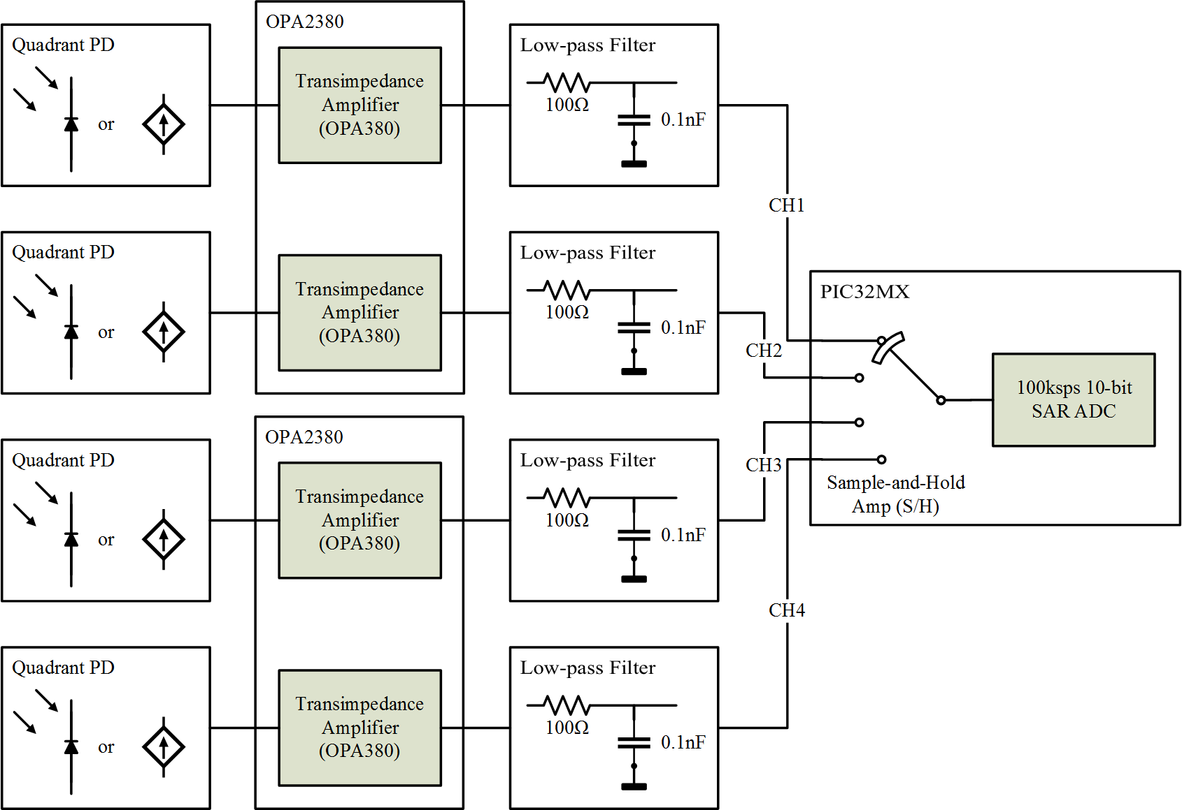

# List of Tables

# List of Abbreviations

|  |  |
| --- | --- |
| ADC | Analog-to-Digital Converter |
|  |  |
|  |  |
|  |  |
| DAC | Digital-to-Analog Converter |
|  |  |
|  |  |
|  |  |
| MCU | Microcontroller Unit |
| PD | Photodiode |
| PWM | Pulse-Width Modulation |
| QP | Quadrant Photodiode |
|  |  |
|  |  |
| SAR | Successive Approximation |
|  |  |
|  |  |
|  |  |

# Introduction

# Importance and Background

## Communication on a water planet

Conversation about the lack of availability of a high-bandwidth communication technique in oceanic environments

## Applications

Untethered underwater rover exploration

Visible light is an unregulated bandwidth

Wearable devices

Secure indoor point-to-point endpoint (not easily hackable, must be line of sight)

## Research Objectives

Investigate a dynamic, light-centric FSO system to be used in oceanic environments

Theoretical analysis of visible light transmission in fresh/salt water

Determination of best transmission frequencies with considerations of distance, immunity to noise, spectrum availability

System design and testing

# Literature Review

## Optics

EM Attenuation (interaction of light in salt/fresh water

Optical properties to consider that will impact system

Absorption and scattering (forward and backward) coefficients of clear natural waters

## Controls

Controls (theory and past research on alignment using a QP)