  - Student Number: 3092883
  - Joshan John

  - Project name

JCloud-PasS

Griffith College Dublin
BSCH-CSP Assignment 2

Table of Contents
1. Introduction 3
2. Tech Stack 3
2.1 List of tech stack 3
2.2 Dependency management 4
2.3 Data management 4
3. Project Structure 4
3.1 Naming Conventions 4
3.2 Design Pattern 4

1. Introduction
Jcloud is a platform-as-a-service application that offers storage services to users. The project is similar to a Dropbox storage service. Jcloud’s dedicated user workspace allows file management for registered users.

2. Tech Stack
The project utilizes Python as the core language for this application, with JavaScript for handling some of the client interactions and authentications. The application is based on Python’s FastAPI framework for backend and Jinja2 templating for web rendering. It also uses HTML and CSS as web technologies.

2.1 List of tech stack
- Python
- UV (Python dependency manager)
- pydrantic (validations )
- Fast API (Python framework)
- Jinja2 (templating)
- HTML
- CSS
- Tailwind CSS (inline CSS)
- JavaScript
- Firebase (authentication)
- Azure (file storage)
- MongoDB (record management)
- UNPKG (icons)
- Google Fonts - Inter (font style)

2.2 Dependency management
The Python backend dependencies are mainly managed using the UV dependency manager (written in Rust), which allows faster parallel downloads and automatically creates a dedicated Python environment. All project configurations are written in the “pyproject.toml” file.

2.3 Data management
The project data is stored across various services. Firebase is used for user authentication and authorization. The workspace directories and folder information are stored in MongoDB clusters. Plus, Azure for file data or blob storage.

3. Project Structure
The project code base is well-structured for maintainability and scalability, and follows a clean code practice and proper naming conventions. All the project secrets are safe and secure.

3.1 Naming Conventions
Code base follows snake case naming convention for functions, files, and folders. But the class names follow Pascal case naming. The function names are descriptive and contain docstrings and comments.

3.2 Design Pattern
Since the application is structured in a monolithic manner, both the frontend and backend are placed inside the /src folder. The business logic or system implementations follow a factory interface programming. Where each low-level service implements corresponding interface classes. So that, even though the tech stack changes or is modified, its functionalities or methods will be the same.
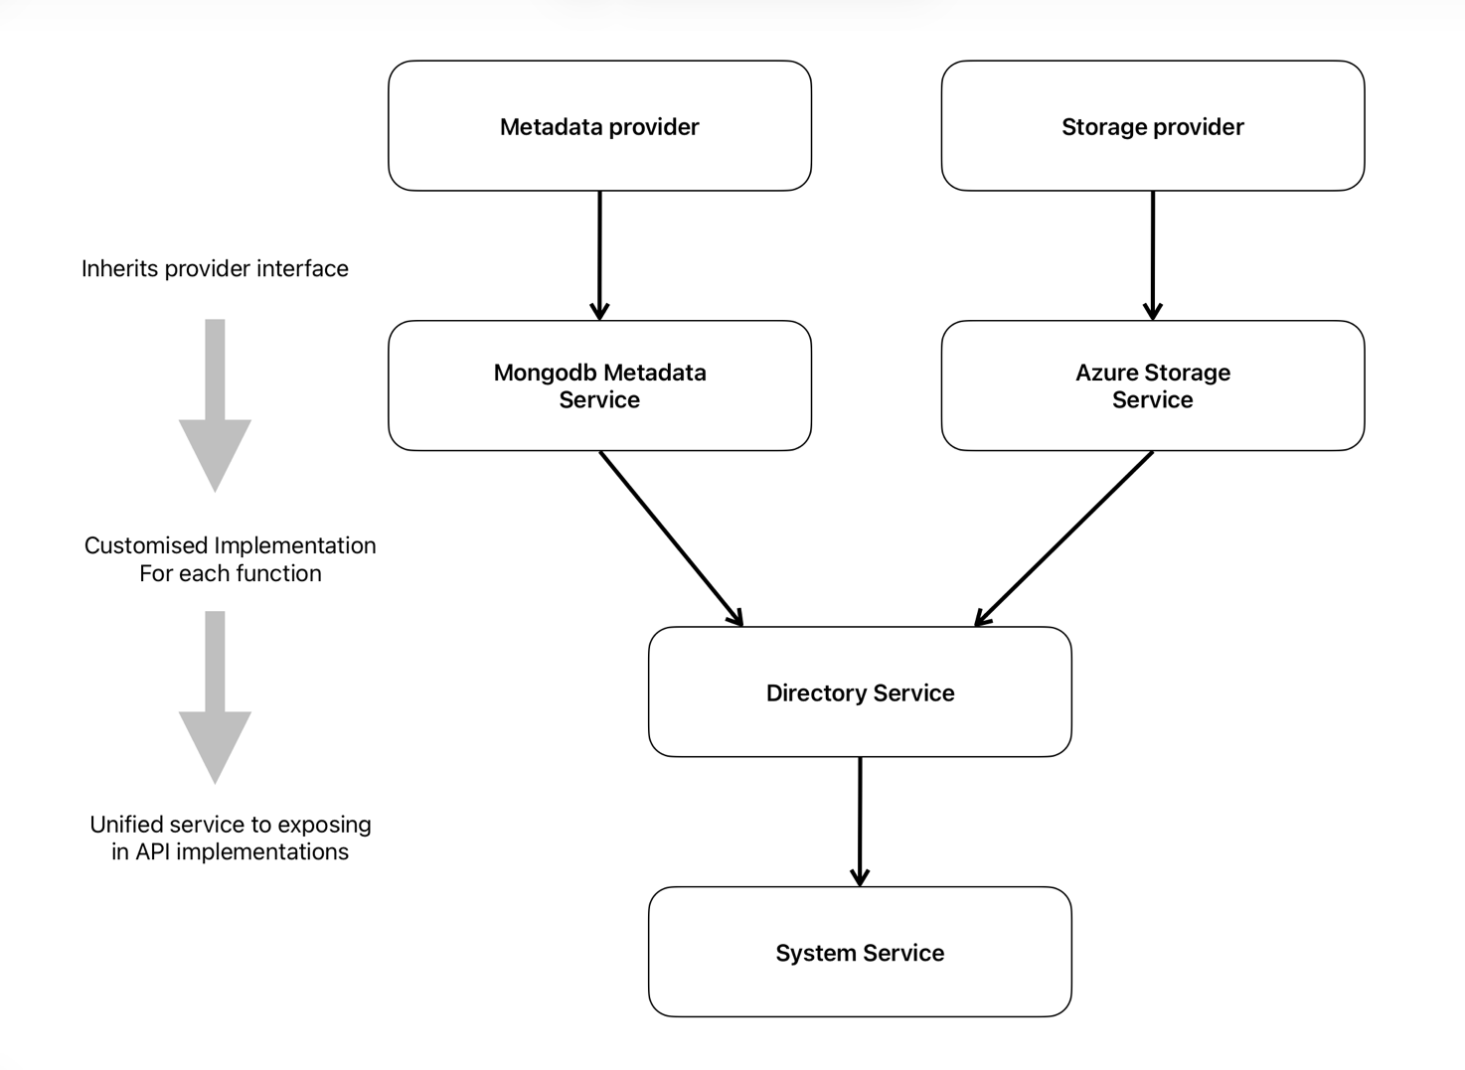
The frontend web programs are organized in templates and static files. The application APIs are placed inside the routes folder. The entity models are organized in the entities folder. The basic connection object creation is placed in the database/core folder. All the service classes are in the services folder, and their interfaces on factory folder. In addition, all the other helpers, constants, and logger are in the utils folder.
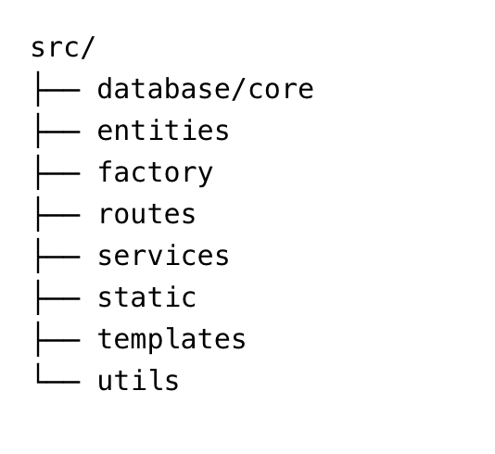
Image of folder structure inside “src” folder

