#### Osaka

#### Database Design Specification

**Database Design**: Database is an important part of any system which is designed to provide a mechanism for storing, managing and retrieving information. PostgreSQL, an object-relational database, was considered for the project. The two reasons behind choosing PostgreSQL were – availability on School’s system and familiarity with the database model. The database designer considered business rules and processes during requirements analysis and came up with an initial draft of database model. The model was reviewed with the team and some modifications were done to accommodate the system requirements. The server used to create database was dbteach2. A new database, called osakagp, was created to store the data needed for Edify quiz.

**Tables:** The four tables created in osakagp DB are quiz, questions, users and users_result.

**Users:** The user login details are stored in the users table. The user details are inserted into this table when a new user or administrator registers. The login credentials entered by the users are validated and the users are allowed to login only if the entered credentials exist in the users table.

**Quiz:** The quiz topics are stored in this table. The quiz could be on the following topics - Politics, Sports, History, Geography, Music, and Science & Technology. The admin chooses the quiz topic from quiz table and fetches the topic-related questions from the questions table.

**Questions:** The questions table contains the questions which are answered in quiz. Question and possible answers are stored as rows in the questions table. The table also contains a separate column for quiz ID. The admin uses the quiz ID to get the questions for the chosen quiz topic.

**User_result:** This table contains the quiz results for all the students. It is loaded with quiz result once the quiz is completed. The user can see the result by quiz date, quiz topic, score and quiz status.

**Entity-Relationship Diagram:**

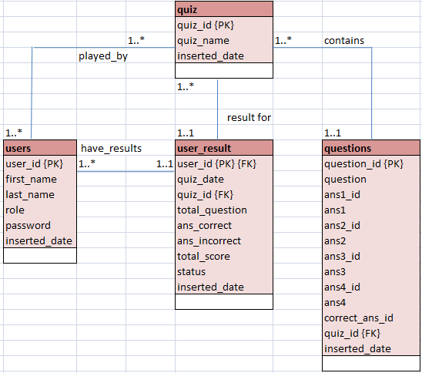

This is the entity-relationship (ER) diagram for the tables used in Edify quiz. The relationship shared among these tables is explained below.

**One-to-One**

- The table **questions** shares a one-to-one relationship with **quiz** table. Each question in the questions table can appear only in one quiz category.

- The table **user_result** shares a one-to-one relationship with **users** and **quiz** tables.The user_result table stores the result of all the quizes played by the students. Each row in the user_result table is linked to one quiz in the quiz table and one user in the users table.

- The **user_result** table shares one-to-one relationship with **users** table. Each row in the user_result table is linked to one user in the users table.

**One-to-Many**

- The **quiz** table shares one-to-many relationship with **questions** table. Each quiz topic has 10 questions in the questions table.

- The **quiz** table shares one-to-many relationship with **users_result** table. Each quiz topic in the quiz table is linked to multiple rows in the users_result table as quiz result is stored for multiple players and can be played on multiple days.

- The **quiz** table shares one-to-many relationship with **users** table. One quiz can be played by mutilple users in the users table.

- The **users** table shares one-to-many relationship with **quiz** table. Each user in the users table can play one or more quiz in the quiz table.

- The **users** table shares one-to-many relationship with **user_result** table. Each user in the users table can have one or more quiz results in the user_result table

**Normalization**: Data normalization was implemented to reduce and eliminate data redundancy.

First Normal Form: All the tables are in 1NF as they contain only atomic values and there are no repeating groups of data.

Second Normal Form: All tables are in 1NF and all of their non-key attributes are fully dependent on their primary keys. There is no partial dependency of any column on primary key.

Third Normal Form: All the tables are in 1NF and 2NF and all non-key attributes are fully functional dependent only on the primary key.

|  |  |  |  |  |
| --- | --- | --- | --- | --- |
| **Table name** | users | | | |
| **Attribute** | **Description** | **Type** | **Nullability** | **Example of values** |
| user_id | Unique ID of admin/student | BIG INT | NOT NULL | Between 1 and  9223372036854775807 |
| first_name | First name of admin/student | VARCHAR (20) | NULL | Mary |
| last_name | Last name of admin/student | VARCHAR (20) | NULL | Ande |
| role | Role of user | VARCHAR (20) | NULL | admin or student |
| password | Password entered by admin/student to access the tool | VARCHAR (10) | NULL |  |
| inserted_date | Timestamp of the transaction | TIMESTAMP | NOT NULL | DEFAULT is the current timestamp. |
| **Primary Key** | user_id | | | |
| **Foreign Key** |  | | | |
| **Index** | user_id | | | |

|  |  |  |  |  |
| --- | --- | --- | --- | --- |
| **Table name** | quiz | | | |
| **Attribute** | **Description** | **Type** | **Nullability** | **Example of values** |
| quiz_id | Unique ID of quiz | BIG INT | NOT NULL | Between 1 and  9223372036854775807 |
| quiz_name | Topic of quiz | VARCHAR (40) | NULL | Politics, Sports |
| inserted_date | Timestamp of the transaction | TIMESTAMP | NOT NULL | DEFAULT is the current timestamp. |
| **Primary Key** | quiz_id | | | |
| **Foreign Key** |  | | | |
| **Index** | quiz_id | | | |

|  |  |  |  |  |
| --- | --- | --- | --- | --- |
| **Table name** | questions | | | |
| **Attribute** | **Description** | **Type** | **Nullability** | **Example of values** |
| question_id | Unique ID of question | BIG INT | NOT NULL | Between 1 and  9223372036854775807 |
| question | The question to be answered by students | VARCHAR (200) | NULL | In which country is the Albert canal? |
| ans1_id | ID of first possible answer | INT | NOT NULL | DEFAULT is 1 |
| ans1 | First possible answer | VARCHAR (40) | NULL | Spain |
| ans2_id | ID of second possible answer | INT | NOT NULL | DEFAULT is 2 |
| ans2 | Second possible answer | VARCHAR (40) | NULL | Belgium |
| ans3_id | ID of third possible answer | INT | NOT NULL | DEFAULT is 3 |
| ans3 | Third possible answer | VARCHAR (40) | NULL | Canada |
| ans4_id | ID of fourth possible answer | INT | NOT NULL | DEFAULT is 4 |
| ans4 | Fourth possible answer | VARCHAR (40) | NULL | Portugal |
| correct_ans_id | The ID of correct answer | INT | NOT NULL | 2 |
| quiz_id | The ID of quiz | BIG INT | NOT NULL | 4 |
| inserted_date | Timestamp of the transaction | TIMESTAMP | NOT NULL | DEFAULT is the current timestamp. |
| **Primary Key** | question_id | | | |
| **Foreign Key** | quiz_id | | | |
| **Index** | question_id, quiz_id | | | |

|  |  |  |  |  |
| --- | --- | --- | --- | --- |
| **Table name** | user_result | | | |
| **Attribute** | **Description** | **Type** | **Nullability** | **Example of values** |
| user_id | ID of user | BIG INT | NOT NULL | Between 1 and  9223372036854775807 |
| quiz_date | Date on which quiz is played | TIMESTAMP | NOT NULL | DEFAULT is Current Timestamp |
| quiz_id | ID of quiz played by the student | BIG INT | NOT NULL | Between 1 and  9223372036854775807 |
| total_question | Number of questions displayed in a quiz | INT | NULL | 10 |
| ans_correct | Number of questions answered correctly before any other student | INT | NULL | Between 0 and 10 |
| ans_incorrect | Number of questions answered incorrectly | INT | NULL | Between 0 and 10 |
| total_score | Number of questions answered correctly before any other student | INT | NULL | Between 0 and 10 |
| status | If a student won or lost the quiz | VARCHAR(10) | NULL | WON or LOST |
| inserted_date | Timestamp of the transaction | TIMESTAMP | NOT NULL | DEFAULT is the current timestamp. |
| **Primary Key** | user_id | | | |
| **Foreign Key** | user_id, quiz_id | | | |
| **Index** | user_id, quiz_id | | | |