

Need Based Sprinkler System Design

MSCS CE CSULB Spring 2015

Author: Joshua Baird 007700067

Advisor: John Tramel

Abstract:

A sprinkler system based on the need of the soil by the sprinkler valve. The requirements for the system are described. This is hardware and software design of the system and the interconnected workings behind each component. A diagram of the entire system, details about the specific hardware, and software diagrams are provided at the end.

Contents

Requirements: 3

Use Case Problem: 3

Proposed Solution: 3

Testing Strategy: 3

System Design 5

System Diagram: 5

Software Design: 6

Software Diagram: 6

RESTFUL API 7

PYTHON CODE: 8

# Requirements:

* The system must be responsive enough to changes in ground moisture that once the moisture level has been reach the sprinkler system is turned off within 5 seconds.
* The system must be running in conjunction with currently installed systems.
  + That is it must be easy to implement and adapt to any already operating sprinkler system.
* The system must provide the user the ability to modify parameters for moisture level at each node.
* The system must be scalable for more than a single sensor. A good range is 1-10 sensors. Two will be used for demonstration.
* It should not require any special training to setup and use.

# Use Case Problem:

A user wishes to add moisture based sensing to his already installed sprinkler system. However he does not wish to go out and buy an entirely new sprinkler system.

With this system he could enjoy the benefits of a moisture sensing sprinkler system without the hassle of tearing out his sprinkler system and installing a whole new system in some cases.

# Proposed Solution:

By simply redirecting the common grounds of the sprinkler valves to the raspberry pi and connecting moisture sensors to an I2C bus, with some setup on a web based setup page (see diagram on last page). The user can tie the moisture node to the common ground input and when a threshold is reached the common ground is bridged back to the common ground of the sprinkler system. So in an essence the raspberry pi is working as a switch with logic for when it is on and off built in.

# Testing Strategy:

The test for this product will be conducted using the system as a whole minus the sprinkler heads as they are difficult to remove and move. Instead Lights will simulate the operation of the sprinkler and a more reliable hand delivery of water will be used. The test will involve replacing the sprinkler heads with Lights that turn on when water is demanded and off when not. Simple LED lights will be used in conjunction with grounding them to the Raspberry PI. Two simple planters pot, with initially dry soil will be used to test. Two moisture sensors will be used for the demo. They will be placed in different buckets to show different readings. The test sequence is as follows:

1. Setup System.
   1. Follow system diagram below for details on connections.
   2. Actual pin numbers and connections will follow
2. Connect to system using laptop and configure sensors.
   1. Set the initial state of the moisture sensors to just above turning off the lights.
3. Pour water onto the sensor area until the light turns off.
   1. Allow the soil to soak up the water. And give it some time before pouring more.
4. Demonstrate that you can adjust the sensors on and off level in real time on the laptop.
5. Repeat with different levels of moisture for each sensor.

# System Design

The system will contain the following main components:

* Raspberry Pi
  + To act as a receiver for the moisture sensors on the I2C BUS
  + To act as a switch like controller for the common wires between the sprinkler valve and a standard sprinkler controller.
  + To act as a server to display a web page setup for the “need” of each moisture sensor.
* Capacitive Moisture Sensor
  + Senses moisture and provides the localized moisture level on a I2C BUS
* Standard Sprinkler system
  + To interface with using the raspberry pi.
* Wifi enabled router- or Network
  + Used to connect devices to the raspberry pi’s web page to setup the levels for turning on and off an individual sprinkler
* A desktop PC or Cell phone
  + capable of connecting to the network and opening a web page.

## System Diagram:

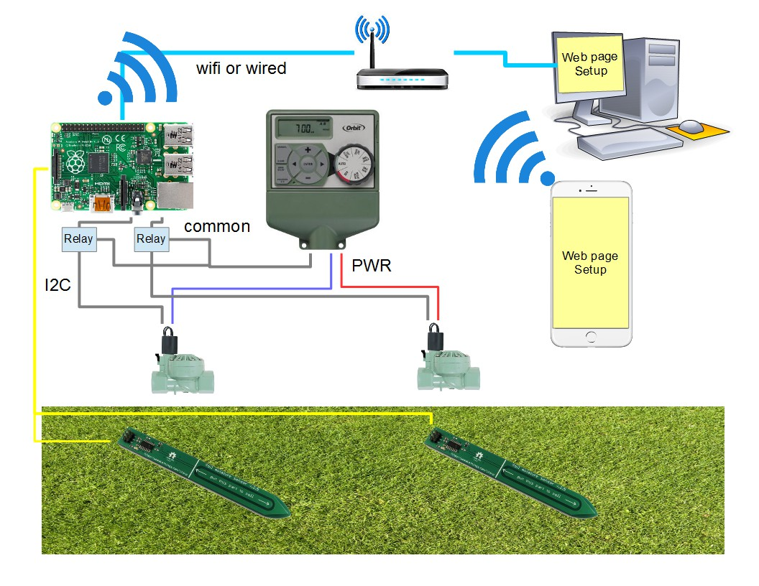

# Software Design:

## Software Diagram:

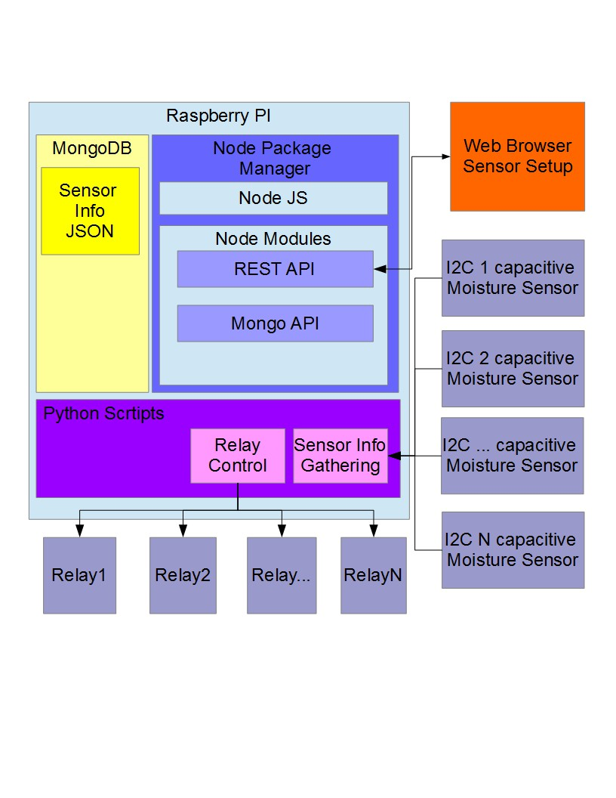

## RESTFUL API

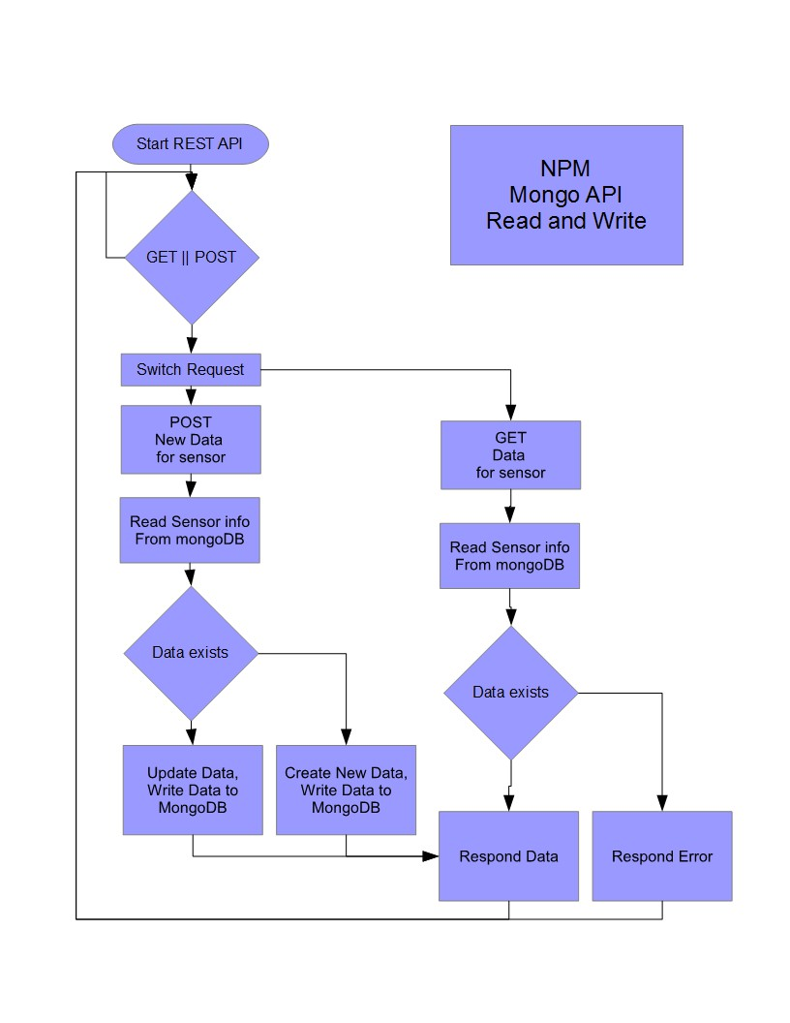

## PYTHON CODE:

