M10: Create your first CL and CD Pipeline
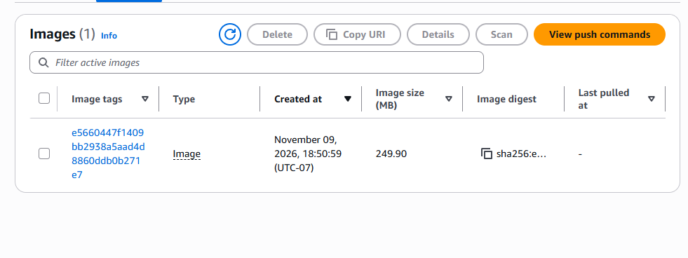
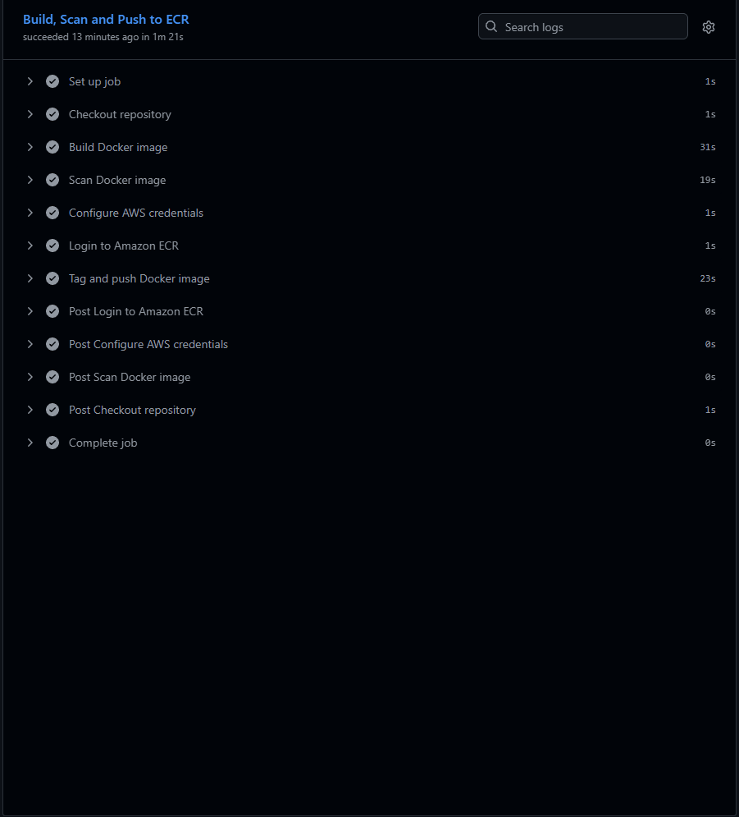
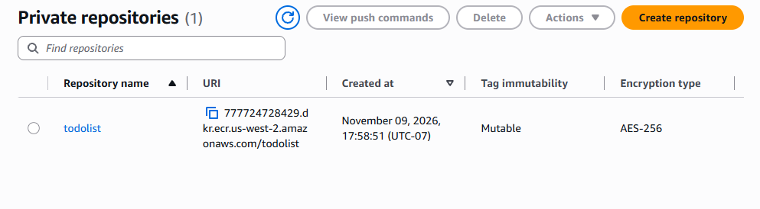
1. What did you learn from creating a CI/CD pipeline?
I learned how GitHub Actions can automate building, scanning, and uploading a Docker image. Instead of manually running every command, the pipeline handles these steps automatically. I also learned how GitHub can connect securely to AWS using IAM roles.
2. What challenges did you encounter?
The biggest challenge was getting GitHub Actions to authenticate with AWS. I kept receiving an error saying the workflow was not authorized to assume the IAM role. After troubleshooting the trust policy and checking the GitHub OIDC identity, I was able to fix the issue and successfully run the pipeline.
3. How did you incorporate security into the pipeline?
I used Trivy to scan the Docker image for vulnerabilities. I also configured AWS IAM and OpenID Connect (OIDC) so GitHub Actions could access Amazon ECR without storing permanent AWS access keys. This helped me understand how security can be included in an automated deployment process.
4. What was the result of your pipeline?
I successfully built the Docker image, ran the security scan, authenticated with AWS, and pushed the image to my private Amazon ECR repository. I verified that the image appeared in ECR with its image tag and digest.
5. How could you improve this pipeline in the future?
I would like to expand the pipeline so it automatically deploys the application after pushing the image to ECR. I could also improve the vulnerability scanning and configure notifications when a workflow fails. This would make the pipeline more useful for real-world application deployments.

