M8: Automate Prior Deployment with IaC
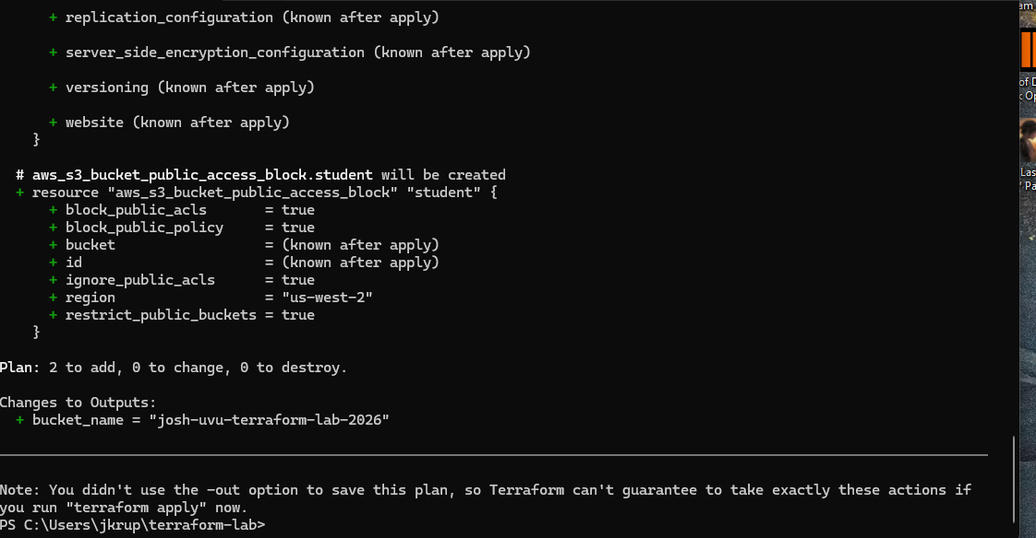
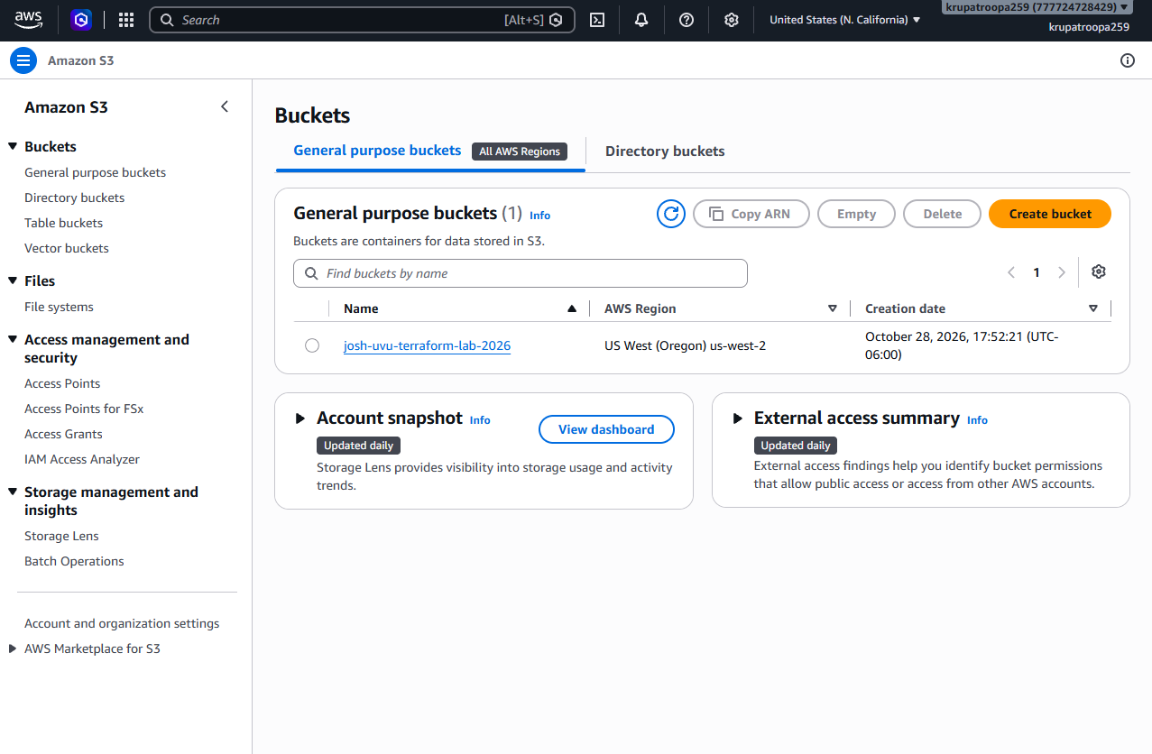
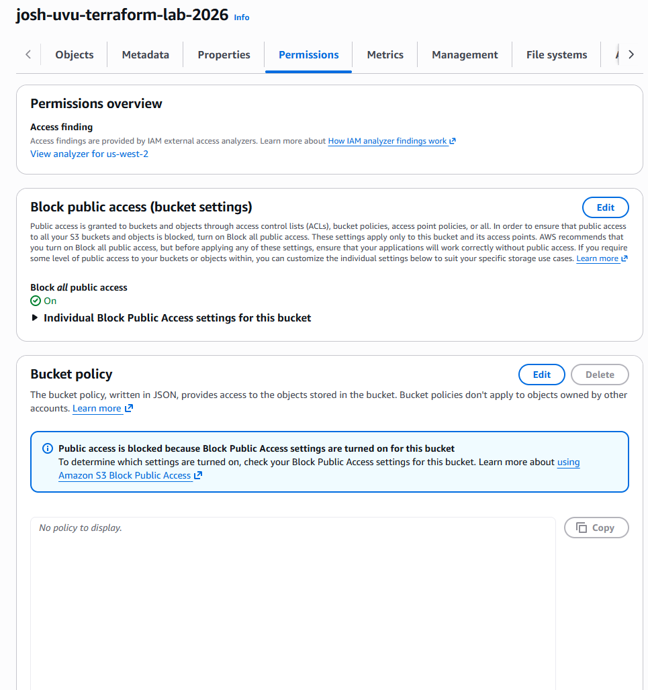
I chose Amazon Web Services because I have already used AWS EC2 a good amount and I enjoy it. I wanted to also build on my experience and learn how to automate AWS resources using Terraform.
I created a Amazon S3 bucket named josh-uvu-terraform-lab-2026 in the us-west-2 region.
The provider block tells terraform which cloud service to connect to and how to configure that connection.
The resource block defines the infrastructure Terraform should create and manage. My configuration includes an S3 bucket and a public-access block.
The plan command previews the changes Terraform intends to make.
My biggest challenge was configuring AWS IAM permissions. Terraform initially failed with an Access Denied error because my IAM user lacked permission to create an S3 bucket. After attaching a custom policy, I encountered additional errors involving S3 configuration permissions. I updated the policy and tested the AWS CLI connection to troubleshoot the problem. Once the permissions were correct, Terraform successfully deployed the bucket.
One major benefit is repeatability. Instead of manually creating and configuring resources in AWS, I can use Terraform to recreate the same infrastructure consistently. This saves time and helps reduce configuration mistakes.

