**Amadeus Value Proposition**

Josh Barber

Department of Physics and Computer Science, Wilfrid Laurier University

CP-601: Seminar in Technology Entrepreneurship

Nur Kurak

December 15, 2021

**Amadeus Value Proposition**

The coronavirus pandemic has been extremely destructive to the economy, disrupting several companies in its wake. Many companies have had to adjust their business strategies to adapt to the new structure of the economy during the coronavirus pandemic and unfortunately other companies have not had the chance to, as several companies had to declare bankruptcy. One sector of the economy that has had to make some big adjustments has been the travel and tourism industry. Within this industry, there is a technological niche run by TMC (travel management corporation) companies to make travel and rental reservations simple for clientele. These companies are the ones responsible for allowing travel agents to book a flight and room reservations at a resort and to also provide travel insurance all within a few simple clicks of a computer mouse. These TMC companies offer what is known as the GDS (global distribution system), which offers inventories, schedules, and fares from suppliers, and it gives agents and online travel agents an opportunity to search and book them: using connectivity APIs for online travel agents and via a manual terminal for agents (travelopro.com, 2020).

Amadeus IT Group is one of the world’s largest TMC technology providers for travel. The company runs platforms that support Airlines, Rail Operators, Hotels, Rental Cars, Ferry and Cruise lines, travel insurance groups, etc. and connects them with travel agents, tour operators and other customer facing entities (Raghavan, 2020). The company was founded in 1987 and initially started off as a technology provider for the airline industry. Over the years, the company has expanded its scope by launching the Airline IT business in 2000 and building on that with the acquisition of Navitaire in 2016 to broaden their offerings for low-cost carriers. The company moved into the hotel IT sector with the acquisition of Newmarket in 2014 and TravelClick in 2018. (Global Report, 2019).

Amadeus has a business-to-business relationship with all these acquired companies as each of them provides backbone technology to simplify the traveler’s experience (Raghavan, 2020). Through these business acquisitions, Amadeus has become the largest GDS provider serving the worldwide travel and tourism industry, with an estimated market share of 38% in 2011 (Eshtiaque, 2014). Amadeus makes its revenue from two key categories of customers. The first category of customers is travel providers, including airlines, hotels, rail operators, cruise and ferry operators, car rental companies, tour operators and insurance companies. The second are travel agencies, including online and offline travel agencies. Most of the companies generated revenue comes from the booking fees they charge airlines for reservations made through their GDS platform. Amadeus is the market leader in airline reservations, which comprises a substantial part of Amadeus’ revenue, which is around 25% of the complete market share (Eshtiaque, 2014).

Amadeus has two key priorities for their clientele, product innovation and technological excellence. These two key priorities allow Amadeus to stay at the forefront of advances in the travel technology industry and preserve the market leading position (Eshtiaque, 2014). However, Amadeus does suffer from some technical issues. The main technical issue Amadeus faces is the defects and errors associated with product enhancements that may not be detected until it unfortunately happens. Also, Amadeus suffers from system technology disruptions from the system being overloaded. Besides technical issues, the downturn of the economy, because of the coronavirus pandemic has really hindered Amadeus revenue streams. In Q1 when the pandemic was declared in 2020, Amadeus experienced a 24% decline in revenues alone. Also, airlines are trying to reduce pricing for reservations so they can stay afloat through this pandemic, which in turn also directly affects Amadeus’ revenue streams. This brings light of other cheaper alternatives, such as the airlines turning to Amadeus’ competitors like Sabre (Eshtiaque, 2014). Subsequently, international air passenger traffic has gone down by 60% since the start of the pandemic (icao.int, 2021). Raghavan states that “the most impact to the air travel industry may be behind us, at least in several regions. Travel may not return to pre-COVID levels anytime soon though“ (Raghavan, 2020), which is unfortunate because airline reservations are Amadeus’ main revenue stream as recently stated.

With the omicron variant of covid being more infectious, it is clear Amadeus must brace for another wave of covid in late 2021. So, the issue at hand is to adjust the business to help mitigate the spread of any diseases or viruses. To do so, there lies a unique value proposition. Allow all tickets and documents to be contactless and QR scanned to eliminate any potential spread of viruses or diseases. Implementing the value proposition could give an advantage over Amadeus' competitors, as this will give customers more confidence in safety. Customers usually make purchasing decisions on a comparative basis, considering all options and determining which solution best fits their priorities (Aulet, 2013). If Amadeus' competitors do not adjust, it will give Amadeus the market advantage essentially because during a pandemic, safety is the number one concern. If you focus on an underserved customer and make a product for that customer that truly meets the customers' need, there is no need to focus on competition because your unwavering focus makes the competition irrelevant (Aulet, 2013). However, normalcy for any air travel anytime soon does not seem to be on the horizon as Scott Keyes, founder of Scott’s Cheap Flights says, “A safe, effective and well-distributed coronavirus vaccine is the linchpin for a return to any travel normalcy,” (Mzezewa et al., 2020). So, until then, ensuring safety for the clientele during this pandemic era could be a potential lucrative opportunity for Amadeus to capitalize on.

The business model in *Figure 1.* describes the revenue streams and the value proposition process. As per Aulet, the business model would be considered a consumable one. The GDS provides revenue primarily on their fee-per-transaction basis, collecting a booking fee from the relevant travel provider for travel bookings processed through their GDS platform. Although such bookings are initiated and completed through travel agencies, the fee is paid by the travel provider. Typically, the GDS providers offer volume-based incentives and other economic inducements to their travel agency customers to process more bookings (Eshtiaque, 2014). Through the value proposition, we can see the offer is to incentivize contactless documents and tickets to the customers, and it would have to be innovated by the company’s IT solutions and through their partner networks to provide secure non-forgeable electronic documents and tickets. The cost to get the value proposition complete would be through planned management and development.

**Figure 1.**

*Amadeus’ business model*  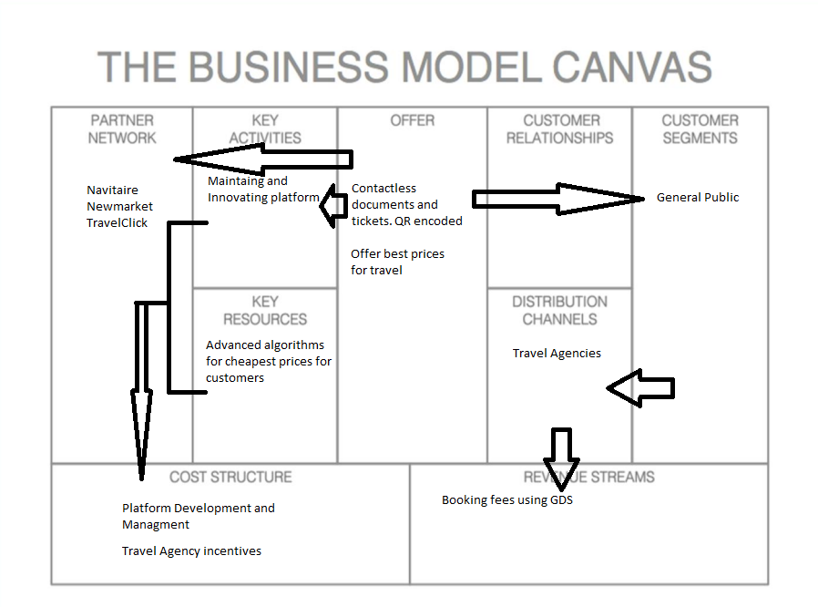

There can be critical risks that can be linked to the initial problems as noted previously. That the company is facing defects and errors on product enhancements that may not be detected until it happens. Incorrect data being streamlined through to the GDS system can make contactless documents and tickets easier to be incorrect themselves once handed back to the issuer, as travel agencies do not necessarily hold the responsibility to then verify the information handed over back over to the public, whereas if a travel agent had to hand over physical copies, it may be more obvious to spot errors. Using more GDS internal APIs and internal systems can result in the GDS system to be overburdened with extra work, which has already been an issue with the current GDS system, as recently stated.

If the current GDS system can adapt to go all electronic, and major testing has been performed from the IT department to mitigate any technical issues when it comes to serving tickets or documents electronically. The proposition would improve Amadeus' market position over its competitors, by not only becoming the most reliable service in their respective market, but also the safest TMC service out there. Travel agencies deal with client relations and knowing safety is being considered would be an attractive asset in this pandemic era.

**References**

Aulet, B. (2013). *Disciplined entrepreneurship: 24 steps to a successful startup*. Wiley.

Eshtiaque, K. M. (2014). *Strategic analysis for Amadeus*. SlideShare. Retrieved December 15, 2021, from <https://www.slideshare.net/kmeshtiaque/strategic-analysis-for-amadeus>

Global Report. (2019). *Amadeus Global Report 2019*. Retrieved December 15, 2021, from <https://corporate.amadeus.com/documents/en/resources/corporate-information/corporate-documents/global-reports/2019/amadeus-global-report-2019.pdf>.

icao.int. (2021). *Economic impacts of covid-19 on Civil Aviation*. Economic Impacts of COVID-19 on Civil Aviation. Retrieved December 15, 2021, from <https://www.icao.int/sustainability/Pages/Economic-Impacts-of-COVID-19.aspx>

Mzezewa, T., Yeginsu, C., Glusac, E., & Firshein, S. (2020, December 22). *9 ways the pandemic will change travel in 2021*. The New York Times. Retrieved December 15, 2021, from <https://www.nytimes.com/2020/12/22/travel/flight-cancellations-cruise-ships-covid-vaccine.html>

Raghavan, V. (2020, July 13). *Amadeus: Powering the transformation of Global Travel (OTCMKTS:Amady)*. SeekingAlpha. Retrieved December 15, 2021, from <https://seekingalpha.com/article/4358160-amadeus-powering-transformation-of-global-travel>

travelopro.com. (2020, October 6). *How to choose a GDS: Amadeus vs Sabre vs Travelport*. Travelopro. Retrieved December 15, 2021, from <https://www.travelopro.com/travelport-vs-amadeus-vs-sabre-gds>