**A Look into Technology Entrepreneurship and Its Three Typologies**

Josh Barber

Department of Physics and Computer Science, Wilfrid Laurier University

CP-601: Seminar in Technology Entrepreneurship

Nur Kurak

September 22, 2021

**A Look into Technology Entrepreneurship and Its Three Typologies**

The main principles of entrepreneurship over the last millennia have changed dramatically. Starting from the basic exchange of goods by trade, to having today's corporate giants. Entrepreneurship was coined by French economist Richard Cantillon in 1723 and was clearly defined by Jean Baptiste Say in 1803. According to Say, an entrepreneur is an economic agent who uses means of production to develop a product. Sells his product to gain revenue and has the purpose of increasing his profits (KWS). A more modern definition of entrepreneurship as defined by Fernandes may be more proper today. Fernandes defines an entrepreneur as "a person who identifies a need and starts a business to fill that void" (Fernandes). Although vague, it does wrap today's meaning of entrepreneur more accurately. A modeled entrepreneur is not always defined by Say's principles. An entrepreneur can be motivated on the foundations of moral purposes only. An entrepreneur does not necessarily need any means of production either, in the digital age that we are in now. Since the third industrial revolution, also referred to as the digital revolution, entrepreneurship has taken a new turn. The technology venture landscape has changed radically in the last decade and will continue to change in the years ahead (Duening, Hisrich, & Lechter). In fact, as of right now, we are currently within the fourth industrial revolution and entrepreneurship is evolving. The speed of current breakthroughs has no historical precedent. When compared with previous industrial revolutions, the Fourth is evolving at an exponential rather than a linear pace (Schwab). Interestingly enough, technology entrepreneurship, being a relatively recent offspring of entrepreneurism, has received considerable attention due to the ubiquity and fast-pace of being connected, dependent, and vulnerable in our modern society (Ferran Giones & Alexander Brem).

In this new age, we have seen radical development in the technology sector and from that, we have our technology entrepreneurs. Technology entrepreneurship is an investment in a project that assembles and deploys specialized individuals and heterogeneous assets that are intricately related to advances in scientific and technological knowledge for the purpose of creating and capturing value for the firm (McPhee & Bailetti). Now that we have new products based on breakthroughs in research; science advances through specific knowledge in an academic field. From these advances in technology, we can see three prominent typologies in which technological entrepreneurs diverge towards: Technology Entrepreneurship, Digital Technology Entrepreneurship, and Digital Entrepreneurship. Instead of proposing a clear-cut conceptualization between digital and technology entrepreneurship, we propose to describe the change in meaning of “technology” as a continuum between the extremes represented by the commercialization of the latest scientific breakthroughs (Ferran Giones & Alexander Brem). The typologies listed group together similar evolutionary paths and growth trajectories. This comes as a response to the diversity of technology origins and outcomes that make it unfeasible to extract homogeneous insights from them if treated as a sole category. (Ferran Giones & Alexander Brem).

The technology entrepreneurship typology focuses on creating new products based on breakthroughs in research, which are science-based advances through specific knowledge in an academic field. (Ferran Giones & Alexander Brem). A perfect example of this is the progress of nanotechnology. Nanotechnology has allowed for substantial growth in many sectors. From medicine to electronics. The digital technology entrepreneurship typology overlaps with the technology entrepreneurship typology, as well as the digital entrepreneurship typology. Digital technology Entrepreneurship focuses on new products based on ICT (Information and Communications Technology) technologies only (Ferran Giones & Alexander Brem). An example of this would be a gaming console or a smart phone. Digital Entrepreneurship focuses on new products and services based on the Internet. Services running only in the cloud using big data or artificial intelligence (Ferran Giones & Alexander Brem). These typologies can have dependencies on each other as conceptualized in Figure 1, as technology entrepreneurs may need the innovations produced from other typologies.

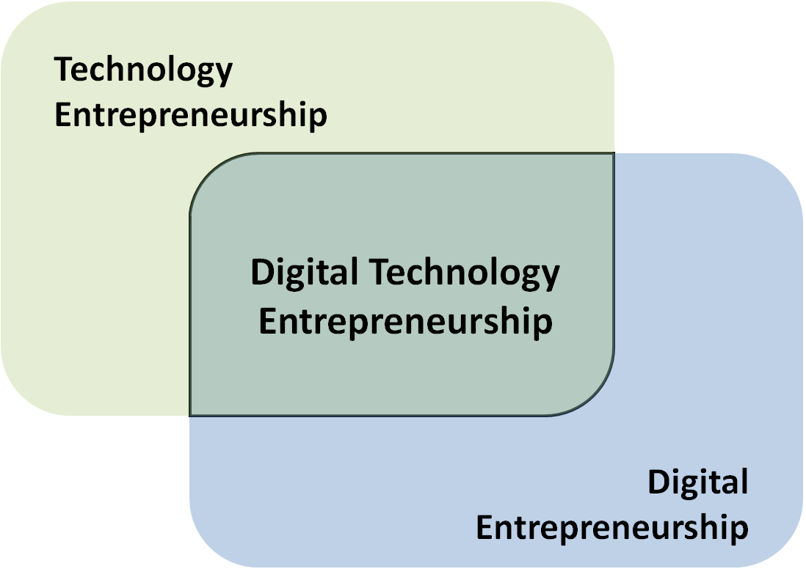

Figure 1. Conceptual representation of technological entrepreneurship typology overlap.

Technology entrepreneurship is a type of entrepreneurship that aims to exploit opportunities related to advances in science and engineering (Ferran Giones & Alexander Brem), which commercializes on the latest scientific breakthrough. One of the latest scientific breakthroughs is graphene, and the implications of it being introduced into the marketplace can be revolutionary. The other two typologies will benefit greatly from this breakthrough. In retrospect, giant leaps of scientific innovations like graphene happens seldomly compared to a successful marketable idea generated from either the digital technology or digital entrepreneurs that supply products or services independently from scientific or engineering breakthroughs. The technology entrepreneur will have to accommodate to the ever shifting marketplace with new engineering or scientific breakthroughs. This of course can pose a risk for other technology entrepreneurs, as many companies try to fill much-needed voids in the marketplace. A notable example of this was the successor of DVD’s. The Blu-ray technology competing against the HD DVD technology. Although Blu-ray technology came out on top, Toshiba lost almost $1 billion supporting the HD DVD format (Reuters). Needless to say, Toshiba didn’t have a good day dropping the production of HD DVD’s.

The success of the digital technology entrepreneurs can be driven on the innovations that technology entrepreneurs produce as digital technology entrepreneurship focuses on the identification and exploitation of opportunities based on scientific or technological knowledge through the creation of digital artefacts (Ferran Giones & Alexander Brem). However, they strategically combine technological product knowledge (“technology push”) with consumer know-how (“market pull”) (Ferran Giones & Alexander Brem). A smart phone is a notable example. Almost every year, a newer product of the same brand of smart phone is introduced to the market with better specifications in hardware, or better features to appease the consumer, yet in concept does generally the same thing as last year’s brand. Digital technology entrepreneurs also rely on an innovation ecosystem as digital entrepreneurs do (Ferran Giones & Alexander Brem). Android or Apple OS updates that offer specific features that are not based on hardware rather just on software could deter customers to switch brand preferences, making the market more competitive.

From a research perspective, digital entrepreneurship is much closer to the information systems’ concepts of artefacts, platforms, and information infrastructure (Nambisan, 2016). Digital entrepreneurs often do not really care about the specific technology behind their business idea, they simply focus on the service that is based on it. Hence, technology here is an input factor only (Ferran Giones & Alexander Brem). The innovation of social media for example has been a concept since the early 2000’s. This innovation doesn’t require a user to have the latest technology to use the services, rather can be used on obsolete technology, as the social media platform is based online.

Digital Entrepreneurs typology is the most applicable typology. Although, fast growth and forward leaps often mean higher failure risks for the ambitious digital entrepreneurs stepping into emerging ecosystems, where the role of each of the players is still unclear and the technology base is still evolving (Ferran Giones & Alexander Brem). It is still a young area in the marketplace that has yet to see its full growth potential. We’re are seeing a fast shift of digital entrepreneurs creating services that completely replace other forms of services. An example is Netflix and other streaming platforms that have replaced the movie rental service. With services being converted over into the digital space, there are many lucrative opportunities.

It is no surprise that some of the most successful technological company’s out there serve by the digital typological approach. It can be so much as an idea that can create profit, rather than a scientific breakthrough. The largest ever initial public offering (IPO) from a technology company took place: Facebook raised over $16 billion USD upon becoming listed in the stock market (Rusli & Eavis). This is true because there is so much void within the digital market that it needs to be filled. The future impact of digital entrepreneurs will revolutionize our way of life. With the internet of things and cloud based artificial intelligence systems being integrated as one, the possibilities are endless.

**References**

Duening, T. N., Hisrich, R. D., & Lechter, M. A. (2015). Preface. *Technology Entrepreneurship*, xxiii-xxiv. <https://doi.org/10.1016/b978-0-12-420175-0.09998-x>

Ferreira, J.J.M., Ferreira, F.A.F., Fernandes, C.I.M.A.S. et al. What do we [not] know about technology entrepreneurship research?. Int Entrep Manag J 12, 713–733 (2016). <https://doi.org/10.1007/s11365-015-0359-2>

Giones, F., & Brem, A. (2017). Digital technology Entrepreneurship: A definition and research agenda. *Technology Innovation Management Review*, *7*(5), 44–51. <https://doi.org/10.22215/timreview/1076>

KWS. (2018, March 16). *Past versus present: How has entrepreneurship evolved with the times?* KWS. Retrieved September 22, 2021, from <https://www.kwsme.com/past-versus-present-how-has-entrepreneurship-evolved-with-the-times/>.

McPhee, C., & Bailetti, T. (2012). Editorial: Technology Entrepreneurship (May 2012). *Technology Innovation Management Review*, *2*(5), 3–4. <https://doi.org/10.22215/timreview/552>

Nambisan, S. (2016). Digital entrepreneurship: Toward a digital technology perspective of entrepreneurship. *Entrepreneurship Theory and Practice*, (414), 1–27. <https://doi.org/10.1111/etap.12254>

Reuters. (2010, August 5). *Toshiba faces $986 million loss on Hd dvds: Nikkei*. CNBC. Retrieved September 22, 2021, from <https://www.cnbc.com/id/23601073#:~:text=Japan's%20Toshiba%20is%20likely%20to,business%20daily%20said%20on%20Thursday>.

Rusli, M. E., & Eavis, P. (2012, May 17). *Facebook raises $16 billion in I.P.O.* The New York Times. Retrieved September 22, 2021, from <https://dealbook.nytimes.com/2012/05/17/facebook-raises-16-billion-in-i-p-o/>.

Schwab, K. (2016, January 14). *The fourth industrial Revolution: What it means and how to respond*. World Economic Forum. Retrieved September 22, 2021, from <https://www.weforum.org/agenda/2016/01/the-fourth-industrial-revolution-what-it-means-and-how-to-respond/>.