1. Can you get the feature names and the descriptions of the toy diabetes data set via python code? Please write down the code and the output of the code. [1 point]

Code:

from sklearn.datasets import load_diabetes

data_bunch = load_diabetes()

print("Feature Names:")

print(data_bunch.feature_names)

print("\nDescrtiption:")

print(data_bunch.DESCR)

Output:

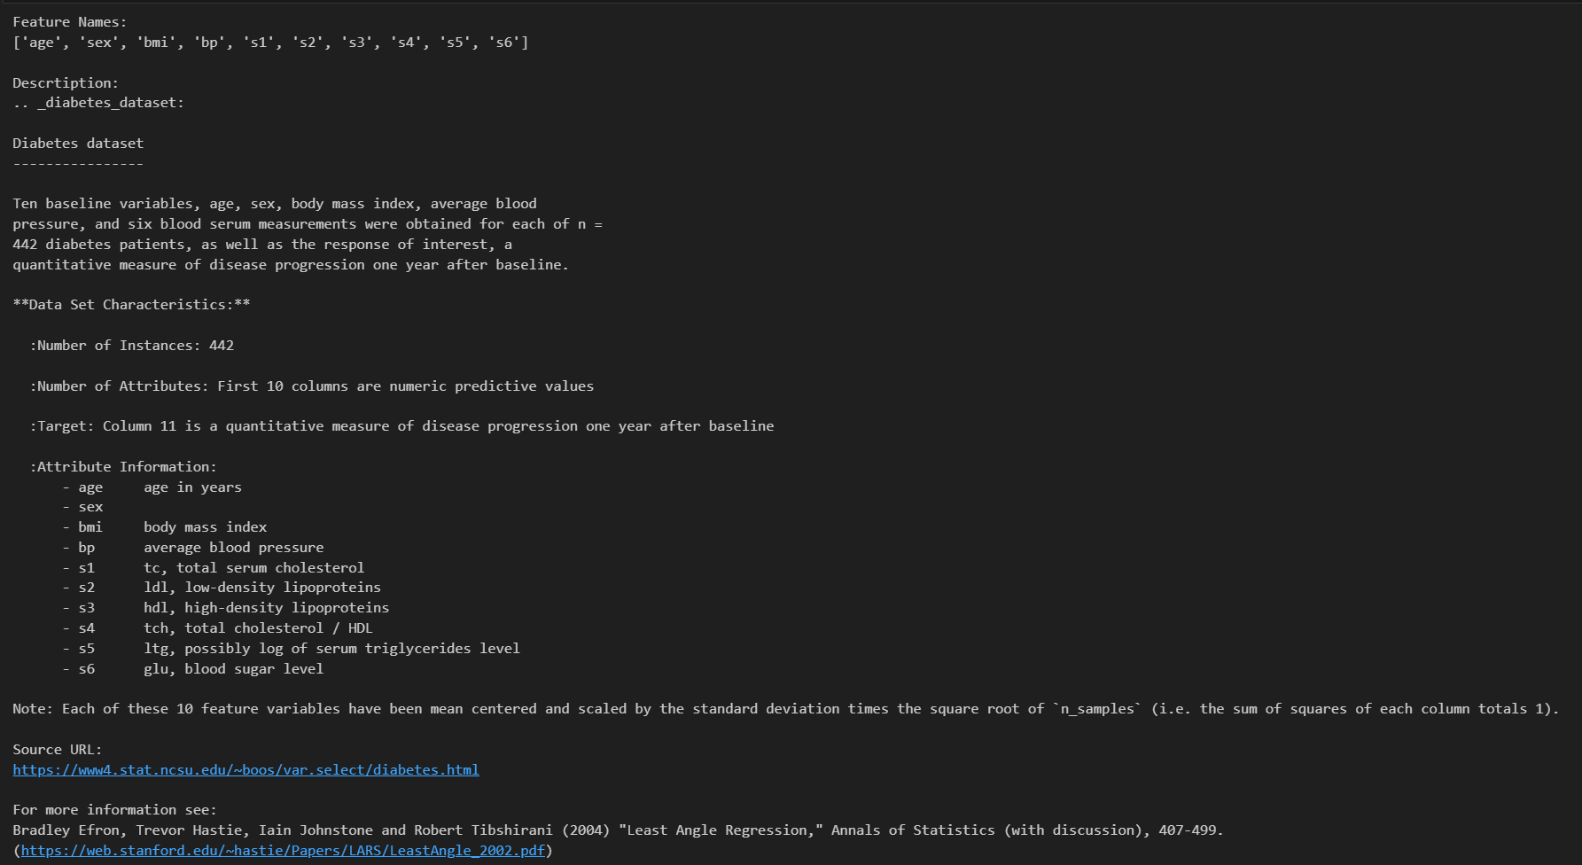

2. It is time to play with another data set of scikit_learn: the wine data set. Use **load_wine**() to load the wine data set and apply logistic regression on it. We split the data set into 80/20. 80% of data points are used for model training, and 20% for test purposes. Please write the code and output (including mean accuracy and confusion matrix) in the answer. [2 points]

Code:

from sklearn.datasets import load_wine

from sklearn.model_selection import train_test_split

from sklearn.linear_model import LogisticRegression

from sklearn.metrics import plot_confusion_matrix

import matplotlib.pyplot as plt

import numpy as np

def warn(*args, **kwargs):

pass

import warnings

warnings.warn = warn

data_bunch = load_wine()

print("Feature Names")

print(data_bunch.feature_names)

print("\nClasses")

print(data_bunch.target_names)

wine_X, wine_y = data_bunch.data, data_bunch.target

def filter_class_2(X, y):

new_X, new_y = [], []

for x, y in zip(X, y):

if y == 2:

continue

else:

new_X.append(x)

new_y.append(y)

return np.array(new_X), np.array(new_y)

wine_X, wine_y = filter_class_2(wine_X, wine_y)

x_train, x_test, y_train, y_test = train_test_split(wine_X, wine_y, test_size=0.2)

logit_regr = LogisticRegression()

logit_regr.fit(x_train, y_train)

logit_regr.classes_

print("\nAccuracy Score")

print(logit_regr.score(x_test, y_test))

plot_confusion_matrix(logit_regr, x_test, y_test)

plt.show()

Output:

