Assignment 8

Josh Barber

barb4630@mylaurier.ca

215854630

1. Fit the 2 estimators with X and evaluate their performance by [v_measure_score](https://scikit-learn.org/stable/modules/generated/sklearn.metrics.v_measure_score.html). Write down the code and compare its performance. (1 point)

from sklearn import cluster

from sklearn.metrics.cluster import v_measure_score

from sklearn.cluster import KMeans

from sklearn import datasets

from sklearn.preprocessing import StandardScaler

iris = datasets.load_iris()

X = iris.data

labels_true = iris.target

#X = StandardScaler().fit_transform(X)

estimators = [

("k_means_iris_3", KMeans(n_clusters=3)),

(f"DBSCAN_0.5", cluster.DBSCAN(eps=0.5))

]

for name, algorithm in estimators:

algorithm.fit(X)

if hasattr(algorithm, "predict"):

labels_pred = algorithm.predict(X)

else:

labels_pred = algorithm.fit_predict(X)

print(name, v_measure_score(labels_true, labels_pred))

print(algorithm.labels_)

1. After fitting the 2 estimators, print the labels of the DBSCAN estimator. If your DBSCAN estimator is stored in variable **est**, you can get the labels by running **print(est.labels_)**. You will see many -1 in the list. What are those data points with the -1 label? If you change **eps** to 1, do you still see it? Can you explain the change? (2 points)

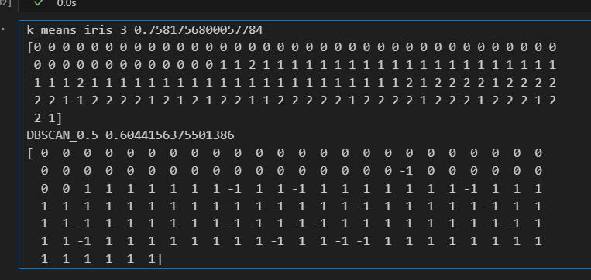K means (3 clusters) and DBSCAN (eps=0.5) v_measure_score and labels

DBSCAN labels noisy data with –1, so all the data points with a label of –1 are considered noisy data and are not put into a cluster.

If we increase the epsilon value to 1, we can see that there is no longer any noisy data. Epsilon is the radius value around a point x, to help determine clusters. Increasing the epsilon value allowed all data points to be clustered.

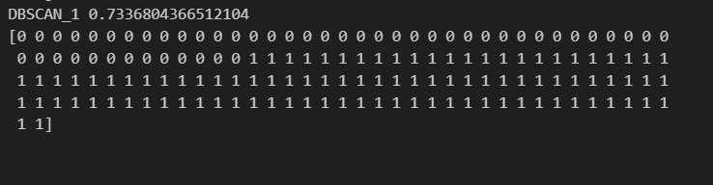DBSCAN (eps=1) v_measure_score and labels