Assignment 9

Josh Barber

barb4630@mylaurier.ca

215854630

Code:

import numpy as np

from sklearn.ensemble import RandomForestRegressor

from sklearn.model_selection import RandomizedSearchCV

from sklearn.datasets import fetch_california_housing

from sklearn.model_selection import train_test_split

from sklearn.metrics import mean_squared_error, r2_score

from sklearn.ensemble import RandomForestRegressor

california_housing_bunch = fetch_california_housing()

california_housing_X, california_housing_y = california_housing_bunch.data, california_housing_bunch.target

x_train, x_test, y_train, y_test = train_test_split(california_housing_X, california_housing_y, test_size=0.2)

# Deafult

rf = RandomForestRegressor(max_features="sqrt", min_samples_split=5, min_samples_leaf=2)

rf.fit(x_train, y_train)

print("random forest regressor with default parameters")

california_housing_y_pred = rf.predict(x_test)

print("Mean squared error: %.2f" % mean_squared_error(y_test, california_housing_y_pred))

print("Coefficient of determination: %.2f" % r2_score(y_test, california_housing_y_pred))

# Random Search Tuning

n_estimators = [int(x) for x in np.linspace(start = 600, stop = 2000, num = 15)]

max_depth = [int(x) for x in np.linspace(10, 80, num = 8)]

max_depth.append(None)

bootstrap = [True, False]

random_grid = {'n_estimators': n_estimators,

'max_depth': max_depth,

'bootstrap': bootstrap}

rf_random = RandomizedSearchCV(estimator = rf, param_distributions = random_grid, n_iter = 10, cv = 5, n_jobs = -1)

rf_random.fit(x_train, y_train)

print("random forest regressor with random search tuning")

california_housing_y_pred = rf_random.best_estimator_.predict(x_test)

print("Mean squared error: %.2f" % mean_squared_error(y_test, california_housing_y_pred))

print("Coefficient of determination: %.2f" % r2_score(y_test, california_housing_y_pred))

rf_random.best_estimator_

Result:

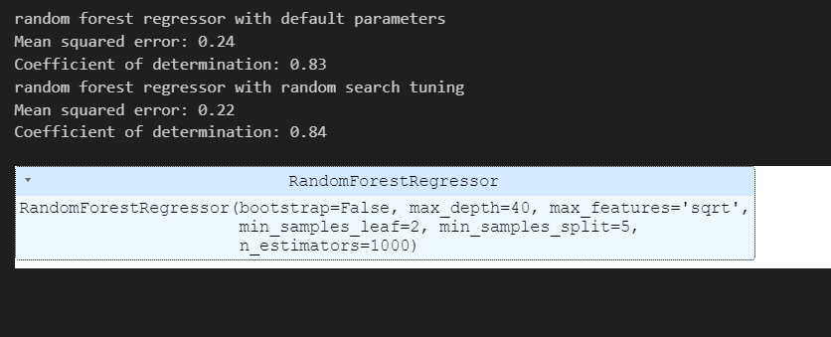

The random search was able to find a better model with tuned hyper-parameters as compared to the default model generated. Although there is not a significant increase in performance over the default model, nevertheless the potential for performance increase would vary dependent on the model and data.