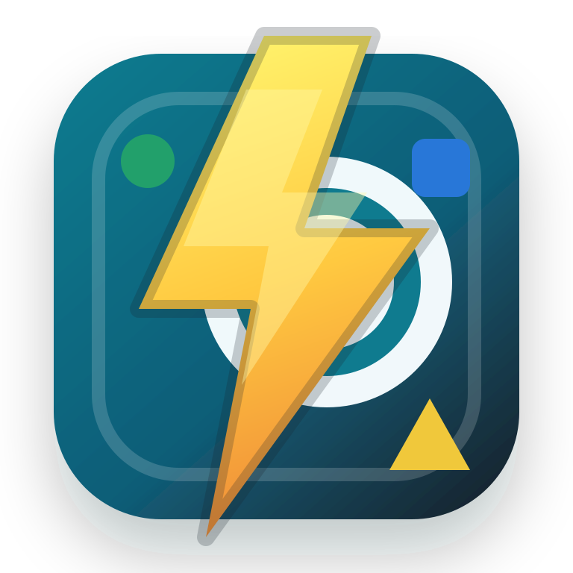
ZAP IT
Style Guide
Visual language, interaction patterns, and implementation standards
Built from the production interface: logo artwork, CSS design tokens, game states, responsive behavior, themes, motion, and accessibility patterns.
CORE IDEA Fast recognition, immediate feedback, and playful energy without sacrificing clarity.

Reference version 1.0 | June 2026

01 / BRAND FOUNDATIONS

The Zap It design character
Zap It is a focused reaction game. Its interface should feel quick, bright, tactile, and trustworthy. Every visual choice should help players identify the target, act confidently, and understand the result without slowing down.
Principle | What it means | Design implication
Immediate | The next action is always obvious. | One dominant action; short labels; strong state changes.
Electric | Energy comes from color, motion, and the bolt motif. | Use yellow and zap effects as accents, not constant decoration.
Clear | Speed never reduces legibility. | High contrast, simple geometry, compact but breathable spacing.
Tactile | Controls respond like physical game pieces. | Pressed movement, impact feedback, depth through restrained shadows.
Inclusive | Touch, keyboard, and assistive technology are first-class. | Visible focus, semantic controls, live status, readable theme variants.

Experience priorities
- Recognition before decoration. The target and matching shape must dominate visual attention.
- Feedback within a fraction of a second. Correct and incorrect actions must look unmistakably different.
- A calm frame around an energetic game. Panels and typography stay restrained so gameplay can feel lively.
- Mobile first. The core play surface is designed for a narrow, one-handed viewport and expands modestly on larger screens.

Voice and terminology
Use | Avoid | Reason
Start, Restart, Play again | Initialize, Reset state | Player language should describe the action, not the implementation.
Zap the matching item | Select the correct option | The brand verb gives instructions personality and specificity.
Wrong item. 10 seconds lost. | Invalid input | State the consequence plainly and immediately.
Zaps/sec | Clicks per second | Use the product's own vocabulary consistently.

WRITING RULE Keep interface copy active, concrete, and brief. Prefer one sentence over explanatory paragraphs.

02 / IDENTITY

Logo, icon, and shape language
 | Primary mark  A lightning bolt strikes a teal target tile. Supporting shapes communicate matching, speed, and playful competition.  Use the full mark for app branding and the simplified icon for browser or compact contexts.

Usage rules
Rule | Specification
Clear space | Keep at least 25% of the logo tile width clear on every side.
Minimum size | Full logo: 40 px digital / 0.42 in print. Favicon: use the simplified icon artwork.
Background | Prefer white, very light neutral, or the app's dark panel color. Preserve edge contrast.
Alteration | Do not recolor individual logo elements, flatten the gradients, stretch, rotate, or add effects.

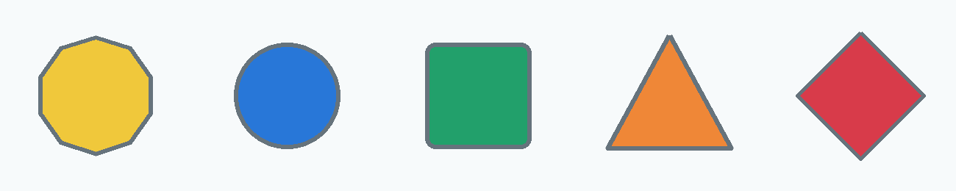
Game shapes

Star, circle, rounded square, triangle, and diamond are the canonical set. Shapes use a bold fill, a subtle dark outline, and enough interior scale to remain recognizable at speed.
SHAPE RULE Do not communicate a gameplay distinction with color alone. Shape and accessible labels remain part of the identity.

03 / COLOR

Core interface palette
The core palette uses deep blue-black for clarity, teal for action, warm yellow for electric brand energy, and restrained semantic colors for outcomes.
Token | Value | Role
Ink | #17212B | Primary text, dark outlines, high-contrast anchors
Muted | #5F6D78 | Secondary copy, labels, supporting metrics
Accent | #0F7B8F | Primary actions, timer ring, active emphasis
Accent strong | #095B6D | Icon color, links, small emphasis on light surfaces
Panel | #FFFFFF | Primary surface and modal background
Field | #EDF3F7 | Inset stat blocks, options, leaderboard rows
Line | #D8E1E7 | Borders and quiet structural dividers
Electric yellow | #FFC940 | Logo bolt and selective brand highlights
Success | #16704A | Correct match feedback
Danger | #BC3152 | Miss feedback and time penalty

Color hierarchy
- Teal is functional. Reserve it for actions, focus, timing, and active structure.
- Yellow is expressive. Use it sparingly for identity and moments of energy.
- Green and magenta-red are semantic. Never reuse them casually where correctness could be inferred.
- Neutral surfaces carry most of the interface. This keeps the colored shapes visually dominant.

Dark mode
Token | Value | Role
Dark panel | #18242D | Main surface
Dark field | #22333E | Inset controls and stat regions
Dark line | #344955 | Borders
Dark accent | #40B9C8 | Primary actions and timer ring
Dark ink | #F1F7FA | Primary text
Dark muted | #A9BBC4 | Secondary text

CONTRAST Treat light and dark mode as separate tested palettes. Do not create dark mode by simply inverting colors.

04 / THEMES

Theme palettes
Themes change the atmosphere and shape palette while preserving the same hierarchy, interaction states, component geometry, and accessibility expectations.
Theme | Primary colors | Character | Usage note
Normal | #2877D8 #22A06B #D83B4A #F0C83B #EF8737 | Balanced and familiar | Default multicolor game experience
One color | User-selected base plus light/dark mixes | Focused and customizable | Shapes use gradients; tiles receive subtle tonal variation
Christmas | #C8D0D6 #C52B2F #167A4A | Festive and crisp | Keep silver readable against both surface modes
Fall | #C65F24 #D99A22 #A83F3F #6F7F3A #7B4B5B | Warm and earthy | Use cream-toned ambient backgrounds
Summer | #F8C630 #FF6F61 #24B8C8 #8CC63F #4F9FEA | Bright and buoyant | Maintain strong borders around light fills

Theme construction rules
- Keep the base neutral system stable: text, panels, fields, lines, focus, and semantic feedback must remain predictable.
- Change ambient background gradients and accent values, but preserve panel readability and action prominence.
- In one-color mode, calculate a light mix and dark mix from the selected color, then choose button text by luminance.
- Test every theme in light and dark mode, during gameplay and inside modal screens.

One-color recipe
Output | Mix | Current implementation
Light companion | Base toward white | 42% white for theme highlight; 72-88% white for tiles
Dark companion | Base toward black | 20% black for accent; 24% black for shape gradient
Button text | Choose by luminance | Dark ink above a 0.62 luminance threshold; white otherwise

GUARDRAIL Seasonal personality belongs in color and atmosphere. Do not change gameplay rules, controls, or information architecture by theme.

05 / TYPOGRAPHY AND LAYOUT

Type system
Zap It uses Arial with Helvetica and system sans-serif fallbacks. The system favors familiar letterforms, compact hierarchy, and heavy weights for rapid scanning.
Role | App size | Weight | Treatment
Primary app heading | 1.32rem | Bold | Tight line height; sentence case
Modal heading | 1.45-2.1rem | Bold | Short phrases; strong contrast
Target name | 1.08rem | Extra bold | Centered; immediate gameplay priority
Eyebrow / label | 0.72rem | Bold | Uppercase; muted; compact
Body / instructions | 0.86-0.92rem | Regular | 1.18-1.3 line height
Metrics | 0.95-1.25rem | Extra bold | Tabular-feeling alignment; short labels
Legal / disclosure | 0.68-0.76rem | Regular | Use only for genuinely secondary required text

Spacing and geometry
Token | Value | Use
Core radius | 0.5rem | Panels, buttons, cells, dialogs, options
Compact radius | 0.45rem | Inset fields, rows, secondary controls
Large shell radius | 0.75rem | Desktop game shell
Core gap | 0.4-0.75rem | Primary layout rhythm
Touch control | 2.55-2.85rem min | Icon buttons, inputs, settings rows
Play grid | 3 x 3, square | Maximum 25rem mobile / 27rem larger viewports
Content shell | 30rem max | Narrow, phone-first centered game experience

Surface and depth
- Panels use a soft translucent white surface in light mode and an opaque dark surface in dark mode.
- Borders define structure before shadows do. Keep the line color quiet but visible.
- Use soft elevation for panels and stronger elevation for primary actions and overlays.
- The game shapes carry their own drop shadow so they separate from the tile without making the tile visually noisy.
LAYOUT RULE Keep the main play loop visible in one narrow column. Avoid sidebars or persistent secondary navigation near the grid.

06 / COMPONENTS

Core component patterns
Component | Visual recipe | Behavior
Top bar | Soft panel, logo lockup, compact icon actions | Keeps brand and utility controls available without competing with play
Target panel | Centered target name and shape; circular timer at right | Waiting state removes shape and timer to simplify the start moment
Stat row | Three equal inset fields | Score, streak, and rate update continuously
Grid cell | 2 px border, 0.5rem radius, pale gradient, centered shape | Press scales to 96%; focus gets a 3 px outline
Primary button | Solid accent fill, white or computed readable text | One dominant action per view; 1 px pressed movement
Ghost button | Panel fill, line border, strong accent text | Secondary or refresh actions
Overlay / dialog | 58% dark scrim, compact panel, strong shadow | Focus moves into the dialog and returns to the trigger on close
Leaderboard row | Field background, rank accent, compact metrics | Current run receives an inset accent ring

Button hierarchy
Level | Use | Examples
Primary | Advance or restart the main flow | Start, Save, Play again
Secondary | Optional maintenance or refresh action | Refresh rankings
Icon | Compact utility action with a clear accessible name | How to play, Leaderboard, Settings, Close

State styling
State | Required signal | Current treatment
Default | Clear affordance | Border, surface contrast, pointer cursor
Pressed | Physical response | Translate 1 px or scale to 96%
Focus visible | Keyboard location | 3 px high-contrast outline with 3 px offset
Disabled | Unavailable but legible | 62% opacity for controls; 55% for grid cells
Correct | Positive outcome | Green border and soft outer ring plus zap impact
Wrong | Error and consequence | Danger border, soft ring, horizontal shake, timer penalty pulse

COMPONENT RULE A state must remain understandable without animation. Motion reinforces the border, color, copy, and focus change.

07 / MOTION AND ACCESSIBILITY

Motion language
Motion is short, responsive, and tied to cause and effect. The interface should never animate merely to stay busy.
Motion | Duration | Purpose | Character
Lightning strike | 140 ms | Confirm a correct zap | Sharp, stepped flash with glow and impact point
Impact compression | 130 ms | Make the chosen tile feel struck | Quick scale and brightness pulse
Wrong shake | 190 ms | Signal a miss | Small horizontal displacement
Timer penalty | 420 ms | Connect the miss to lost time | Danger color and brief scale increase
Board refresh | 520 ms | Separate rounds and reveal the next set | Fast 3D flip with a mid-animation content swap

- Keep gameplay feedback below roughly half a second so it feels immediate.
- Lock the board during a round transition to prevent accidental double input.
- Avoid springy or decorative motion that obscures shape recognition.
- Provide a reduced-motion path when the product adds broader motion preferences.

Accessibility requirements
Area | Standard
Semantics | Use native buttons, fieldsets, labels, ordered lists, and dialog roles.
Names | Every icon-only control needs an accessible name and matching title where useful.
Status | Timer, messages, score-save feedback, and leaderboard loading use appropriate live regions.
Keyboard | Numpad mirrors the 3 x 3 board; Space restarts; Escape closes overlays.
Focus | Move focus into opened dialogs and return it to the originating control on close.
Contrast | Test each seasonal palette in both modes; retain borders around pale shapes.
Privacy | Keep the score-sharing warning visible and avoid requesting identifying information.

NON-NEGOTIABLE Do not remove visible focus, accessible labels, dialog focus management, or live feedback while restyling components.

08 / RESPONSIVE AND IMPLEMENTATION

Responsive behavior
Viewport | Behavior
Base / mobile | Full-height narrow shell, 0.7rem outer padding, 25rem maximum grid, touch-first controls.
42rem and wider | Center the app in the viewport, add body padding, increase shell padding, allow a 27rem grid.
24rem and narrower | Hide leaderboard rate details and stack the score-save input and button.
Active play | Prevent body scrolling and overscroll so the game surface remains stable.

Implementation checklist
Check | Requirement
Brand | Use the approved logo artwork and canonical five-shape set.
Tokens | Reference shared variables for ink, muted, surfaces, line, accent, success, danger, focus, and elevation.
Hierarchy | Keep one primary action and one dominant gameplay target per view.
Themes | Verify Normal, One color, Christmas, Fall, and Summer in light and dark mode.
States | Test default, pressed, focus, disabled, correct, wrong, loading, empty, and saved states.
Motion | Preserve cause-and-effect timing and board locking during transitions.
Responsive | Check narrow phone, standard phone, and centered desktop layouts.
Accessibility | Retain semantic HTML, accessible names, focus return, keyboard mapping, and live status.
Privacy | Keep the public-score warning and player-name validation intact.
Copy | Use short player-facing language and the verb “zap” consistently.

Do / do not
Do | Do not
Use color to establish action and outcome. | Color every surface or turn the interface into a palette showcase.
Keep geometry simple and repeated. | Introduce unrelated radii, ornate icons, or decorative textures.
Make feedback immediate and redundant. | Depend on animation or color alone.
Let the shapes be the playful focal point. | Add visual noise around the grid.
Write for a player in motion. | Expose technical or backend language in the interface.

SOURCE OF TRUTH This guide reflects the current production files: assets/brand/logo.svg, styles.css, index.html, and app.js.

End of guide

