Q1: List the first name and last name of all players who have ever played in the league and their current club if applicable. List the players in ascending alphabetical order, primarily on last name and secondarily on first name. A game is still considered to have been 'played' even if it was cancelled or a walkover. (1 mark)

SELECT FirstName, LastName, ClubName

FROM player

LEFT JOIN playerteam -- Different for inner vs left

ON player.playerID = playerteam.playerID

INNER JOIN clubplayer

ON player.playerID = clubplayer.playerID

RIGHT JOIN club

ON clubplayer.ClubID = club.ClubID

WHERE clubplayer.FromDate < CURDATE() && (clubplayer.ToDate IS NULL || clubplayer.ToDate > CURDATE())

GROUP BY FirstName, LastName, ClubName

ORDER BY FirstName, LastName ASC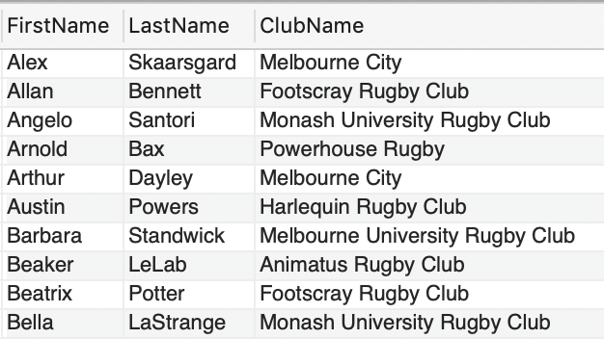

143 rows returned

Q2: List the full name (presented as a single string) of female players who have played for more than one team. (1 mark)

SELECT CONCAT(FIRSTNAME," ", LASTNAME) As Name

FROM player

INNER JOIN playerteam -- Different for inner vs left

ON player.playerID = playerteam.playerID

INNER JOIN clubplayer

ON player.playerID = clubplayer.playerID

RIGHT JOIN club

ON clubplayer.ClubID = club.ClubID

WHERE Sex = 'F'

GROUP BY FirstName, LastName, ClubName

HAVING count(ClubName)>1

ORDER BY FirstName, LastName ASC

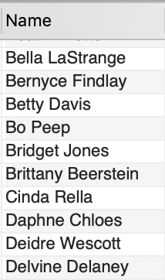

73 rows returned

Q3: List the full name (presented as a single string) of players who have never played in a 'mixed’ competition. (1 mark)

SELECT CONCAT(FirstName, " ", LastName) As Name

FROM

player

WHERE playerID NOT IN (

SELECT player.PlayerID

FROM player

NATURAL JOIN playerteam -- Different for inner vs left

NATURAL JOIN game

NATURAL JOIN season

NATURAL JOIN competition

WHERE CompetitionType LIKE "%Mixed%"

GROUP BY PlayerID, CompetitionType

)

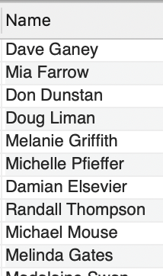

15 rows returned

Q4: List the season year(s) with the highest number of cancelled games, and the corresponding number of cancelled games in the year(s). (2 marks)

SELECT SeasonYear, COUNT(SeasonYear)

FROM game

NATURAL JOIN season

WHERE T1Score is NULL AND T2Score is NULL

GROUP BY SeasonYear

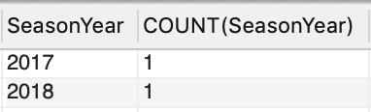

2 rows returned

Q5: List the name of the clubs where the number of current male members is not the same as the number of current female members. For these clubs, present the number of current male and female players, and the absolute difference between the number of current males and females in the club. Order the results by the absolute difference between current males and females in the club, with the club having the highest difference listed first. (2 marks)

SELECT ClubName, SUM(Sex LIKE 'M') as Males, SUM(Sex LIKE 'F')as Females , ABS(SUM(Sex LIKE 'M') - SUM(Sex LIKE 'F')) as Difference

FROM club

NATURAL JOIN clubplayer

NATURAL JOIN player

WHERE clubplayer.FromDate < CURDATE() && (clubplayer.ToDate IS NULL || clubplayer.ToDate > CURDATE())

GROUP BY ClubName

HAVING Males != Females

ORDER BY Difference DESC

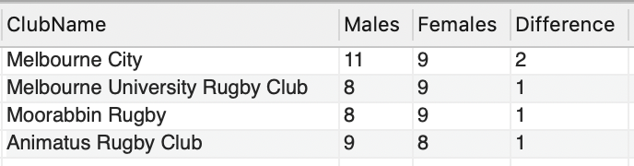

4 rows returned

Q6: List the first name, sex, and number of games played in 2018 and 2017 of players who played more games in 2017 than in 2018. There might be players that didn’t play in 2018 but did in 2017. You should take these cases in account as well. A game is still considered to have been 'played' even if it was cancelled or a walkover. (2 marks)

SELECT FirstName, LastName, SEX

FROM player

NATURAL JOIN playerteam

NATURAL JOIN game

NATURAL JOIN season

GROUP BY FirstName, LastName, SEX

HAVING SUM(SeasonYear LIKE 2018) < SUM(SeasonYear LIKE 2017)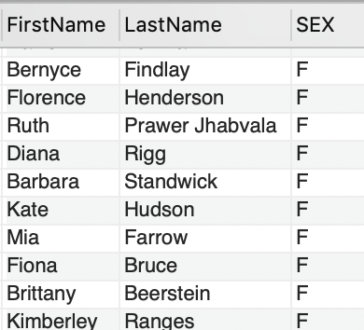

50 rows returned

Q7: List the name of all teams that scored more than 100 points in the Bingham Trophy in 2017, along with the total points they scored. Order the result according to the points the team scored, highest scoring team first. (2 marks)

SELECT TeamName,

SUM(CASE

WHEN Team1 = TeamID THEN T1Score

WHEN Team2 = TeamID THEN T2Score

END) AS SCORE

FROM competition

NATURAL JOIN season

NATURAL JOIN game

INNER JOIN team

ON game.Team1 = team.TeamID OR game.Team2 = team.TeamID

WHERE CompetitionName LIKE "Bingham Trophy"

AND SeasonYear = 2017

GROUP BY TeamName

HAVING SCORE > 100

ORDER BY SCORE DESC

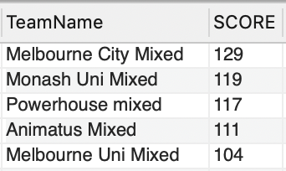

5 rows returned

Q8: For the player who has spent the fewest number of days as a member of ‘Melbourne City’ club as of April 30th 2020, give the full name (presented as a single string) and the total number of days spent as a member. Only consider players who have been a member of the club at some point (i.e. do not include players who have never been signed up with Melbourne City). Assume there are no joint shortest serving players. (3 marks)

SELECT CONCAT(FirstName, " ", LastName) as Name, DATEDIFF('2020/04/30', FromDate) as Duration

FROM club

NATURAL JOIN clubplayer

NATURAL JOIN player

WHERE clubName LIKE "Melbourne City"

AND ToDate is NULL

GROUP BY FirstName, LastName, FromDate

ORDER BY Duration ASC

LIMIT 1

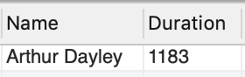

1 rows returned

Q9: A ‘foreign game’ is when a player has played a game in a team which was not part of the club they were a member of at the time. Find the first and last names and the number of ‘foreign games’ played for the 20 players who have played the most ‘foreign games’. List them from highest number of foreign games to lowest. (3 marks)

SELECT FirstName, LastName, COUNT(\*) AS NumberOfForeign

FROM player

NATURAL JOIN playerteam

NATURAL JOIN clubplayer

JOIN team

ON playerteam.TeamID = team.TeamID

JOIN club

ON club.ClubID = clubplayer.ClubID

WHERE team.ClubID != club.ClubID

GROUP BY FirstName, LastName

ORDER BY NumberOfForeign DESC

LIMIT 20

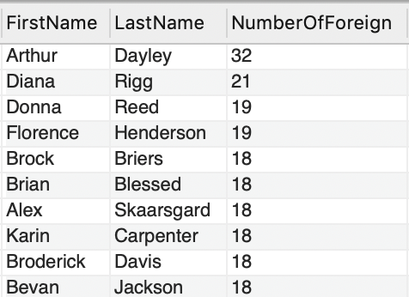

20 rows returned

Q10: Return the team name, the highest number of walkovers (forfeits) the team has ever given away in a season, and the season year(s) during which this occurred for teams who have given away 2 or more walkovers in the same season. Assume that any game with one team scoring 28 and the other scoring 0 implies that the game was a walkover. (3 marks)

SELECT TeamName, SeasonYear, COUNT(\*) AS NumForfeits

FROM team

INNER JOIN game

ON game.Team1 = team.TeamID OR game.Team2 = team.TeamID

NATURAL JOIN season

WHERE (T1Score = 0 AND T2Score = 28) OR (T1Score = 28 AND T2Score = 0)

GROUP BY TeamName, SeasonYear

HAVING NumForfeits >= 2

ORDER BY NumForfeits DESC

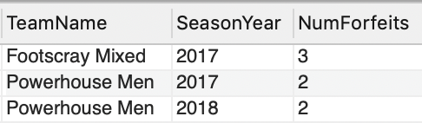

3 rows returned