**Machine Learning 2021 Homework 1**

310511048 張奕廷

1. **Bayesian Linear Regression**
   1. $A$ and $B$ are said to be conditionally independent if

$$P\left(A ∣ B,C\right)=P\left(A ∣ C\right)$$

Since $(x,t)$ is a new test point and label, $(x,t)$ are the training data and corresponding label, and $w$ is only trained on $(x,t)$,we can conclude that $(x,t)$ and $(x,t)$ are independent given $w$. Hence, we can obtain:

$$p\left(t ∣ w,x,x,t\right)=p\left(t ∣ x,w\right)$$

Furthermore, $w$ is only dependent on its training data , hence:

* 1. The equations from textbook page 93 are list below.

$$\begin{aligned}p\left(x\right)=N(x∣μ,Λ^{-1})\#\left(2.113\right)\end{aligned}$$

$$\begin{aligned}p(y∣x)=N(y∣Ax+b,L^{-1})\#\left(2.114\right)\end{aligned}$$

$$\begin{aligned}p\left(y\right)=N(y∣Aμ+b,L^{-1}+AΛ^{-1}A^{T})\#\left(2.115\right)\end{aligned}$$

$$\begin{aligned}p(x∣y)=N(x∣Σ\left(A^{T}L\left(y-b\right)+Λμ\right),Σ)\#\left(2.116\right)\end{aligned}$$

$$\begin{aligned}Σ={\left(Λ+A^{T}LA\right)}^{-1}\#\left(2.117\right)\end{aligned}$$

From 1.1, we know that,

$$p\left(t ∣ x,x,t\right)=\int_{-∞}^{∞}{p\left(t ∣ x,w\right)p\left(w ∣ x,t\right)dw}$$

**First Step**

To derive $p\left(t ∣ x,x,t\right)$, we first derive $p\left(w ∣ x,t\right)$, from hint:

$$p\left(w ∣ x,t\right)∝p\left(t ∣ x,w\right)p\left(w\right)$$

By equation (2.114),

$$p\left(t ∣ x,w\right)=N\left(t ∣ w^{T}Φ\left(x\right),β^{-1}I\right) \\ ⇒A=Φ{\left(x\right)}^{T},b=0,L=βI$$

and by equation (2.113), we obtain the prior distribution as follows,

$$p\left(w\right)=p\left(w ∣ α\right) \\ =N\left(w ∣ 0,α^{-1}I\right) \\ ⇒μ=0,Λ=αI$$

Then, by equation (2.117) and substitute the results above,

$$Σ={\left(Λ+A^{T}LA\right)}^{-1} \\ ={\left(αI+Φ\left(x\right)βIΦ{\left(x\right)}^{T}\right)}^{-1} \\ ={\left(αI+β\sum_{n=1}^{N}{Φ\left(x_{n}\right)Φ{\left(x_{n}\right)}^{T}}\right)}^{-1} \\ =S$$

Hence, by equation (2.116),

$$p\left(w ∣ x,t\right)=N\left(w ∣ S\left(Φ\left(x\right)βIt\right),S\right) \\ =N\left(w ∣ βS\left(Φ\left(x\right)t\right),S\right)$$

**Second Step**

Now we derive $p\left(t ∣ x,w\right)$. Again, by equation (2.114),

$$p\left(t ∣ x,w\right)=N\left(t ∣ w^{T}Φ\left(x\right),β^{-1}I\right) \\ ⇒A=Φ{\left(x\right)}^{T},b=0,L=βI$$

By equation (2.113) and the derivation from first step,

$$p\left(w ∣ x,t\right)=N\left(w ∣ βS\left(Φ\left(x\right)t\right),S\right) \\ =p\left(w ∣ μ,Λ^{-1}\right) \\ ⇒μ=βS\left(Φ\left(x\right)t\right),Λ^{-1}=S$$

Finally, by equation (2.115) and substitute the results above,

$$p\left(t ∣ x,x,t\right)=\int_{-∞}^{∞}{p\left(t ∣ x,w\right)p\left(w ∣ x,t\right)dw} \\ =N\left(t ∣ βΦ{\left(x\right)}^{T}S\sum_{n=1}^{N}{Φ\left(x_{n}\right)t_{n}},β^{-1}I+Φ{\left(x\right)}^{T}SΦ\left(x\right)\right) \\ =N\left(t ∣ m\left(x\right),s^{2}\left(x\right)\right)$$

1. **Linear Regression**
   1. Feature Selection

(a) **Code Result.**

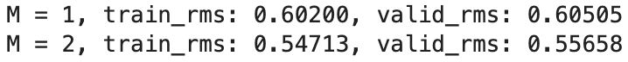

(b) **Code Result. Explain.** I remove one feature from the dataset at a time and observe the RMS error. As we can see from the code result, both training and validation RMS error are greatest when feature 8 (*median income*) is removed. As a result, the feature *median income* is the most contributive one in this dataset.

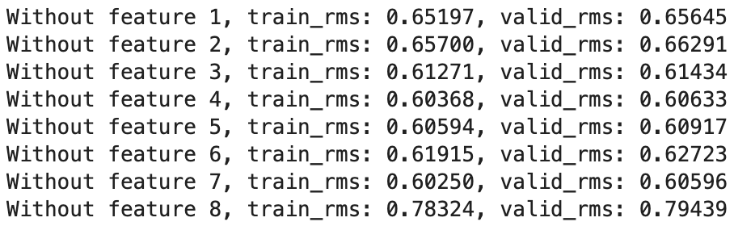

* 1. Maximum Likelihood Approach

(a) **Explain.** In problem 2.1, I already used polynomial as the basis function for my regression model. However, polynomials are *global* basis functions, each affecting the prediction over the whole input space. *Local* basis functions are often more appropriate, so I choose Gaussian distribution as the basis function.

(b) **Code Result. Explain.** Since we’re not required to find the best parameters for basis functions in this homework, I choose the Gaussian distribution as follows,

$$N\left(μ=\frac{m}{M+1},σ^{2}={\left(0.05\right)}^{2}\right)$$ where $M$ is the order of basis function and $m$ is all positive integers less than $M$. Below is the code result, we can see that as $M$ increases, the training error slightly decreases yet the validation error increases significantly after $M=14$, which means that the model is overfitting. Also, I discover that changing the basis function to Gaussian doesn’t make the RMS error better than in problem 2.1. I think this is because I didn’t choose the best parameters for Gaussian.

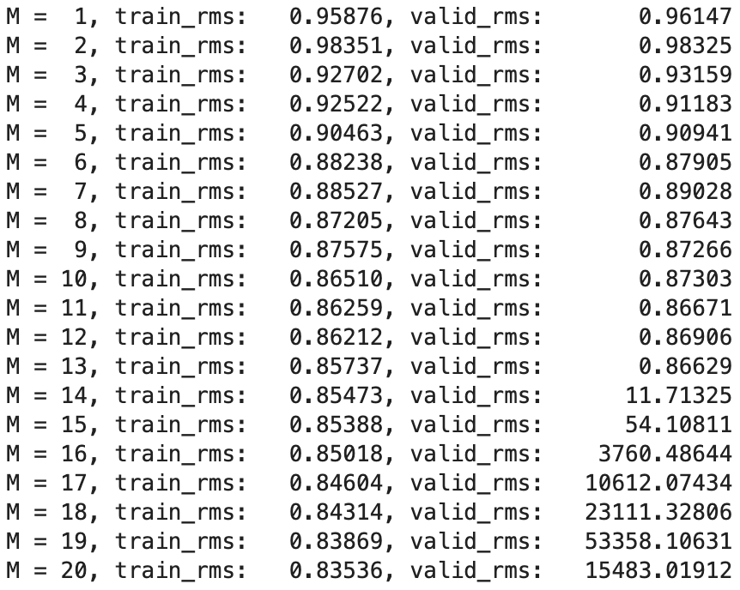

(c) **Code Result. Explain.** Code result for N-fold cross validation with N set as 5 are as follows. Obviously, we can see that every fold has similar behavior. When the order is low ($M=1\sim 5$), both training and validation RMS error are still high, demonstrating that the model is underfitting, but when the order grows higher ($M=10\sim 13$), the error seems to converge. However, the validation RMS error starts to increase significantly when $M=14$ yet the training RMS error keep on decreasing, indicating the model is overfitting.

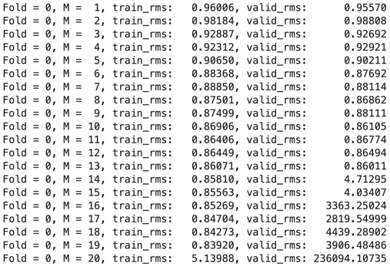 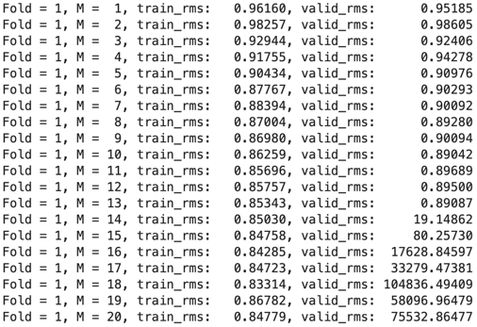

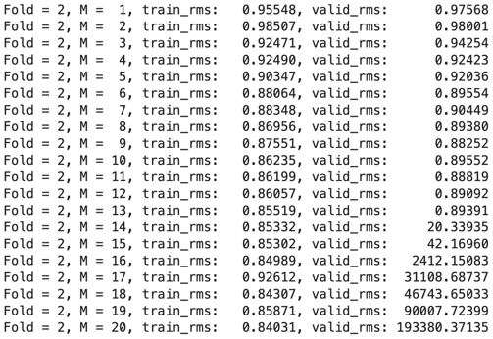 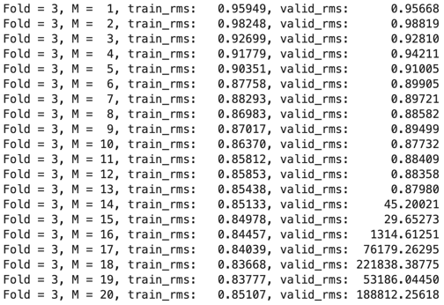

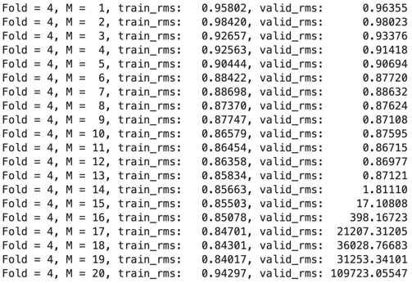

* 1. Maximum A Posterior Approach

(a) **Explain.**

**Maximum Likelihood**

$$w_{ML}=\underset{w}{argmax}\left( \ln\left(p\left(t ∣ x,w,β\right)\right)\right) \\ ∝\underset{w}{argmax}\left(-\frac{β}{2}\sum_{n=1}^{N}{{\left(y\left(x_{n},w\right)-t_{n}\right)}^{2}}\right) \\ ∝\underset{w}{argmin}\left(\frac{β}{2}\sum_{n=1}^{N}{{\left(y\left(x_{n},w\right)-t_{n}\right)}^{2}}\right)$$

**Maximum a Posterior**

$$w_{MAP}=\underset{w}{argmax}\left( \ln\left(p\left(w ∣ x,t,α,β\right)\right)\right) \\ ∝\underset{w}{argmax}\left( \ln\left(p\left(t ∣ x,w,β\right)\right)+\ln\left(p\left(w ∣ α\right)\right)\right)$$

If we choose Gaussian distribution as the prior, then

$$w_{MAP}∝\underset{w}{argmax}\left(-\frac{β}{2}\sum_{n=1}^{N}{{\left(y\left(x_{n},w\right)-t_{n}\right)}^{2}}-\frac{α}{2}{\left\|w\right\|}^{2}\right) \\ ∝\underset{w}{argmin}\left(\frac{β}{2}\sum_{n=1}^{N}{{\left(y\left(x_{n},w\right)-t_{n}\right)}^{2}}+\frac{α}{2}{\left\|w\right\|}^{2}\right)$$

The difference between *maximum likelihood* and *maximum a posterior approach* is highlighted in red in the above equations, which is the prior distribution. In *maximum likelihood approach*, there is no this term. Also, the final derivation of *maximum likelihood approach* can be viewed as **L**east **S**quares (**LS**), while in *maximum a posterior approach*, if we choose Gaussian distribution as the prior, the final derivation can be viewed as **R**egularized **L**east **S**quares (**RLS**). Due to the regularized term, we can avoid models from overfitting to training data to some extent with *maximum a posterior approach*.

(b) **Code Result.**

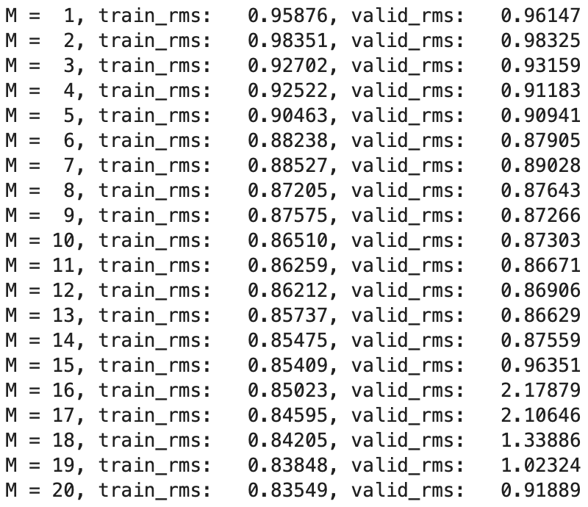

(c) **Explain.** Compared to the results from *maximum likelihood approach*, applying *maximum a posterior approach* can indeed ease the effect of overfitting. As we can see in the code result above, with the regularized term parameter set as $λ=0.0001$, the validation RMS error is much smaller compared to previous results in problem 2.2.