**Fields**

patient.drug.actiondrug

patient.drug.activesubstance.activesubstancename

patient.drug.drugadditional

patient.drug.drugadministrationroute

patient.drug.drugcharacterization

patient.drug.drugcumulativedosagenumb

patient.drug.drugcumulativedosageunit

patient.drug.enddate

patient.drug.drugenddateformat

patient.drug.drugindication

patient.drug.drugintervaldosagedefinition

patient.drug.drugrecurreadministration

patient.drug.drugstartdate

patient.drug.drugstartdateformat

patient.drug.drugstructuredosagenumb

patient.drug.drugstructuredosageunit

patient.drug.drugtreatmentduration

patient.drug.drugtreatmentdurationunit

patient.drug.medicinalproduct

patient.drug.openfda.brand_name

patient.drug.openfda.generic_name

patient.drug.openfda.manufacturer_name

patient.drug.openfda.route

patient.drug.openfda.substance_name

patient.patientagegroup

patient.patientdeath

patient.patientonsetage

patient.patientonsetageunit

patient.patientsex

patient.patientweight

patient.reaction.reactionmeddrapt

patient.reaction.reactionoutcome

patient.summary.narrativeincludeclinical

primarysource.qualification

serious

seriousnesscongenitalanomali

seriousnessdeath

seriousnessdisabling

seriousnesshospitalization

seriousnesslifethreatening

seriousnessother

patient.drug.actiondrug

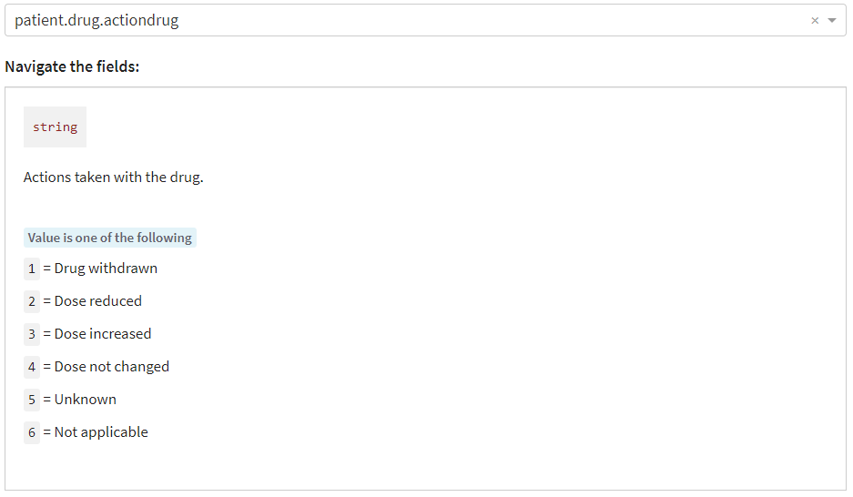

patient.drug.activesubstance.activesubstancename

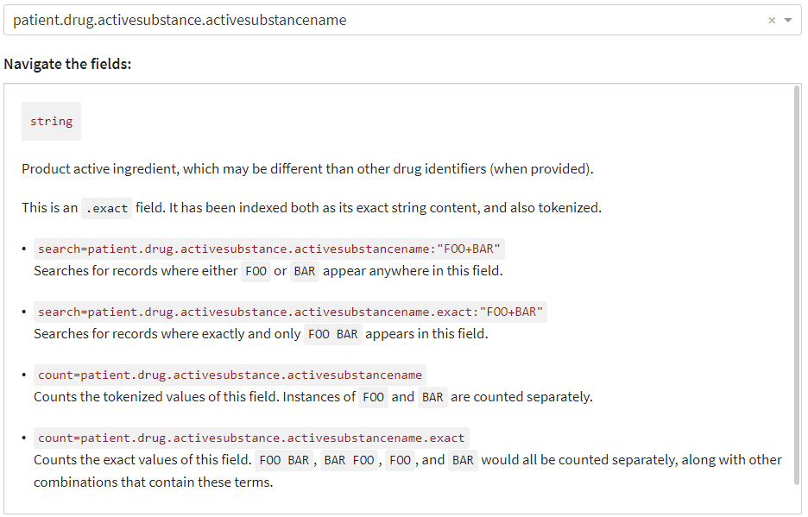

patient.drug.drugadditional

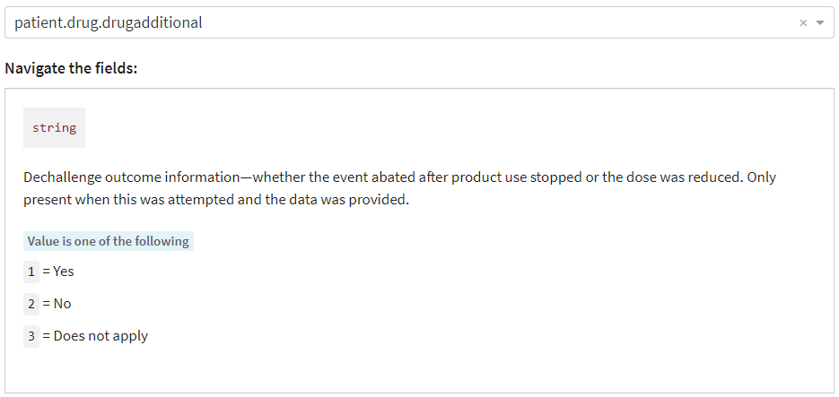

patient.drug.drugadministrationroute

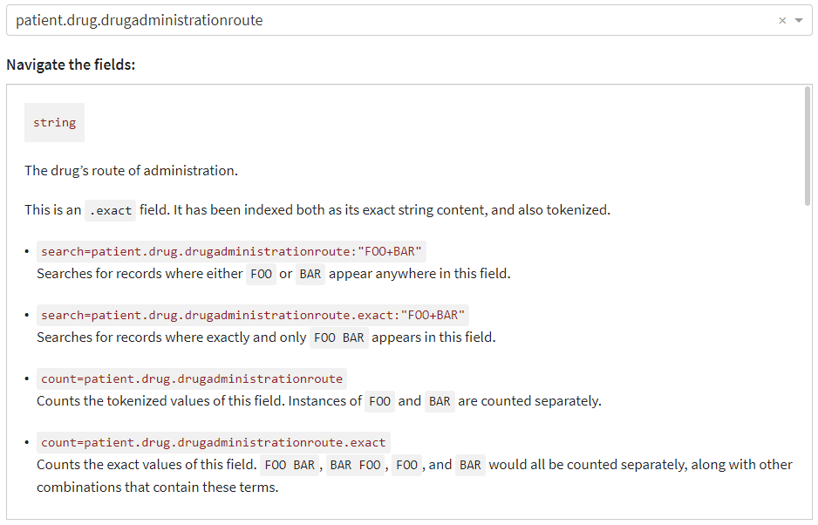

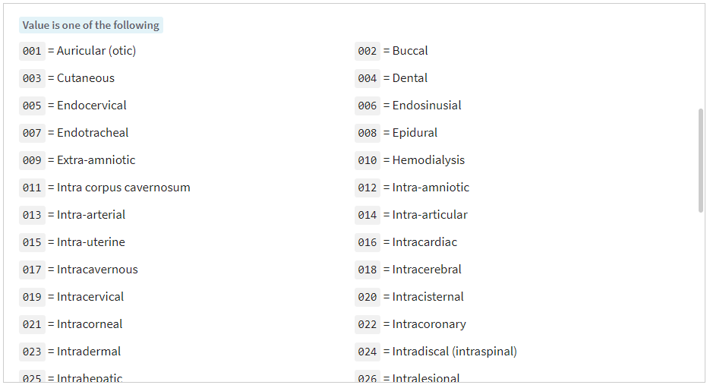

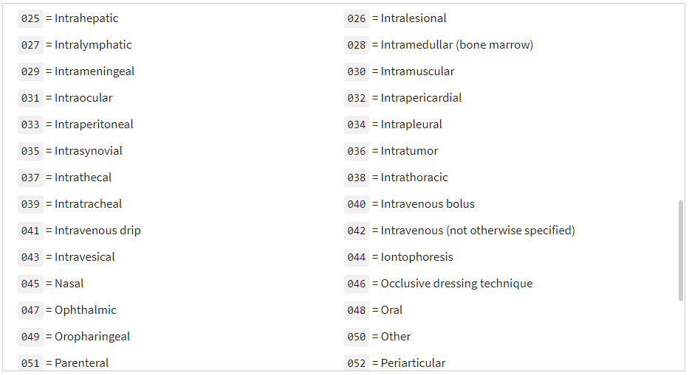

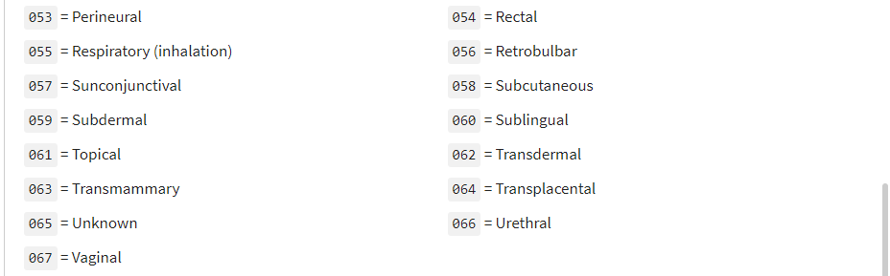

patient.drug.drugcharacterization

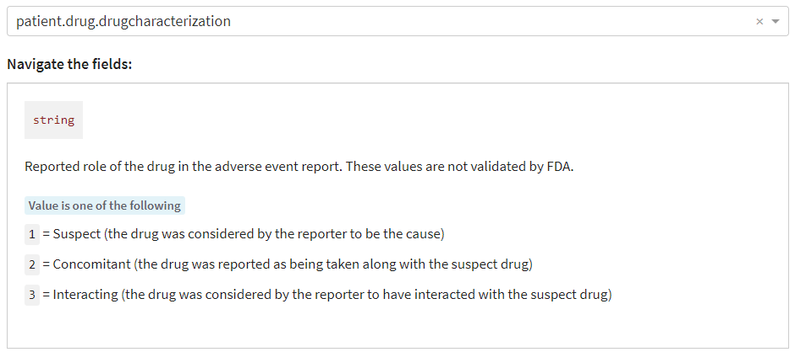

patient.drug.drugcumulativedosagenumb

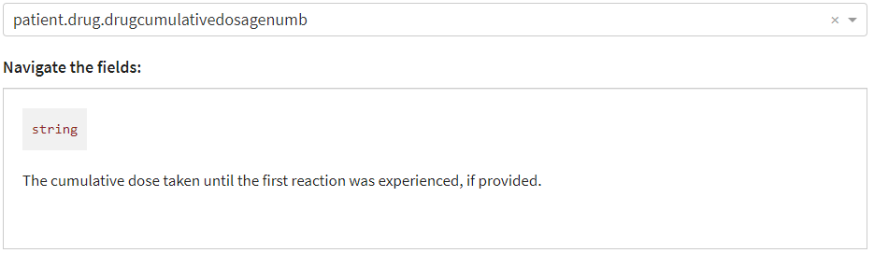

patient.drug.drugcumulativedosageunit

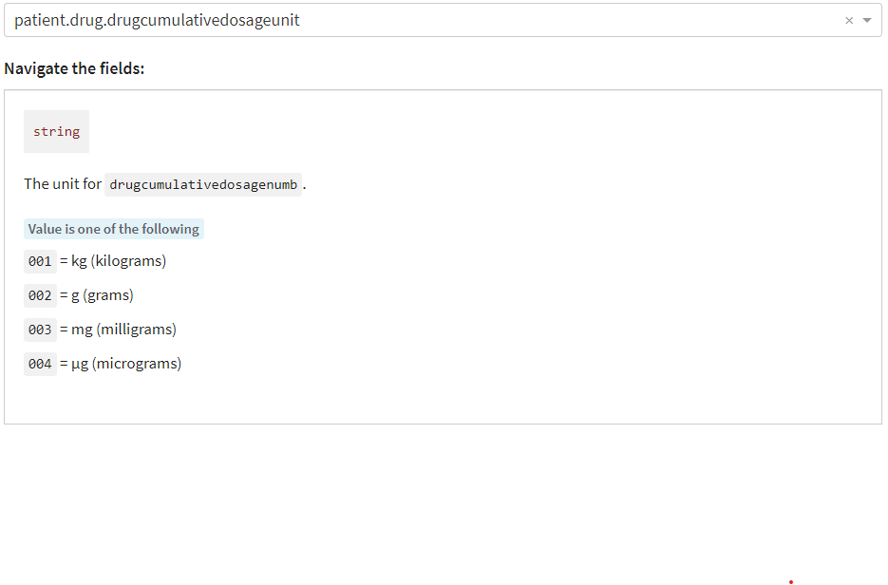

patient.drug.enddate

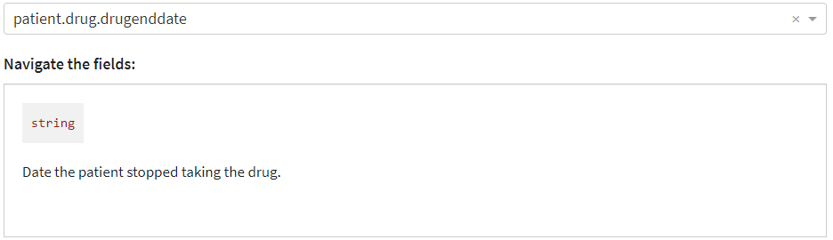

patient.drug.drugenddateformat

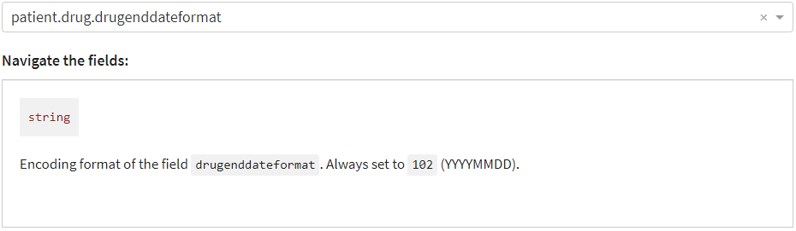

patient.drug.drugindication

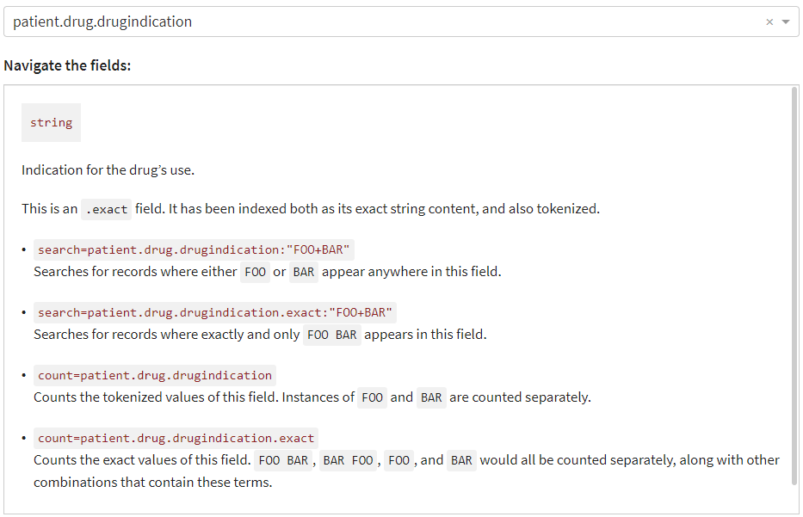

patient.drug.drugintervaldosagedefinition

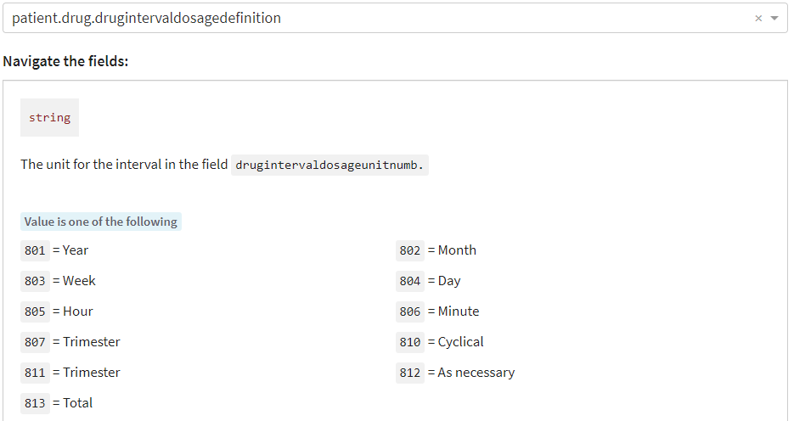

patient.drug.drugrecurreadministration

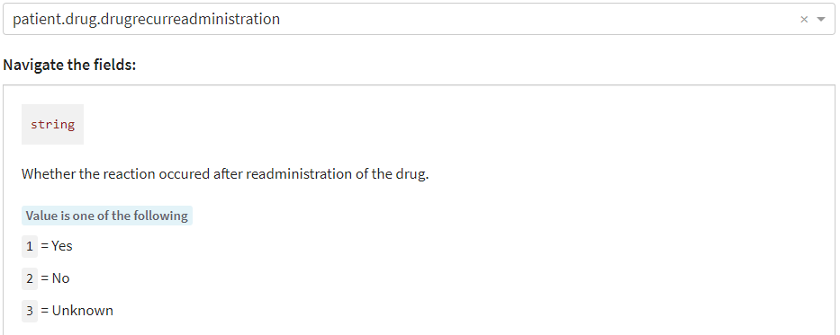

patient.drug.drugstartdate

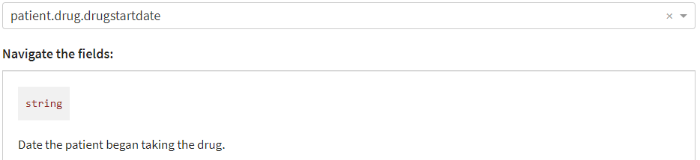

patient.drug.drugstartdateformat

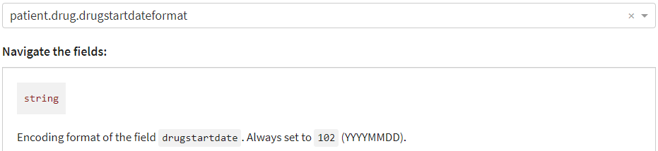

patient.drug.drugstructuredosagenumb

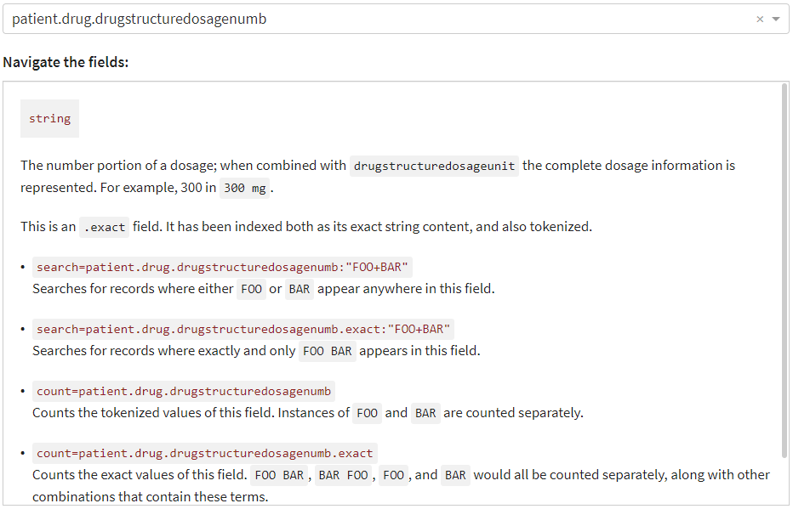

patient.drug.drugstructuredosageunit

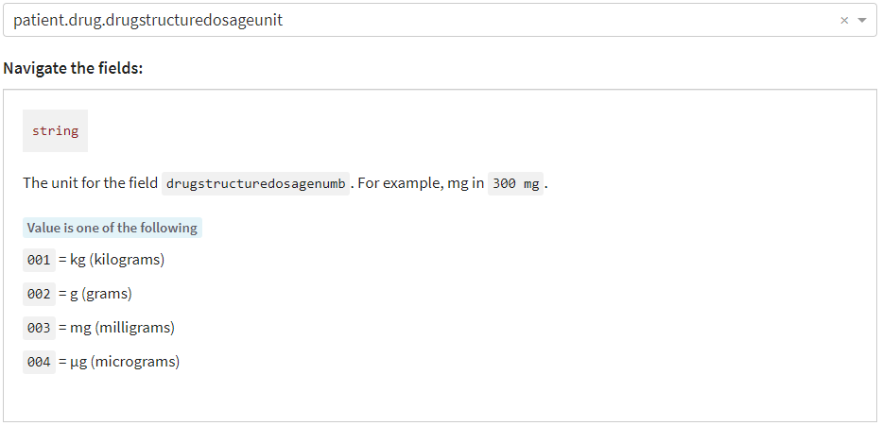

patient.drug.drugtreatmentduration

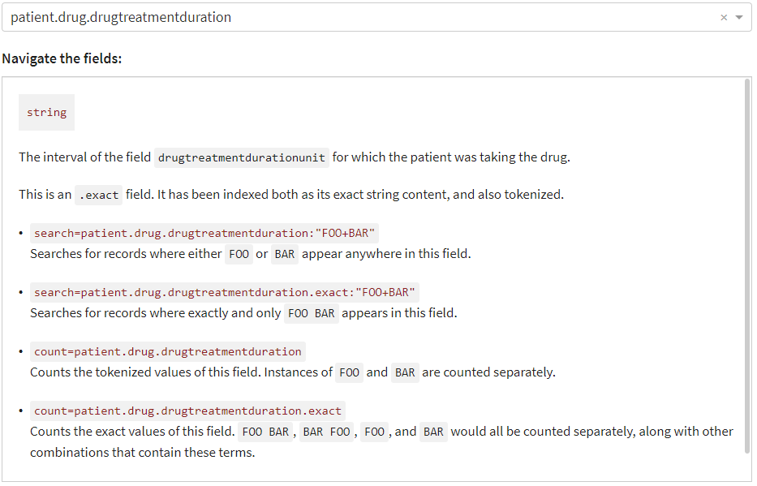

patient.drug.drugtreatmentdurationunit

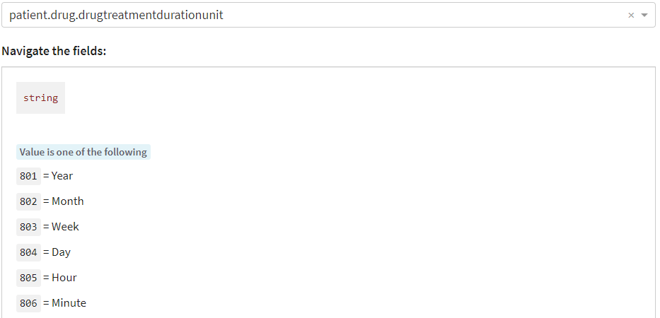

patient.drug.medicinalproduct

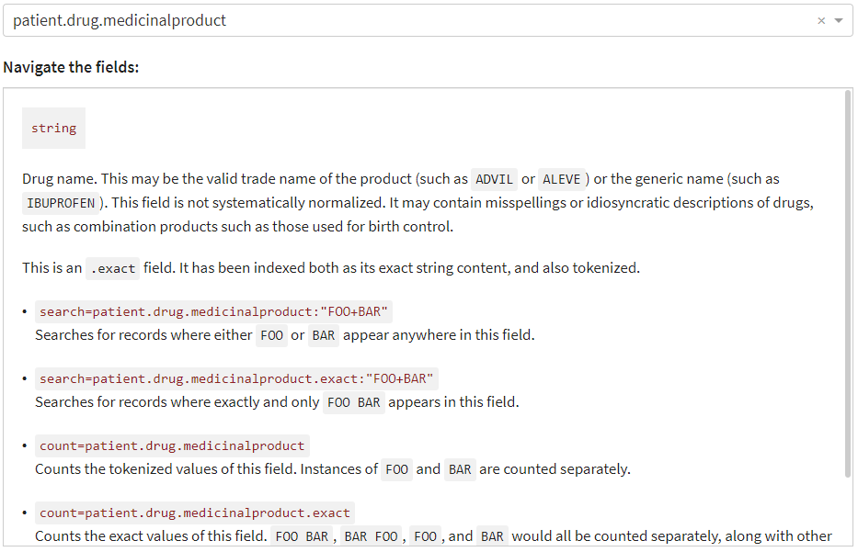

patient.drug.openfda.brand_name

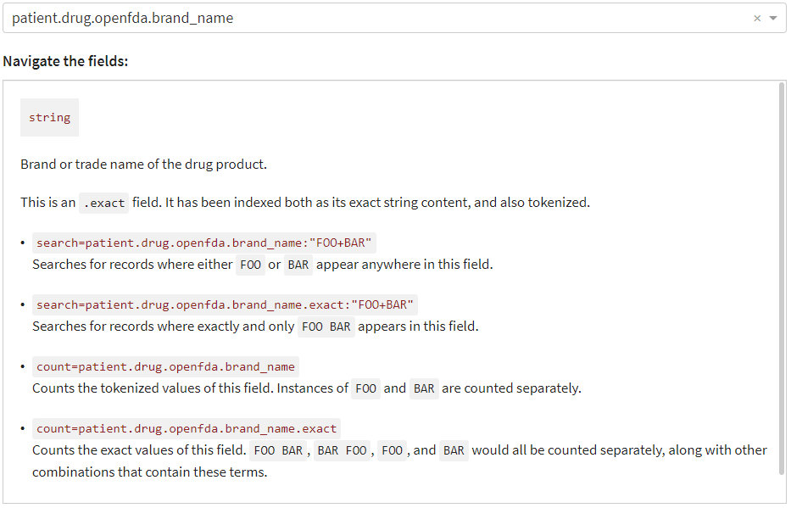

patient.drug.openfda.generic_name

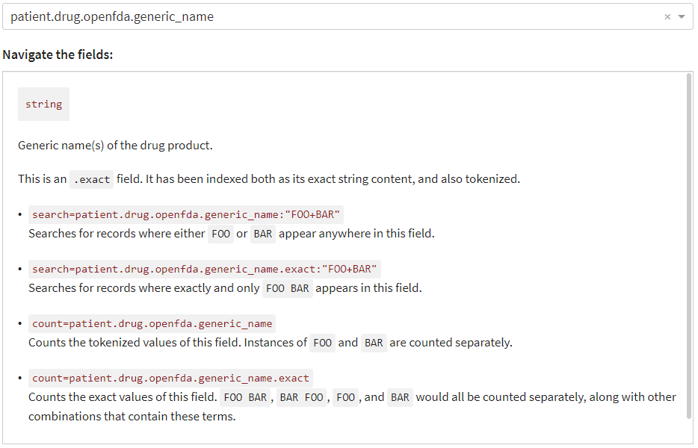

patient.drug.openfda.manufacturer_name

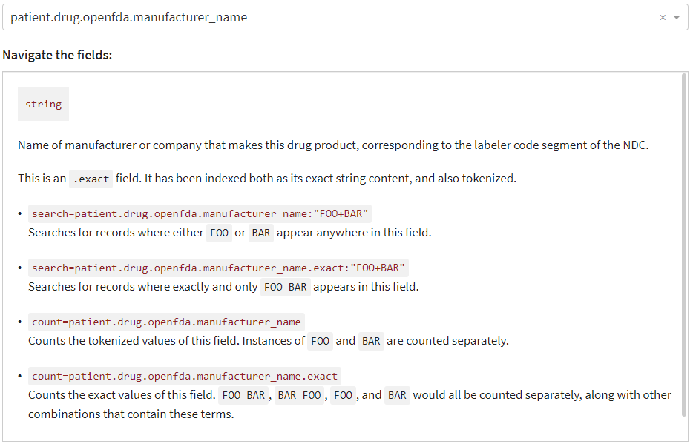

patient.drug.openfda.route

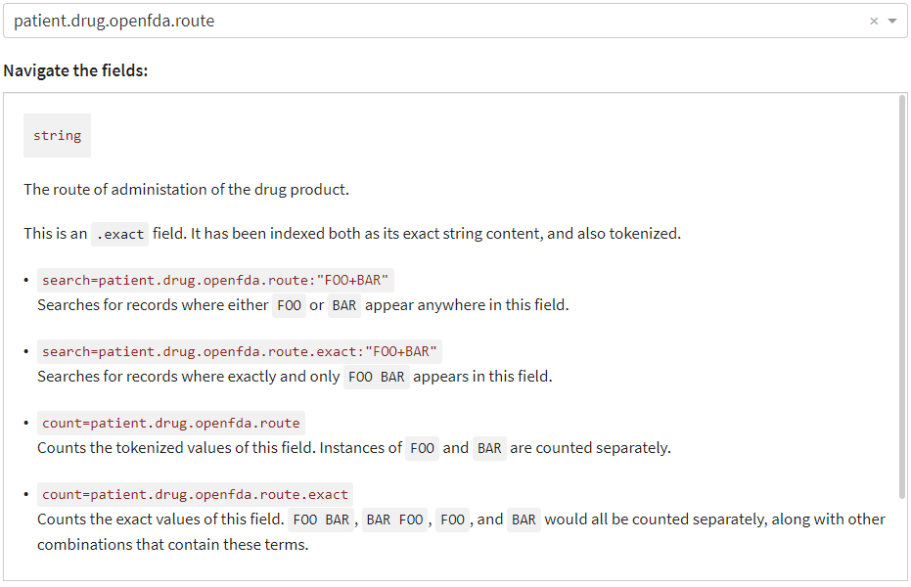

patient.drug.openfda.substance_name

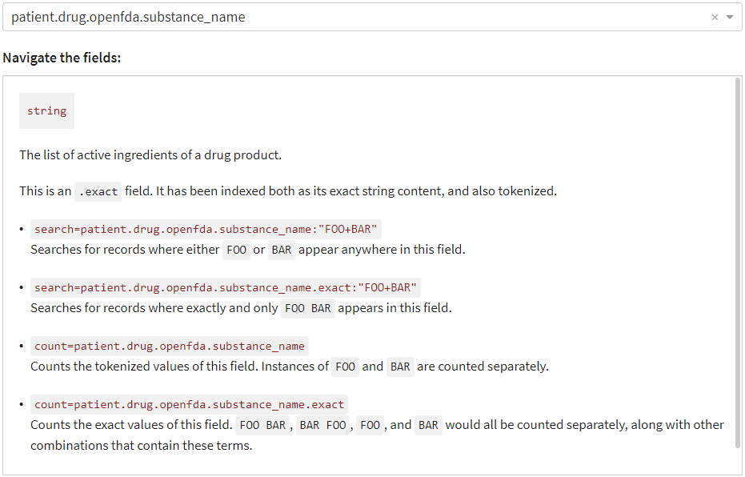

patient.patientagegroup

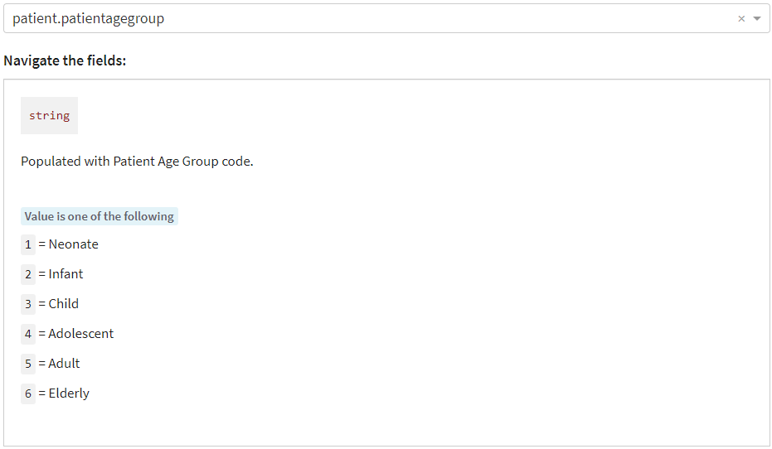

patient.patientdeath

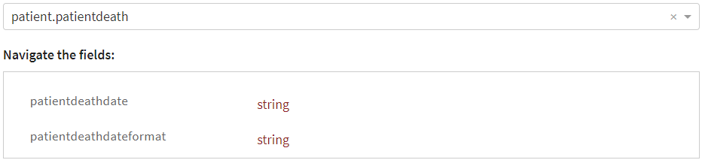

patient.patientonsetage

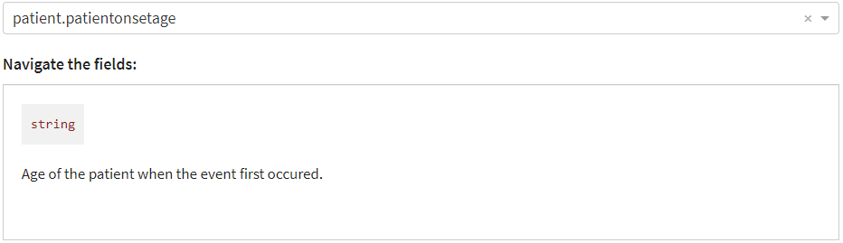

patient.patientonsetageunit

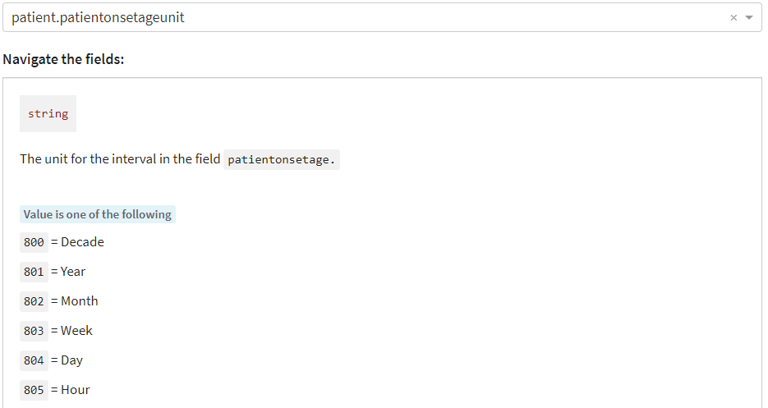

patient.patientsex

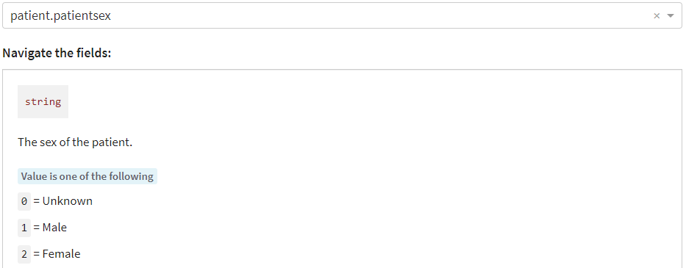

patient.patientweight

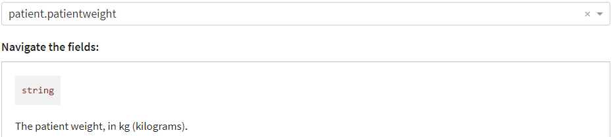

patient.reaction.reactionmeddrapt

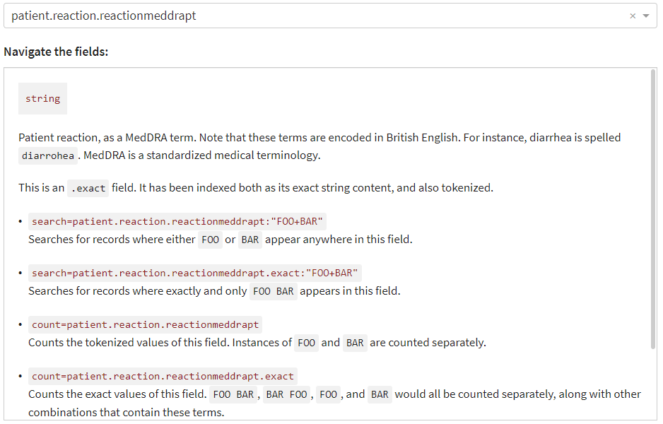

patient.reaction.reactionoutcome

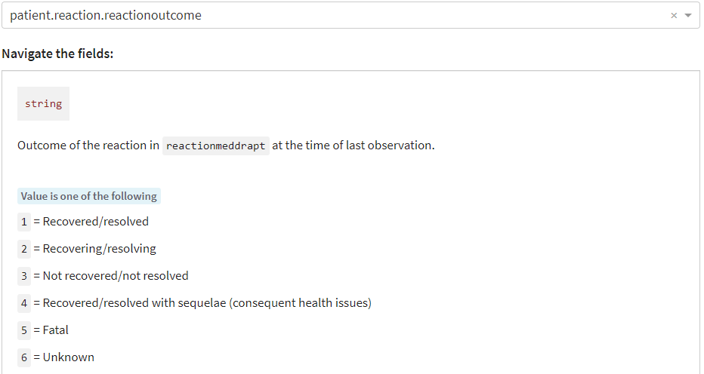

patient.summary.narrativeincludeclinical

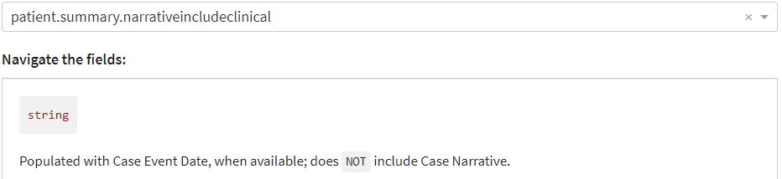

primarysource.qualification

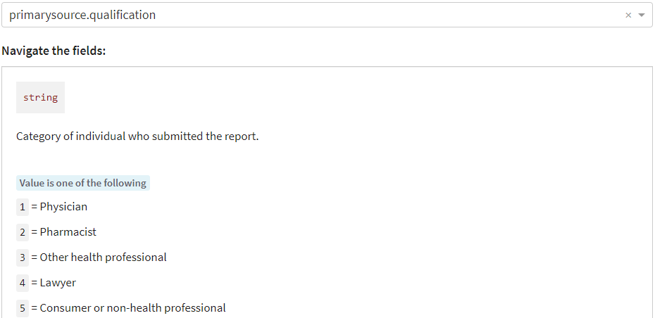

serious

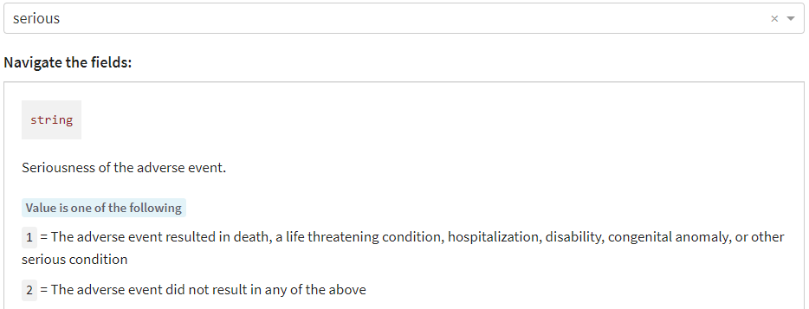

For the following, the value is 1 if the adverse event resulted in the condition listed in the name and is absent otherwise:

seriousnesscongenitalanomali

seriousnessdeath

seriousnessdisabling

seriousnesshospitalization

seriousnesslifethreatening

seriousnessother