Test Number | 1
Relevant Objective | 1.g
Description | Input various data into the key input of the regular login screen. The valid key I will use will be 1234.
Purpose | To ensure that the login screen is both secure and works as intended.
Test Data | T: [ 1]: 1234  [ 2]: 222333  [ 3]: 2001  E: [ 4]: My name is jeff  [ 5]: 12345678901234567  [ 6]: 1a2b3c4ddeed  [ 7]: abcdefghijklmnopq  B: [ 8]: 9999999999999999  [ 9]: 0000000000000000  [10]: 00000000000000000  [11]: (nothing)
Expected Outcome | [1]: Should be accepted as the correct key and main screen should open.  [2]: Program should tell the user that the key is invalid, as it is not the key I set (1234).  [3]: Program should tell the user that the key is invalid, as it is not the key I set (1234).  [4]: Program should tell the user that the key is invalid, as it contains characters.  [5]: Program should tell the user that the key is invalid, as it is longer than 16 in length.  [6]: Program should tell the user that the key is invalid, as it contains characters.  [7]: Program should tell the user that the key is invalid, as it is longer then 16 in length.  [8]: Program should tell the user that the key is invalid, as it is not the key I set (1234) ([8] is 16 in length).  [9]: Program should tell the user that the key is invalid, as it is not the key I set (1234) ([9] is 16 in length).  [10]: Program should tell the user that the key is invalid, as it is longer than 16 in length.  [11]: Program should tell the user that the key is invalid, as the key has to at least be 1 in length.
Actual Outcome | [All]: Pass
Evidence:
[1]: Opened
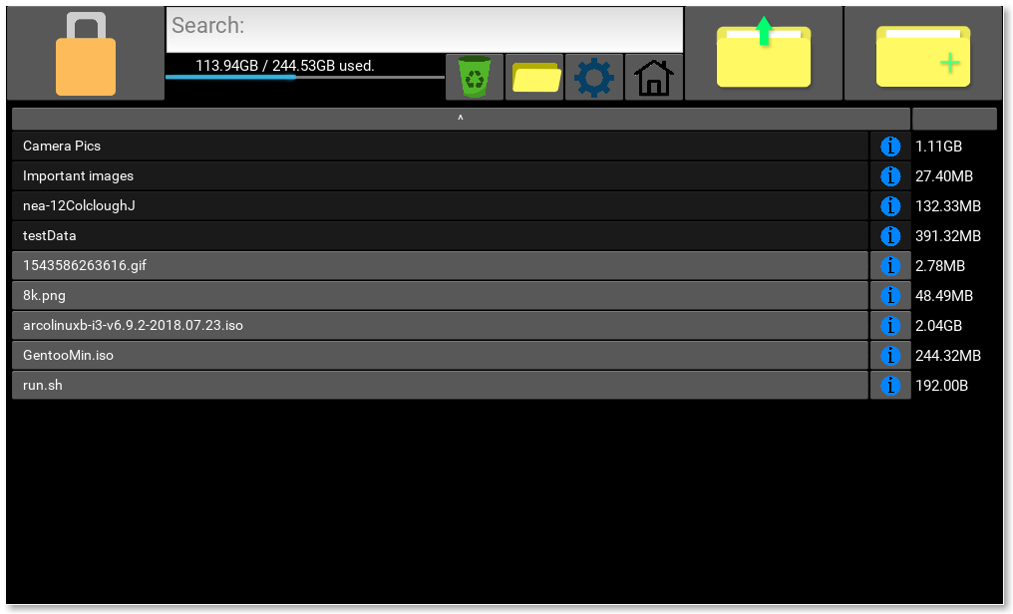

[2, 3]: Invalid
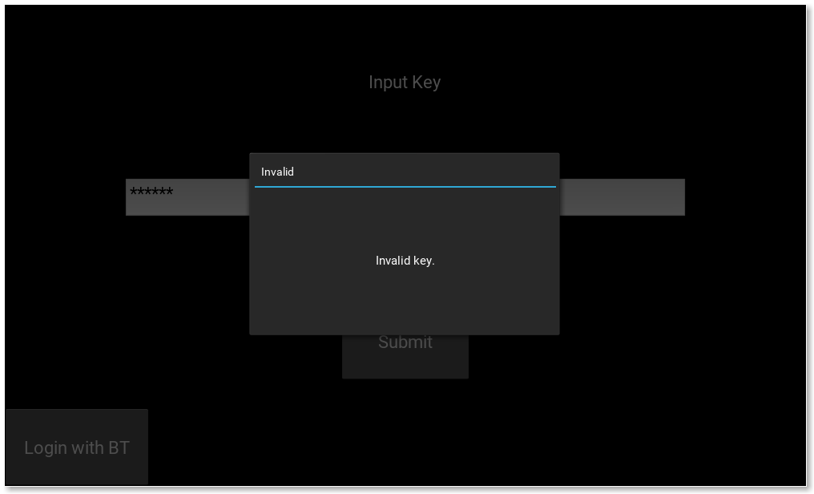
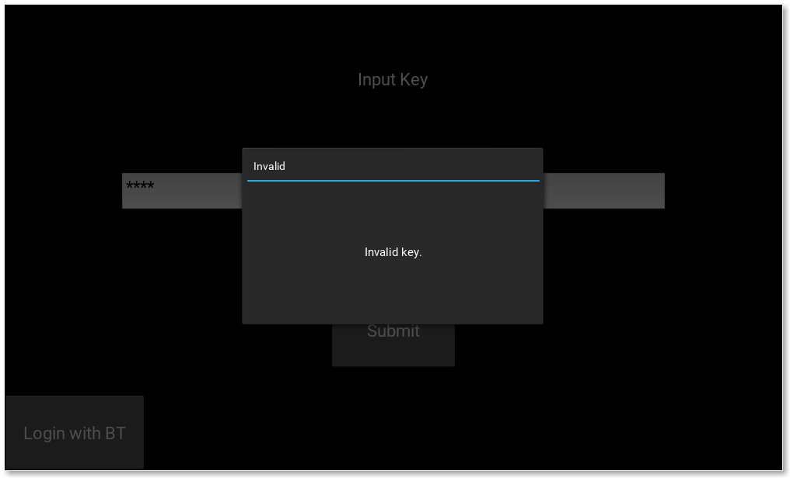
[4, 6]: No characters:
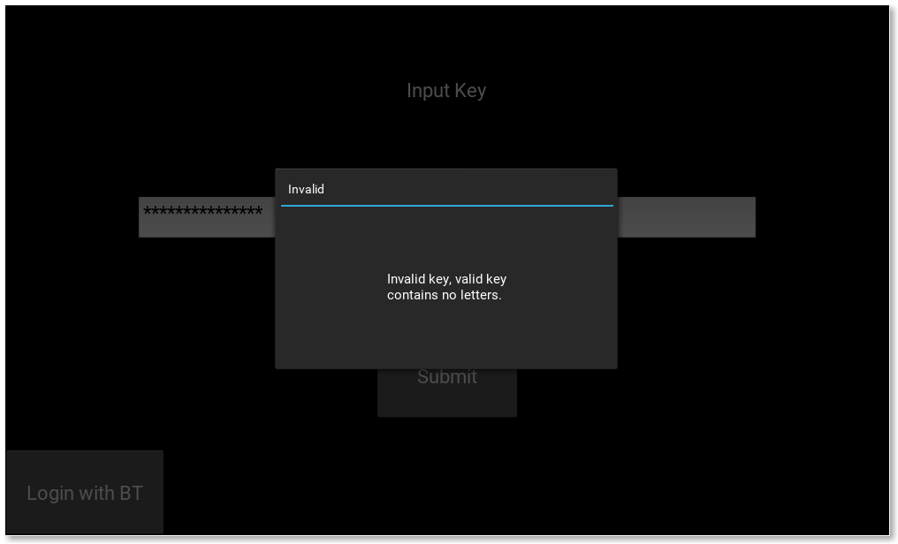
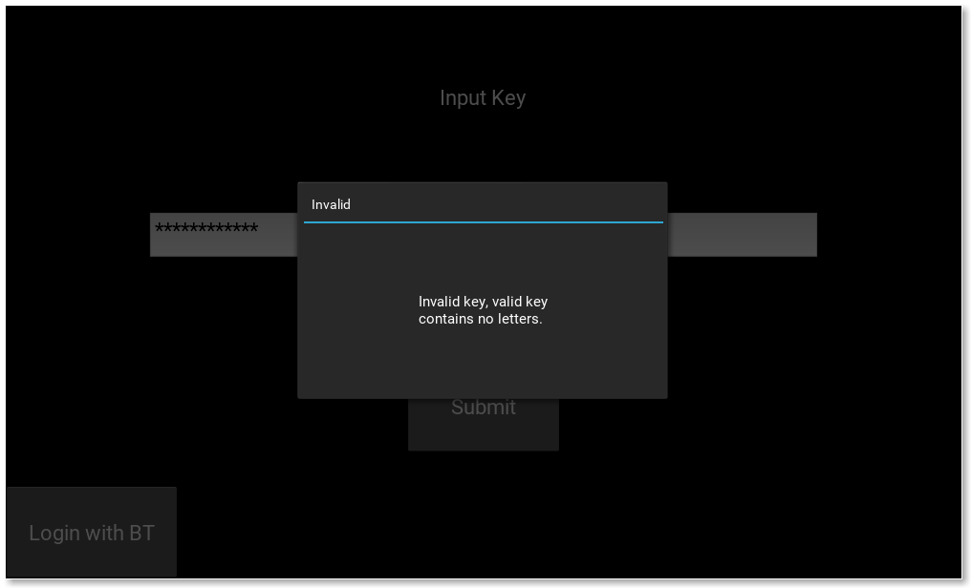
[5, 7, 10]: Input too long:
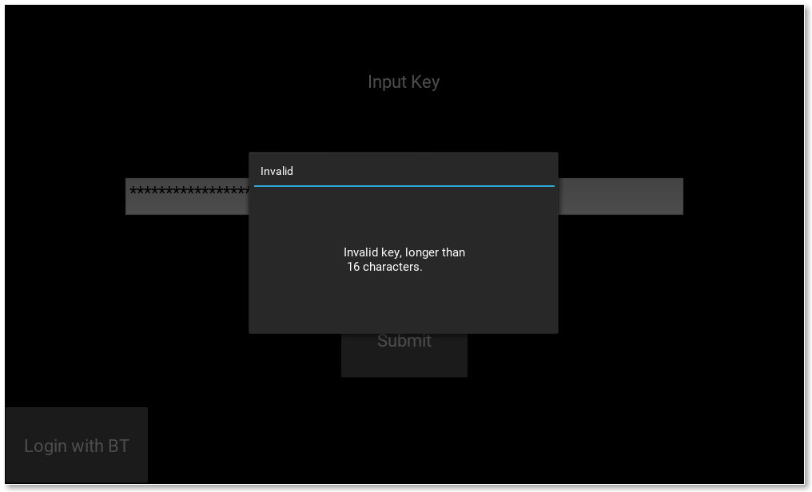

[8, 9]: Invalid key

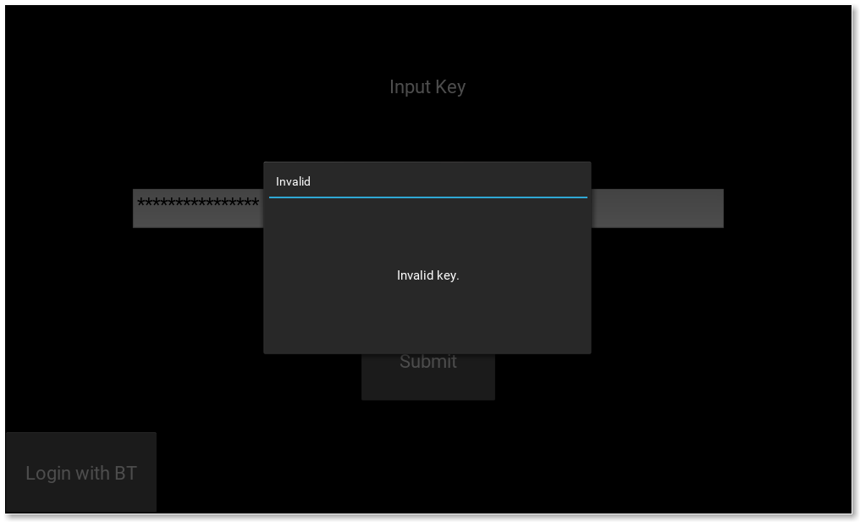
[11]: Invalid key, has to be at least 1 in length.
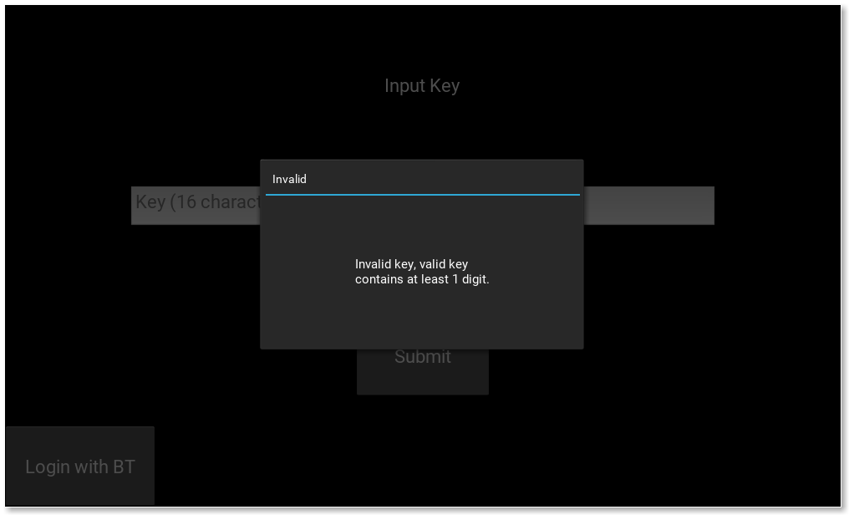

Test Number | 2
Relevant Objective | 1.L
Description | Switch login screen to Bluetooth login screen from regular login screen with Bluetooth disabled.
Purpose | To check that it will warn the user that Bluetooth is not available.
Test Data | Only one available input: (T) Click “Login with BT” button.
Expected Outcome | A popup should appear telling the user that Bluetooth is not available, and why (for the user to debug their Bluetooth problem).
Actual Outcome | Pass
Evidence:
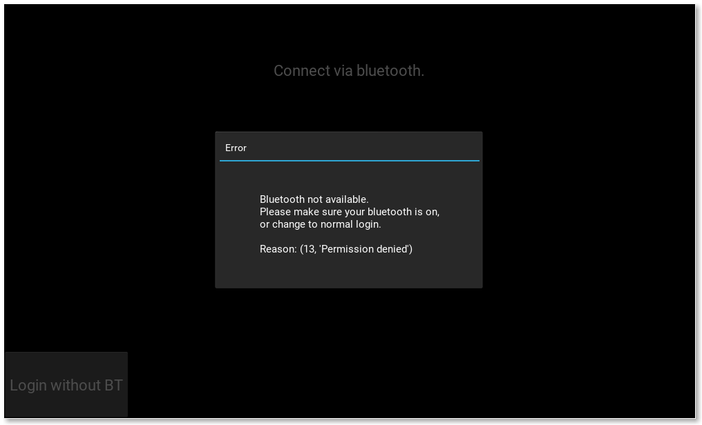
Test Number | 3
Relevant Objective | 2.b
Description | Connect to PC from mobile device.
Purpose | To check that the mobile device can actually connect, and if not displays the appropriate message.
Test Data | T: [1]: Click “josh-pc” to connect to my PC.  E: [2]: Click “josh-pc” when the program is not running on the PC.  [3]: Click “josh-laptop” when the program is running on the PC.  B: [4]: Click “josh-pc” when the program is running on both my laptop and the PC.  [5]: Click “josh-laptop” in the same situation as [4].
Expected Outcome | [1]: Connects successfully and changes screen to the pad screen.  [2]: Should not connect and asks user to retry.  [3]: Should not connect and asks user to retry.  [4]: Should connect to “josh-pc” successfully and change screen on the PC.  [5]: Should connect to “josh-laptop” successfully and change screen on the PC.
Actual Outcome | [All]: Pass
Evidence:

Test Number | 4
Relevant Objective | 1.g.ii, 2.b, 2.d
Description | Enter the key from the mobile app.
Purpose | Test that the key is either accepted, or declined by the server.
Test Data | (The app doesn’t let you enter more than 16 numbers.)  T: [1]: 1234 (The set key)  [2]: 12340  [3]: 2001  B: [4]: 9876543210123456  [5]: 7389123612645815  [6]: 0000000000000000  [7]: (nothing)
Expected Outcome | [ 1]: PC program should log in and change screen to main screen.  [2-7]: App should say that the key is invalid.
Actual Outcome | [All]: Pass
Evidence:

Test Number | 5
Relevant Objective | 2.f
Description | Browse files + download files within the mobile app.
Purpose | To test that the user can browse the files in the Vault and also download.
Test Data | T: [1]: Click to open the file browser.  [2]: Click a folder.  [3]: Click a file.  [4]: Click to go back up one directory.  [5]: Exit the file browser.
Expected Outcome | [1]: File browser should open.  [2]: The file browser should navigate to that folder.  [3]: The file should download to the users downloads folder. A popup should open on the PC showing the current status of the transfer, and once complete, the file should be found in the users “Download” folder.  [4]: The file browser should display the contents of the folder above the current folder.  [5]: Should return to main screen.
Actual Outcome | [All]: Pass
Evidence:

[1] Opening the file browser: [2] Opening a folder:
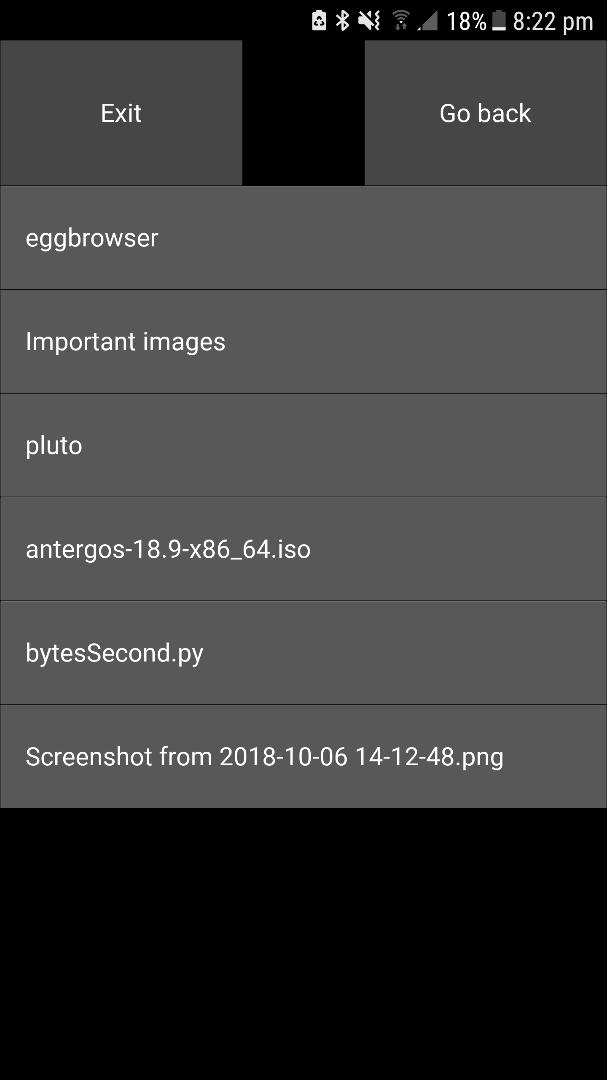
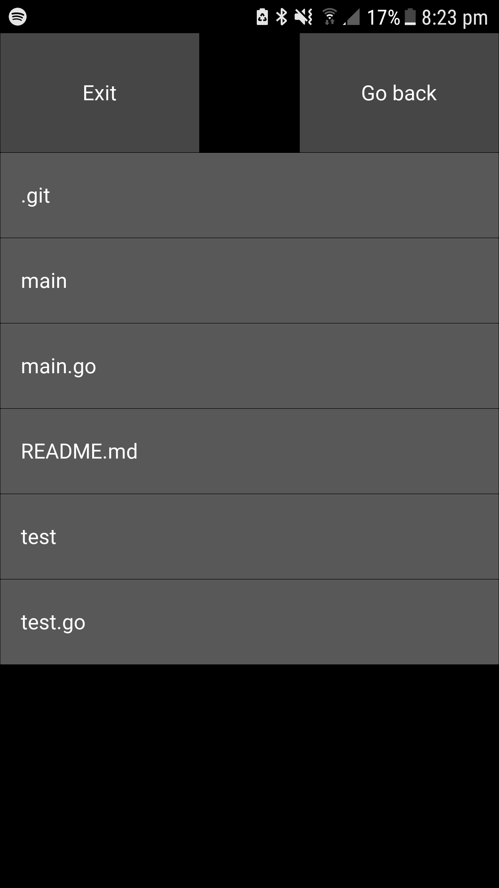

[3] Clicking a file (“Screenshot from 2018-10-06 14-12-48”):
View on PC program:
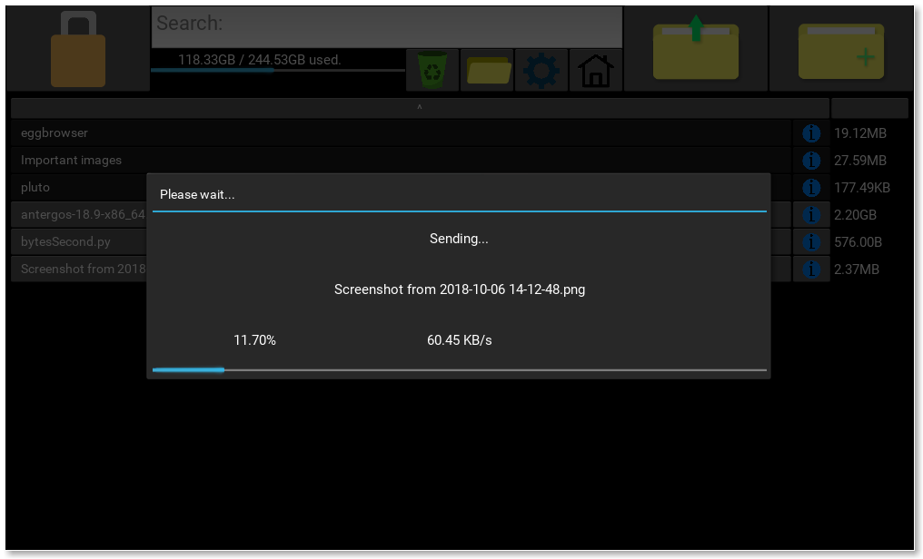
When done on phone: Download folder:
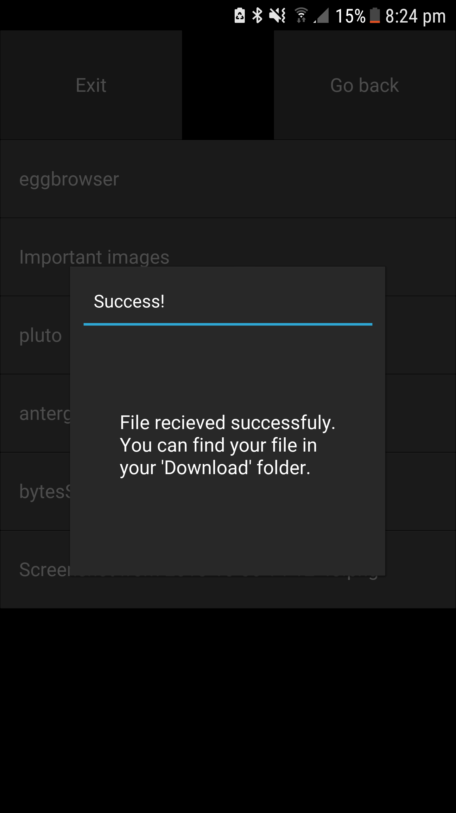
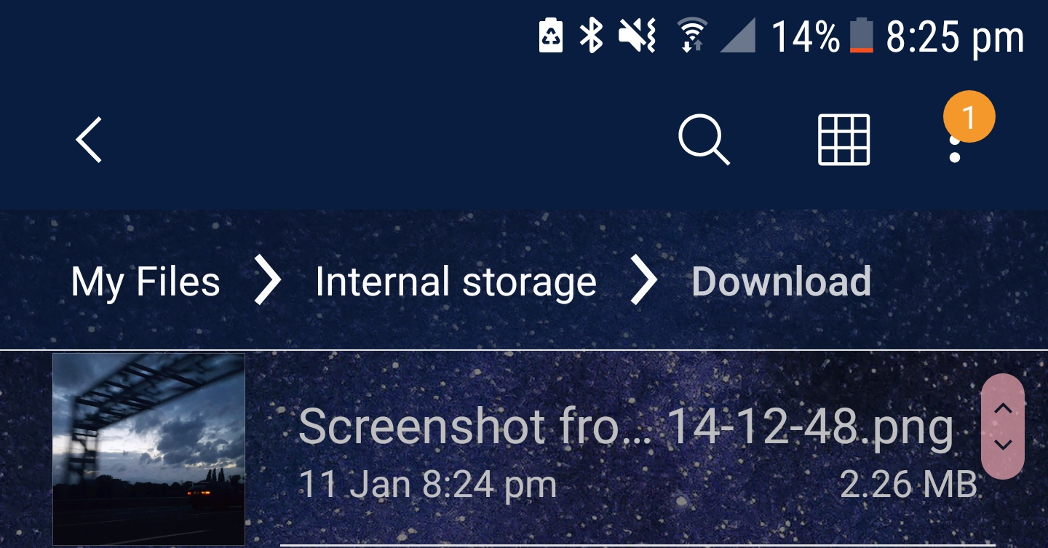

Test Number | 6
Relevant Objective | 3.c
Description | Disconnect from the Bluetooth server. (Close the mobile app)
Purpose | To check that temporary files are deleted and that the program is locked once connection is lost to the mobile device.
Test Data | T: [1]: Log into the program using the mobile device, open a file, close the file and disconnect from the program.
Expected Outcome | [1]: The temporary files should be deleted and the program should be locked.
Actual Outcome | [All]: Pass
Evidence:
Vault unlocked using app:
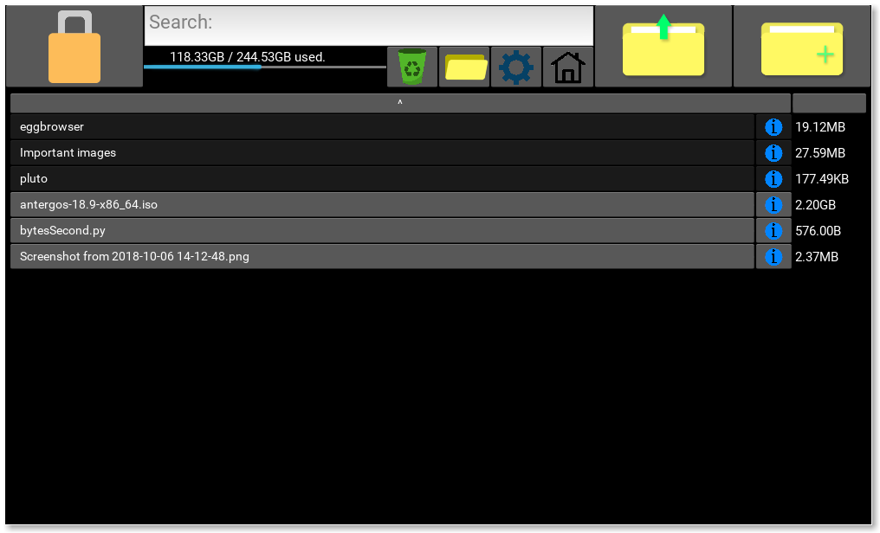
File opened:
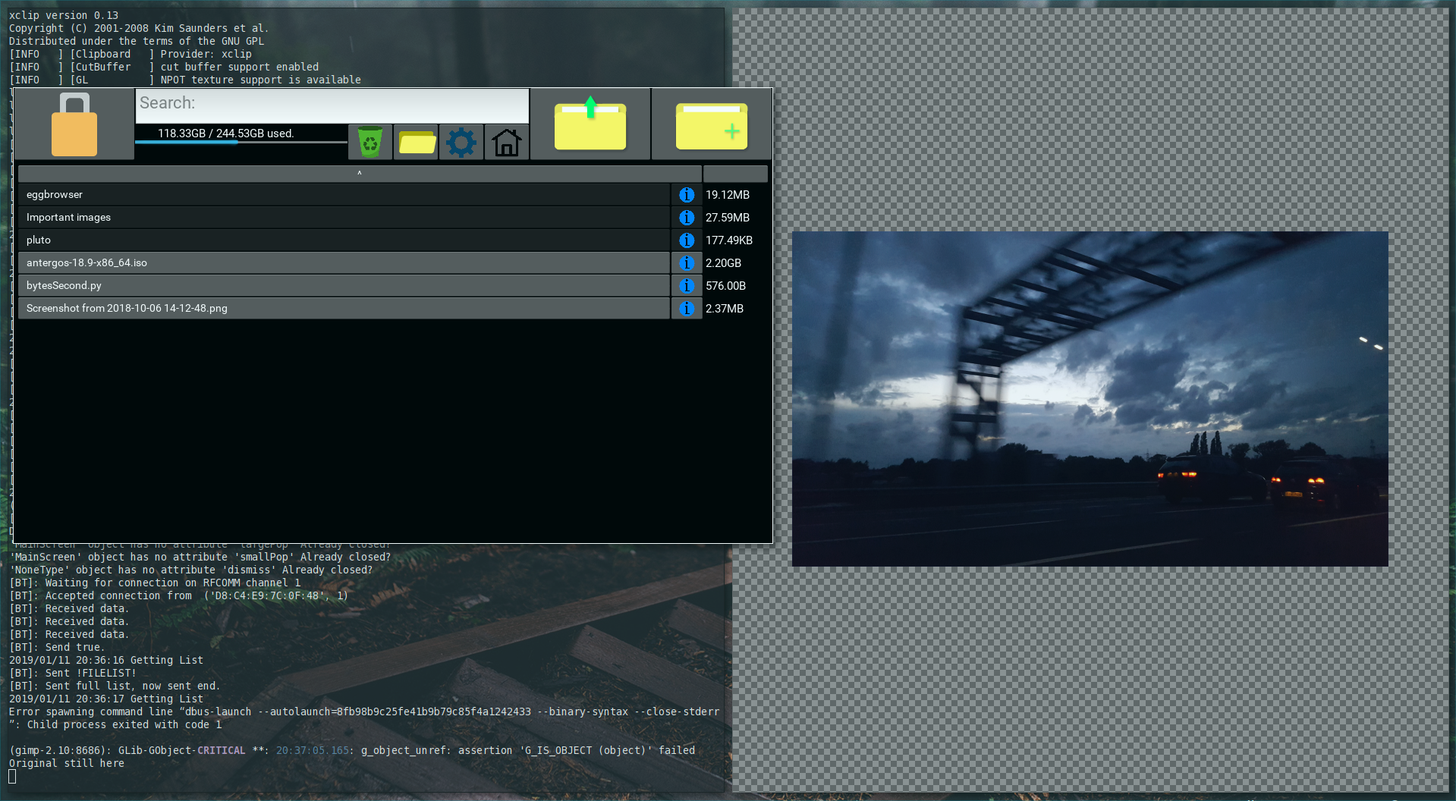
Disconnected from vault, and list /tmp directory to make sure temporary files have been deleted:
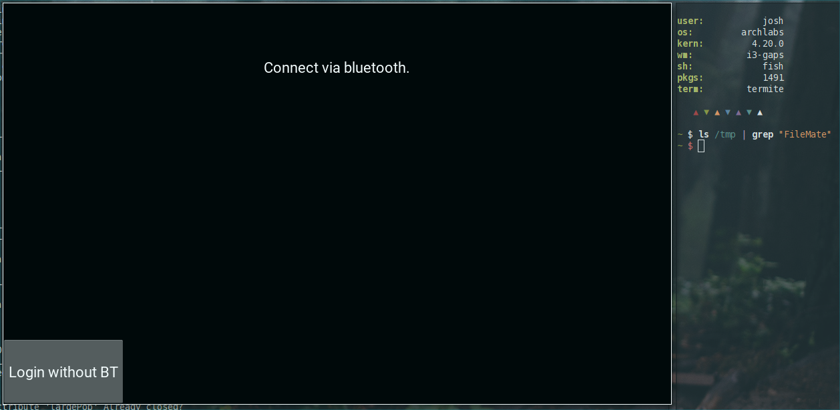
Test Number | 7
Relevant Objective | 3.e
Description | Delete a file, open the recycling folder and recover it.
Purpose | To check that when a file is deleted and recovered to the correct location.
Test Data | Delete a file in the Vault, go into the recycling folder, click the file, exit the recycling folder and see if it has been recovered.
Expected Outcome | The file should be in the recycling folder when the file has been deleted, and should return to the Vault where it was deleted from once you recover it.
Actual Outcome | The file is recovered to the root folder of the Vault, instead of the place it was deleted from.
Evidence:

Files in Vault/eggbrowser/:
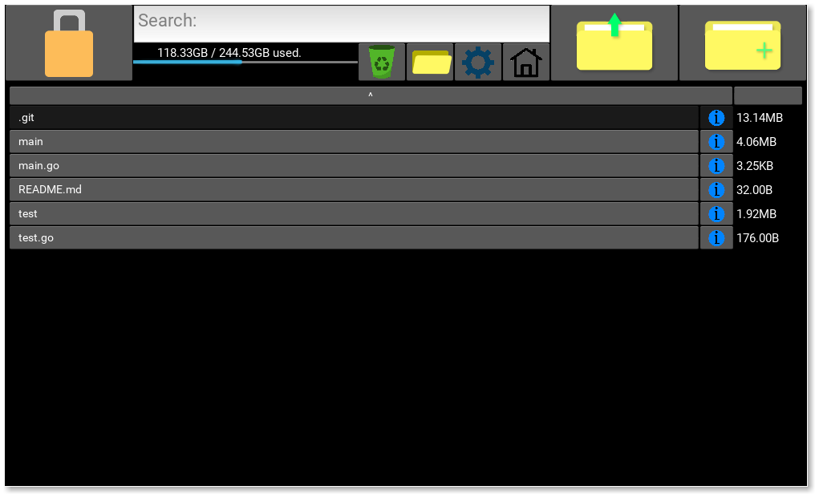
Delete test.go:
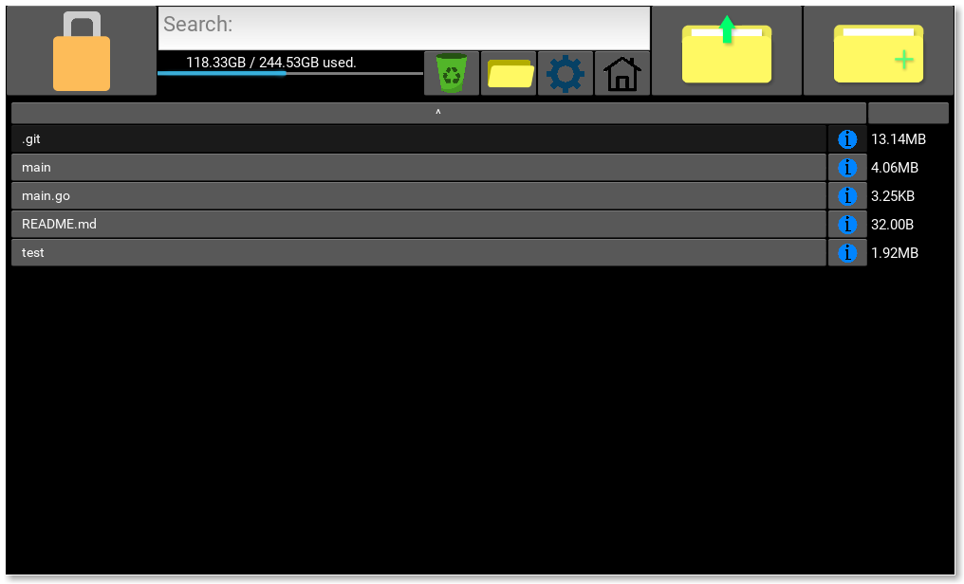
Go to recycling folder:
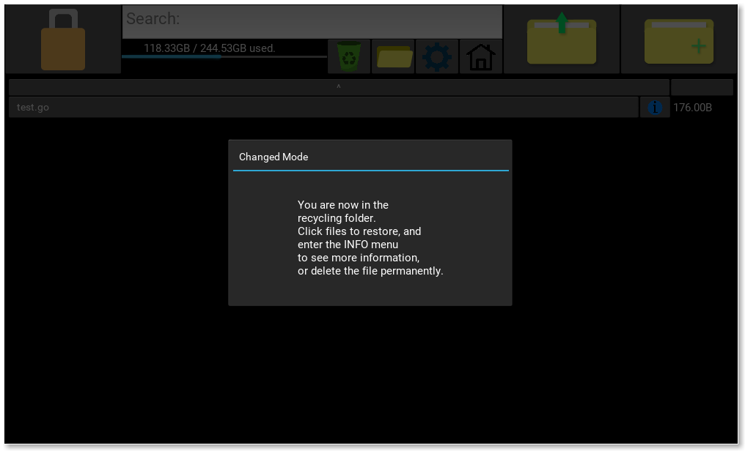
Recover test.go, and return to the root directory of the vault:
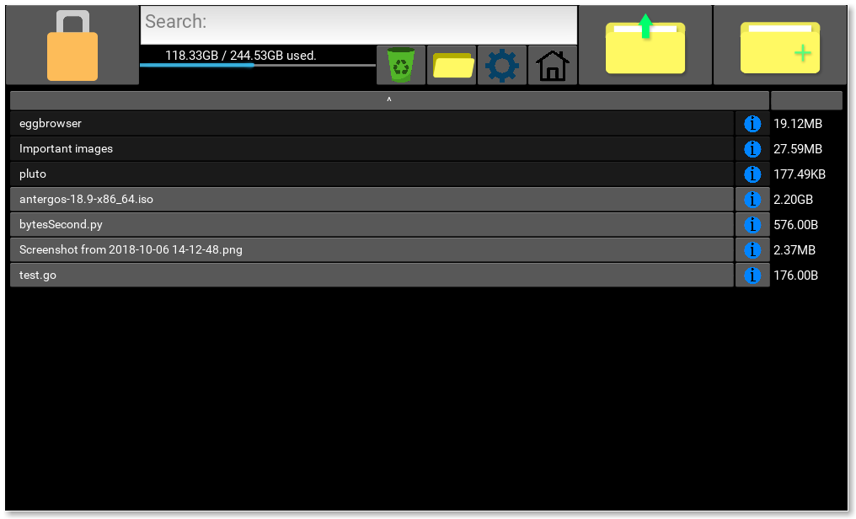

Test Number | 8
Relevant Objective | 1.m
Description | Click the home button to return to the root directory of the Vault..
Purpose | Check that the home button functions as required.
Test Data | T: [1]: Click the home button while in the root directory.  [2]: Click the home button while in another folder.
Expected Outcome | [1]: Buttons in the file browser should remain the same.  [2]: The contents of the home folder should be loaded into the file browser.
Actual Outcome | [All]: Pass
Evidence:

In a folder:
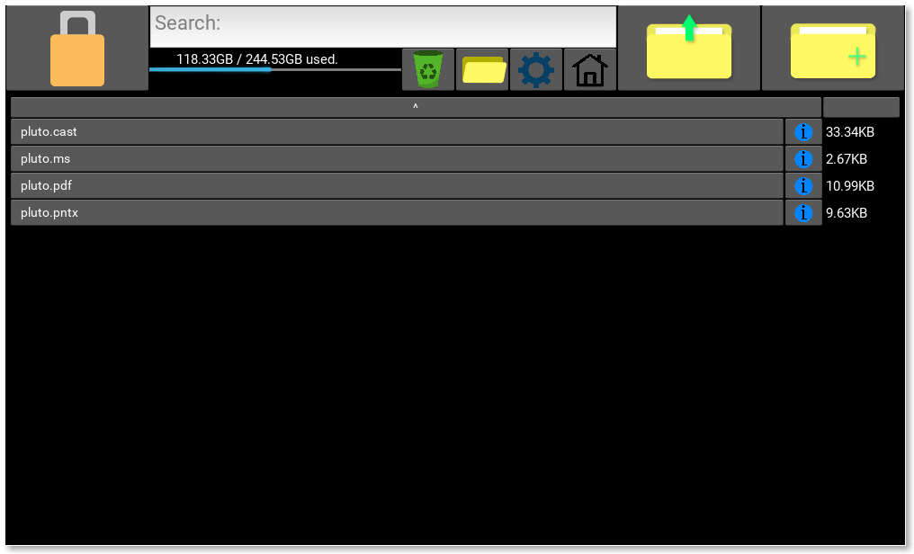
Pressed home button:
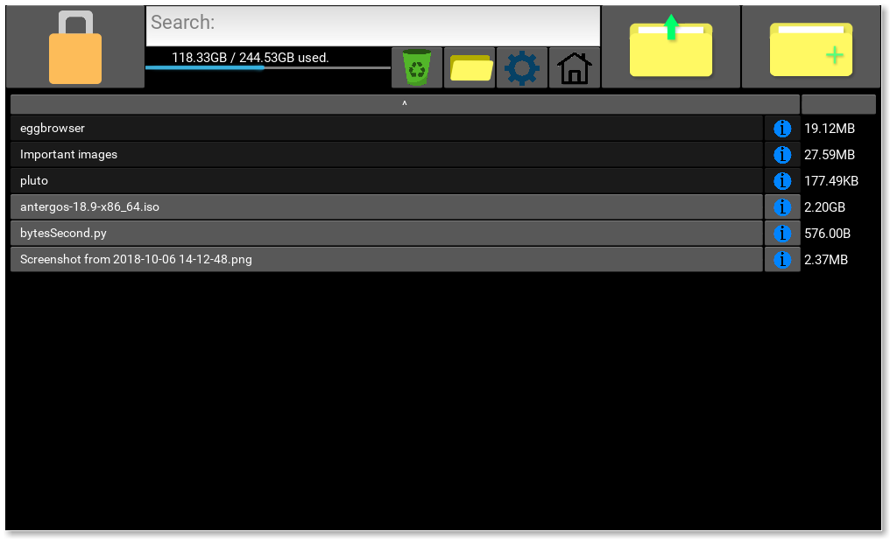

Test Number | 9
Relevant Objective | 1.k
Description | Re-size the window.
Purpose | Check that the GUI remains intact when you resize the window.
Test Data | T: Resize the window.
Expected Outcome | Widgets on the screen should resize to fit the new window size.
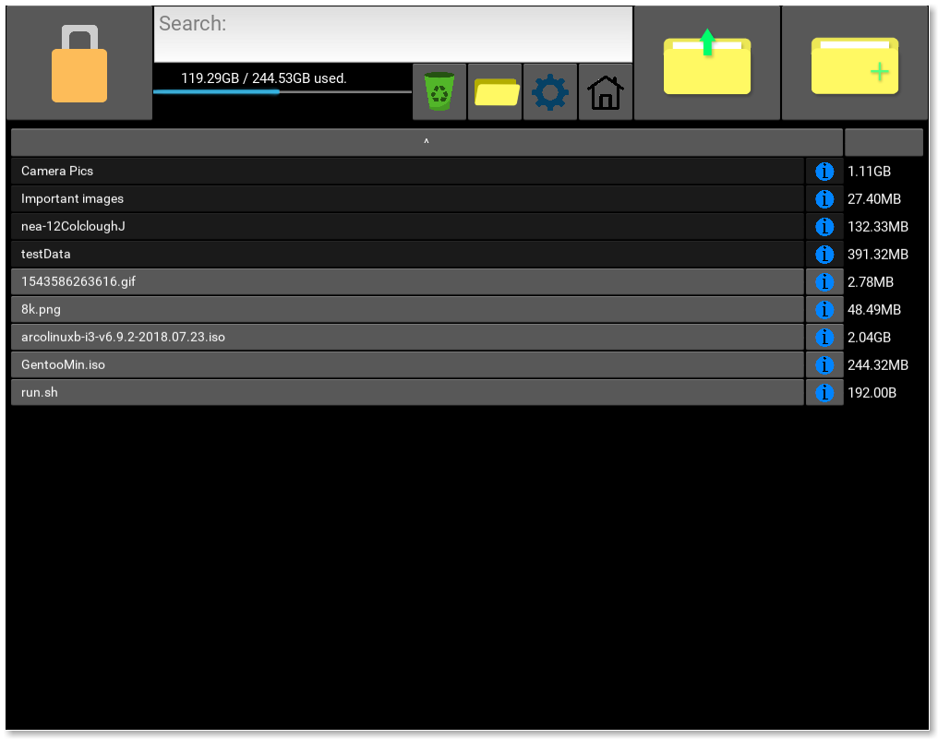  Actual Outcome | Pass
Evidence:

Test Number | 10
Relevant Objective | 1.o
Description | Change the direction of the sorts.
Purpose | To check that the sorts work.
Test Data | [1]: Sort by name ascending (folders separated by files).  [2]: Sort by name descending (folders separated by files).  [3]: Sort by size ascending.  [4]: Sort by size descending.
Expected Outcome | [All]: Should sort correctly.
Actual Outcome | [All]: Pass
Evidence:
[1]:
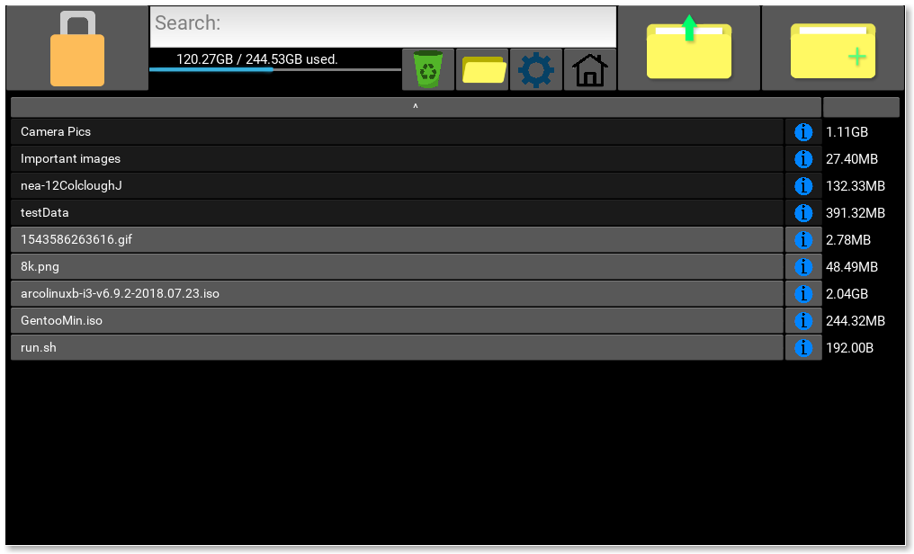
[2]:
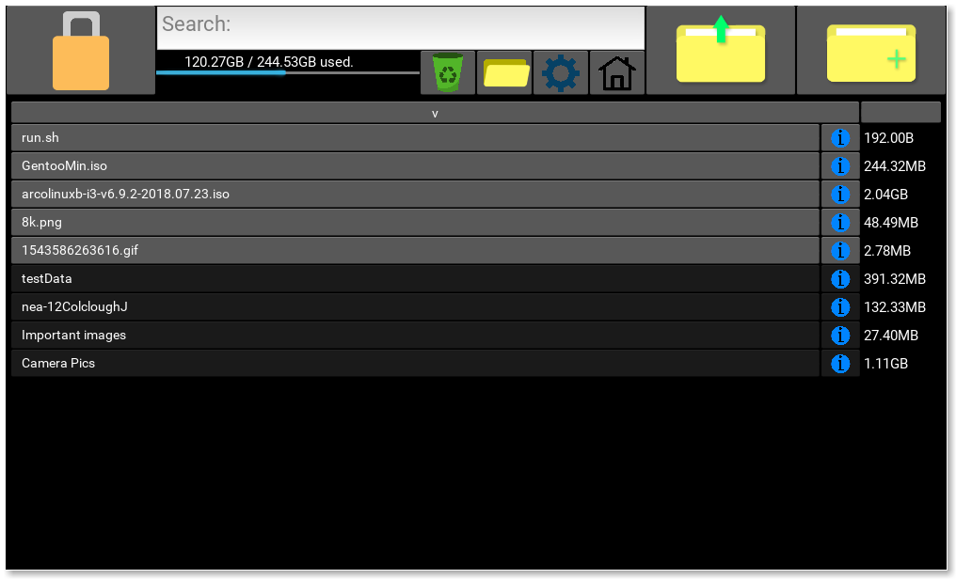
[3]:
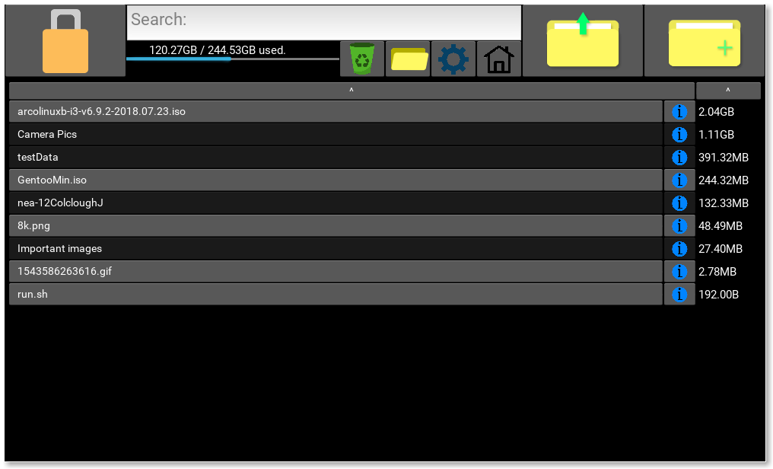
[4]:
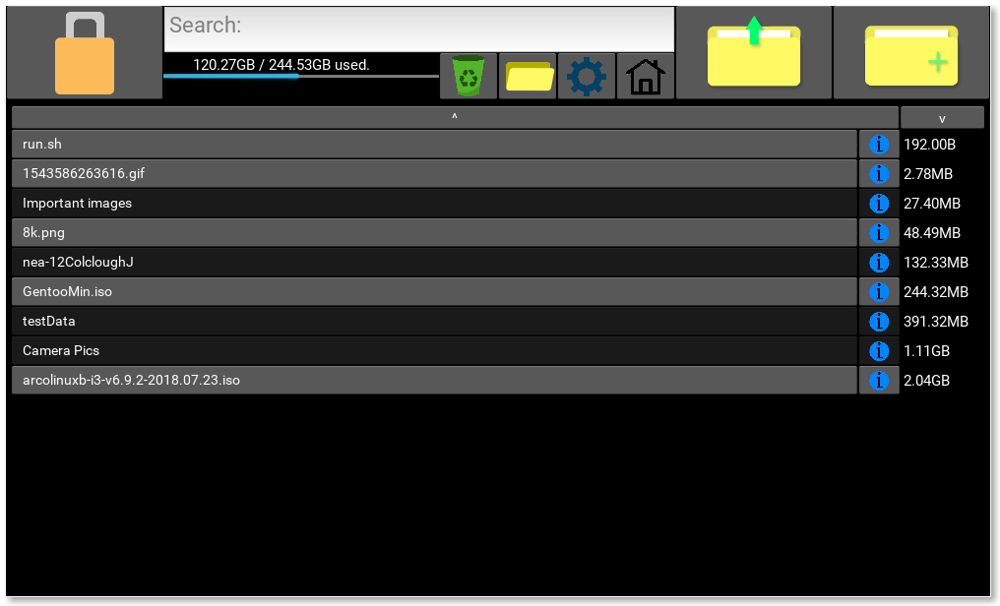

Test Number | 11
Relevant Objective | 1.n.iii
Description | Time how long it takes to decrypt a large file (2.04GB) compared to the prediction made by the popup that opens (encDecPop) displaying the predictions.
Purpose | Make sure the time prediction is accurate (otherwise it is pretty infuriating for the user).
Test Data | Decrypt a 2.2 GB file (2,203,779,072) and time it. Get the first available time prediction.
Expected Outcome | The difference between the time actually taken and the prediction should be +-2 seconds.
Actual Outcome | Pass: Predicted 25.09 seconds (19.88+5.21), took 25.537 seconds.
Evidence:
Started timer when it started, took me 5 secs to get a screenshot. (Predicted = 25.09 seconds)
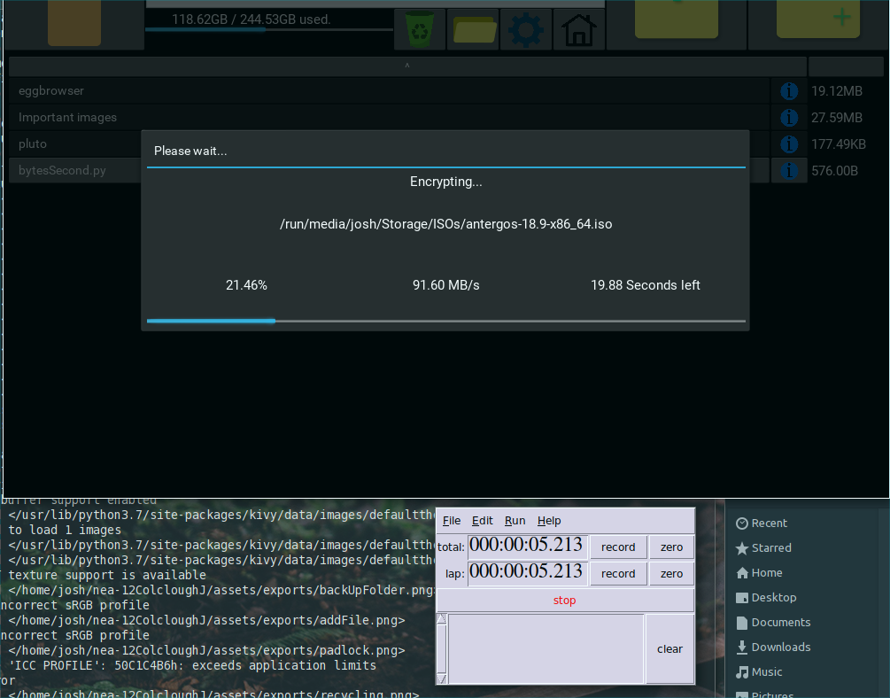
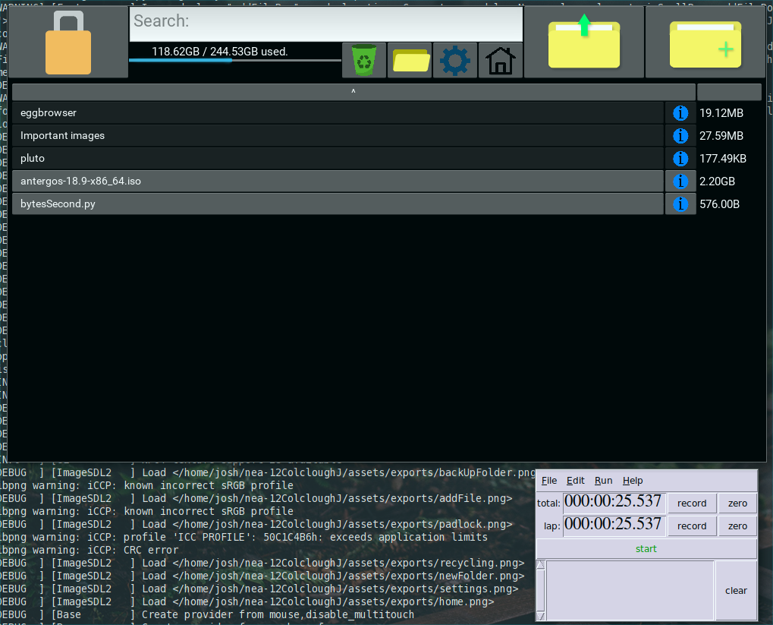
Finished:

Test Number | 12
Relevant Objective | 1.n.ii
Description | Compare the speed of encryption/decryption with the Go benchmark function.
Purpose | To check that the speed is found to be accurate.
Test Data | [1]: Encrypt a 244.3 MB file using the PC program.  [2]: Encrypt a 244.3 MB file using Go benchmark.  [3]: Decrypt a 244.3 MB file using the PC program.  [4]: Decrypt a 244.3 MB file using Go benchmark.
Expected Outcome | [All]: Speeds should be similar (within +-5 MB/s).
Actual Outcome | (Done on different computer to in unit tests)  [1]: 107.86 MB/s 2269321613 ns/op  [2]: 107.66 MB/s  [3]: 95.56 MB/s 2556627030 ns/op  [4]: 92.19 MB/s
Evidence:
[1, 2]:
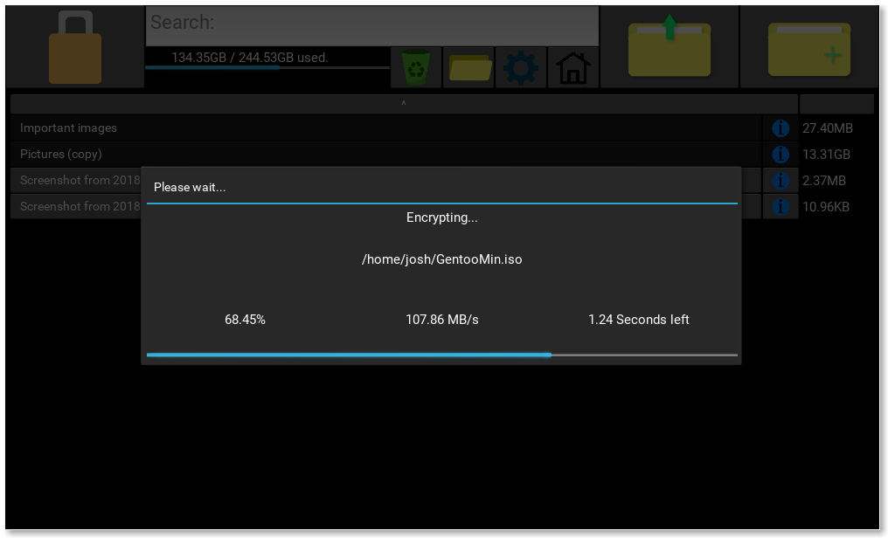
[3, 4] (darker background due to multiple popups):
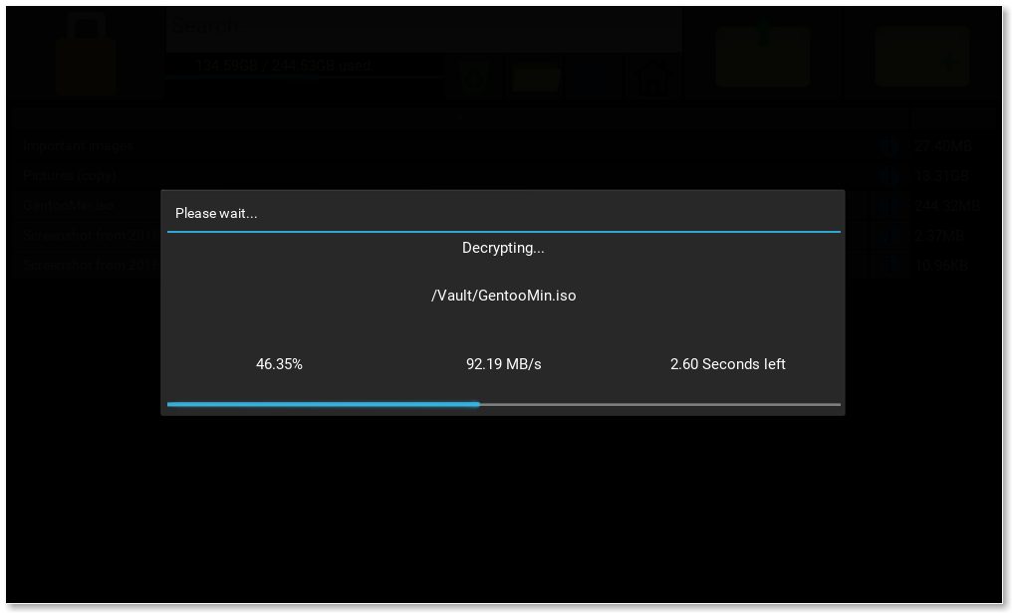
Test Number | 13
Relevant Objective | 3.e
Description | Delete a file into the recycling bin, and then delete it permanently and check it has been deleted.
Purpose | Check that it works.
Test Data | Permanently delete the file called “TqAoUIWq1yvmQBgyAIS8PQ==” in encrypted form, “test12_3.png” in decrypted form.
Expected Outcome | The file should not be available anywhere.
Actual Outcome | Pass
Evidence (checking recycling bin in vault):
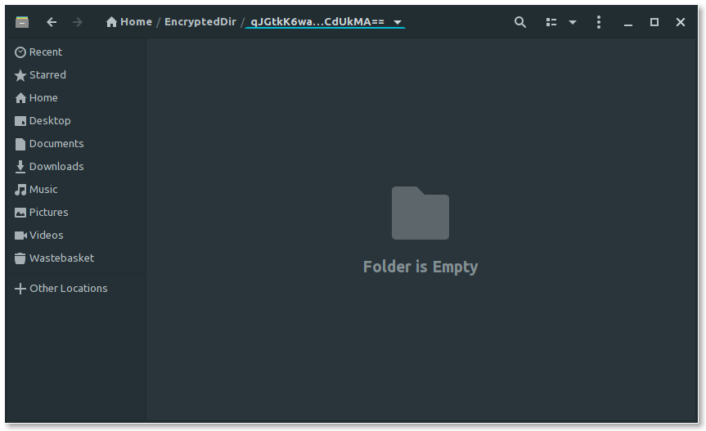
Test Number | 14
Relevant Objective | 3.i
Description | Decrypt a file to a location outside of the vault.
Purpose | To check it works normally.
Expected Outcome | File should be decrypted successfully.
Actual Outcome | Pass
Evidence:
Before:
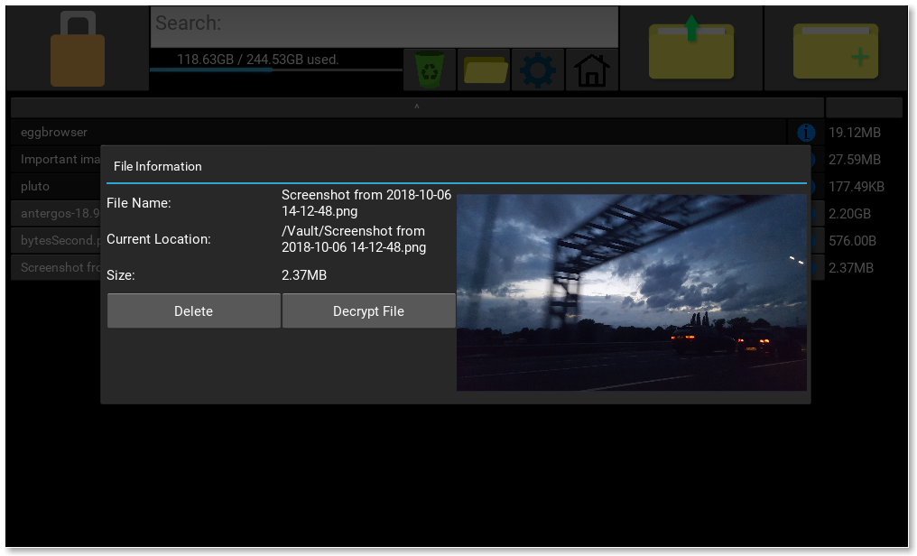
Input:
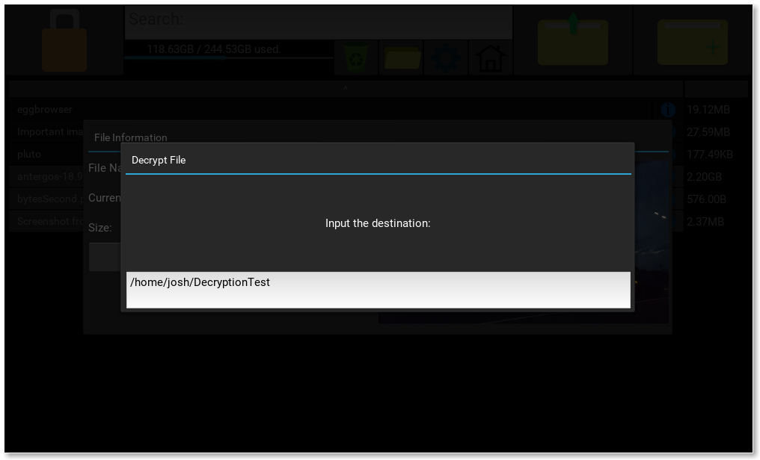
After:

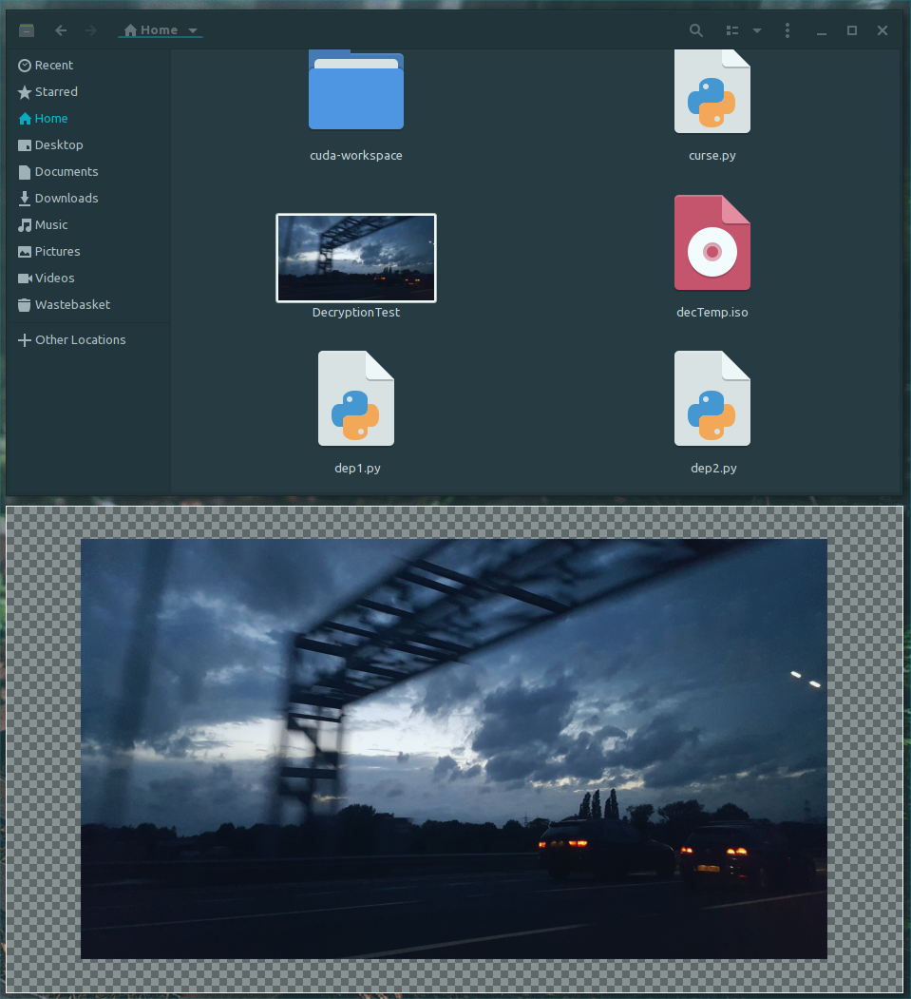
Top tile is file manager in /home/josh/, bottom is the open decrypted image.

Test Number | 15
Relevant Objective | 3.i
Description | Decrypt a folder to a location outside of the vault.
Purpose | To check it works normally.
Expected Outcome | Folder should be decrypted successfully, with all files and folders in the correct place.
Actual Outcome | Pass
Evidence:
Before:
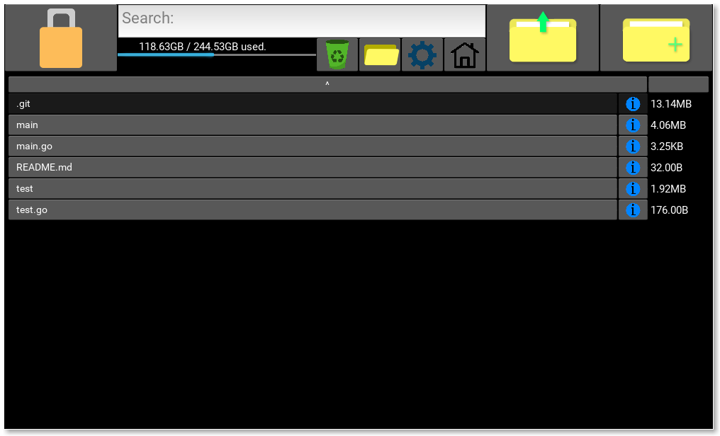
Input:
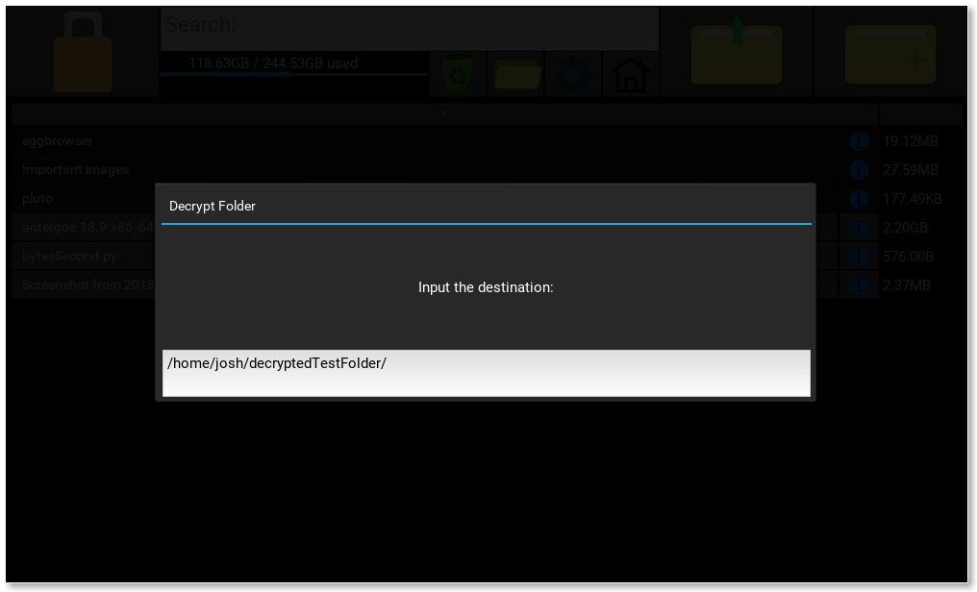

After:
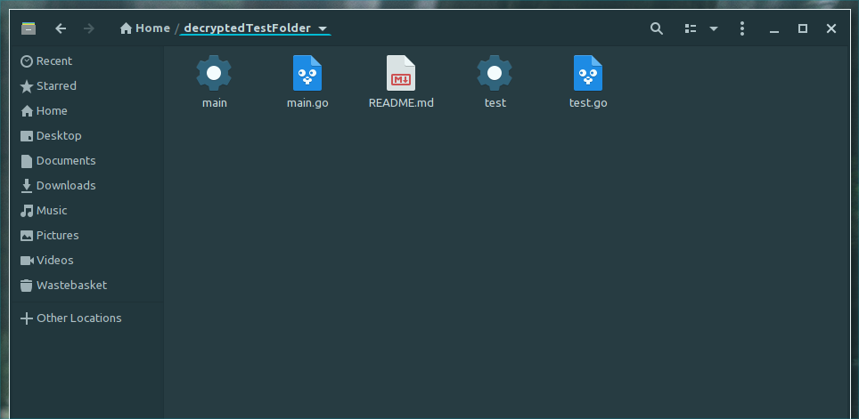
Test Number | 16
Relevant Objective | 1.f
Description | Create a new folder inside the vault.
Purpose | Make sure that it can be created.
Test Data | T: [1]: “bob”  [2]: “longfoldernameAbcdefghijklmnop”  [3]: “Perfectly normal folder name”  (Possibly Erroneous)  E: [4]: “\n\n\n\r\xAAaaaaaaaaaaaaaa”  [5]: “FOLDER NAME THAT IS WAY TOO LONG aaaaaaaaaaaaaaaaaaaaaaaaaaaaaaaaaaaaaaaaaaaaaaaaaaaaaaaaaaaaaaaaaaaaaaaaaaaaaaaaaaaaaaaaaaaaaaaaaaaaaaaaaaaaaaaaaaaaaaaaaaaaaaaaaaaaaaaaaaaaaaaaaaaaaaaaaaaaaaaaaa”  [6]: “hello/new/folder”
Expected Outcome | [1-4, 6]: Folder should be created with no issues.  [5]: A popup should show telling the user that the file name is too long.
Actual Outcome | [All]: Pass
Evidence:
File names 1-4 and 6:
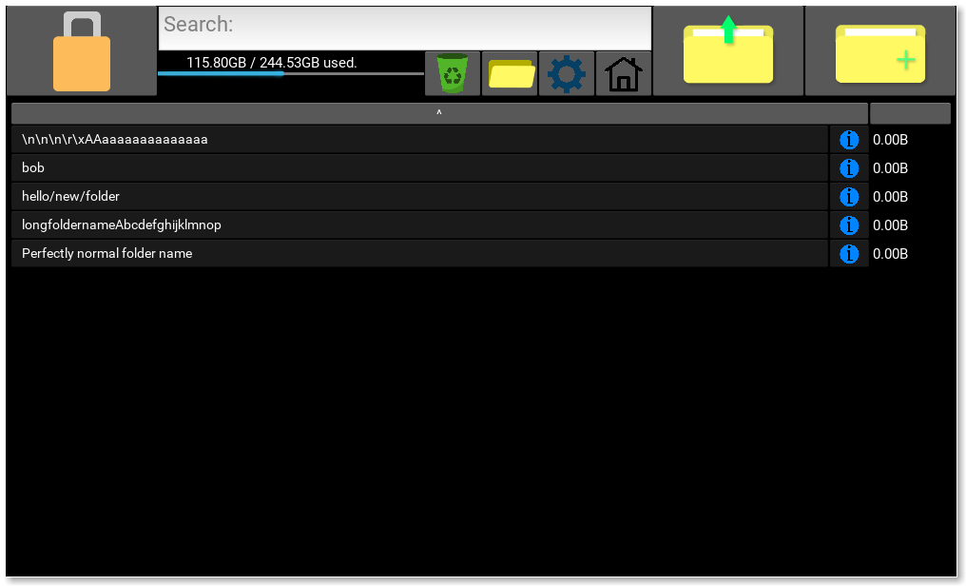
File name 5:
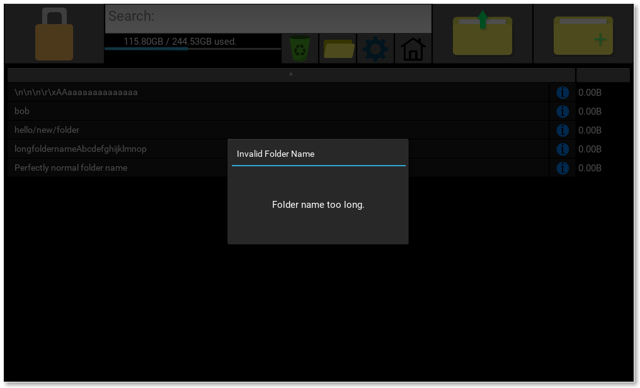
Test Number | 17
Relevant Objective | 1.r
Description | Attempt to go up one directory while in the root directory of the Vault.
Purpose | Check that the user is confined to the vault, so the program does not try to decrypt file names that are not encrypted.
Expected Outcome | The displayed files should remain the same when I click to go up.
Actual Outcome | Pass

Test Number | 18
Relevant Objective | 1.q
Description | Search for an item that is not in the vault.
Purpose | Check that the user is warned when the item is not found.
Test Data | “brownian motion” - search term (it is not in the vault).
Expected Outcome | A popup should open warning the user that the file could not be found.
Actual Outcome | Pass
Evidence:
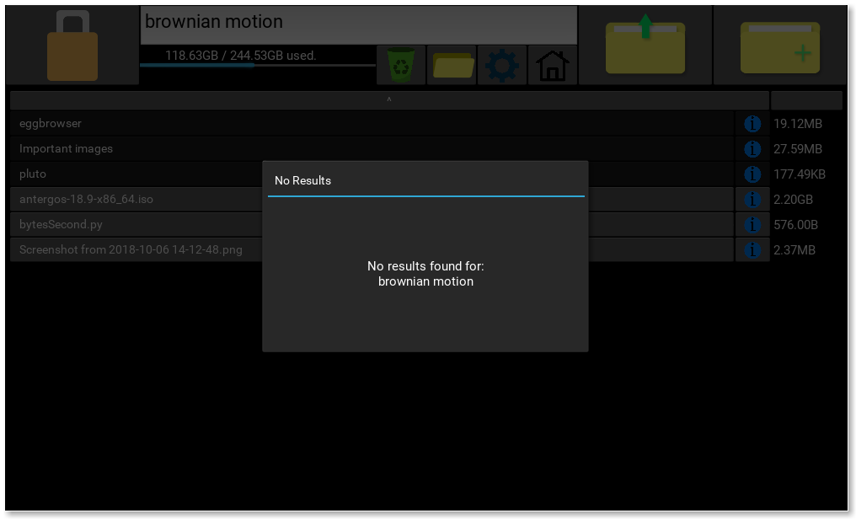
Test Number | 19
Relevant Objective | 1.q
Description | Search for an item that is in the vault.
Purpose | To check that the item is found.
Test Data | A lot of files (534 files). Some of them contain the string “processing”, so I will search for the folder “processing-3.4”, which there is only 1 of.
Expected Outcome | Should only show the folder “processing-3.4”
Actual Outcome | Pass
Evidence:
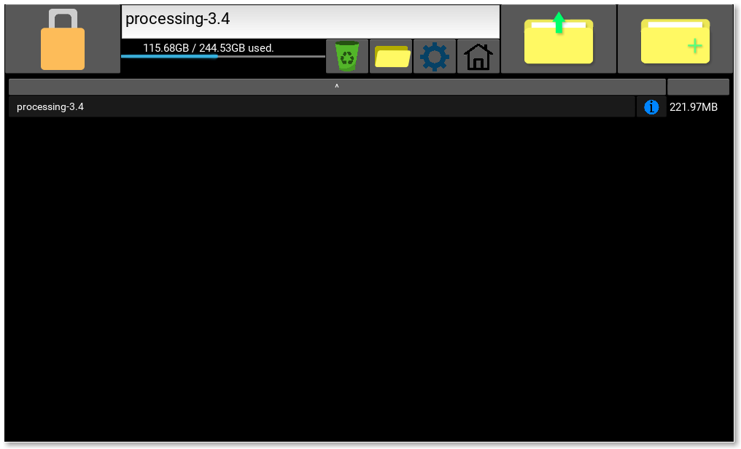
Test Number | 20
Relevant Objective | 3.g
Description | Open a file then lock the program with the file open.
Purpose | Check that the file is removed regardless of if it is open.
Expected Outcome | File should be removed and should not be in /tmp/FileMate/file.
Actual Outcome | Pass
Evidence:
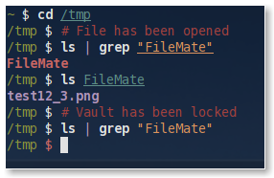
Changed directory to /tmp, which is the temporary folder on my PC. Then I opened the file in the program, then list the files in /tmp, filtering the output for “FileMate” (which is what I ended up calling the program).
Then I listed the contents of /tmp/FileMate/, to view the temporary FileMate files.
Then I locked the app, and checked again for the FileMate folder, and it had been deleted.

Test Number | 21
Relevant Objective | 1.j
Description | View more information on an image, then view more information on a file that is not an image.
Purpose | Check that a preview of the image is shown, and if the file is not an image then a preview is not shown.
Expected Outcome | The preview should be shown for the image, but not shown for the regular file.
Actual Outcome | Pass
Evidence:
With an image:
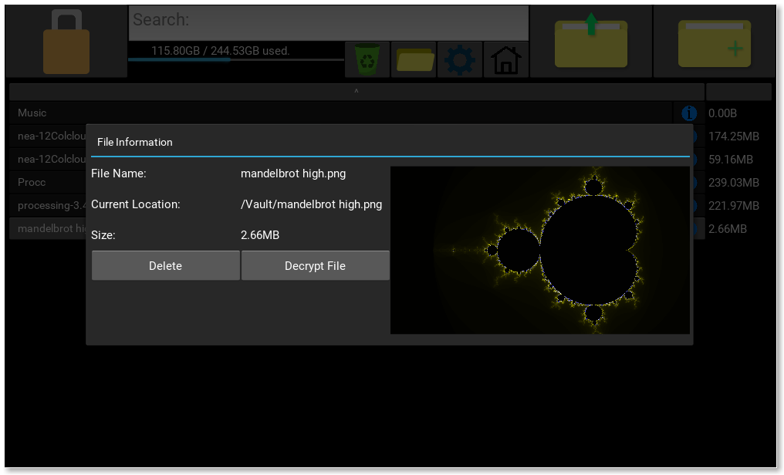

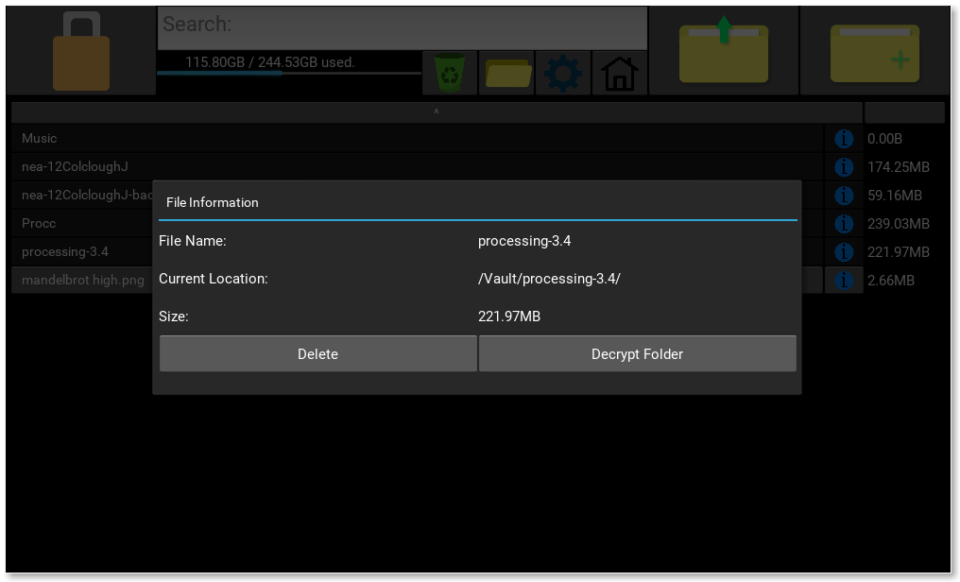
With a folder:
Test Number | 22
Relevant Objective | 1.d, 3.i
Description | Decrypt folder to different locations.
Purpose | Make sure that the user can’t break the input.
Test Data | T : [1]: “/home/josh/folder/”  [2]: “/home/josh/folder”  [3]: “/home/josh/aaaaaaaaaaaaaaaaaaaaaaaaaa/”  (Potentially Erroneous)  E: [4]: “/root/hmm” (Erroneous if user does not have permission)  [5]: “home/josh/folder/”  [6]: “/home/josh//////////////////////////////////////////folder/”  B: [7]: “/home/josh/\n\n\n”  [8]: “/home/josh/aaa/a/a/aa/”
Expected Outcome | [1-3]: Should decrypt no problem.  [4]: Popup should warn user that it cannot be decrypted here.  [5]: Same as [4]  [6]: Same as [4] and [5]  [7]: May work fine.  [8]: Should make the file path correctly then decrypt files to aaa/a/a/aa/.
Actual Outcome | [All]: Pass
Evidence:
[1-3]:
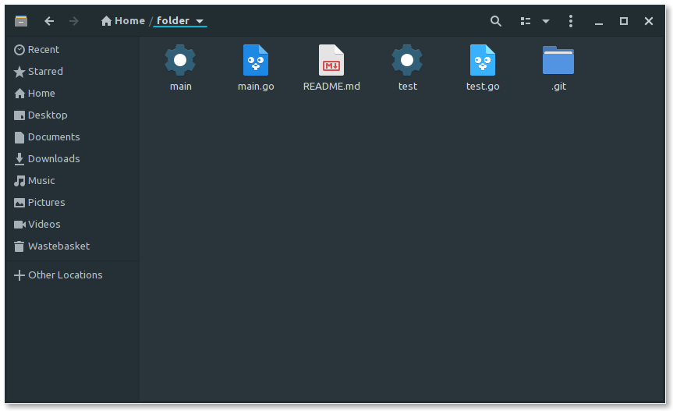
[4]:
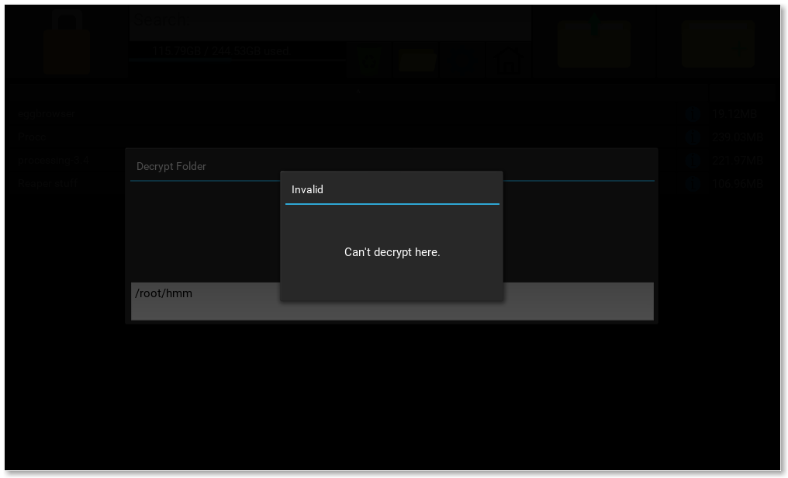
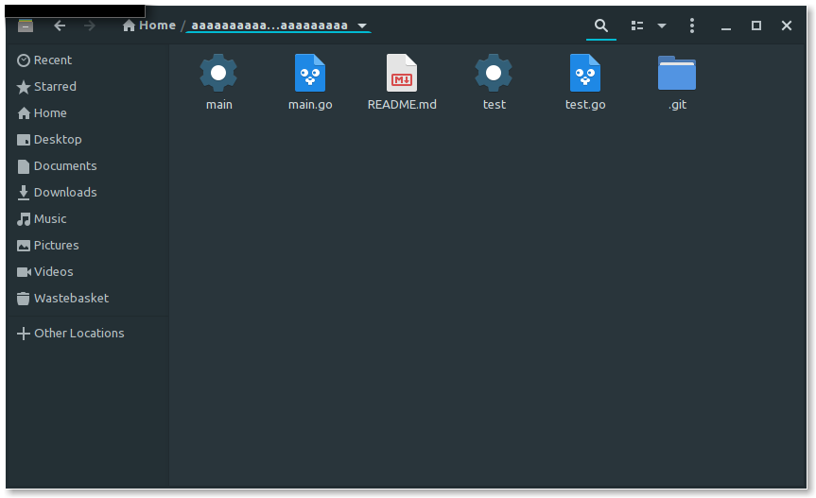
[5]:
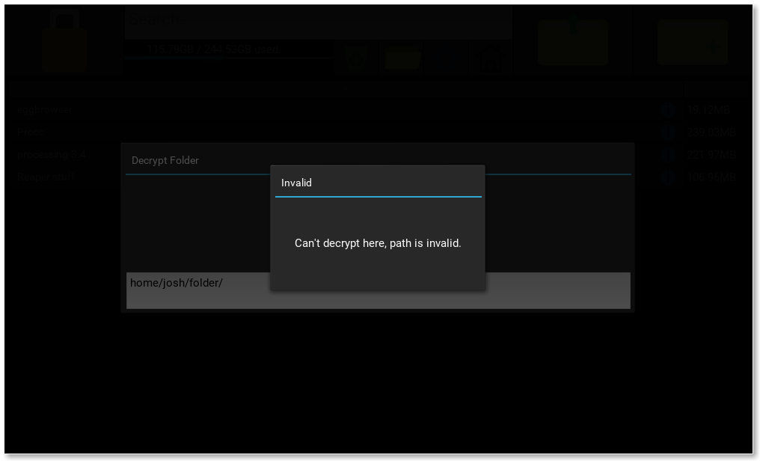
[6]:
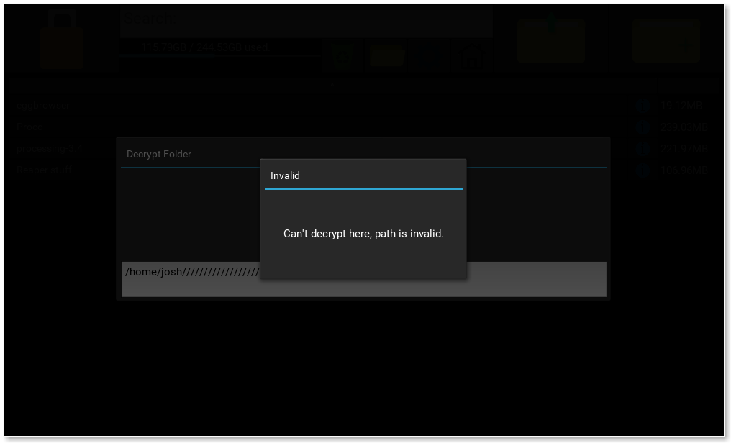
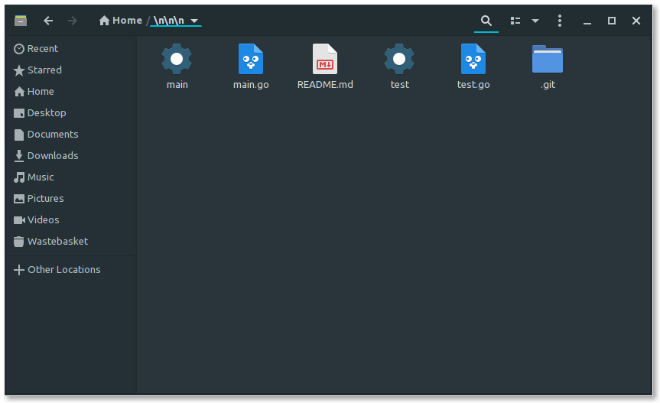
[7]:
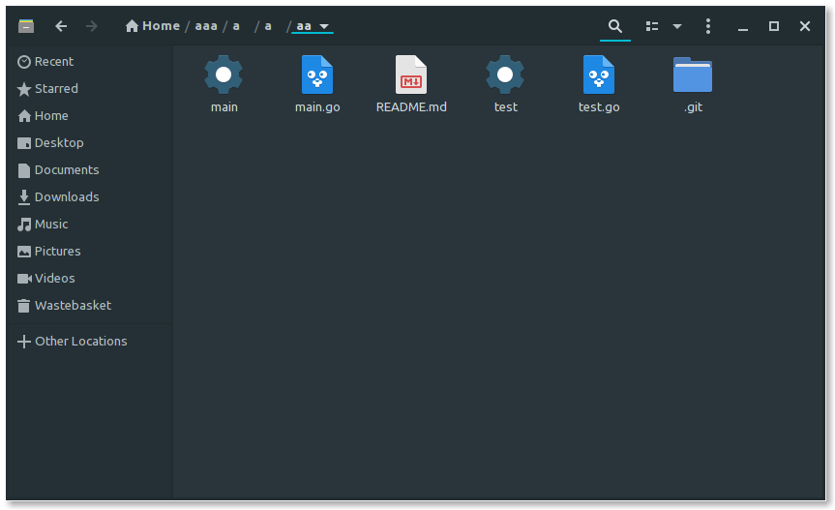
[8]:

Test Number | 23
Relevant Objective | 2.e
Description | On the mobile app, click to connect to a device that is not running the PC app.
Purpose | To check the user is warned that the program can’t connect to the device.
Expected Outcome | A popup should be shown on the mobile telling the user that the app could not connect to the device.
Actual Outcome | Pass
Evidence:
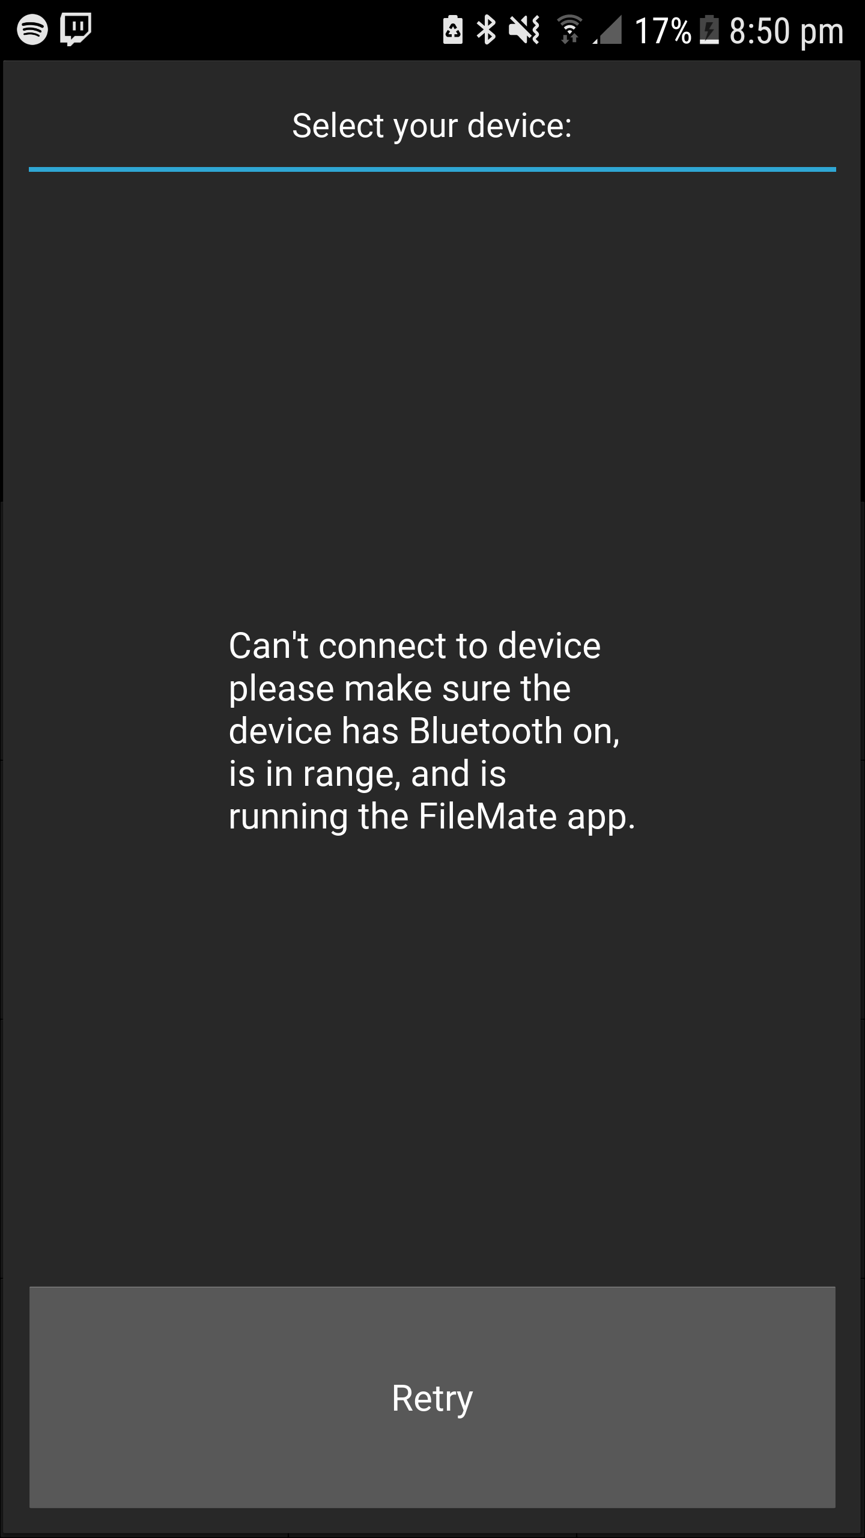
Test Number | 24
Relevant Objective | 3.a
Description | Change the vault location (using the Settings screen).
Purpose | Make sure the user can easily change vault location.
Test Data | From “/home/josh/EncryptedDir/” to:  T: [1]: “/home/josh/newFolder/”  [2]: “/home/josh/newFolder”  [3]: “newFolder”  [4]: “newFolder/subFolder/”  [5]: “newFolder/subFolder”  B: [6]: “/home/josh/folderWithEncFiles/”  E: [7]: “/home/josh/folderWithEncFilesDifferentKey/”, log in with the different key, then change vault to “/home/josh/EncryptedDir/”.
Expected Outcome | [1-2]: Should create folder.  [3-5]: Should create folder relative to the input.  [6]: Has the same key as the original location, so should work just fine.  [7]: Hopefuly handles it ok.
Actual Outcome | [1-6]: Pass  [7]: Tried to decrypt file names, but showed gibberish.
Evidence:
[1, 2]:
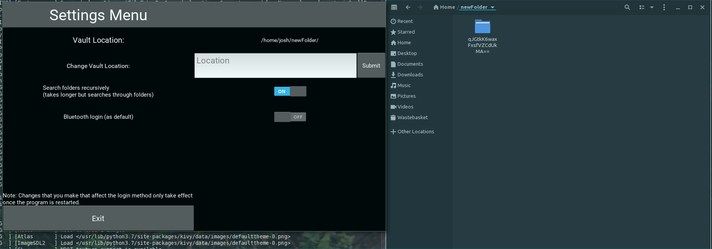
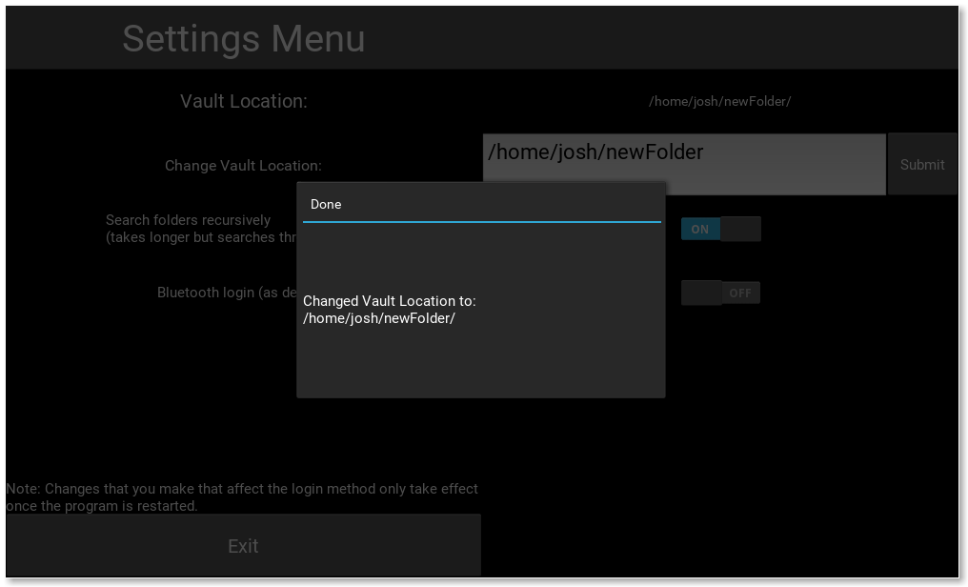

[3]:
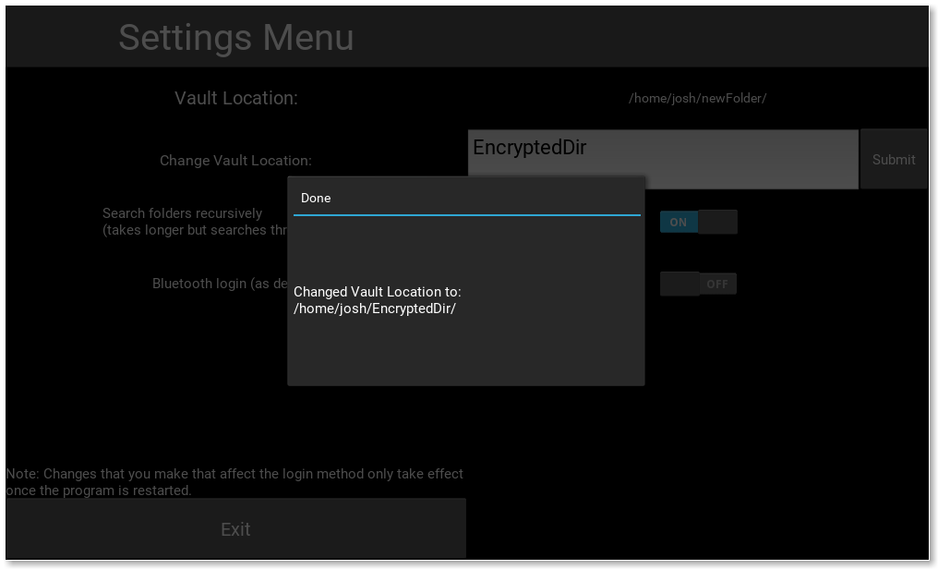
[4]:
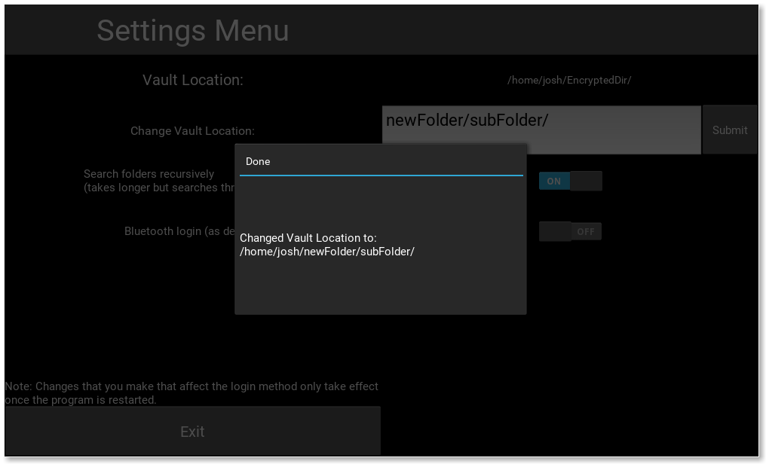

[5]:
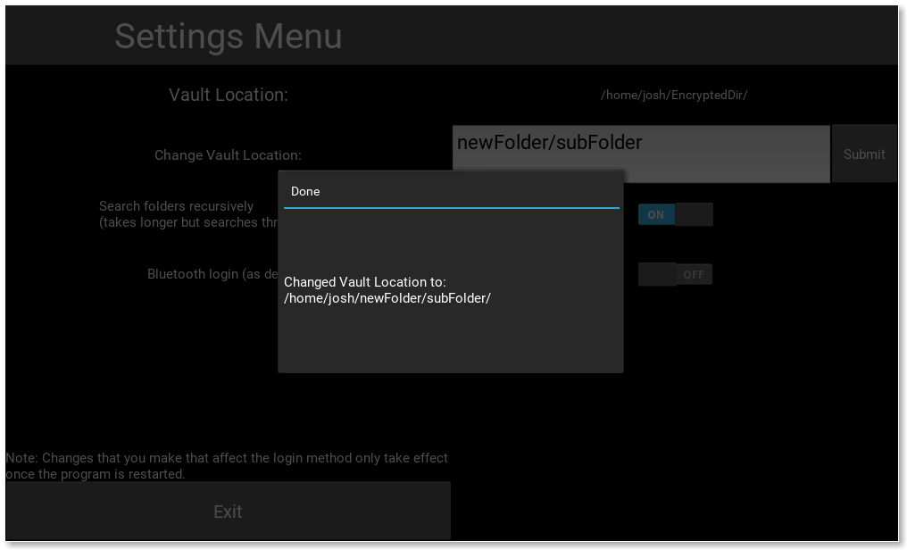
[6 (in 2 parts)]:
Change vault to /home/josh/folderWithEncFiles/
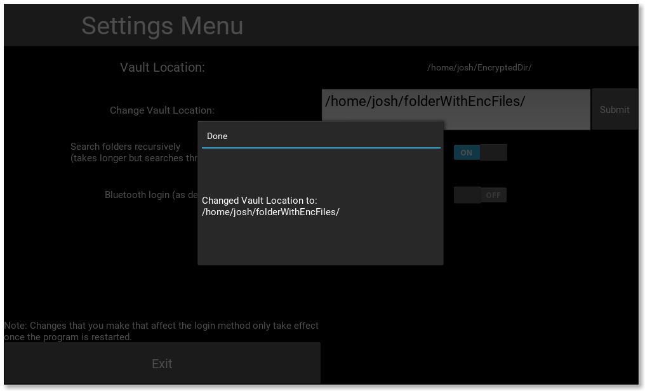

View vault:
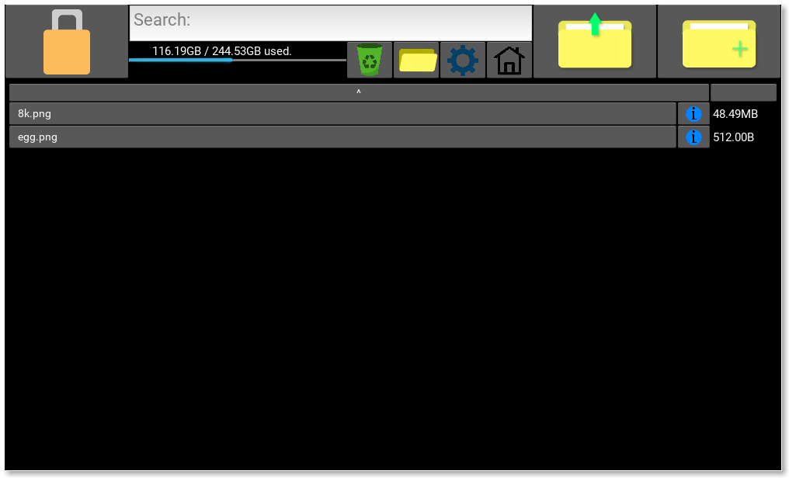
[7]: (The one that broke)
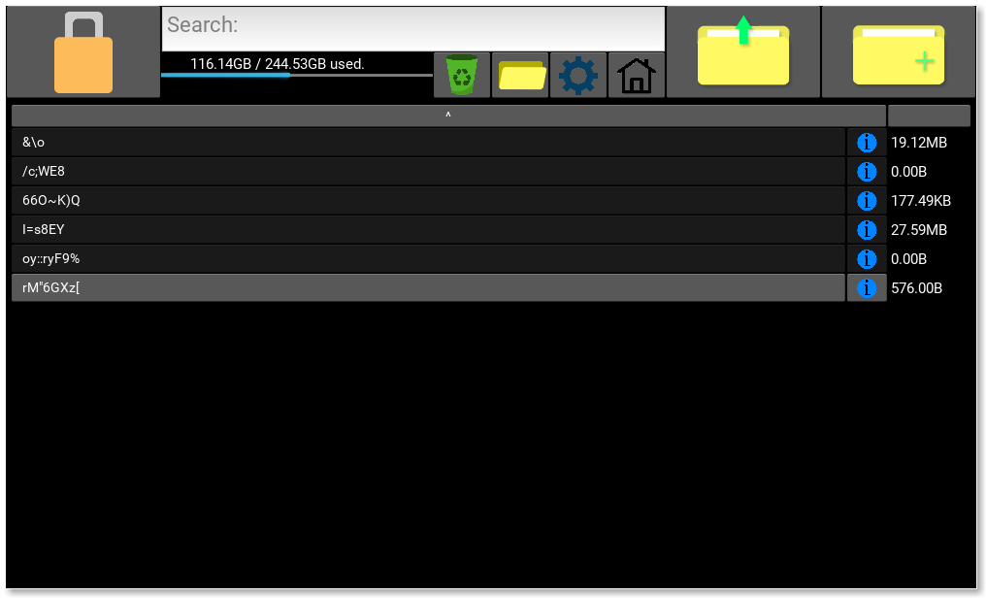

Test Number | 25
Relevant Objective | 3.a
Description | Move a vault onto a USB stick, and access it on another computer.
Purpose | To make sure that use case is possible.
Expected Outcome | The user should be able to access all files in the vault using my program, if they enter the key correctly and if the vault location is set correctly in the configuration files.
Actual Outcome | Pass
Evidence:
USB on this computer:
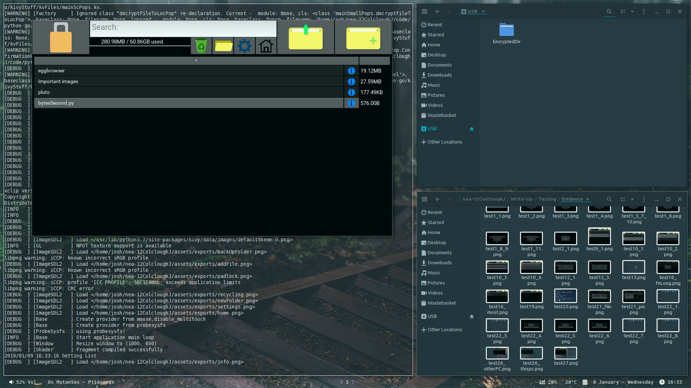
Left is the program, top right is the contents of the USB (= EncryptedDir).

USB on another computer:
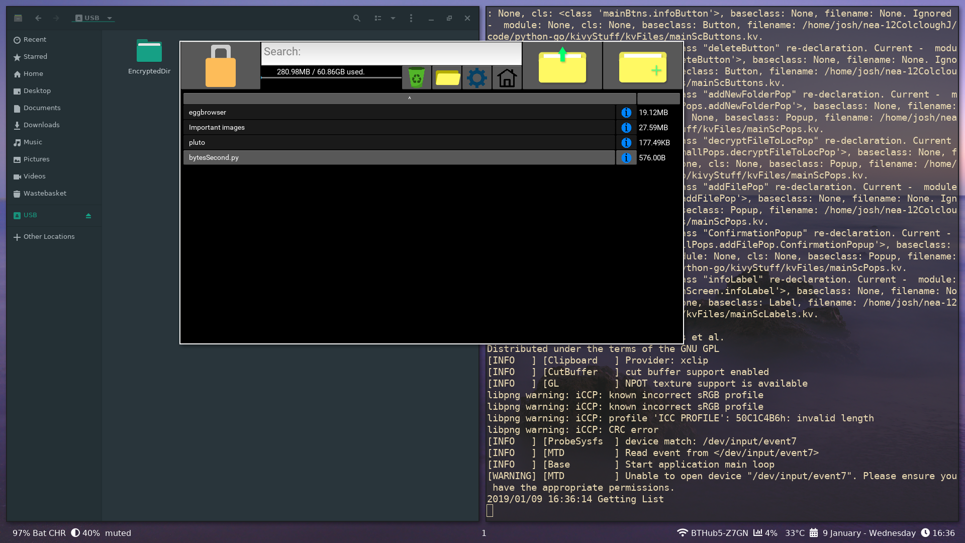

Test Number | 26
Relevant Objective | 3.a
Description | Move the vault AND the program onto a USB stick, and run the program from the USB stick on multiple computers.
Purpose | Check that the use case is possible, and working on different machines is smooth.
Expected Outcome | The user should be able to access all files in the vault using my program, if they enter the key correctly and if the vault location is set correctly in the configuration files, using a relative vault location.
Actual Outcome | Pass
Evidence:
On this computer:
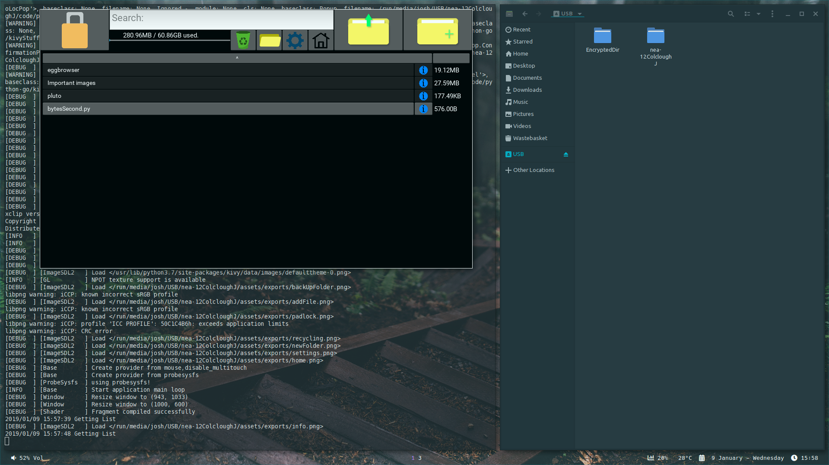
Right tile shows contents of USB stick, left is the program running showing the contents of USB/EncryptedDir.

Here it is running off the USB stick on another computer:
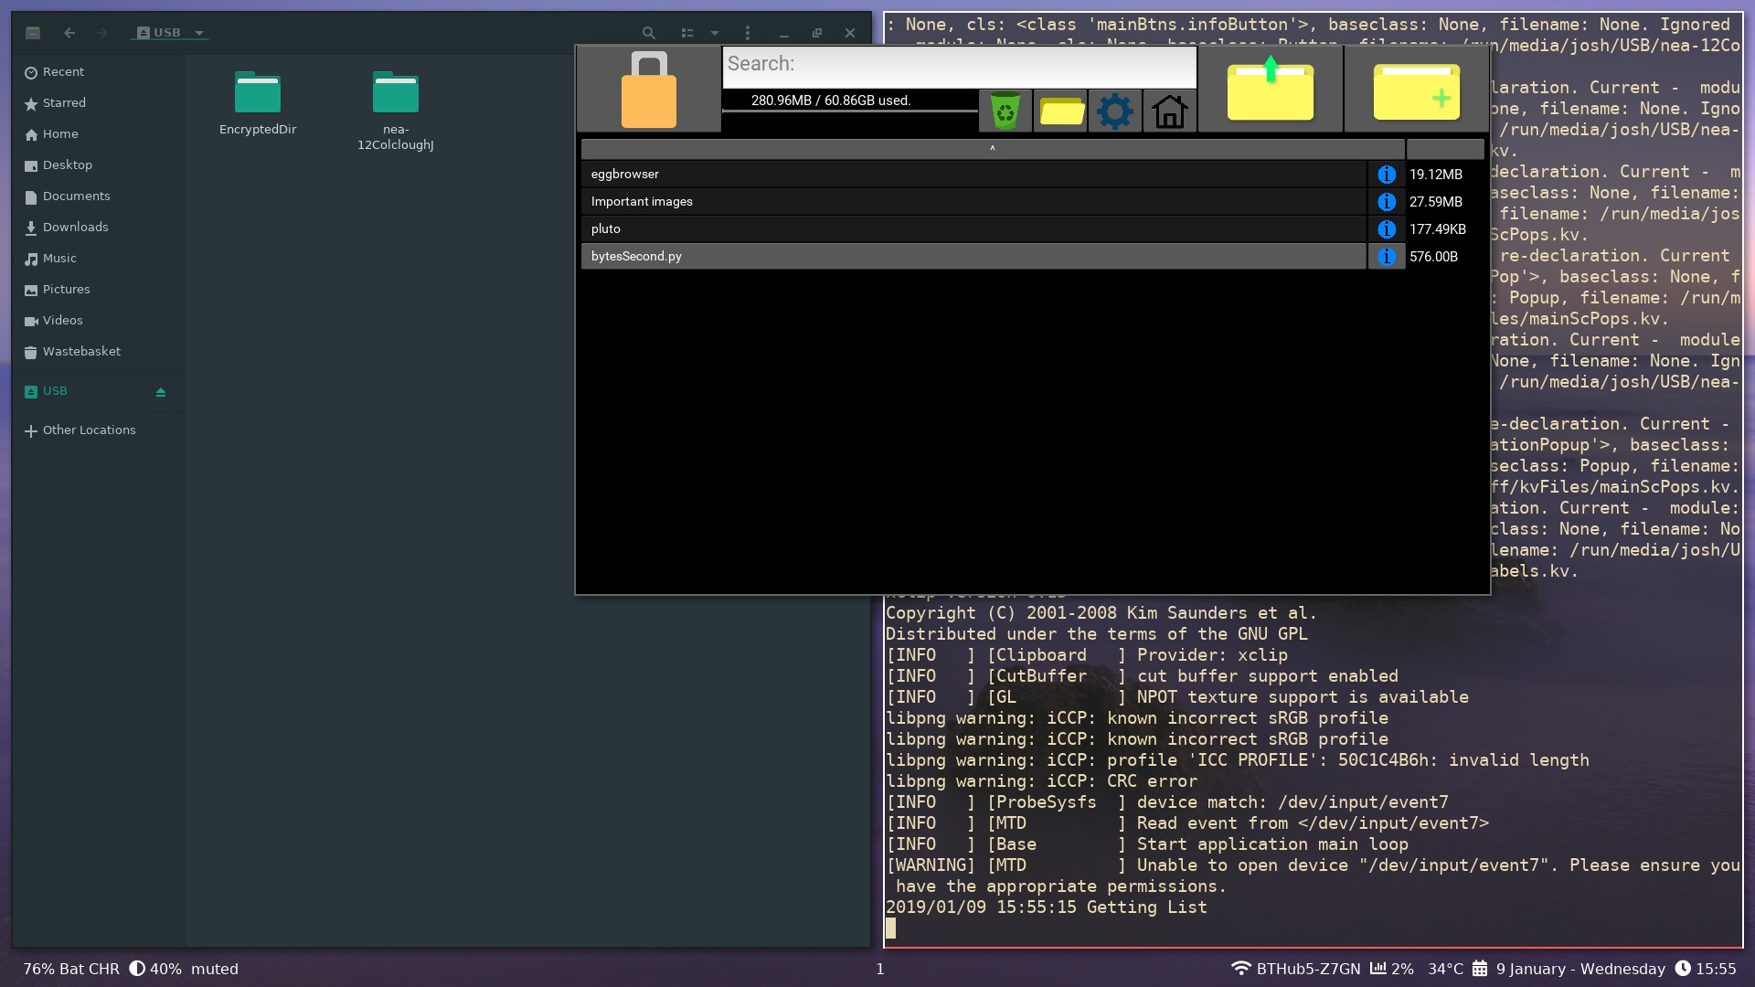
Test Number | 27
Relevant Objective | 1.h.i
Description | Check my program is not using too much CPU time when idle (<5%), and not too much memory (<100 MiB).
Purpose | To make sure that my program is not using up CPU time when it is really doesn’t need to be doing anything, and that it is not too memory hungry.
Expected Outcome | Should be below 5% CPU usage and 100 MiB of memory, as it isn’t a huge program.
Actual Outcome | Pass- 0% CPU usage and 34.4 MiB memory usage.  The memory usage is still a bit high (comparable to my file manager at 35 Mib), and I believe this is due to the loading of images for the info button on files, when it could probably be loaded once instead of once for every button.
Evidence:
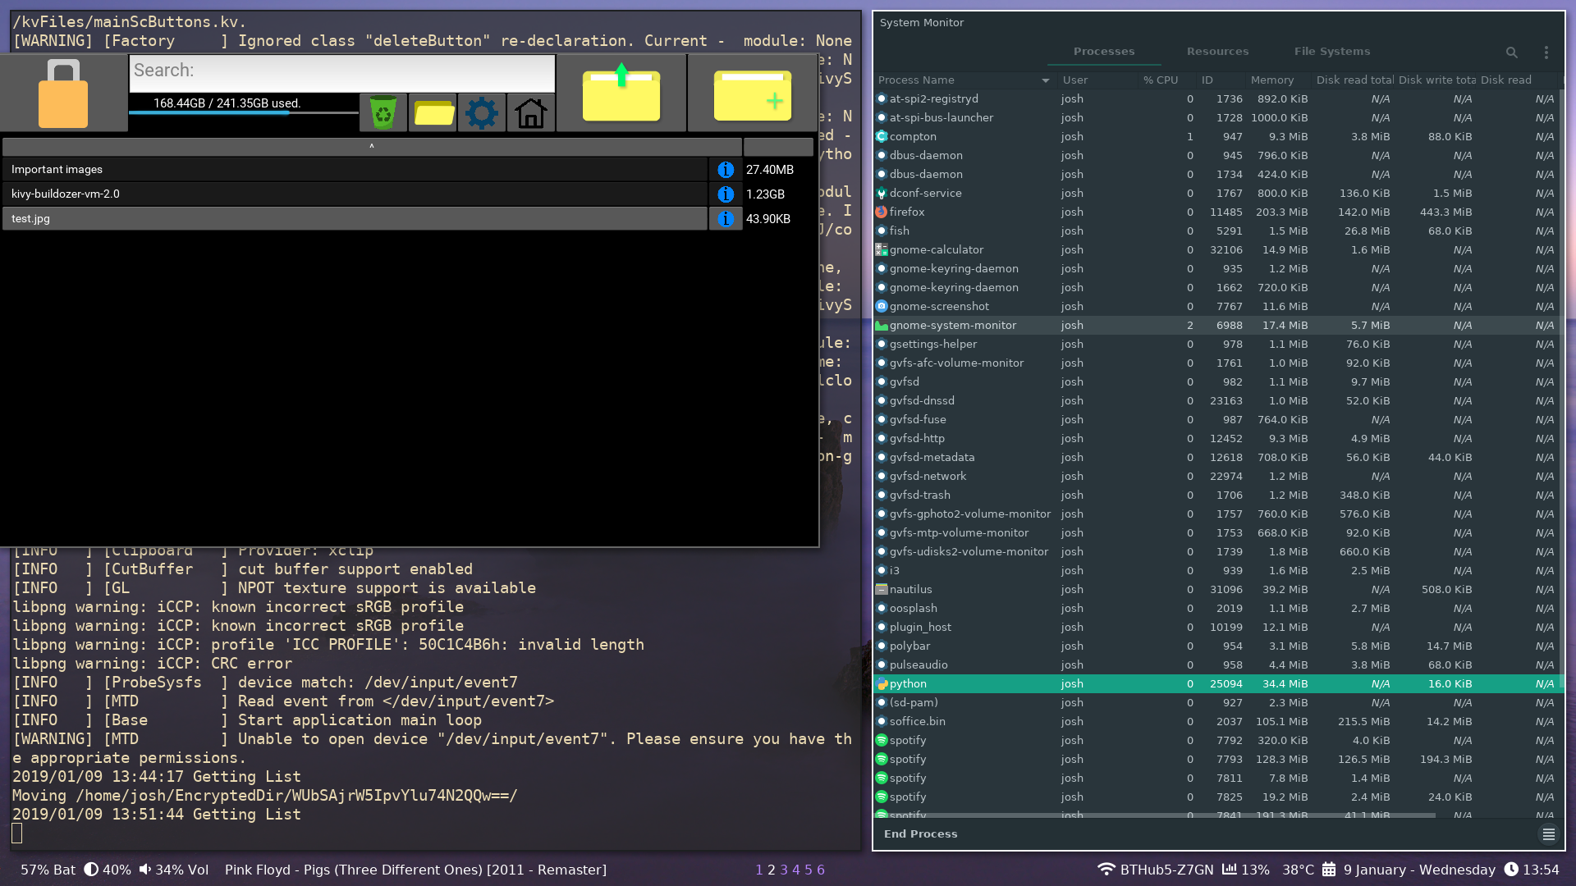
Here I have my program sitting idle, with a task manager open (the `python` task is highlighted).

