Based on the Bayesian HMM, it appears that 3 (or possibly 2 behaviors) are present in addition to a ‘burrow’ behavior.

|  |  |
| --- | --- |
| Behavior | Probability |
| 1 | 0.33 |
| 2 | 0.31 |
| 3 | 0.25 |
| 4 | 0.07 |
| 5 | 0.03 |
| 6 | 0.01 |
| 7 | 0.00 |

The MAP estimate corresponded with the following state-dependent density distributions for step lengths and turning angles (only shown for the top 3 behaviors).

**Step Length**

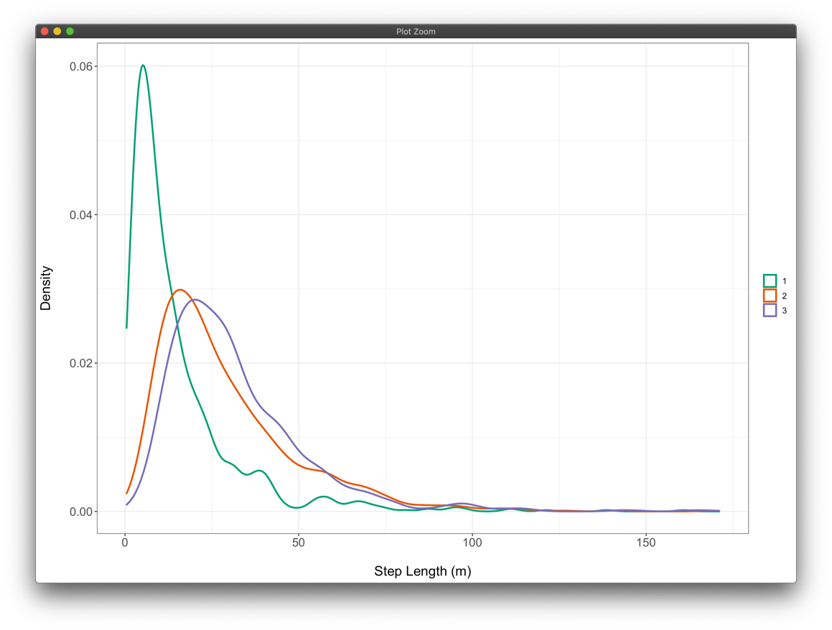

**Turning Angle**

Based on these distributions, it appears that SL distributions are nearly identical for states 2 and 3, but TA distributions are slightly different. However, these states may be better off lumped together in terms of describing the movements of active armadillos.