Based on a Bayesian HMM run with 7 and subsequently 3 max possible groups, it appears that 2 behaviors are present in addition to a ‘burrow’ behavior. By running the model iteratively, I am able to assign behaviors (that are retained) to all analyzed observations. Perhaps there is a better way to do this?

The MAP estimate corresponded with the following state-dependent density distributions for step lengths and turning angles.

**Step Length**

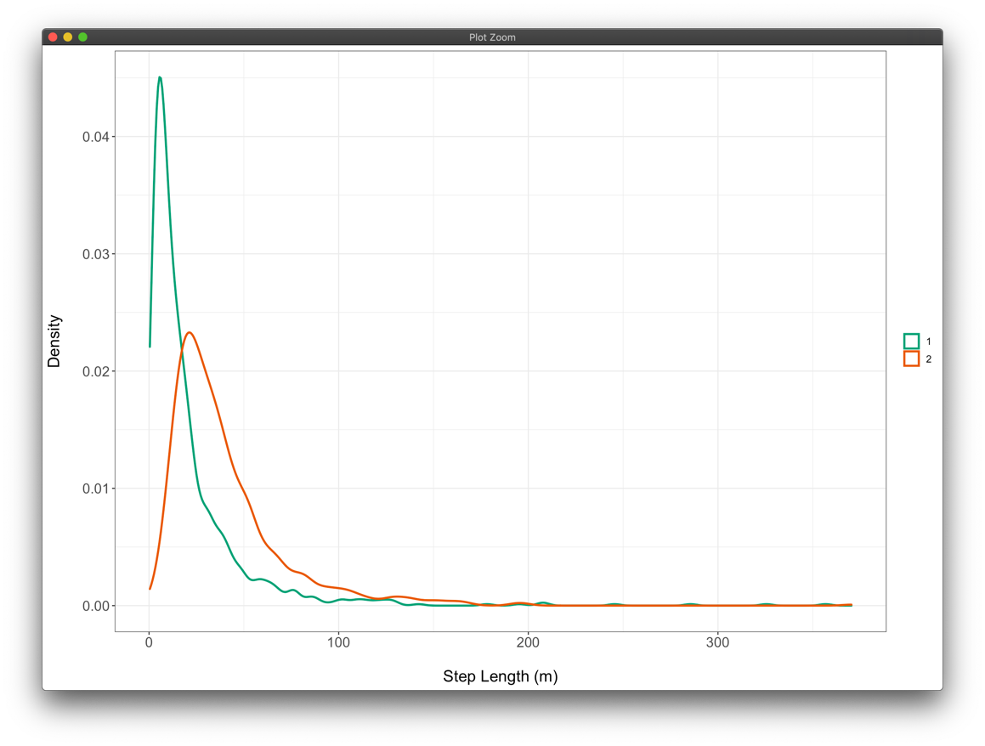

**Turning Angle**

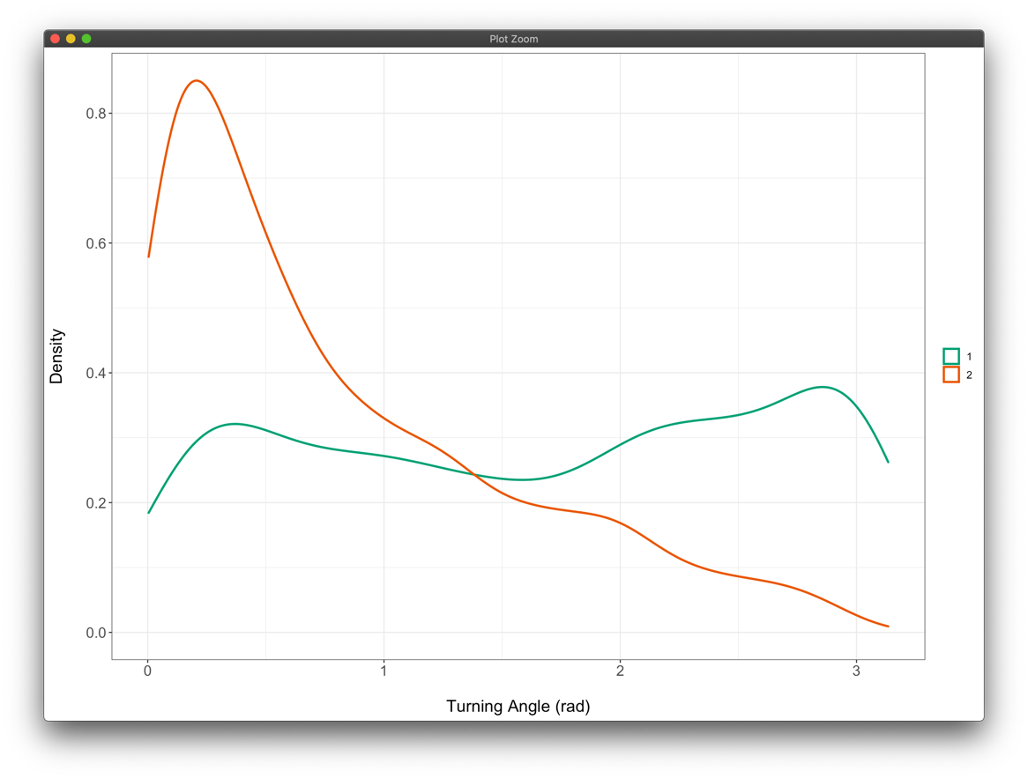

Based on these distributions, it appears that there is a behavior with longer SL and lower TA (‘transit’) and another with slightly lower SL and relatively uniform TA (‘foraging’). These match our expectation of what the distributions for SL and TA should look like for these states.

The z.k’s are then merged into the original dataset that was filtered for observations at a 5 min time step and included burrow locations. An example of a focal ID (‘tm15’) is shown below with behaviors annotated along the track. NA values denote observations where either SL or TA was missing, which precluded analysis by the model.

There seems to be a little mixing of foraging and transit behaviors along different paths, but it’s hard to tell exactly what is going on since there is a lot of overlap. We can plot the time series of these observations and aggregate per day to assess what is going on.

Here is an example of the temporal pattern of behavior proportions on a daily basis for tm15:

There are some changes here and there for this ID, but hard to say from this plot alone what could be happening. Since the resistance surface of ‘transit’ movements show faster movement during nights of greater lunar illumination, let’s see if there’s a relationship between daily behavior proportion and lunar illumination based on all IDs:

Based on these plots, it appears that there is an increase in the proportion of transit behavior as lunar illumination increases. But a similar trend is also observed for the foraging state. This may indicate that the armadillos spend more time out of their burrows on days with greater illumination. To focus back on ID tm15, I will show a subset of this plot for only this individual:

This ID appears to show a difference from the population trend in that burrow and foraging behavior proportions held constant with lunar illumination, but transit behavior occurred more frequently when the moon was brighter.

Finally, I will show what these behaviors look like overlayed on top of environmental covariates. I can dig into this further by extracting covariate values for each observation and evaluating the values of these covariates for each of the three states.

*Distance to Road*

*Elevation*

*NDVI*

For this particular individual, the track does not appear to veer far off from the road, negating the impact of the other covariates. On these stretches of road, the foraging and transit behaviors appear to be mixed quite regularly, which matches up with Nina’s understanding that these armadillos stop frequently to dig up termite mounds. The burrow locations all tend to be relatively clustered on the east side of the animal’s range, most of which appear to occur right next to the road.

The inspection of relationships for other individuals might bring some relationships to light, but it does appear that there is a relatively high level of inter-individual variability in movement patterns. Other covariates that possibly reflect ideal conditions or habitat for termite mounds may also be important to include as covariates with respect to behavior changes and for the resistance model. Additionally, the daily behavior proportions may be slightly different if we can find a way to summarize behavior proportions per each unique active/inactive period, which is complicated by armadillos activity spanning 2 days (overnight).