Joshua Brock

ECE5930 – Radar Signal Processing

HW 8 – Backprojection

(a) Point Target (300x300 resolution)

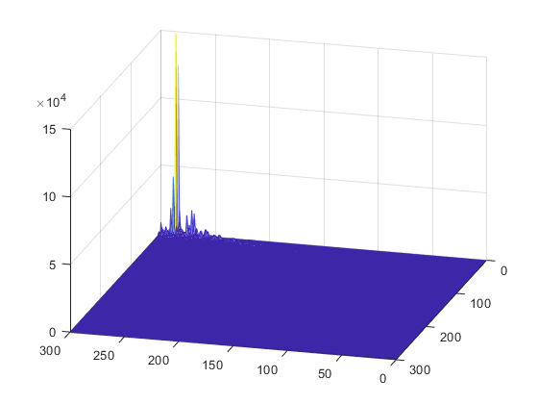

(b) Scene (500x500 resolution)

I learned a fair amount while doing this homework. I learned more about backprojection and how to implement it. I was also reminded of interpolation using FFT’s from looking at SDL’s code. I learned that while backprojection is fairly simple in theory, it can be challenging to get the indexing just right, especially when it comes to indexing into the interpolated image. Indexing was something I had some issues with. I was able to overcome those issues when I went back and watched the lecture where we went through the code and some things were further clarified.

I actually got the back projection running pretty fast. The 500x500 USU image only took about 5 minutes, which is much faster than I expected it to be. I think preallocating the arrays helped a fair amount with speed.

Code:

% Simulate a SAR system.

addpath(genpath('../../utils/'));

clear;

image = 2;

%% Radar info

height = 2000;                          % [m] height of radar

freqPulseRepitition = 700;              % pulse repetition frequency

sampleInterval = 1/freqPulseRepitition; % sample interval

pulseDuration = 6.0e-6;               % duration of LFM pulse (Tr)

fmRate = 4\*1e6\*1e6;                     % LFM FM rate

platformVelocity = 200;                 % [m/s] velocity of platform

speedOfLight = 3e8;                     % speed of light

lambda = 0.03;               % [m] wavelength of radar

carrierFreq = speedOfLight/lambda; % carrier frequency

AntennaLength = 1;                      % antenna length

Fs = 30e6;                        % (fast time) samples per second

Ts = 1/Fs;                % sample time

squintAngle = deg2rad(30);

theta3dB = lambda / AntennaLength;

plotNumber = 0;

plotNumber = plotNumber + 1;

figure(plotNumber);

if (image == 1)

    recieved = load('sarIMG1.mat');

else

    recieved = load('sarIMG2.mat');

end

miny = 7000;

maxy = 8000;

minx = 0;

maxx = 280.105;

% pointY = 7000;

% pointX = 264.25;

rangeGateTime = 5.176788819470330e-05;

%% first sample paramameters

if image == 1

    eta0 = -19.788571428571426;

    y0 = 0;

    x0 = -3.957714285714285e+03;

else

    %recieved = load('sarIMG2.mat');

    eta0 = -23.777142857142859;

    y0 = 0;

    x0 = -4.755428571428572e+03;

end

recvSignal = recieved.recv;

mesh(real(recvSignal));

%% compute azimuth distance values

nAzTimes = size(recvSignal,1);

azTimes = (0:(nAzTimes-1)) \* sampleInterval + eta0;

azVals = azTimes \* platformVelocity;

%% number backprop pixels

numPixY = 500; %pixels

numPixX = 500;

dY = (maxy - miny) / numPixY;

dX = (maxx - minx) / numPixX;

chirpTimeList = 0:Ts:pulseDuration;

nSamples = length(recvSignal(1,:));

chirp = mychirpcausal(chirpTimeList,pulseDuration,fmRate,0);

convolutionLength = nSamples + length(chirp) - 1;

NfftRg = 2^nextpow2(convolutionLength);

chirpFft = fft(conj(chirp),NfftRg);

%% Backprojection

reconimg = zeros(numPixX, numPixY);

jlist = zeros(numPixX);

taulist = zeros(numPixX);

idxlist = zeros(numPixX);

for k = 1:length(azTimes)   % for each azimuth position

    ry = 0;

    rx = azVals(k); % only x changes

    rz = height; % radar position

    u = rx;

    recvchirp = recvSignal(k, :);

    if (max(abs(recvchirp)) == 0) % norecvSignal here

        continue;

    end

    recvchirpfft = fft(recvchirp, NfftRg);   % transform

    rgCmpfft = recvchirpfft .\* chirpFft;            % multiply

    rgCmp = ifft(rgCmpfft);                         % inverse transform

    rgCmp = rgCmp(1:convolutionLength);             % choose the piece to keep

    % for each pixel y

    for iIdx = 1:numPixY%nrowsrecon

        y = miny + (iIdx-1) \* dY; % miny

        z = 0;

        a1 = rx + y\*tan(squintAngle + theta3dB/2);

        a2 = rx + y\*tan(squintAngle - theta3dB/2);

        numj = 0;

        for jIdx = 1:numPixX

            x = minx + (jIdx-1) \* dX;

            % if the target falls in the beam

            if (x < a1 && x > a2)

                numj = numj + 1;

                jlist(numj) = jIdx; %[jlist jIdx];

                dist = norm([ry,rx,rz] - [y,x,z]);

                tautilde = dist\*2/speedOfLight;

                taulist(numj) = tautilde; %[taulist tautilde];

                idx = floor((tautilde - rangeGateTime + pulseDuration/2)/Ts + 1);

                idxlist(numj) = idx; %[idxlist idx];

            end

        end

        interpRow = interp1((1:convolutionLength), rgCmp, idxlist);

        jct = 0;

        for kIdx = 1 : numj

            jIdx = jlist(kIdx);

            reconimg(iIdx,jIdx) = reconimg(iIdx,jIdx) + ...

                exp(1j\*2\*pi\*carrierFreq\*taulist(kIdx))\*interpRow(kIdx);

        end

    end

end

figure(10);

imagesc(abs(reconimg));