CS 1632 - DELIVERABLE 5: Static Analysis

Josh Demusz – joshdemusz

Github: https://github.com/joshdemusz/CS1632-D5

Summary

When fixing code with Findbug, I focused on fixing one method at a time. I would check which methods had issues, fix those issues, and run the test suite in order to check if regression errors were created. If so, I would fix these errors until all tests were passed. By fixing the code this way, regression issues were fixed almost as soon as they were created, and I did not have to back track to any previously edited method.

When cleaning up code using Checkstyle, I essentially just ran Checkstyle and made the recommended changes for each file until all style errors were fixed. I also frequently ran the test suite to make sure that I did not accidently create regression errors.

With this project, I did not seem to have any major issues or challenges. The only minor issue I had had to do with Cbeckstyle. In the given Checkstyle xml, the lexicographical ordering of imports contradicted with the InteliJ IDE’s default ordering. Thus, when I would try to manually reorder imports in the IDE, it would automatically undo it. To fix this issue, I just changed the import ordering setting in InteliJ.

Findbug Screenshots

ButtonPanel.java

Before & After:



Direction.java

Before & After:



JBefunge.java

Before & After:

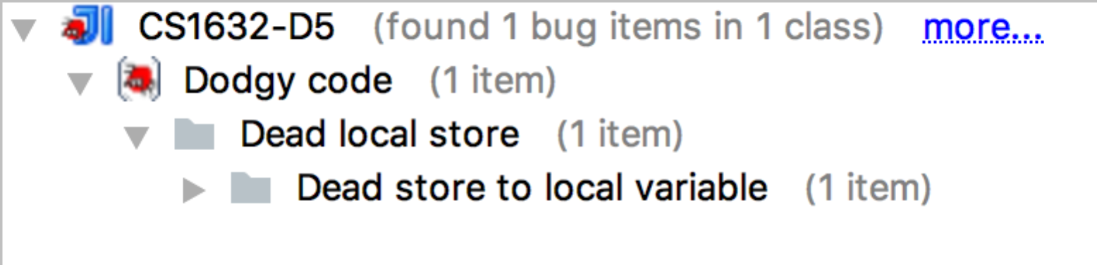

Location.java

Before:

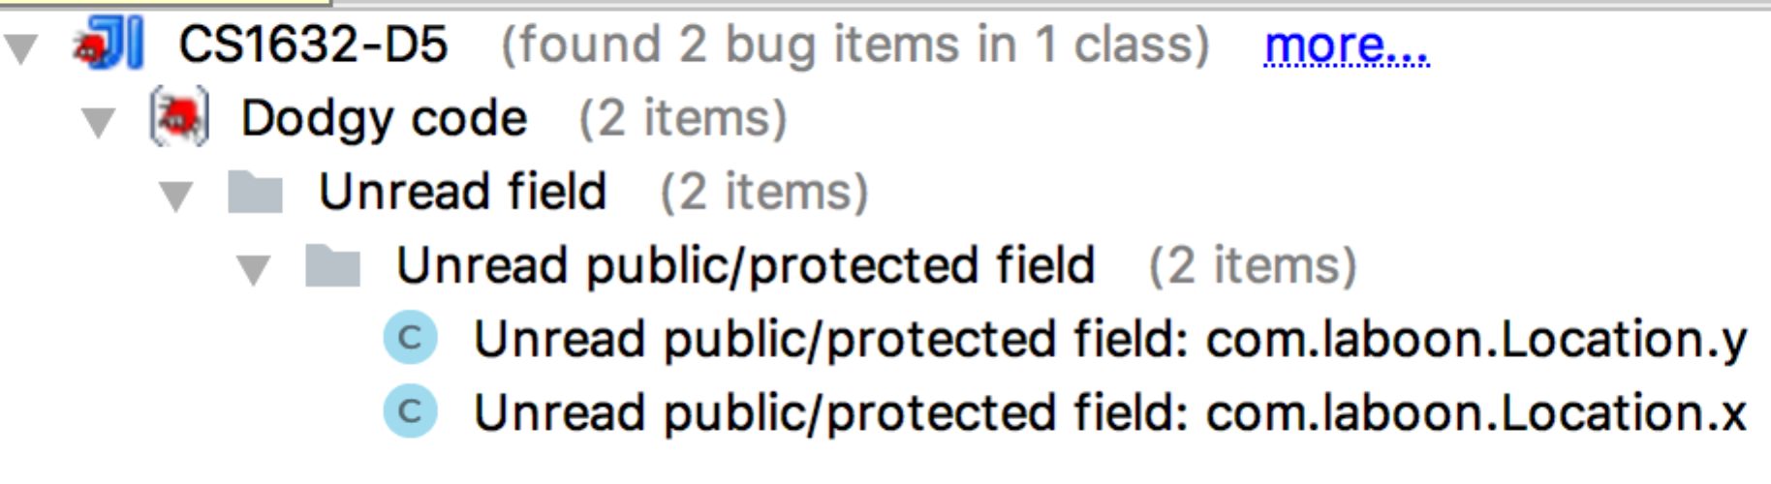

After:



MainWindow.java

Before & After:



MainPanel.java:

Before & After:



PinningTest.java

Before & After:



ProgramArea.java

Before:

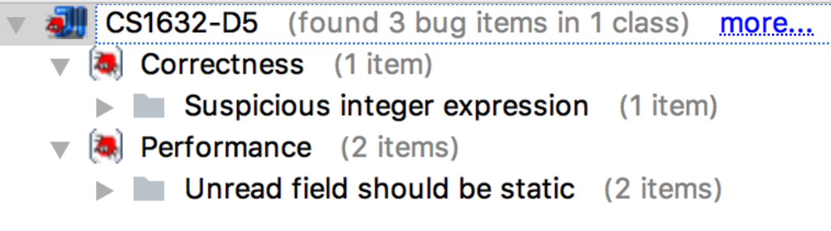

After:



ProgramExecutor.java

Before:

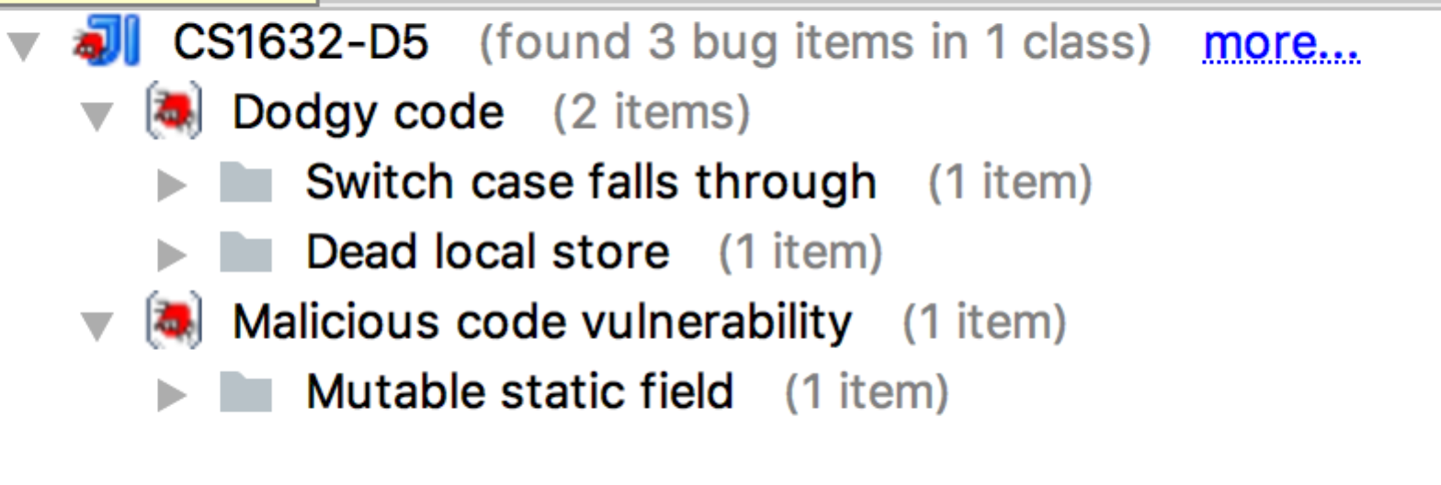

After:

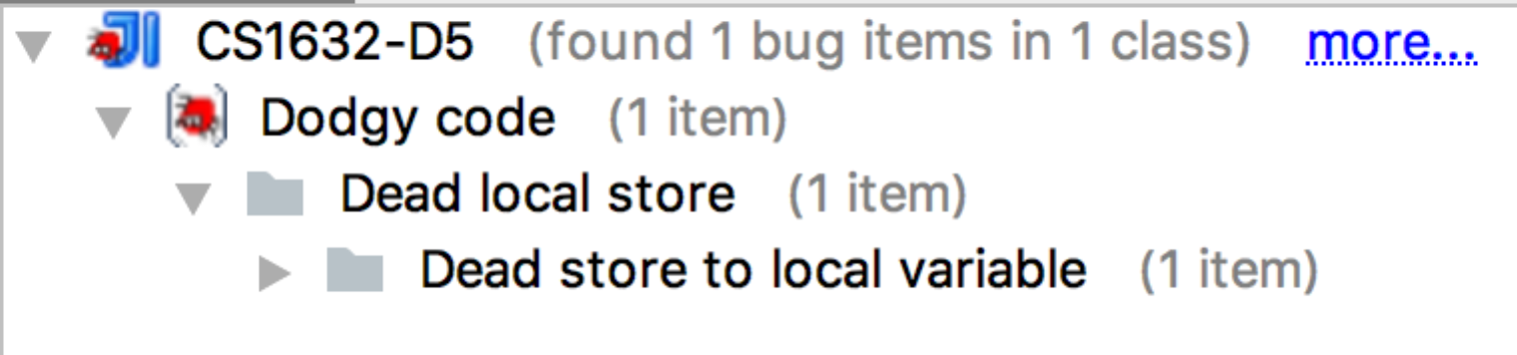

ProgramStack.java

Before:

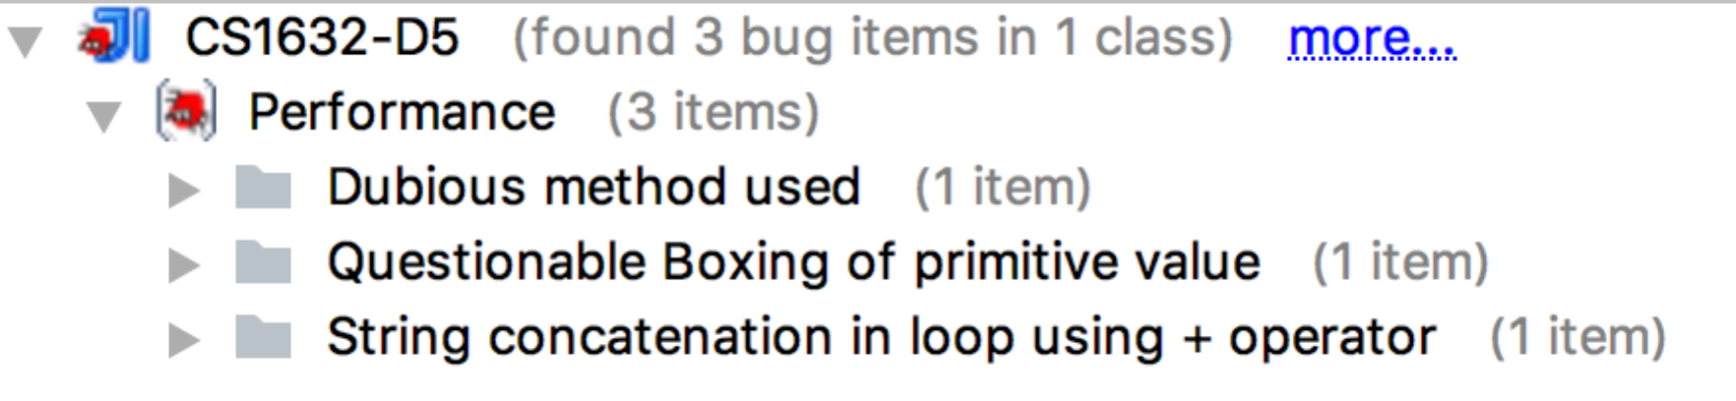

After:



RunButton.java

Before & After:



StepButton.java

Before:

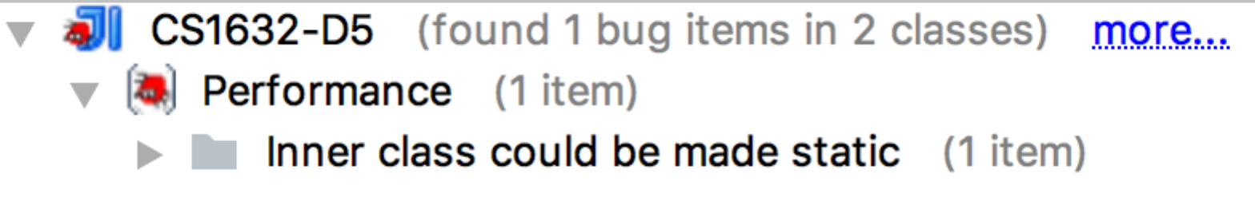

After:



Checkstyle Screenshots

Before:

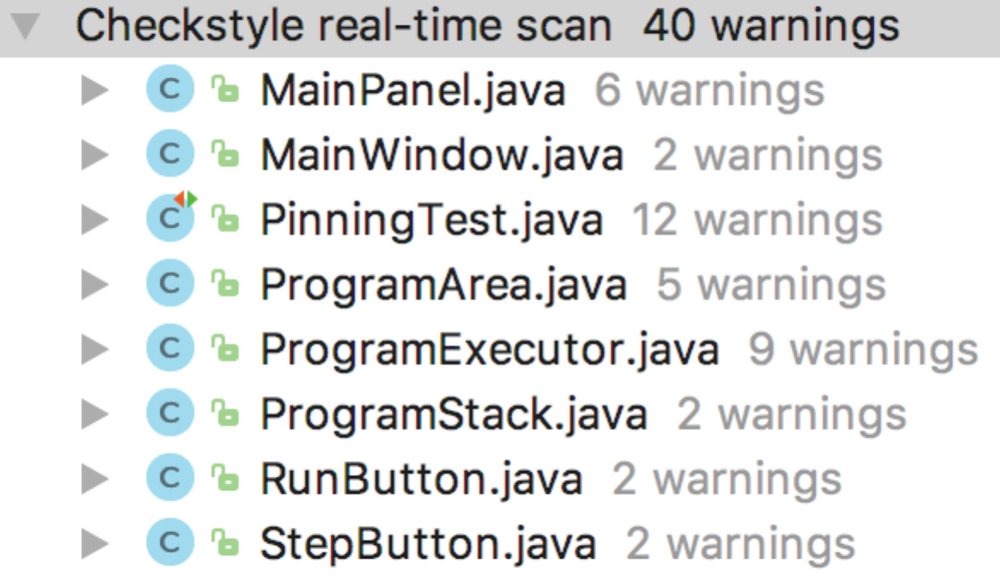

After:

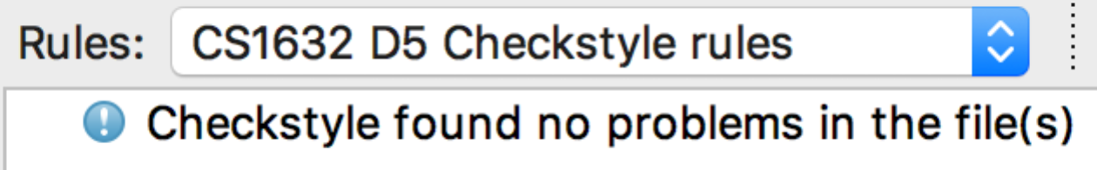

Check for Regression Errors

Findbugs:

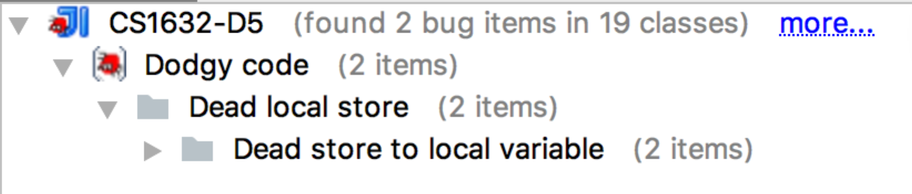

CheckStyle:

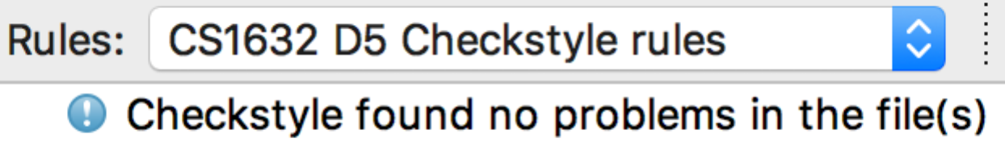

Test suite:

