**Remote Access Instructions**

6/13/2014

**Remote Access to Outlook—Portal.MicrosoftOnline.com**

1. Surf to http://portal.microsoftonline.com
2. Enter your email address and login password in the areas provided

**Remote Access to Network Resources via Remote Desktop Client Setup** (certain employees)

1. Put a shortcut to Remote Desktop Client (RDC) on your desktop.
   1. If you are a MAC client, you'll have to [download RDC from Microsoft](http://www.microsoft.com/en-us/download/details.aspx?id=18140).
   2. If you are a Windows client, navigate to Start | Programs | Accessories |right click on Remote Desktop Connection | Send To | Desktop (create shortcut)
2. Open the shortcut
3. Select the OPTIONS tab
4. Enter the computer address: **mail.essentialhospitals.org:xxxx** (where xxxx is your individual 4-digit key
5. Username: NAPH\{your username from work}
6. Select the DISPLAY tab and move the Remote Desktop Size slide bar all the way to the right (towards More)
7. Change COLORS to Highest Quality
8. The next time you open RDC it will remember the defaults you selected.

**Remote Access to Network Files via SSL VPN File Transfer (all staff)**

Transfer File From the Network to Your Remote Computer

1. 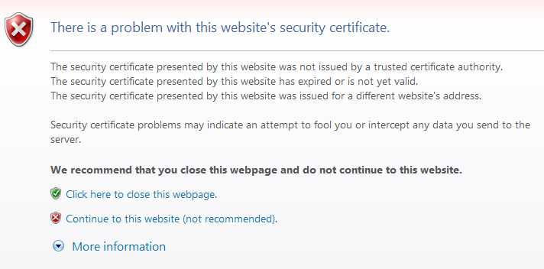Surf to: remote.naph.org (save this as a favorite and/or create a desktop shortcut)
2. The screen below appears. Select the CONTINUE TO THIS WEBSITE option.
3. Your username is your work login (i.e., mcampbell—not your email address). 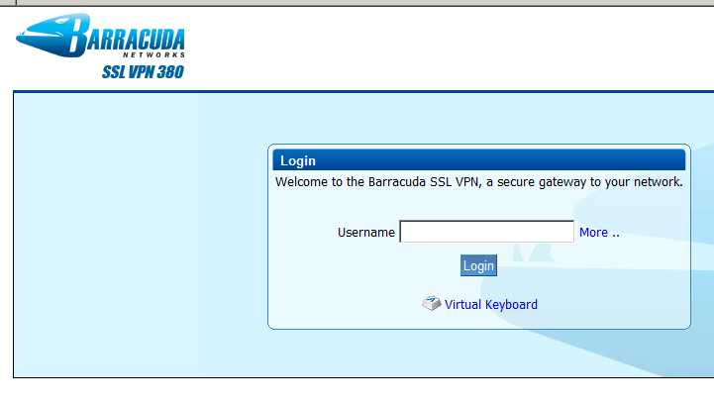
4. Your password is your regular login password. 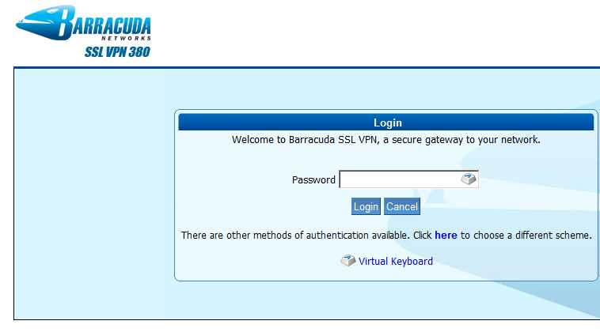
5. Select the RESOURCES tab to access network drives. 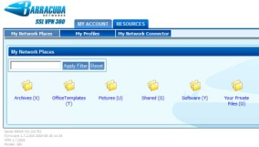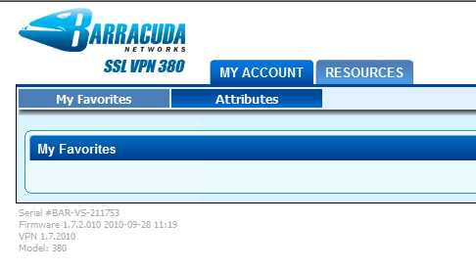
6. You may get a warning to enable pop-ups for this site. Select the option to always enable pop-ups for this site.
7. A window appears showing the directory files/folders. Navigate to the file you want and double click on it. You'll save that file to your remote computer. 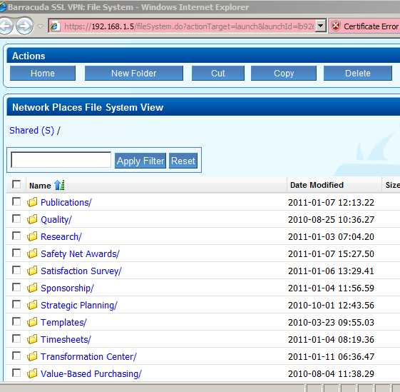
8. Use the programs on your remote computer to review/edit the file.

Transfer File From Your Remote Computer to the Network

1. Surf to: remote.naph.org (save this as a favorite and/or create a desktop shortcut)
2. The screen below appears. Select the CONTINUE TO THIS WEBSITE option.
3. Your username is your work login (i.e., mcampbell—not your email address). 
4. Your password is your regular login password. 
5. Select the RESOURCES tab to access network drives. 
6. You may get a warning to enable pop-ups for this site. Select the option to always enable pop-ups for this site.
7. A window appears showing the directory files/folders. Navigate to the folder where you want to put the file you're uploading. Select the UPLOAD FILES button under ACTIONS. Follow the prompts to upload your file.