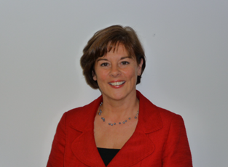

**Lynne Maher, PhD, MBA**Director of Innovation  
*Ko Awatea*

Associate Honorary Professor of Nursing

*The University of Auckland*

Lynne has had an extensive health care career ranging from critical care nursing, operational and board posts at local and national level during which she has been highly influential in creating significant improvement in health systems. Lynne has a wealth of experience in the development of models of care including patient and family experience, GP practice and ambulatory and emergency care. Her work has also resulted in the development of a number of products to support health care teams to better understand approaches for improvement and innovation including:

* **NHS Sustainability Model and Guide** - provides a diagnostic tool and guidance to increase the likelihood of sustainability of improvements for project teams.
* **Creating the Culture for Innovation** - a guide developed to support senior leaders to develop a culture for innovation within their organizations
* **Thinking Differently** - a book designed specifically for front line teams who want to achieve transformational change through creativity and innovation.
* **Experience Based Design** - an innovative method of co-designing health services with patients based upon their actual experience of the service provided.
* **Smart Guide to Developing Pathways** – Developing effective pathways by working with patients and family and co-designing care.
* **Productive General Practice** - A modular learning program that is being successfully used in general practice to improve local services for patients and families.
* **High Impact Changes for Nursing and Midwifery -** The Essential Collection of case studies illustrating high quality, cost effective care provided by NHS teams.

Lynne has previously worked in the NHS and has also supported health systems in Canada, Denmark, Norway, Saudi Arabia and America in their efforts to achieve innovation and improvement. Lynne teaches on the Kaiser Permanente Improvement Institute and is a Steering Board Member for the Commission for Hospital Improvements in Melbourne and an Advisory Board Member of the CORE Research Study, The Department of General Practice, The University of Melbourne.