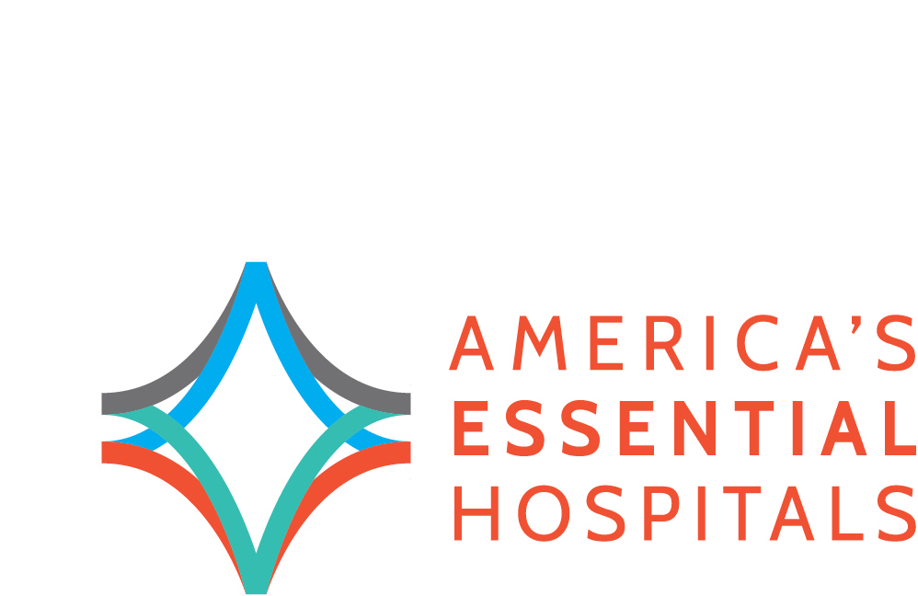

2015 fellows Program, Session I

Monday, June 22 – Friday, June 26, 2014

The Westin Gaslamp Quarter | San Diego

**Agenda**

Adaptive Leadership: Mobilizing for Change

Session Objective: Participants will strengthen the leadership skills needed to mobilize their organization to adapt and thrive in challenging environments.

|  |  |
| --- | --- |
| Monday, June 22 | The Westin Gaslamp Quarter and UCSD MEdical center | |
| 7:30 – 8 am | Breakfast (provided) |
| 8 - noon | Fellows-only session begins |
| noon – 12:45 pm | Lunch (provided) |
| 12:45 – 1:30 pm | Travel to UCSD Medical Center   * Bus will depart at 1 pm |
| 1:30 – 4:30 pm | Site Visit to UCSD Medical Center |
| 4:30 – 5 pm | Travel back to hotel |
| 6 pm | Networking Dinner (provided) |
| Tuesday, June 23 | The westin Gaslamp quarter | |
| 8 – 8:30 | Breakfast (provided) |
| 8:30 – 12:15 pm | Fellows Session |
| 12:15 – 1 pm | Lunch (provided) |
| 1 – 5 pm | Fellows Session |
| 5:30 – 7 pm | Reception |
| Wednesday, June 24 | The westin gaslamp quarter | |
| 8 – 8:30 am | Breakfast (provided) |
| 8:30 – noon | Fellows session |
| Noon – 1:30 pm | Working lunch (provided) |
| 1:30 pm | Fellows-Only Session Adjourned |
| 3:30 - 5pm | VITAL2015 Opening General Session |
| 5:30 - 7 pm | Opening reception |
| Thursday, June 25 | The westin gaslamp quarter | |
| 7 -8 am | Breakfast (provided) |
| 8 - 9 pm | Critical Conversations |
| 9-10:15 am | General Session |
| 10:15 - 10:45 am | Break |
| 10:45 am - Noon | Education Breakout Sessions |
| Noon – 2 pm | Gage Awards Luncheon |
| 2:15-2:45 pm | Mini-Sessions |
| 3 – 3:30 pm | Mini-Sessions |
| 3:30-4:15 pm | Poster Sessions |
| 4:15 – 4:45 pm | Rapid-Fire Presentations |
| 6:30 - 10 pm  USS Midway | VITAL2015 Celebration |
| Friday, June 26 | The Westin Gaslamp District | |
| 7-8 am | Breakfast (provided) |
| 8-9 am | Critical Conversations |
| 9 am – Noon | Closing General Session |

*PLEASE NOTE:*

*VITAL2015 Programming Begins on Wednesday, June 24 at 3:30 pm. Fellows are required to attend all general sessions, receptions, and specific breakout sessions that will be announced shortly. The complete Fellows session adjourns Friday, June 26 at noon. Please make plans accordingly.*