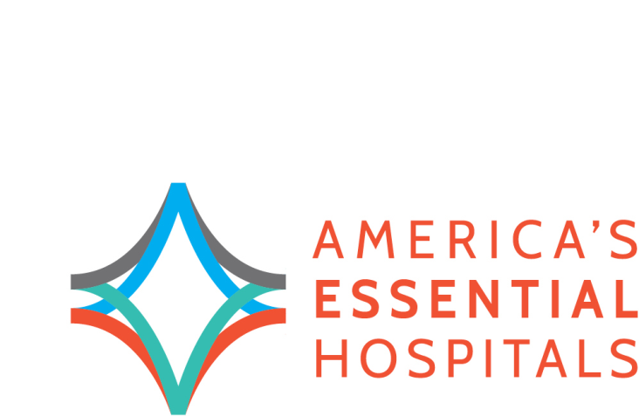May 1, 2015

The Honorable Joseph Crowley

1436 Longworth House Office Building

Washington, D.C. 20515

The Honorable Charles Boustany

1431 Longworth House Office Building

Washington, D.C. 20515

Dear Representatives Crowley and Boustany,

On behalf of America’s Essential Hospitals – the leading champion for hospitals and health systems dedicated to high-quality care for all, including the most vulnerable - I would like to extend our support for **H.R. 2124, the Resident Physician Reduction Shortage Act of 2015**.

America’s Essential Hospitals is committed to training the nation’s future health care leaders. In fiscal year 2013, our more than 250 member hospitals trained on average 254 physicians per hospital, which is 14 times as many as those trained at other U.S. teaching hospitals. Additionally, 41 percent of essential hospitals train 25 or more full-time residents above their graduate medical education (GME) caps, whereas only 11 percent of other teaching hospitals train 25 or more residents above their caps – this is indicative of the teaching commitment of essential hospitals.

Essential hospitals experience firsthand the difficulties associated with residency shortages as well as lack of funding for new residency slots. The Resident Physician Reduction Shortage Act seeks to eliminate the stress placed on essential hospitals which maintain a strong teaching commitment, despite funding shortfalls. This bill will increase residency slots by 15,000 over five years and requires that one-third of new slots be given only to hospitals that train residents above their GME caps. This legislation would make great strides in ensuring that the physician workforce continues to grow and teaching hospitals, particularly public and non-profit hospitals, are able to maintain their commitment to training the next generation of health care professionals.

Thank you for your leadership and ongoing support for hospitals. We look forward to working with you to move this legislation forward.

Sincerely,

Bruce Siegel, MD. MPH

President and CEO

America’s Essential Hospitals