Setting Up Serial Communication

* Connect Arduino to Raspberry Pi via usb cable provided with Arduino
* Run Raspberry pi
* Enable Serial and I2C in PiConfig

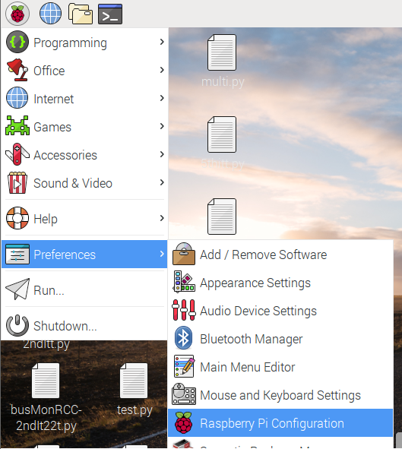

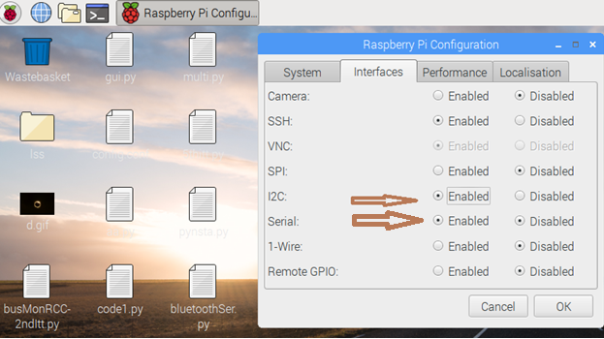

* Restart raspberry pi.
* Open Terminal and execute these commands:
* sudo apt-get install python-serial
* sudo pip install pyserial
* Connect Arduino to raspberry pi
* Execute
* ls /dev/tty\*
* and find line with /dev/ttyACM0 or something line /dev/ttyACM1 etc, check for ACM with any number 0,1,2 etc.

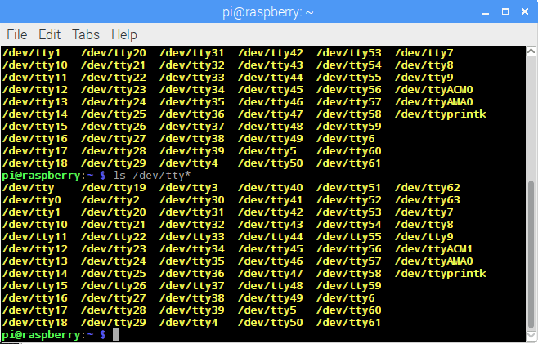

* Open python program and change ser=serial.Serial(“dev/ttyACM1”,9600) to the ACM number you found. Like if, in your case you got ACM0 then the line should look like ser=serial.Serial(“dev/ttyACM0”,9600)
* Now run the code using python 2.7