CP3566 — Lab 2: FakeStore
Deliverables — what to hand in and how to know you are done
Read this alongside LAB2.docx. It is the checklist for your submission and shows what a finished lab looks like.

1. What you hand in
Submit the whole project folder (leave out the target/ and data/ folders — both are rebuilt automatically). It must compile from clean and run.
- The five classes you implement (the only files you change):
- JdbcProductDao — findById, search, categories, reserve
- JdbcOrderDao — insert, findByNumber, findByIdempotencyKey
- JdbcUserDao — emailExists, insert
- StandardCheckoutService — reserveAndPrice, assemble
- StandardRegistrationService — validate
- ANSWERS.docx — the six written questions, completed (the questions are in Section 4).
- Your code compiles from clean: ./mvnw clean compile
- All tests pass: ./mvnw test → 15 / 15 green (Section 3).
- The oversell proof passes: ConcurrencyTest → 10 / 40 / final stock 0.
Do NOT change the abstract classes, the final service templates, the records, or the web/error classes. You may add your own helper classes or methods.
You are done when…
A good cart returns a priced order (server prices, 13% tax, total, an FS-… number); empty cart → 422, quantity 0 → 422, unknown id → 404, over-stock → 409; a rejected multi-line order leaves stock untouched; the order reads back; and registration works with a hashed password, rejecting duplicates (409) and bad input (422). The test suite checks all of this for you.

2. How it is graded
Area | Weight
Catalogue — search/filter/sort/paging in SQL, parameterised, 404 on missing | 20%
Order — validation, 422/404/409, server pricing, tax, totals, number, Location | 30%
Stock — no overselling, one transaction, rejected order leaks no stock | 20%
Registration — validation (422 with field messages), duplicate (409), hashed password | 15%
Code quality — patterns followed, structure respected, clear inline comments | 10%
Understanding — your written answers (ANSWERS.docx) | 5%

Understanding counts: a feature that works but you cannot explain does not get full marks; a small bug you clearly understand still earns most of them. Write enough inline comments that a reader follows your reasoning.

3. Check your work with the tests
Run the test suite continuously as you work (new to JUnit? read TESTING.docx):
./mvnw test
On the starter every test fails ("TODO: implement …"). As you implement each class, more turn green. Your goal is all 15 green. The 15 tests:
# | Test (what it checks) | Area
1 | findById returns a known product | Catalogue
2 | findById of a missing id returns empty | Catalogue
3 | categories are non-empty and alphabetical | Catalogue
4 | search filters by category and reports a total | Catalogue
5 | a good order is priced from the server with correct tax and total | Order
6 | the placed order can be read back | Order
7 | empty cart → 422 | Order
8 | quantity 0 → 422 | Order
9 | unknown product → 404 | Order
10 | not enough stock → 409, stock never oversold | Stock
11 | a rejected multi-line order leaks no stock | Stock
12 | same Idempotency-Key replays; a new key makes a new order | Order
13 | valid registration stores a HASH, never the plaintext | Registration
14 | registering the same email twice → 409 | Registration
15 | bad input → 422 with a message per field | Registration

This is the goal — every test green, BUILD SUCCESS:
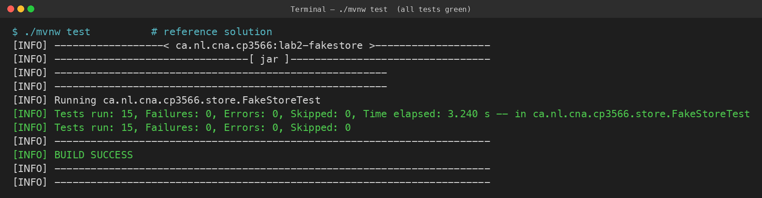
./mvnw test once your five classes are implemented

And the oversell proof (run it once your order path works):
./mvnw -q compile exec:java -Dexec.mainClass=ca.nl.cna.cp3566.store.ConcurrencyTest
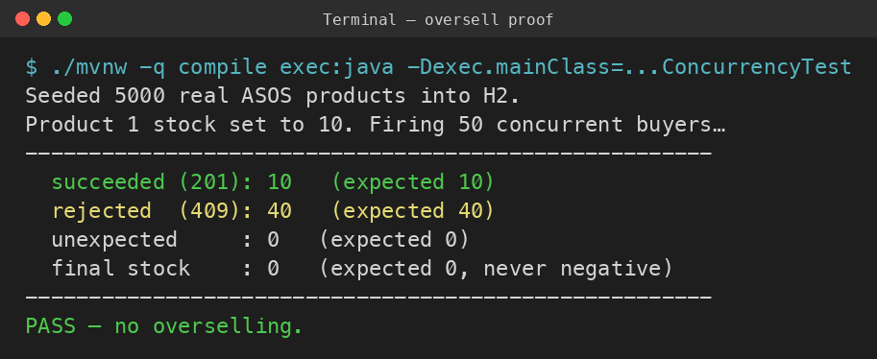
ConcurrencyTest — 50 buyers, 10 units, nobody oversold

4. Written questions
Answer each in a short paragraph, in your own words, in ANSWERS.docx. These are worth marks — a feature you cannot explain does not earn full marks.
Q1. Why are the prices on a placed order taken from the server’s product record (product.price()) rather than from the request body?
Your answer: ________________________________________________________________________________________________________________________________________
Q2. Your reserve() uses a single guarded UPDATE … SET stock = stock - ? WHERE id = ? AND stock >= ?. Why is that safe under many simultaneous buyers, and what would go wrong with a SELECT-then-check-then-UPDATE?
Your answer: ________________________________________________________________________________________________________________________________________
Q3. The whole order runs in one transaction. What does that transaction cover, and what would break if each line were committed separately?
Your answer: ________________________________________________________________________________________________________________________________________
Q4. Why does a duplicate registration return 409 while bad input returns 422 — what is the difference between those two situations?
Your answer: ________________________________________________________________________________________________________________________________________
Q5. Why is storing a plaintext password a problem even for a fake store, and what is the per-user salt in PasswordHash for?
Your answer: ________________________________________________________________________________________________________________________________________
Q6. (Architecture) Why are ProductDao / OrderDao / UserDao abstract, and what does the web layer gain by depending on them instead of on your Jdbc…Dao classes directly?
Your answer: ________________________________________________________________________________________________________________________________________

