

|  |
| --- |
| **Activity 2.2.4 Logic Converter** |

Introduction

Now that you are all experts at logic simplification using Boolean algebra and K-Mapping and can implement virtually any combinational design using AOI, NAND, and NOR gates, it’s time to let you in on a little secret. A tool located within the Multisim Circuit Design Software, called the *Logic Converter*, can do much of this work for you. You might be asking yourself why you weren’t given this tool sooner. As an engineer you need to know how to design these types of circuits with and without the aid of such tools. Besides, who do you think designs tools like the Logic Converter? That’s right, an engineer.

In this activity you will complete a brief tutorial and use the Logic Converter to create and simulate both an AOI and NAND circuit design.

Equipment

* Circuit Design Software (CDS)

Procedure

Multisim’s Logic Converter is not a real-world component but is a virtual tool that can be used to produce a logic circuit from an entered truth table or logic expression.

Though you will not be using it in this activity, the Logic Convertercan also be attached to a circuit to derive its equivalent truth table and logic expression.

The layout of the Logic Converter’s interface panel is shown below (next page).

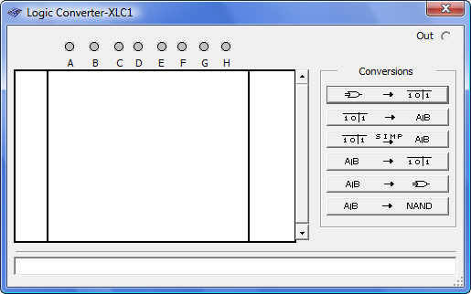

Inputs

Truth Table

Logic Expression

Converts a truth table into a simplified logic expression.

Converts a logic expression into a truth table.

Converts a logic expression into an AOI logic circuit.

Converts a logic expression into a NAND logic circuit.

Converts a truth table into an un-simplified logic expression.

Complete the following steps to learn the capabilities of the Logic Converter.

1. Start Multisim and click on the Logic Converter button in the instrument toolbar. Place the icon in the workspace and double-click the icon to open the instrument interface panel.
2. In the *Inputs* section of the Logic Converter, select input A, B, and C.
3. In the *Truth Table* area of Logic Converter, enter the truth table as shown below.

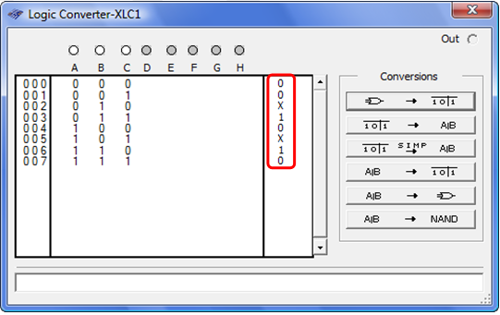

1. To generate the un-simplified logic expression, select the button. The logic expression will be displayed in the *Logic Expression* area of the Logic Converter as shown below.

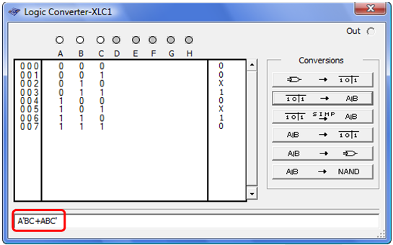

1. To generate the simplified logic expression, select the button. The logic expression will be displayed in the *Logic Expression* area of the Logic Converter as shown below.

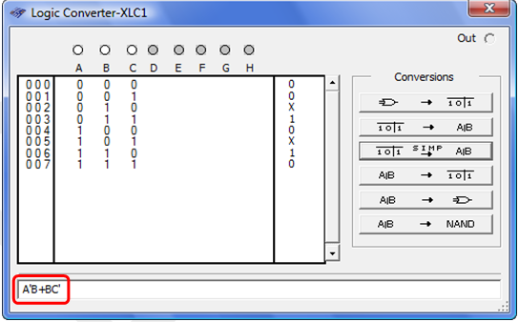

1. To generate the AOI logic circuit for this logic expression, select the button. The AOI logic circuit will be added to the drawing area of Multisim as shown below.

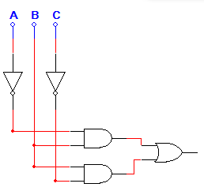

1. To generate the NAND logic circuit for this logic expression, select the button. The NAND logic circuit will be added to the drawing area of Multisim as shown below.

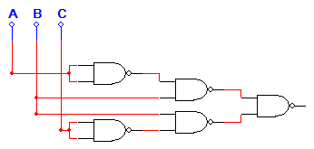

The truth table shown below is for the *Majority Vote – Voting Machine* project that you completed in the previous lesson. Let’s use the Logic Converter to create an AOI and NAND only logic circuit for this project.

|  |  |  |  |  |
| --- | --- | --- | --- | --- |
| P | V | S | T | Vote |
| 0 | 0 | 0 | 0 | 0 |
| 0 | 0 | 0 | 1 | 0 |
| 0 | 0 | 1 | 0 | 0 |
| 0 | 0 | 1 | 1 | 0 |
| 0 | 1 | 0 | 0 | 0 |
| 0 | 1 | 0 | 1 | 0 |
| 0 | 1 | 1 | 0 | 0 |
| 0 | 1 | 1 | 1 | 1 |
| 1 | 0 | 0 | 0 | 0 |
| 1 | 0 | 0 | 1 | 1 |
| 1 | 0 | 1 | 0 | 1 |
| 1 | 0 | 1 | 1 | 1 |
| 1 | 1 | 0 | 0 | 1 |
| 1 | 1 | 0 | 1 | 1 |
| 1 | 1 | 1 | 0 | 1 |
| 1 | 1 | 1 | 1 | 1 |

1. Enter the truth table for the *Majority Vote – Voting Machine* into the Logic Converter. Unfortunately, you can’t change the variable names in the Logic Converter*,* so variables ***P, V, S,*** and ***T*** will be represented by ***A, B, C,*** and ***D***.
2. Use the Logic Converter to first generate, and then simplify the logic expression for the output ***Vote***.
3. Use the Logic Converter to create the AOI logic implementation of the *Majority Vote – Voting Machine*. Use switches for the inputs ***A, B, C,*** and ***D*** (which you should now rename ***P, V, S,*** and ***T***)and a probe or LED circuit for the output ***Vote***. Verify that the circuit is working as expected. Print a copy of the circuit and attach it below.



Majority Vote – Logic Converter – AOI

1. Use the Logic Converter to create the NAND only logic implementation of the *Majority Vote – Voting Machine*. Use switches for the inputs ***A, B, C,*** and ***D*** (again, you should rename them ***P, V, S,*** and ***T***)and a probe or LED circuit for the output ***Vote***. Verify that the circuit is working as expected. Print a copy of the circuit and attach it below.



Majority Vote – Logic Converter – NAND Only

**Conclusion**

1. How did the AOI implementation of the *Majority Vote – Voting Machine* created by the *Logic Converter* compare to the design that you completed manually in the previous lesson?

It was pretty much the same, exept it was easier to make with the logic converter.

1. In terms of hardware efficiency, how does the NAND Only implementation compare to the AOI implementation?

The NAND only implementation uses less ICs compared to the different ICs needed on the AOI logic.

1. Though the logic converter is a very powerful tool, it does have some limitations. What are these limitations?

It cannot place the switches and the power source