

Activity 2.1.7 DeMorgan’s Theorems

Introduction
Despite all of the work done by George Boole, there was still more work to be done. Expanding on Boole’s studies, Augustus DeMorgan (1806-1871) developed two additional theorems that now bear his name. Without DeMorgan’s Theorems, the complete simplification of logic expression would not be possible.

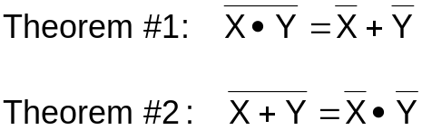

As we will seen in later activities, DeMorgan’s Theorems are the foundation for the NAND and NOR logic gates.

In this activity you will learn how to simplify logic expressions and digital logic circuits using DeMorgan’s two theorems along with the other laws of Boolean algebra.

Equipment
- Paper & Pencil

Procedure
Using DeMorgan’s theorems and the other theorems and laws of Boolean algebra, simplify the following logic expressions. Note the theorem/law used at each simplification step. Be sure to put your answer in Sum-Of-Products (SOP) form.
- 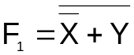
F= X*Y’
- 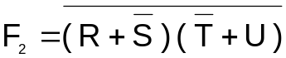
F= (R’+S)+(T+U’)
- 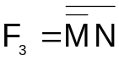
F= M*N’
- 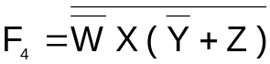
F= WX’+Y+Z’
- 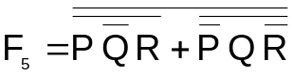
F= (P’+Q+R’)(P+Q’+R)
- 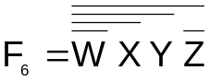
F= W+X’+Y’+Z

Let’s see how we would utilize DeMorgan’s theorems to simplify a digital logic circuit.
- Write the UN-SIMPLIFIED logic expression for the output Do-Nothing in the logic circuit shown below.
F=(X’+Y”)(Y’Z’”)+(Y’+X”)
The output is call Do-Nothing because that is exactly what the circuit does, nothing; yet it’s a good example for learning about DeMorgan’s theorems.
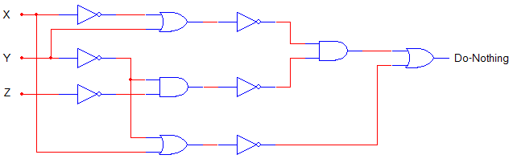

- Using DeMorgan’s theorems and the other theorems and laws of Boolean algebra, simplify the logic expression Do-Nothing. Be sure to put your answer in Sum-Of-Products (SOP) form.
F=X’+X’YZ’+Y’Z

- In the space provided, draw an AOI circuit that implements the simplified logic expression Do-Nothing. For this implementation you may assume that AND & OR gates are available with any number of inputs.
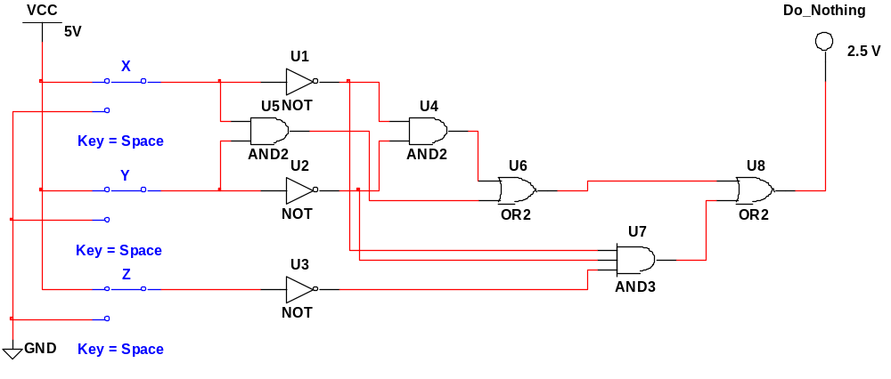

Do-Nothing – I
- Re-implement the circuit assuming that only 2-input AND gates (74LS08), 2-input OR gates (74LS32), and inverters (74LS04) are available. Draw this circuit in the space provided.
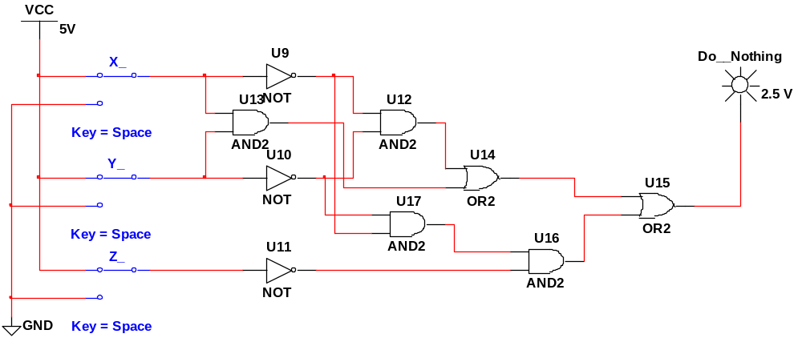

Do-Nothing – II

Conclusion
- Draw the gate equivalent for DeMorgan’s two theorems.
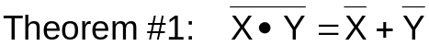
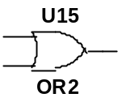

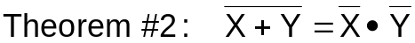
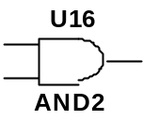

- How would you prove that the original Do-Nothing circuit and the simplified version are equivalent?
By making a truth table and comparing them.

- Your company was SO pleased with the money you saved them on the coffee vending machine project (last activity) that they’ve promoted you to VP of engineering and given you a raise to $100 per hour. Congratulations.
Your first decision as VP is to start manufacturing the simplified version of the Do-Nothing circuit. (Did we mention that the circuit doesn’t do anything?)
If each GATE cost 20¢ and you made 100,000 units, how much of the company’s money did you waste on your first project?
$20,000

Did you get fired?

Yea, probably so…

