**MODULE 3 ASSESSMENT**

**Name:** Josiah Joed G. Getes

**Course & Year:** BSCS – 1

* **Write a code that would determine the count and sum of the prime numbers within a particular range positive. In which it would require the use of the following functions:**
  + bool isPrime (int x) // this function would determine if integer x is prime or not. Return 1 if x is prime 0 if otherwise
  + int countPrimeInRange (int start, int end) // count the primes in range by using the isPrime (int x) function
  + 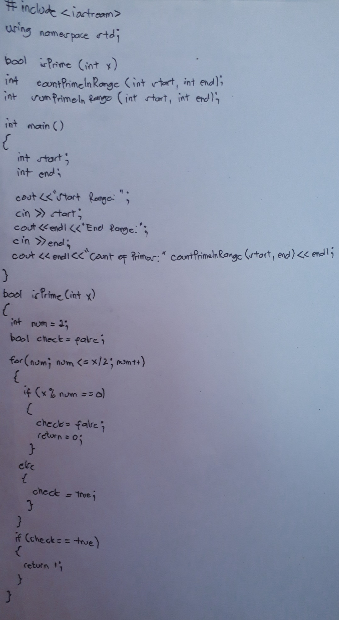int sumPrimeInRange (int start, int end) // find the sum of primes in range by using the isPrime (int x) function

