**LAB EXERCISE #2**

**Name:** Josiah Joed G. Getes

**Course & Year:** BSCS – 1

**Objectives:** To create a branching and looping flowchart for specified problem

To convert the flowchart to C++ code using the if-else and while statement in C++ then test it on a C++ compiler.

**Materials:** Pen, Paper, C++ compiler (MinGW using Code::Blocks IDE)

**Procedure:**

1. Conceptualize a flowchart that would compute and display the sum of factors of 5 or 7 below 100.

2. Convert the flowchart into a C++ code by systematically translating each symbol of process, condition etc. to one line of statement.

3. Copy the code that you’ve written into the Code::Blocks IDE then compile it. It may be necessary to debug for some syntax error.

4. If there are some syntax or semantic error(s) of your code, update your flowchart first then reflect it to your final code.

**FLOWCHART**

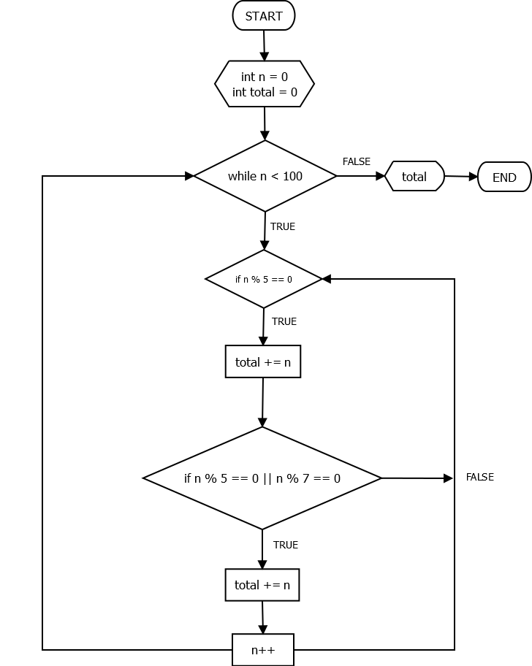

**CODE**

