**LAB EXERCISE #1**

**Name:** Josiah Joed G. Getes

**Course & Year:** BSCS – 1

**Objectives:** To identify the needed input and output of the given problem

To construct a step-by-step procedure to accomplish the required process visualized through flowcharting

**Materials:** Pen and paper

**Procedure:**

1. Examine the problems that are written on the problems section of this exercise.

2. Determine the input and output of the problems.

3. Analyze the step-by-step procedure in order to realize the required process.

4. Draw a flowchart out of the step-by-step procedure that you’ve realized. When doing a repetition structure, the condition that would enable the loop to continue must always follow the true path.

5. You may simulate your flowchart by manually placing initial values on your variables.

**Problems:**

1. Display the numerical equivalent of the grade equivalence table shown below

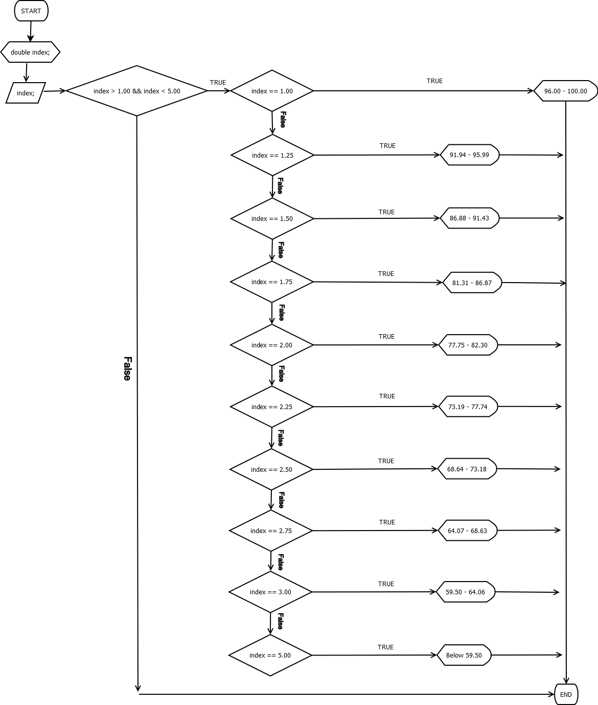

1. Count how many ***even numbers*** from *n* number of inputs.

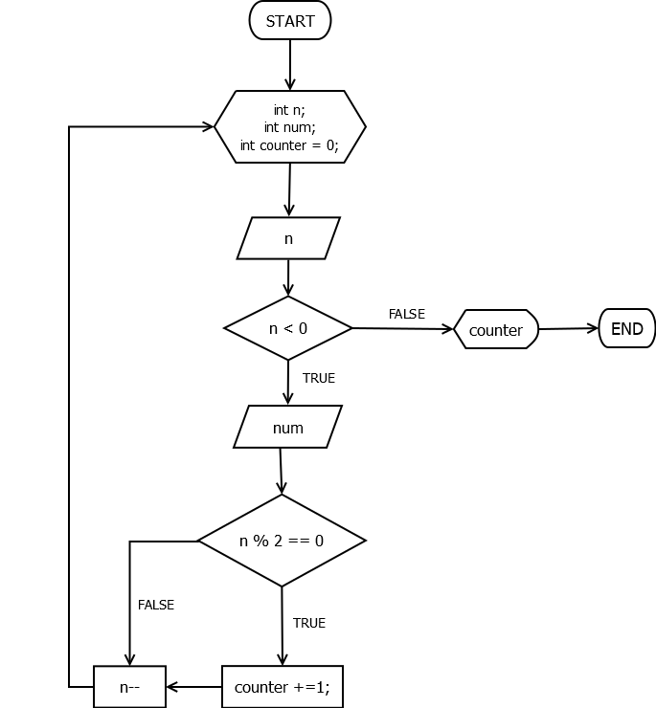

1. Determine which number has the ***most*** factors from a range of positive input. If more than one number has the most factor, display only one.

