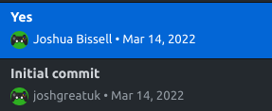
Project Oasis Log Notes

1:
- Project Setup
- Character movement
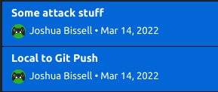
2:
- Attack system
- Health bars
- Damage popups


3:
- Basic enemys
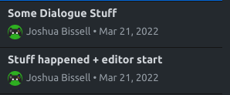
- Finished attack system

4:
- Player Interaction
- Start of dialogue system backend

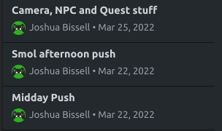
5:
- New attacks to test the system
- Quest system
- Save manager notes
- Test Quests
- NPCs, camera zooming to them

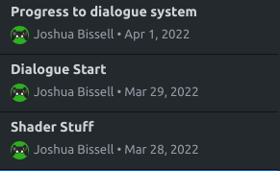
6:
- Reubens cool model
- Shader stuff, toon shaders
- Debug messages
- Dialogue system start
- Desert stalker walk cycle

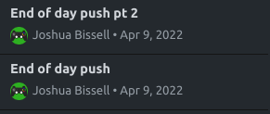
7:
- Naughty attributes
- Test dialogue
- Dialogue system complete
- Mini quest log

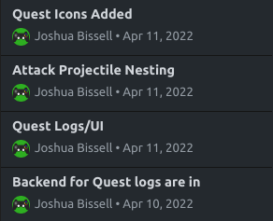
8:
- Full quest log ui
- Quest log code

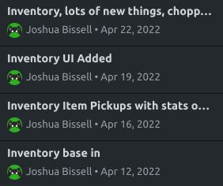
9:
- Inventory
- Item pickups
- Item Drops

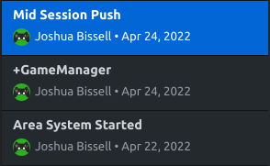
10:
- Area system
- Moved player to its own scene
- Main Menu
- Alpha levels
- Quest board

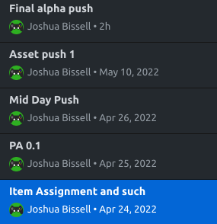
11:
- Item assignment
- Damage upgrade NPC
- Alpha level content, quests and dialogue
- Terrain was untextured, fixed
- Alpha 1

