Read Across America Week

March 3-7

Monday, March 3: *The Cat in the Hat* day! 

\*Students may wear a hat to school with their school uniform.\*

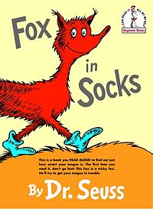Tuesday, March 4: *Fox in Socks* day!

\*Students may wear crazy socks with their uniform.\*

Wednesday, March 5: *Wacky Wednesday*! 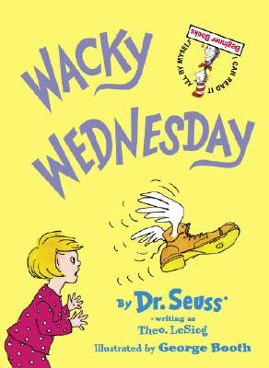

\*Students can dress wacky and have crazy hair!\*

 Thursday, March 6: *Oh, the Places You’ll Go!* day

\*Students may wear something that shows what they want to be when they grow up.\*

Friday, March 7: *The Sleep Book* day! 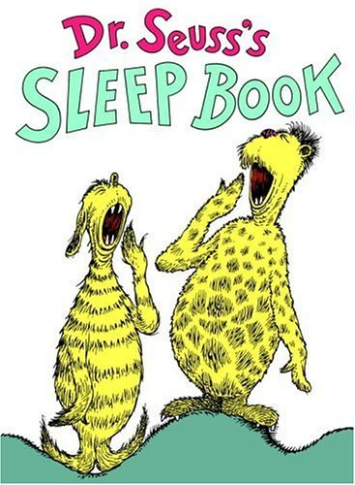

\*Students may wear pajamas to school!\*