**MIS 301 Group 11 Final Report**

1. ***Summary and Findings in Phase 3***

In phase 3, we found various different relationships through our data. For total cost, we found that scenario 80 had the greatest total cost, exceeding $7500. The scenario with the lowest total cost was scenario 82, hovering around the $3500 mark. There seem to be several possible causes for these large discrepancies within the data. Firstly, overutilized warehouses led to inefficiencies while properly managed or underutilized warehouses spread costs over smaller volumes, thus decreasing total costs. For example, in the largest scenario previously mentioned, scenario 80 had a mild capacity utilization of 74% for warehouse 1, an average utilization of 60% for warehouse 2, but a staggering 100% capacity utilization for warehouse 3. Compared to scenario 82, the scenario with the lowest total cost, both warehouses 1 and 3 have a capacity utilization of 42, and warehouse 2 has a capacity utilization of 89%. We see this trend amongst other scenarios as well and believe that better capacity utilization could remedy high cost. Cost variance did not seem to make a significant statistical difference in our data, however, when looking at total cost. For example, scenario 31 has a high-cost variance of 7.3 and a total cost of just over 5,500 yet scenario 14, with a very low-cost variance of 4, has a total cost of just under 5,500. Each store and scenario also followed a unique path with warehouse use, as there was not one warehouse that the stores relied on. Finally, we found that additional demand has a slight correlation with total cost, likely due to increased shipping quantities. However, not every scenario with a higher demand is bound to have higher total costs. It seems that higher demand coupled with poor capacity utilization is the biggest cause of inefficiencies, therefore increasing total costs.

1. ***Methodology and Results***

We used Tableau to capture images of our datasets made in Excel. Through each comparison that we made, our goal was to make a clear and concise chart that would explain our data in a simple way. For our first section, we used a horizontal bar chart to depict the difference in total cost between each transportation scenario. The horizontal bar chart gave us a clear image of which scenario was most expensive, and we were also able to see which scenario was least expensive. The results of this were scenario 80 being the most expensive and scenario 82 being the least expensive. Through this, we can see which scenario would hurt or help a business the most.

The second system we used to make our data clearer and more concise was another horizontal bar chart. In this chart, we wanted to look further into which warehouse was utilizing their capacity at the best percentage across all scenarios. To do this, we found the capacity utilization for each warehouse in each scenario and then did the average of each warehouse. When we placed these averages into Tableau, we were able to clearly see that Warehouse 1 had the highest capacity utilization, while Warehouse 3 had the lowest capacity utilization. The horizontal bar chart depicted this in a simple and easily digestible format for us to understand and explain.

For the third method we used more horizontal bar charts, but this time we had four different graphs of bar charts to help the reader understand our data a bit better. Our methodology for this was to insert our data from excel, which was gathered through VBA into a Tableau file. The data that we used was based on how many times each warehouse brought items to a certain store. In the data that we have presented, it is clear to see that for Store 1, Warehouse 3 made deliveries the most. We then see that for Stores 2, 3, and 4 Warehouse 2 made the most deliveries. This showed us that Warehouse 2 was most likely running the best system since they are getting the most business.

For our fourth chart, we used a scatter plot to show our findings. On our X-axis we had the total cost, and we place cost variance on our Y-axis. This gave us a clear relationship between our cost variance compared to our actual physical costs. By importing our cost variance and cost data directly from Excel to Tableau, we were able to make a direct connection between the two. What we were able to find was that as cost increased, cost variance also increased. This relationship did not have many outliers, and the scatter plot made it easy for us to see when different parts got bunched up together.

For our fifth chart, we wanted to add some additional insight that we found. The additional insight that we added was based on our data from our excel sheet, which was then put into Tableau. The data that we were looking to find was the connection between total cost and total demand. We used a scatterplot chart so that we were able to see where scenario was placed on the table compared to the other scenarios. What we found was that as demand increased, costs also increased. This makes sense as something needed more can be worth more to all the stores.

1. ***Relationship we aimed to capture for each task***

We aimed to capture different relationships for each task that we talked about in the previous step. These relationships that we aimed to capture were much easier to find once we placed our database into Tableau.

The first relationship we aimed to capture was the total cost for each scenario. This was done by using a bar chart to see which bar was the highest and lowest throughout it. This gave us an answer as to what was the highest and lowest cost among all the scenarios.

The second relationship we aimed to find was how each warehouse utilized the capacity they were able to have. We did this by using horizontal bar charts and putting the average of all scenarios together. We separated each warehouse by their averages and were able to see that warehouse 1 utilized their capacity the best, followed by 2 and 3. This gave us some insight into how efficient each warehouse is, and how 2 and 3 should increase their utilization.

The third relationship that we aimed to find was which warehouses typically serve which stores. There are four stores and three warehouses, so we decided to break this into four charts to see the results for each store. The relationship we were aiming to find was which warehouses served which store the most. The horizontal bar chart showed us these relationships well.

The fourth relationship we aimed to find was between transportation costs and cost variance. The relationship we found here was that as transportation costs increase, cost variance also increases.

The fifth relationship we aimed to find was how total demand impacted total cost. What we learned here was that as total demand increased, total cost also did.

Meaning of each visualization

Part 1: Meaning: Through our first visual we were trying to see the differences between each scenario when it came to total cost. For this we graphed the total cost across the X-Axis and which scenario it was along the Y-Axis. Since we were using a Horizontal Bar Chart, this allowed us to see which scenario cost the most, which was the meaning of our graph.

Part 2: Meaning: Our second visual was to show the capacity utilization for each warehouse. The meaning of this is that while warehouses have a certain amount of capacity for products, some are only using parts of it. The more you can fully utilize the space, the better your business will be. Since we found that Warehouse one had the best capacity utilization among all of the warehouses, we would say that this warehouse is utilizing the space it has best.

Part 3:

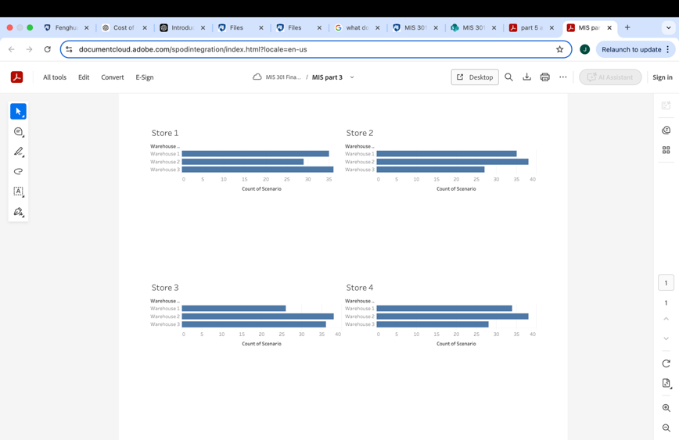

Meaning: Through this visual, we tried to understand which warehouse typically serves each store. For this, we graphed the number of scenarios on the x-axis and the warehouse that served the different scenarios on the y-axis. We repeated this step for each store and tried to observe the trends. As we can observe, all three stores have different patterns which means there is not a single warehouse that mostly serves all the stores. However, we can notice that warehouse 2 does play a crucial role in meeting the store's needs for store 1, warehouse 3 serves the greatest number of scenarios and warehouse 2 the least. On the other hand, for other stores including stores 2,3 and 4 warehouse 2 supplies the greatest number of products, indicating the heavy reliance on it.

Part 4:

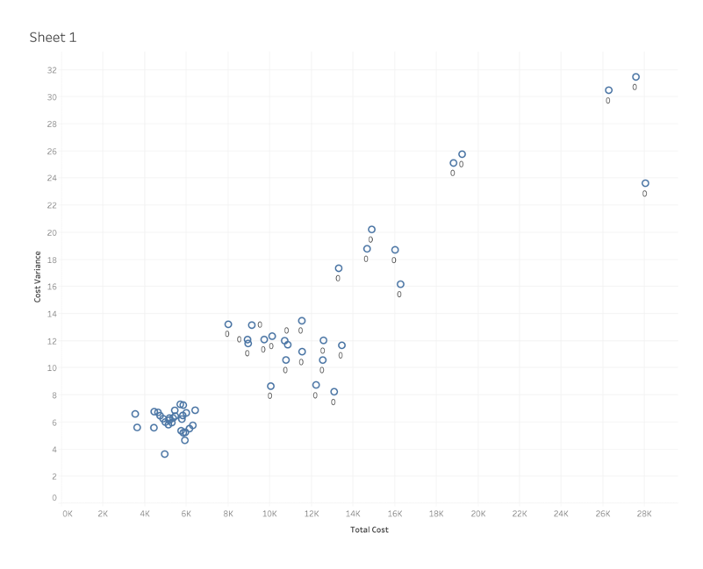

This graph illustrates the relationship between transportation costs, demand variance, and individual cost variance. It shows that an increase in demand variance will lead to higher individual cost variance, and also higher overall transportation costs. This could possibly occur because an element of variability and changes in planning can make it more complicated, leading to possible inefficiencies such as capacity that is not utilized to its fullest or having a higher reliance on flexible but more costly transportation options.

From the graph, you can see that as demand variance increases, transportation costs will also likely increase. This could happen as companies respond to different, varying, up and down demands and have to utilize different shipping methods such as expedited, varied shipping sizes, or more frequent shipping.

The linear trends on the graph do imply a directly proportional relationship. There is also an area along this linear trend around the 4-6k total cost and 4-8k cost variance range that is a close cluster. There are a comparable number of data points within this range as compared to the rest of the chart. This could indicate that after this range, there is a sort of plateau effect where companies adopt standardized processes that can more readily handle unexpected changes without excesses or extremely high additional costs incurred.

Part 5:

Meaning: The above scatter plot captures the relationship between Total Demand (x-axis) and Total Transportation cost (Y-axis) across all scenarios. The x-axis represents the total demand from all stores in each scenario and the y-axis the total cost incurred for transporting goods from warehouses to stores. As evident, there is a positive correlation between both the variables- as the demand increases, the total transportation cost rises. In other words, higher demand leads to higher demand, likely due to increased shipping quantities. However, we can also observe there are some outliers, indicating scenarios with unusually high costs for a given demand. For instance, we can see a few scenarios having a similar demand level to others but still having a slightly higher transportation cost than the similar scenarios. This could be due to inefficiencies such as suboptimal warehouse utilization.

Business Recommendations:

Recommendation 1: As mentioned, the three stores ( 2, 3 & 4) are mostly reliant on warehouse 2 for their supplies. This helps with better inventory management and streamline the operations, ensuring better control over stocks. But this possesses a business risk as any issues at the warehouse, including system failures, or natural disaster could disrupt the supply chain for these stores. To mitigate this risk, we recommend to reevaluate demand patterns and redistributing inventory to the other two warehouses. The steps will be helpful in case of any issues with warehouse 2 and ensure a continuous flow of supplies. Furthermore, considering the huge volume of trade from warehouse 2, the company should invest in more advanced machinery and tools to optimize the warehouse utilization and meet the demand more efficiently

Recommendation 2: As higher demand drives higher costs, the company should focus on optimizing transportation routes and warehouses for scenarios with higher demands. Moreover, the company should investigate scenarios where costs are unexpectedly high for a given demand level and do a root cause analysis for those cases. Some strategies to mitigate this introducing group shipments to reduce the number of transportation trips for stores located near each other. Additionally, for stores with high demand, the company should pre-position inventory closer to high-demand seasons in order to save costs and fulfil the order requirements efficiently.

Recommendation 3: The visual analysis also reveal that some warehouses are consistently being overutilized whereas others remain underutilized. The company should bring strategic changes in their planning, shifting fulfillment responsibilities to underutilized warehouses and ensure even distribution of workload. This could also be achieved by implementing cross-warehouse collaboration where orders are automatically transferred between warehouses based on the demand requirements from each warehouse.

***Appendices***

***Phase 3 visuals:***

***Part 1-***

***Part 2-***

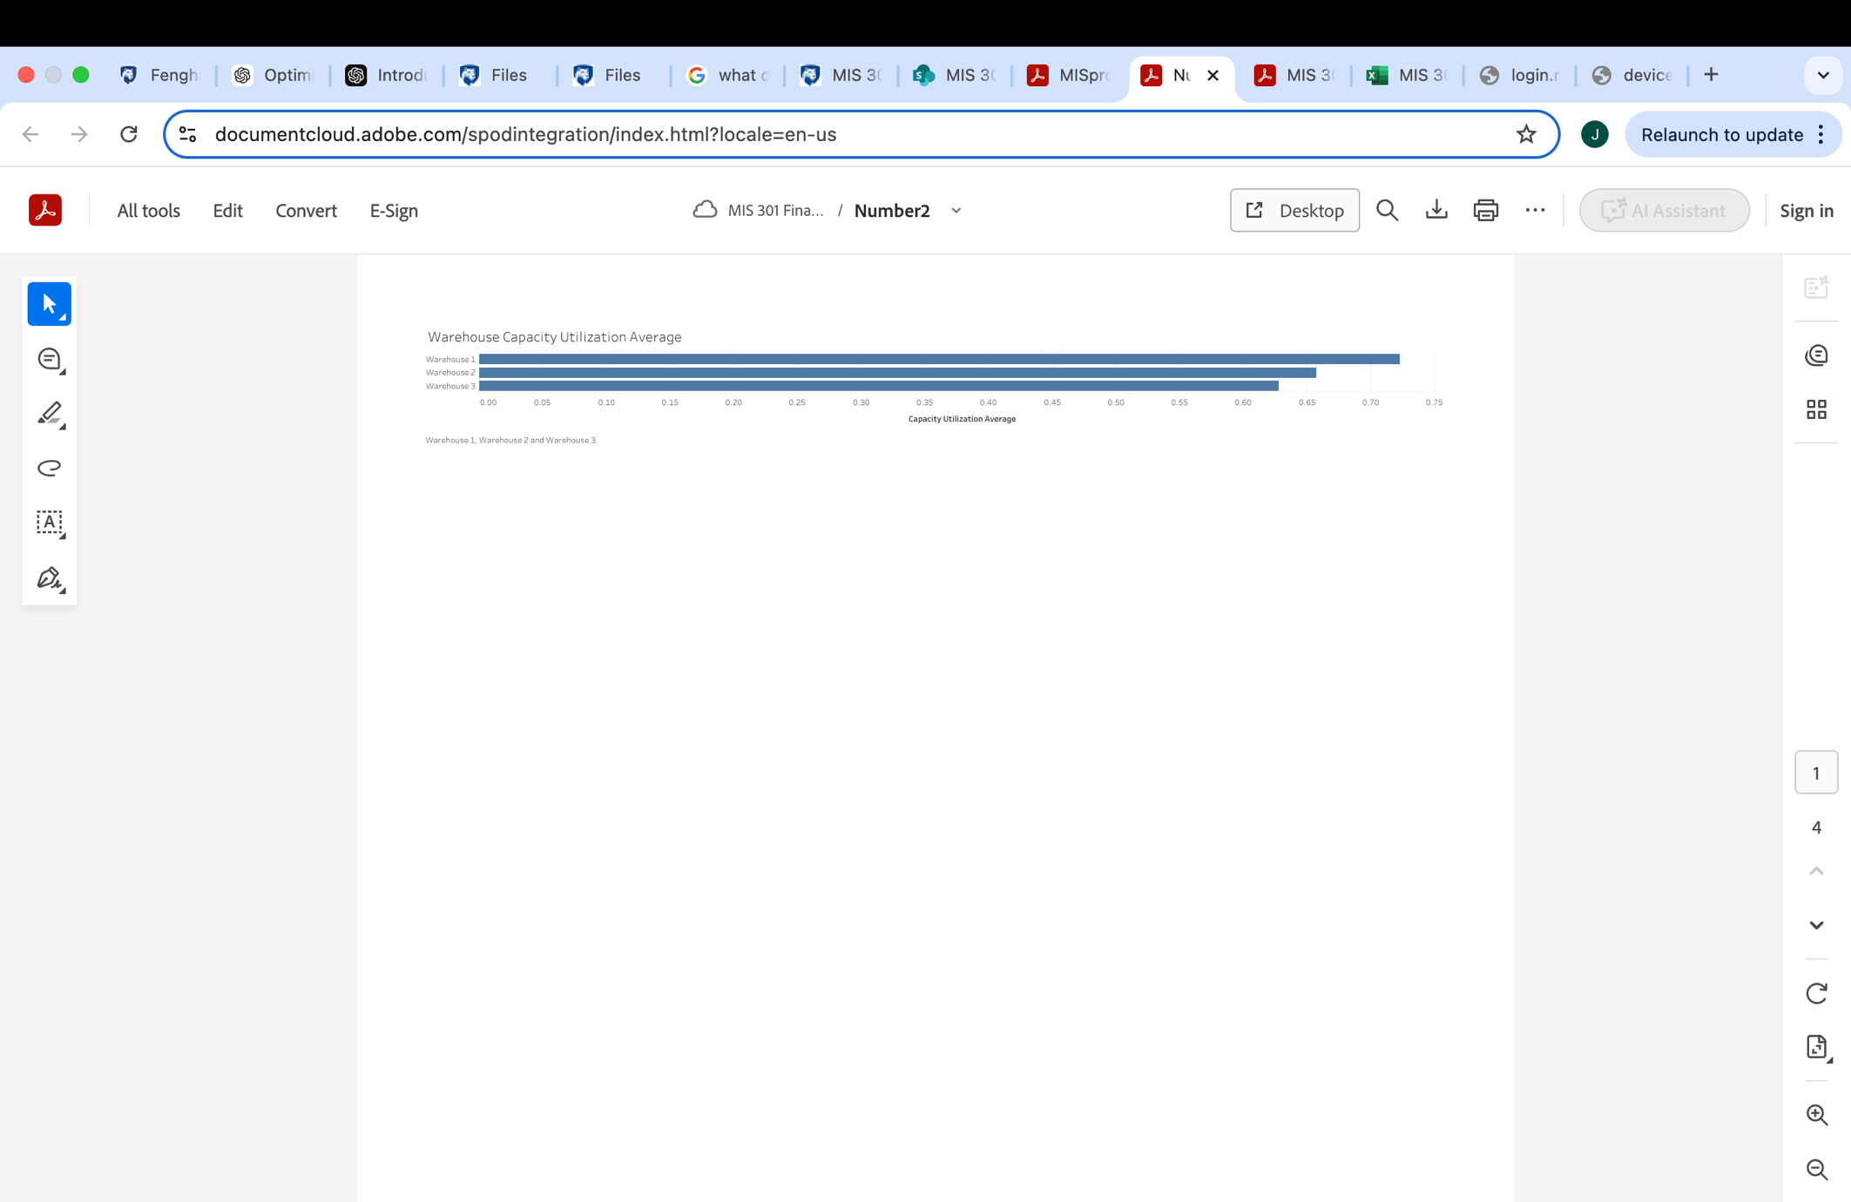

***Part 3-***

***Part 4-***

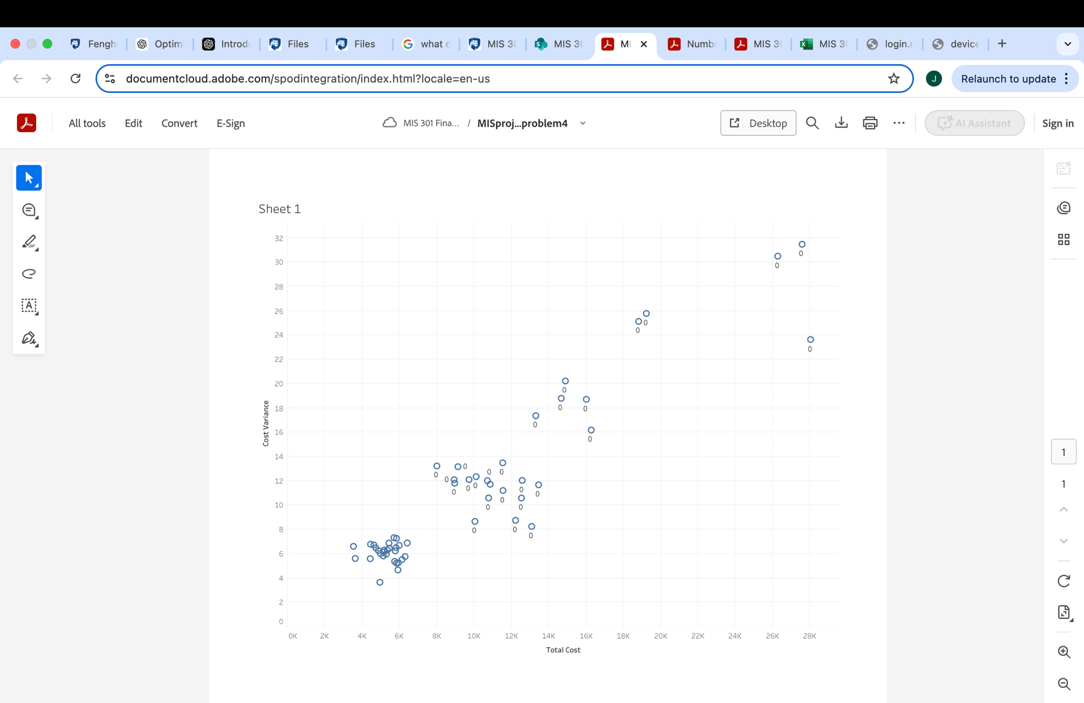

***Part 5-***

