Character & Set Design: Design Report

For the first assessment of COMS31000 we were tasked with designing an Olympoid within Maya. The brief was to use a wide range of techniques to produce a robot that could compete in the 2020 Olympic games. This will give us the experience of producing a character through the whole pipeline from concept all the way to lighting which will be covered more in the second assessment. We should model components from real reference objects and demonstrate our understanding of a wide range of techniques.

1. Pre-Production and Planning

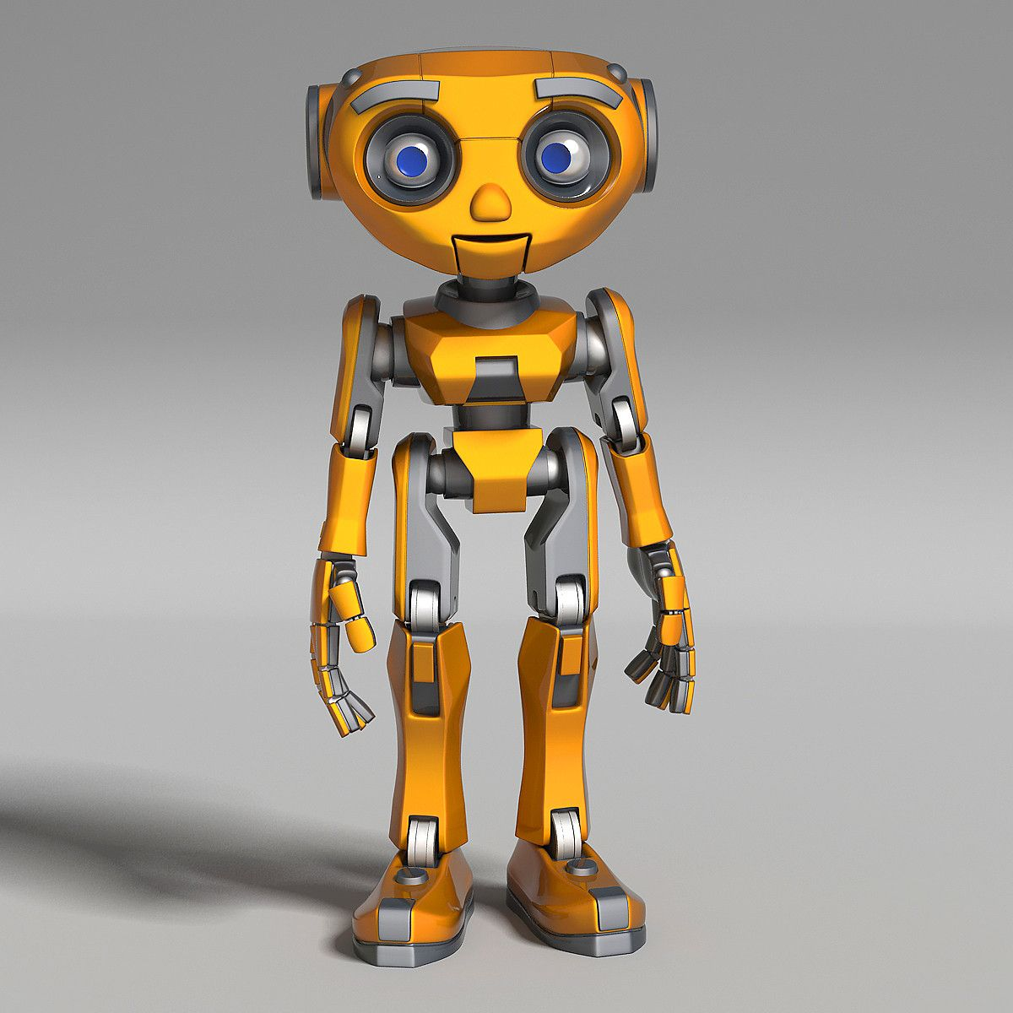

I started from where I know best, and that’s research. I initially looked up different types of robots which gave me an idea of complexity that I would have to undergo. There are a wide variety of styles that I found, and at this point I decided I would have to make a choice of what sport my robot could compete in. My initial thoughts were to make a humanoid style robot with a torso and limbs – as seen on the image to the right - however I felt this was not original enough. My favourite form of exercise is cycling, and with there being multiple events in the Olympics around this I thought that it would be an ideal choice.

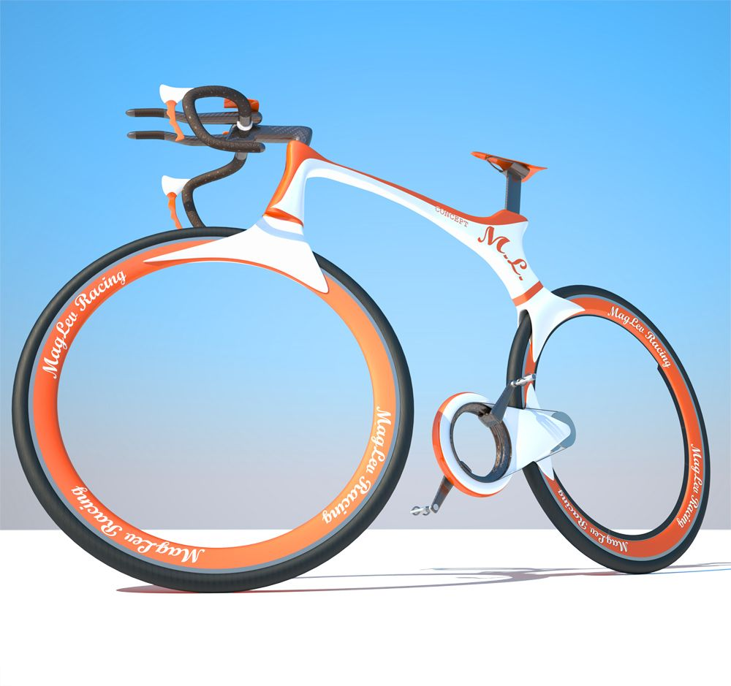So how am I going to build a bike robot? Am I going to have to design both the cyclist and the bike? Or could the bike be the robot? I feel that if bikes were to be controlled by a robot, it would only cause extra work for the teams as two products would have to be built. My initial research started with looking at modern bikes. This gave me inspiration to styles that I could use. One feature which intrigued me on the bike to the left was the empty tyres. These give a very futuristic look to the bike, and I feel that this would suit the “Olympoid” theme. I will take note of this style and try to incorporate it into my design.

The next avenue of research I went down was that of robot bikes. There seemed to be a small collection online that seemed relevant to my style, which backed up the originality of my concept. Many bikes that I found needed a driver, so I used a lot of these styles for my own design, but it meant that I could remove certain aspects that were not necessary with no driver.

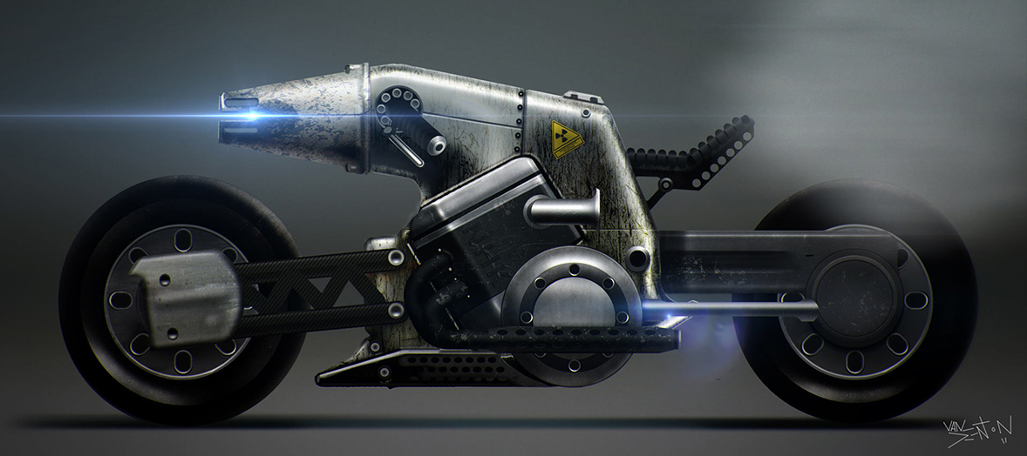Paul Denton, the designer, has a collection of motorbike designs that incorporate a modern look that could almost be considered robotic. I used a lot of his ideas to create my own concept. One of his designs in the collection can be seen to the right. In this image I extremely like the shape of the body. The smooth yet almost rigid shape contrast well with each other. The tapered light at the front is a nice feature.

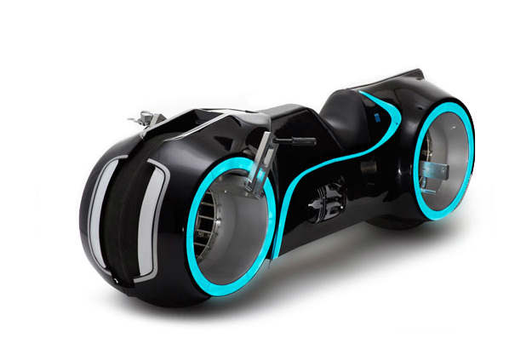

The final inspiration that I drew from my research was the Tron Bike. I have always liked smooth lines with the lights that contrast the black background. I may try to incorporate the curved lines running through the body, and in the future part of this project, may try to illuminate it. The lights that surround the wheels also add to the futuristic style.

Due to my broken arm I was unable to draw any sketches of my initial ideas. However, I did use some small drawings in the designing stage to trace over in Maya. The takeaway points from the research are as follows:

* Design a robot that is in itself a bike. No rider needed.
* Due to no rider being needed, certain aspects can be lost, such as handlebars and pedals.
* Keep in touch to the futuristic design of the bikes above.
* Smooth curves on a rigid body add to the modern style.
* The wheels can be hollow, and no gears are required.

1. Techniques and Surfaces

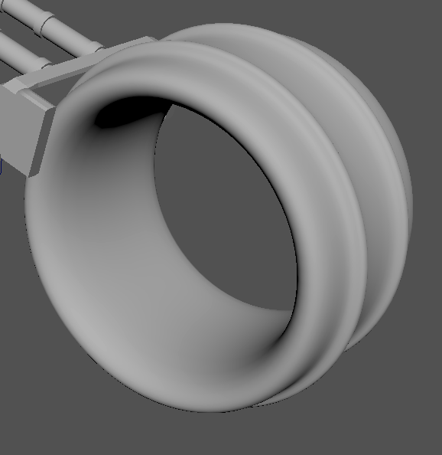

The starting point for this project was the wheels. I felt that they were a fundamental part of the design and could adjust the rest of the project around the outcome of them. They were not too difficult to make. By creating a polygon pipe in the rough size that was desired I then went forward with adding subdivisions and inserting edge loops onto the outer faces. From here I extruded the specific areas required. This can be seen on the outside of the tyre.

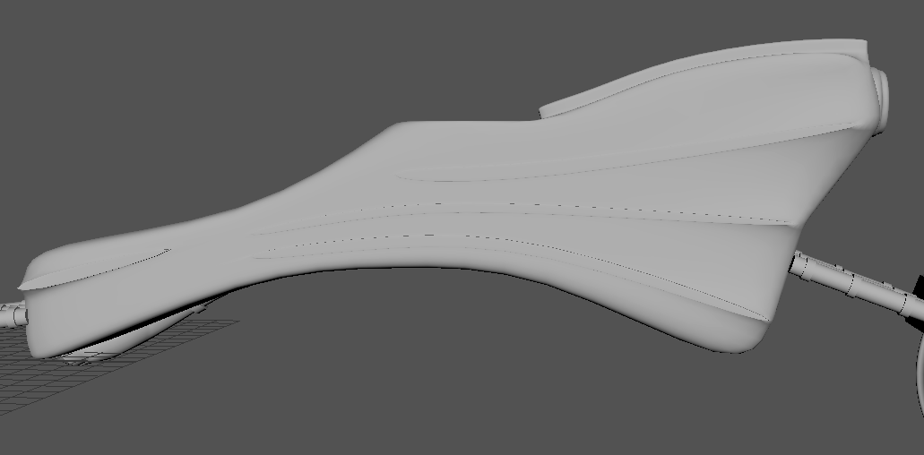

The body was not too difficult to create. The processes used were as follows:

- Importing an image of a rough sketch of the shape of the body

- Creating a polygon cube, adding subdivisions and extruding/pulling the faces.

- Symmetry through Z axis so that other side is identical.

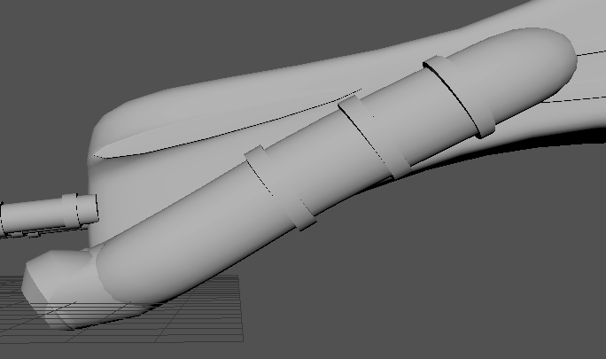

The exhaust and headlamps used similar processes:

- Draw out a curve, I experimented with both CV and Pencil curve tools. Both produced a similar effect

- Create a polygon cylinder and then extrude the cylinder along the curve. This allows awkward shapes to easily be constructed.

- On the bottom of the exhaust I bevelled the edges which gives a chamfered look to them.

- Added edge loops at certain points and then extruded them.

- Mirror over the World Z-axis once in place.

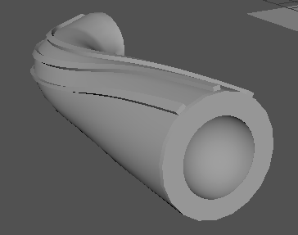

The headlamps used extra techniques on top of the techniques used above

- Taper out during the extrusion along curve.

- Twisting by 90 degrees during the extrusion, I thought this added a nice effect to the flowing lines along the headlamp.

- Boolean difference using a sphere placed in the middle at the face. This created a light socket effect

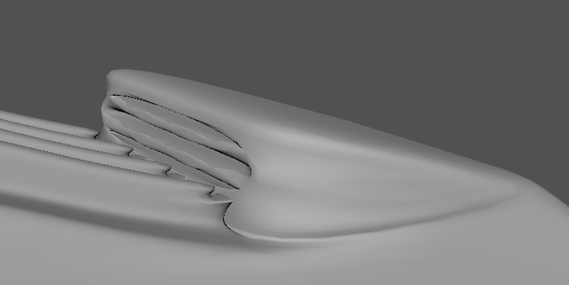

The grill used the following techniques:

- Selecting the faces and edges along one side

- Wedge tool of a small angle with minimal subdivisions to lift up the face that will hold the vents. Could’ve just extruded it but would’ve taken considerably longer.

- Boolean difference of extruded cubes for hollowing out the actual vents.

|  |  |
| --- | --- |
| **Technique Used** | **Where in the character and which surfaces?** |
| Adding Subdivisions on polygonal faces | This was used all over the model. In particular on the body and the connectors to the wheels. |
| Extrusions on polygons | Mainly on the body but also on minor parts to add detail such as the wheels and headlights. |
| Bevelling | Used on the exhausts to add a chamfered effect |
| Wedging | On the top surface of the body three faces and three edges selected and wedged at 30 degrees. |
| Booleans | Boolean difference used for the grill on top of body and on the ends of the headlights with a sphere. |
| Extrusion along a curve | Both the headlights and exhausts used a cylinder which is then extruded along the curve. |
| Taper and Twist | Used on the headlights on the extrusion along a curve. |
| Mirror | Used for both the headlights and exhausts to get place in same position on opposite side |
| EP and Pencil Curve | Used for creating the curve used in the extrusions. |
| Insert Edge Loop | Used in multiple places to place new edges, which are then manipulated using other techniques. Used all over such as the tyre. |
| Importing an image | Imported a rough sketch of the shape of the body, so that I could more accurately shape it. |

1. Process and Discussion

The design process for the production of this model were unoriginal. The methodology that I followed was to Research, Conceptualise, Design and then Evaluate. I found this worked very well for the creation of the Olympoid as it contained a very eccentric brief that required a lot of fine tuning to the final product.

The design evolved throughout the whole process, starting with my initial concept ideas in my brain that were not very concrete. I initially was thinking of creating a human like robot with legs and arms that would suit a specific purpose, however during the initial research stage I felt that this approach was not original enough, as I wanted my character to stand out from the crowd. Once the research stage was completed, I started to take notes of anything that popped into my mind. Any idea, even if it was not relevant, helped to move forward in the concept stage as it was sparking more creativity which for a Computer Science student does not come about often.

Although I could not draw to my broken arm, I was typing up detailed notes of individual parts that I would create and any relevant techniques that could be used to create them. The techniques that I used throughout the production of this model were on the whole suitable for each individual part. One of the most suited techniques I felt were the extrusions along a curve to produce an irregular pipe. This worked extremely well as it gave me the flexibility of the shape that the pipe would take, also allowing options such as the taper and twist. Although adding sub-divisions and extruding is not a complicated technique, I felt that it worked extremely well for the body of the bike. It allowed me to fill the space of the image that I had imported very easily. As I knew how to use this technique very well, I did not bother to experiment with others as I wanted to be able to spend time on more intricate parts of the character. If time was not of the essence I would have rather used NURBS to create a more irregular surface.

I chose to add the extruded lines along the body of the bike to add more detail. As discussed in the research I felt that the lights along the Tron bike looked very futuristic and would like to incorporate them into my design. Although the lights cannot be seen with the Ambient Occlusion image, in the next step of the production of this character I will be including them.

Throughout the design stage I was evaluating each component. There were a lot of times where I would design a component and once attached/implemented onto the bike it would not suit the design. This is why the design process must include evaluation, and I felt this worked very well. I was also not the only evaluator of the product. I asked friends and family their opinions of different sections of the bike, which allowed me to see the product from different viewpoints.

Overall, I felt that the production of this bike was very educational. I learnt a lot about the design process of creating a product from start to finish. There were choices I made which were not right, such as not using NURBS to create some irregular components and not being able to draw the concept. The lack of guidance without the drawing made me feel that I was making decisions on the spot, and not taking enough time to think about them. If I was to do this differently, I would spend more time in the Research and Conceptualise stages as these will help guide you to a more well-rounded and detailed product.

1. Appendix: Research

Here is a small collection of additional images and sketches that I found during my research stage. Although the majority are motorbikes, they seem to fit the futuristic style.

