Character & Set Design: Design Report 2

For the second assessment of COMS31000 we were tasked with continuing on with the first part of the project. However, we were not to model any more of the Olympoid, we were now tasked to use Autodesk Maya to texture, light and render our model. The first task in which I embarked in was try to create some colour schemes from research.

1. Pre-Production and Planning

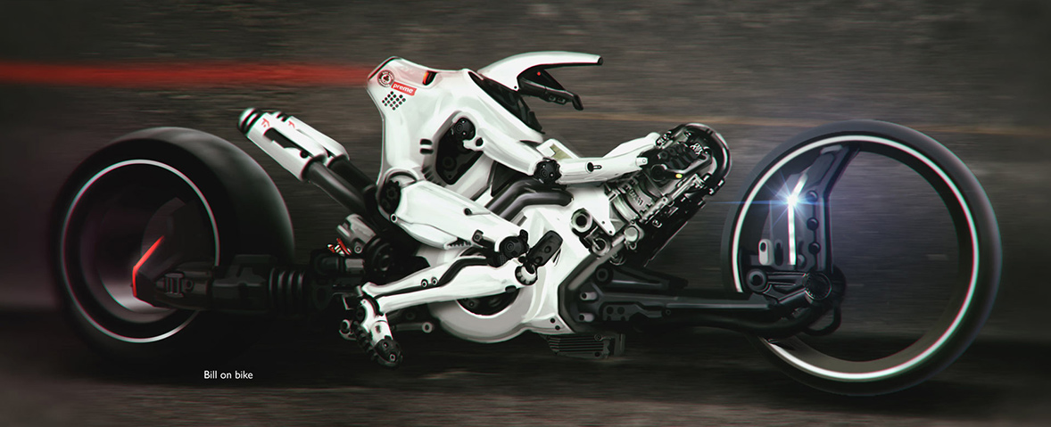The image to the right gave me a lot of inspiration in the texturing process. I really liked the tyres and how they were black on the outside, white on the inside and then hollow. I will most likely use this concept or similar in my own. The shiny white metal all over is an interesting feature, this may be similar to what I pursue in my design.

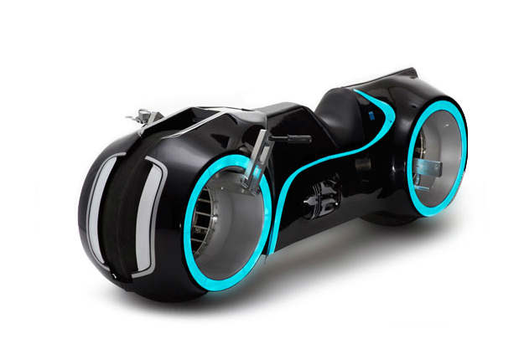

When I first saw this image, the lights sprung out at me and I thought that I had to incorporate them into my robot somehow. On second glance I almost see a carbon fibre like material on the outside. This is very suitable as its light, hard and it looks very appealing. This material may have to come into play when I texture my robot, but if there’s no pre-set I may have to create it myself. An issue with adding plenty of lights throughout the model would be that it increases the compute power needed by a large amount

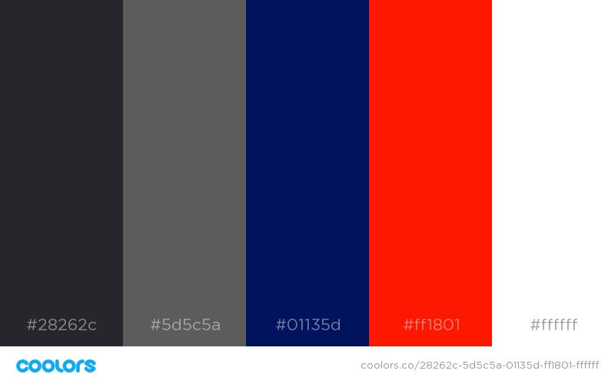

Due to my experience in web design, I had come across an extremely useful tool that generates colour schemes. I decided to do some browsing and came across this one on the right. As my robot will be from the United Kingdom, I felt that the red, white and blue was a necessity. The light grey, and dark grey seem to go well with these colours so this will be used at the focus point during my texturing.

1. Texturing the Scene

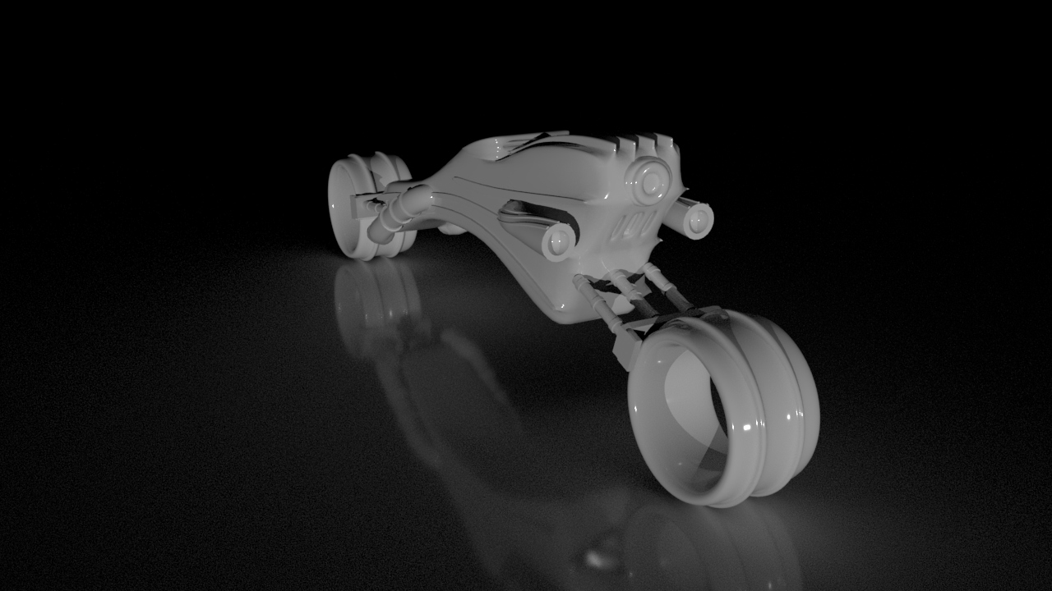

The first stage in the design was to texture the scene, however I felt that there were a few things that I needed to get straight first. The camera needed to be fixed, and temporary lighting had to be added. So, this is exactly what I did. Added a fixed camera so that the render was always in the same positions, then added a texture of ai_StandardSurface all over and finally added a couple directional lights. Seen to the right.

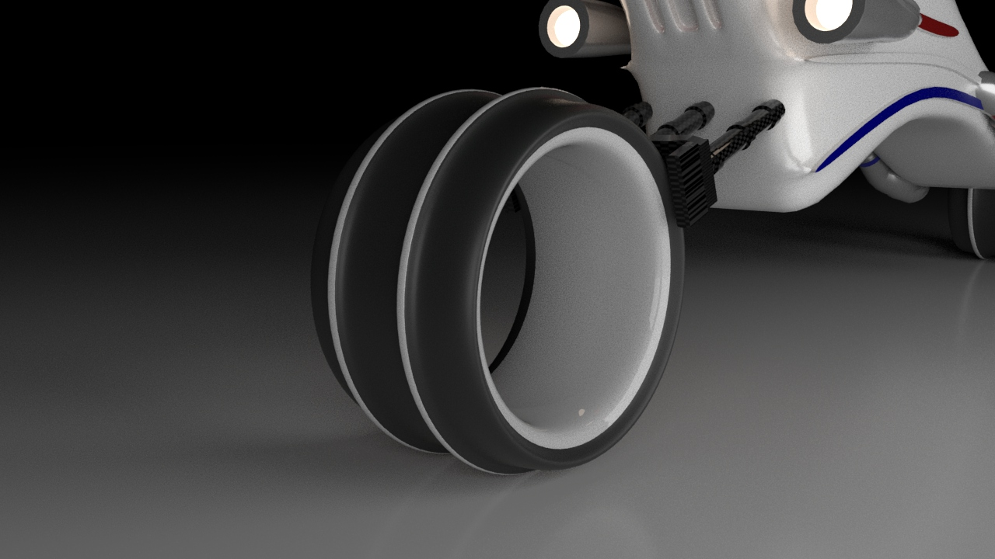

I thought a good starting place would be the wheels. I started with the tyres which were not too hard to simulate a rubber effect with. I used the Standard Surface Shader in a dark grey/black colour., but to add the rubber feel to them I increased the specular roughness. This gave it a matte feel which resembles a slick tyre and decreases the reflection. The inspiration for the inside of the tyre was taken from the research in image 1. I used a standard shader in a light grey colour taken from the colour scheme, and then kept the roughness very low. I added a light sheen in white to keep the shader reflective almost like a metallic paint. You can see the parts in it where the light is reflecting off of it.

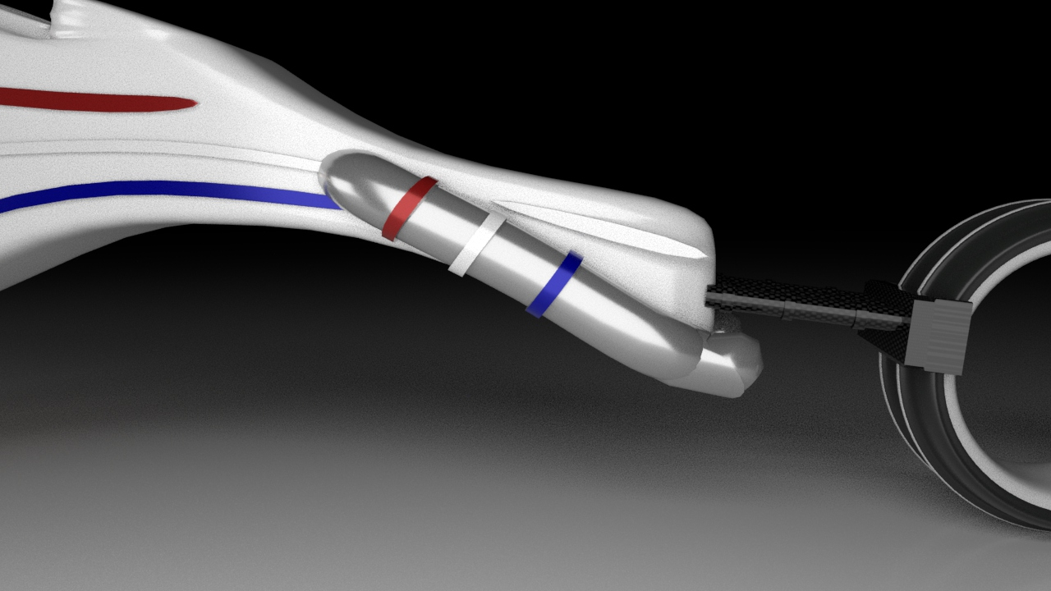

The next stage of the texturing was the exhaust. I felt that most exhaust pipes were made from a shiny metal, such as aluminium. So, this is exactly what I tried to replicate. The main part of it was textured with again a StandardShader. I chose a metallic grey colour for the base, and then increased the metalness to about 2/3. To high and the material did not look realistic. To texture the coloured rings along the body I chose the metal shader I created above, however I just changed the base colour to the specific colour required. This kept the feel that the paint was on top of the metal. The outcome of this part was very successful in my eyes. The light reflects well off of it, and it certainly looks like a metal material.

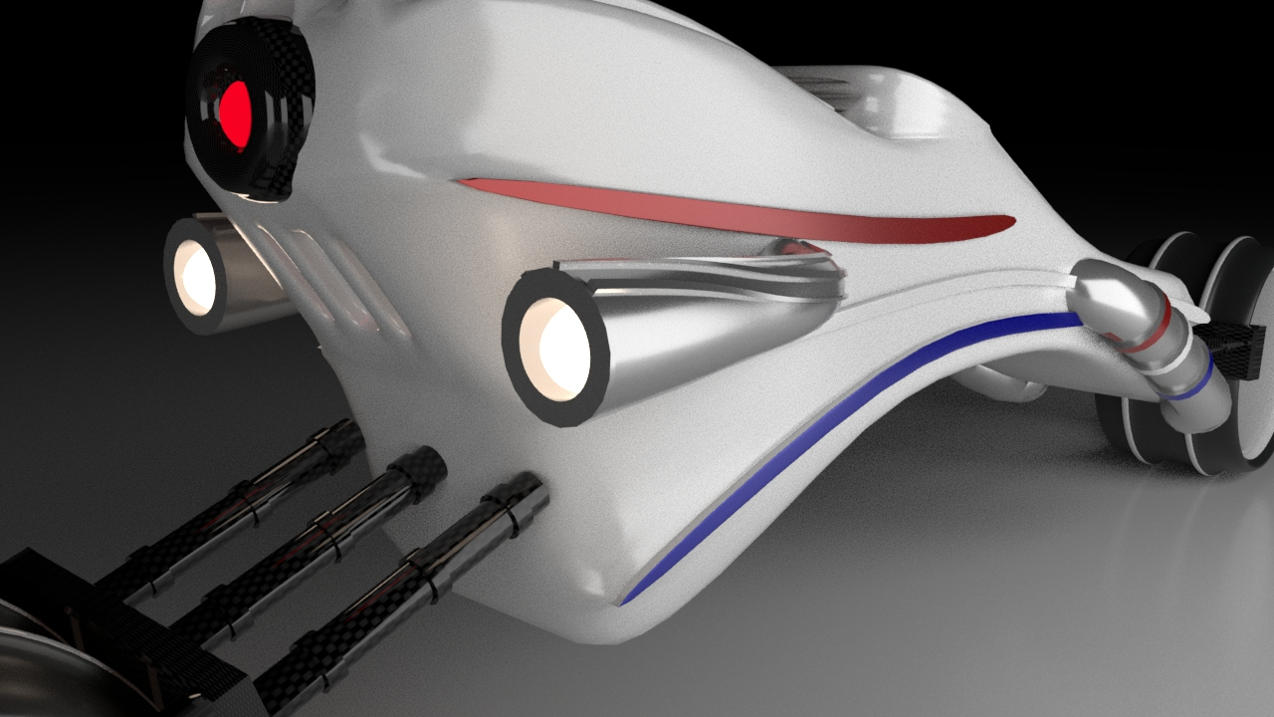

For the headlamps, I felt that the consistency of the metal was a good choice, I liked the way they worked together as they are both reasonably similar parts. I was tempted to add the red, white and blue again on the extruded parts, but felt it may be overkill. For the actual lighting I had two options. Use a shader and then increase the emission, or what I chose to do was create a sphere, change it to a mesh light and place it inside the hole. This gave me more options on the style of the lighting, such as change it from a colour to a temperature which gives it a more realistic feel.

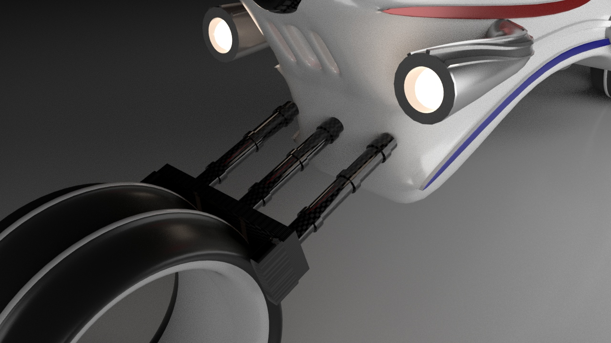

One material that I mentioned in the research was the carbon fibre. I could not find an in-built texture for it so I decided to create it myself in the shader network. To do this I used the cloth texture, increased the UV frequency, and changed the colours to dark grey/light grey. This then was outputted into a StandardShader’s base colour. With some tweaks on the shaders coat and roughness I was then able to simulate the thin film on top of the carbon fibre. The shader network can be seen in the appendix. This process took some time to perfect as I wanted a realistic carbon fibre material.

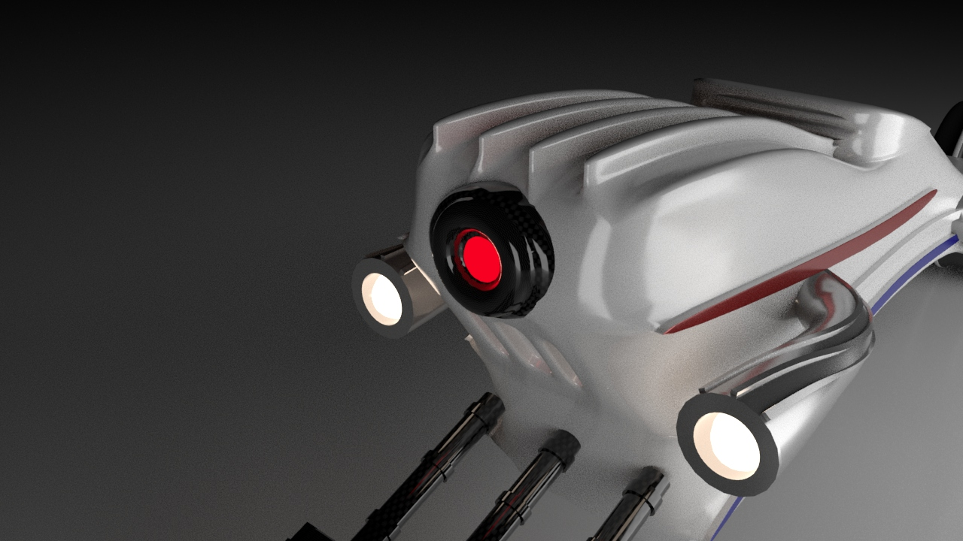

For the robot eye I felt that the outer casing would be a suitable area to reuse the Carbon Fibre shader I created. As its close to the suspension the two parts play off of each other very well. For the actual eye, I used the same technique as the headlamps, however instead of using temperature to determine the colour I chose a specific colour. This is because I wanted more of a LED similarity that the temperature would not produce. The amount of lights used are quite high so I will have to limit it at that to reduce the computational power required to render out the image. This is why I could not use lights along the body as I had planned to in the first part of this project.

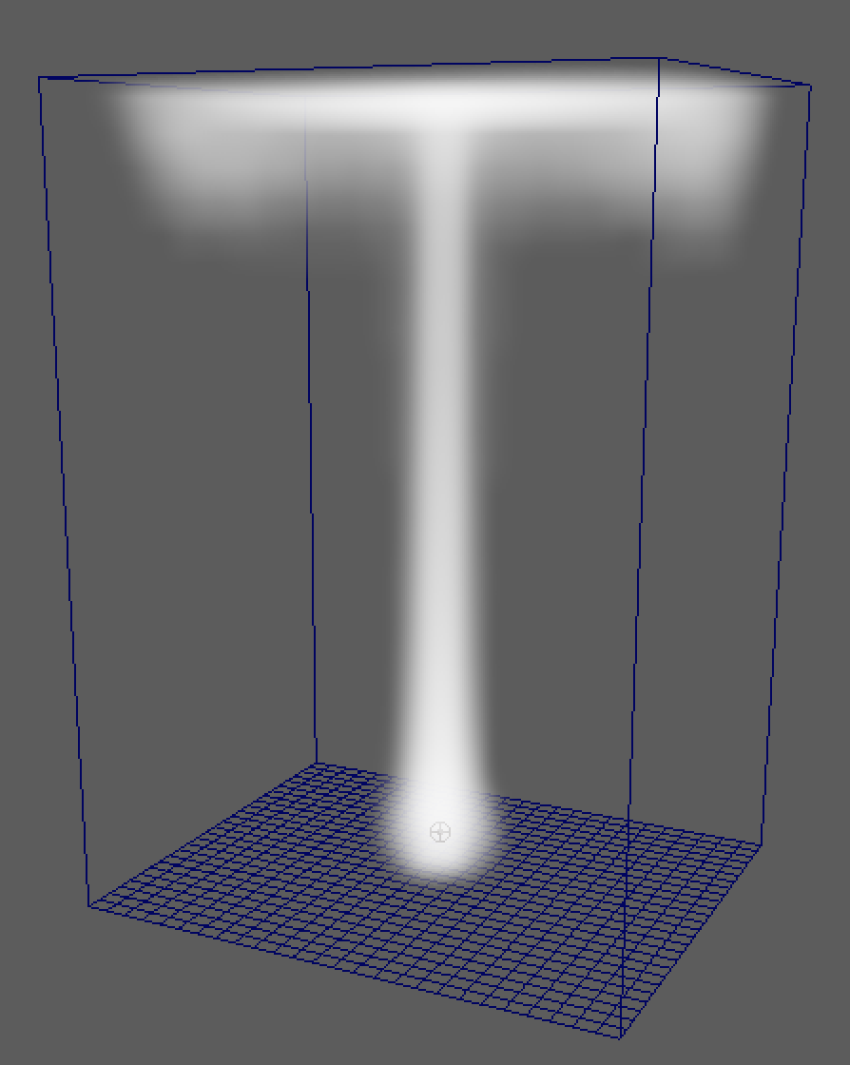

The final addition to the bike wasn’t exactly a texture, it was an effect. I did some individual research into adding smoke effects into a scene and executed it. It required me to look into how the particles work. This included dissipation, bouncy, density and more details about how the temperature works for particles. I feel that this was a nice addition as it adds some form of movement to the static image. It did however increase render time, but not to drastically. I added the smoke to both of the exhausts. If I had more time to spare, I would have added some form of smoke or dust to tyres to show the heat that they would be operating at.

1. Rendering the Scene

The first task of rendering the scene was to add the background image that I would be using. I experimented with HDR maps onto a sky dome, however I felt like this was cheating as it incorporated all the lights as well, and hence I wouldn’t need to look into how they worked. So, I took my perspective from the camera I had first placed and created an image plane with the image of my choice. The camera required a bit of a reshuffle to get the bike into the right place, but it ended up looking like it was in scale with the image.

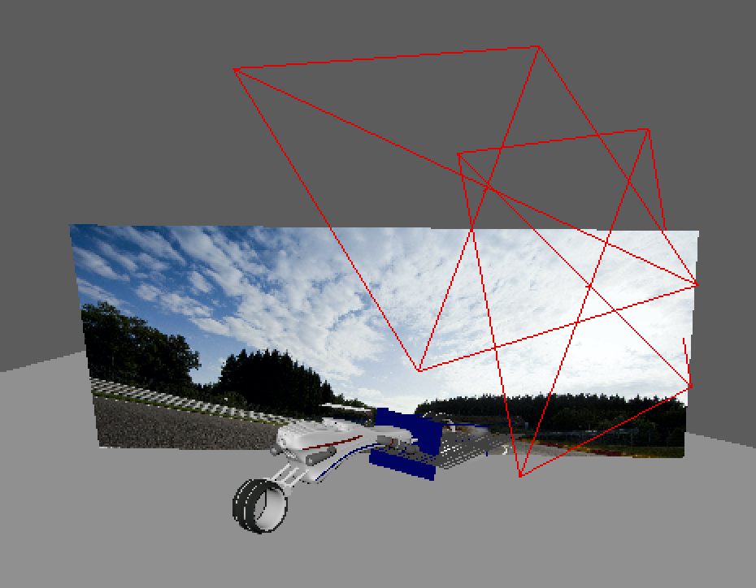

Now that positioning was all okay, I moved onto the lighting. Instead of using a skydome light to illuminate the whole scene, I decided on using three Area Lights. I increased the size of them and unchecked the normalize box. It looked good, and the direction seemed to replicate where the sun was in the scene, however it was way too bright. To correct this, I changed from using colour, to using temperature, adjusted it accordingly and eventually it looked like the sun was shining from above!

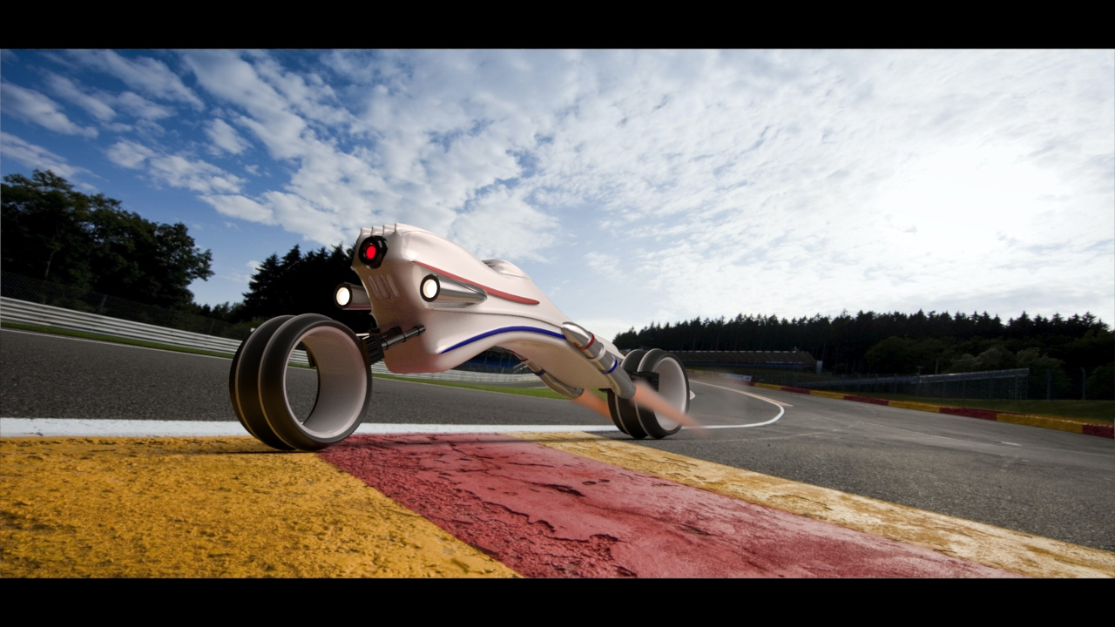The final edition to rendering the scene was the shadows. To do this I added a plane underneath the tyres of the bike and added the aiShadowMatte material to it. This meant that the only thing to be shown is the shadows. It worked very well as you can see to the left.

1. Highlights and Challenges

In the texturing and rendering of this bike I experienced many highlights and challenges. The highlights include the creation of the Carbon Fibre using the shader network, which was interesting to learn about how shaders can be combined to create a more appealing effect. Another highlight for me was learning about how to incorporate the shadows into the scene. This was a bit of a challenge as I needed the shadows to appear to be on the ground of the image plane, but once I understood the mechanics of the shadow shader it was not too difficult.

The final, but most intriguing highlight was learning about how smoke particles worked. This was a bit over the top, as it required me learning a whole new side of Arnold, but the challenge was appealing to me and I do not regret incorporating it at all.

The biggest challenge during this stage of the project was definitely trying to position the bike into a scene. I spent countless hours experimenting with different images, different angles and different techniques. But in the end the most basic technique worked. If it wasn’t for the shadows, I do not feel that the bike would have looked so correct in the scene.

I experimented with a couple online shaders form repositories, however in the end I did not use them as the ones that I created worked much more effectively in describing exactly what I wanted. I did use a few online tutorials to guide me through how the shader network worked, but the majority of the ideas I incorporated were my own.

The use of a HDRI map was an interesting stage of my development. Although I did not use it, I thought that it was a very clever idea, and would definitely consider using it more in the future.

1. Discussion and Conclusion

Overall, I believe that the final image looks great, however there certainly could be more improvements that would have added more detail. For example, I would have liked to look a displacement maps in-depth, to give the bike a more 3D feel. With more time I would have tried to create the carbon fibre texture that used a displacement map of the same cloth material used. Another addition that would have been interesting to look into would be to use a 3D camera to capture my own scene. This would reduce the inaccuracy of the positioning of the bike and give me more flexibility of the scene.

I also did not use UV maps in the texturing part of this project. This would have been a nice tool to learn more about, however I came across some issues running it on my computer so decided not to pursue it anymore. With more time I would have tried to give the body a UV Map with my own texture made on photoshop or importing a tyre track vector and using that for more detail.

I did try to look into adding motion blue to the image to give it more of a dynamic feel, however I could not get it to work. I think that it requires actual movement of the bike. Animation would’ve been interesting to look into as well. But I would have liked to change the geometry slightly, especially around the wheels.

1. 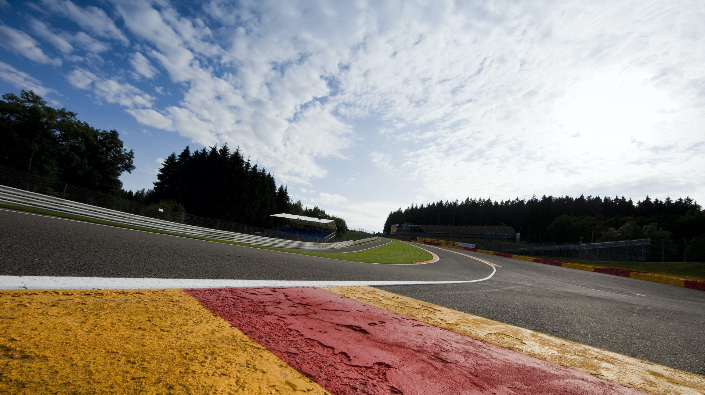Appendix

