**Experiment 2**

**Aim:**  
To design a responsive banking user interface using HTML and CSS.

**Objective:**  
The objective of this experiment is to create a visually appealing and responsive banking UI layout using only HTML and CSS. This helps reinforce modern layout practices such as Flexbox and responsive design principles without using JavaScript.

**HTML Code:**

<!DOCTYPE html>

<html lang="en">

<head>

<meta charset="UTF-8">

<meta name="viewport" content="width=device-width, initial-scale=1.0">

<title>Responsive Banking UI</title>

<link rel="stylesheet" href="styles.css">

</head>

<body>

<div class="bank-container">

<h1>Bank Account</h1>

<div class="balance-card">

<p>Balance</p>

<h2>$10,000</h2>

</div>

<div class="button-group">

<button class="deposit">Deposit</button>

<button class="withdraw">Withdraw</button>

</div>

</div>

</body>

</html>

**CSS Code:**  
styles.css

* {

margin: 0;

padding: 0;

box-sizing: border-box;

font-family: Arial, sans-serif;

}

body {

display: flex;

justify-content: center;

align-items: center;

height: 100vh;

background-color: #f0f2f5;

}

.bank-container {

text-align: center;

padding: 2rem;

background: white;

border-radius: 10px;

box-shadow: 0 4px 12px rgba(0, 0, 0, 0.1);

width: 90%;

max-width: 400px;

}

.balance-card {

background: #e3f2fd;

padding: 1.5rem;

border-radius: 8px;

margin: 1rem 0;

}

.balance-card h2 {

color: #0d47a1;

font-size: 2rem;

}

.button-group {

display: flex;

justify-content: space-around;

gap: 1rem;

}

button {

padding: 0.7rem 1.5rem;

border: none;

border-radius: 5px;

font-size: 1rem;

cursor: pointer;

transition: 0.3s;

}

.deposit {

background-color: #4caf50;

color: white;

}

.withdraw {

background-color: #f44336;

color: white;

}

button:hover {

opacity: 0.9;

}

**Output:**

* A centered interface with the title "Bank Account"
* A balance card showing "$10,000"
* A green **Deposit** button and a red **Withdraw** button side by side
* Responsive design that adjusts layout and size gracefully on mobile, tablet, and desktop screens

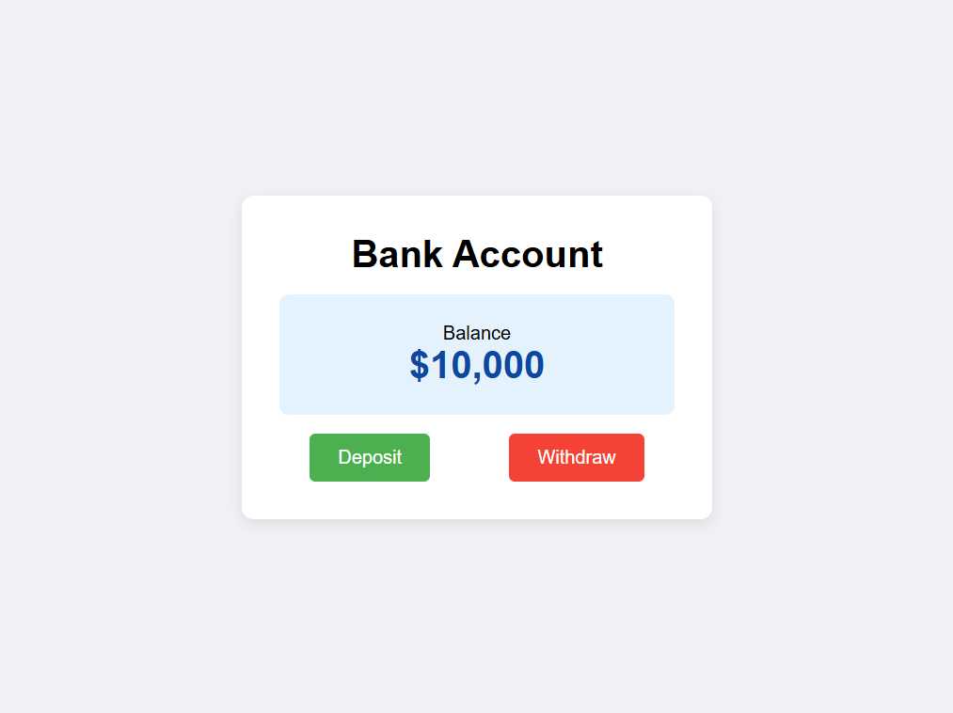

**Submitted by:**

* **Name:** Parwaaz Joshi
* **UID:** 23BIS70101