**Experiment 3**

**Aim:**  
To build a responsive admin dashboard using CSS Grid and implement theme switching using HTML and CSS.

**Objective:**  
The objective of this experiment is to design a professional-looking admin dashboard with clearly separated sections (header, sidebar, content, and footer) using CSS Grid layout. Additionally, the interface supports light/dark theme switching using only CSS, enabling practice in advanced layout and adaptive design principles.

**HTML Code:**

<!DOCTYPE html>

<html lang="en">

<head>

<meta charset="UTF-8" />

<meta name="viewport" content="width=device-width, initial-scale=1.0"/>

<title>Admin Dashboard</title>

<link rel="stylesheet" href="styles.css">

</head>

<body>

<div class="dashboard">

<header class="header">

<h1>Admin Dashboard</h1>

<label class="theme-switch">

<input type="checkbox" id="toggle-theme">

<span class="slider"></span>

</label>

</header>

<aside class="sidebar">

<nav>

<ul>

<li><a href="#">Home</a></li>

<li><a href="#">Users</a></li>

<li><a href="#">Settings</a></li>

</ul>

</nav>

</aside>

<main class="main">

<h2>Welcome to the Admin Panel</h2>

<p>This area can be used for data visualizations, reports, or messages.</p>

</main>

<footer class="footer">

<p>&copy; 2025 Dashboard Inc.</p>

</footer>

</div>

</body>

</html>

<script>

const toggle = document.getElementById('toggle-theme');

toggle.addEventListener('change', () => {

document.body.classList.toggle('dark');

});

</script>

**CSS Code:**

css

:root {

--bg-color: #ffffff;

--text-color: #000000;

--sidebar-bg: #f4f4f4;

--header-footer-bg: #e0e0e0;

}

body.dark {

--bg-color: #121212;

--text-color: #ffffff;

--sidebar-bg: #1e1e1e;

--header-footer-bg: #2c2c2c;

}

body {

margin: 0;

font-family: Arial, sans-serif;

background-color: var(--bg-color);

color: var(--text-color);

transition: background-color 0.3s ease, color 0.3s ease;

}

.dashboard {

display: grid;

grid-template-areas:

"header header"

"sidebar main"

"footer footer";

grid-template-columns: 200px 1fr;

grid-template-rows: auto 1fr auto;

min-height: 100vh;

}

.header {

grid-area: header;

background: var(--header-footer-bg);

display: flex;

justify-content: space-between;

align-items: center;

padding: 1rem 2rem;

}

.theme-switch {

position: relative;

display: inline-block;

width: 50px;

height: 24px;

}

.theme-switch input {

opacity: 0;

width: 0;

height: 0;

}

.slider {

position: absolute;

cursor: pointer;

top: 0;

left: 0;

right: 0;

bottom: 0;

background-color: #888;

border-radius: 24px;

transition: 0.4s;

}

.slider:before {

content: "";

position: absolute;

height: 18px;

width: 18px;

left: 3px;

bottom: 3px;

background-color: white;

border-radius: 50%;

transition: 0.4s;

}

input:checked + .slider {

background-color: #4caf50;

}

input:checked + .slider:before {

transform: translateX(26px);

}

.sidebar {

grid-area: sidebar;

background: var(--sidebar-bg);

padding: 1.5rem;

}

.sidebar ul {

list-style: none;

padding: 0;

}

.sidebar a {

text-decoration: none;

color: var(--text-color);

display: block;

margin: 1rem 0;

}

.main {

grid-area: main;

padding: 2rem;

}

.footer {

grid-area: footer;

background: var(--header-footer-bg);

text-align: center;

padding: 1rem;

}

/* Theme toggle logic */

#toggle-theme:checked ~ .dashboard {

background-color: var(--bg-color);

}

#toggle-theme:checked ~ body {

background-color: var(--bg-color);

}

**Output:**

* A complete, responsive admin dashboard layout
* Theme toggle switch in the header to switch between light and dark modes
* Sidebar with working nav layout, and content + footer aligned using CSS Grid
* Clean layout with section separation and responsiveness

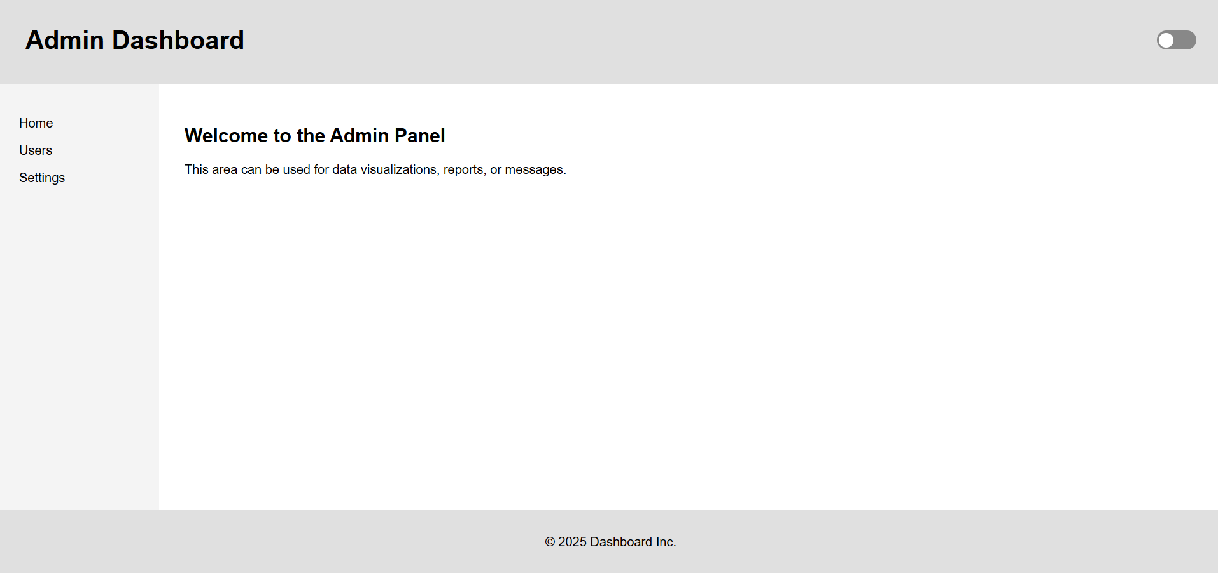

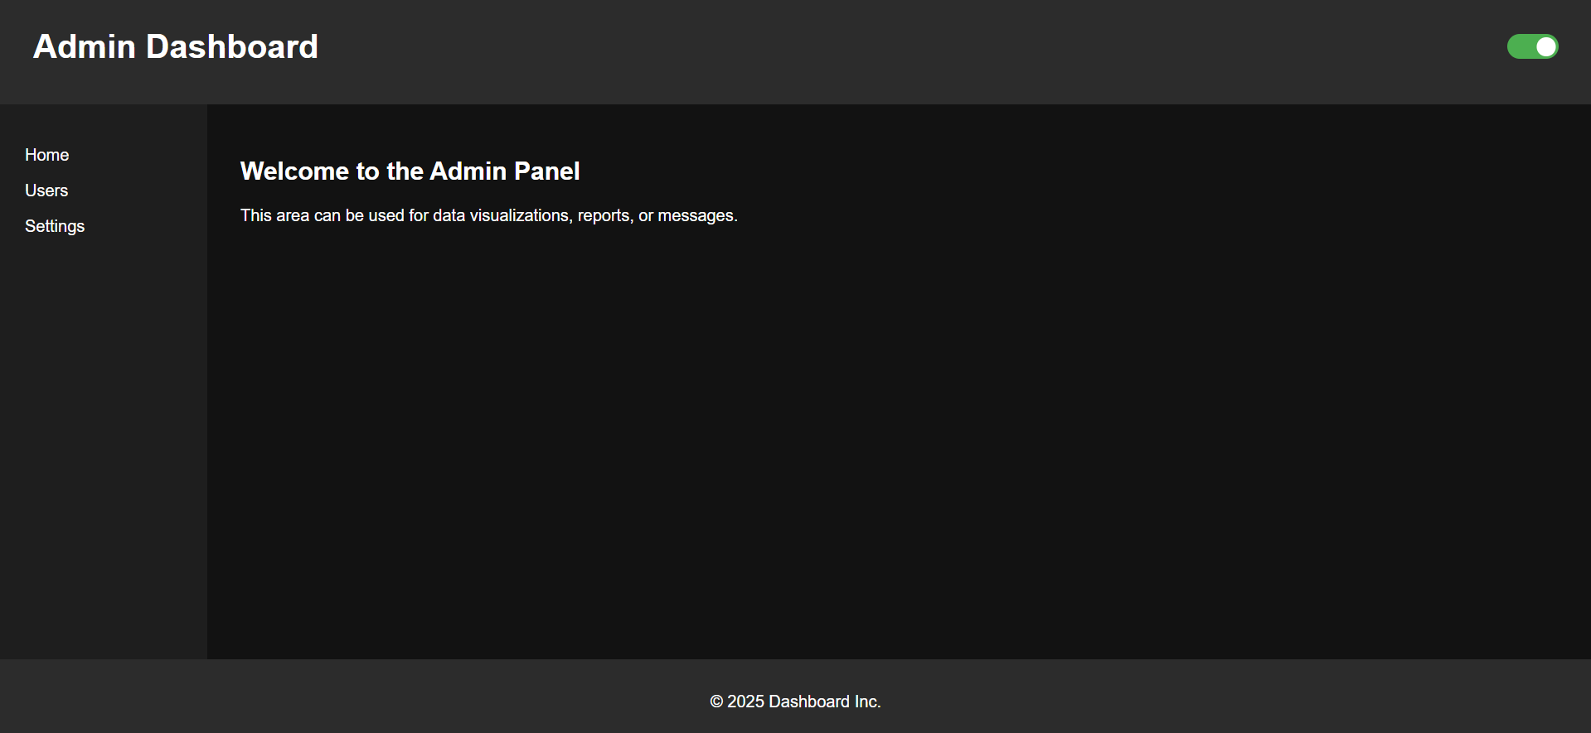

**Submitted by:**

* **Name:** Parwaaz Joshi
* **UID:** 23BIS70101