**Experiment 4**

**Aim:**  
To implement a live character counter that updates in real-time as the user types in a textarea.

**Objective:**  
The objective of this experiment is to practice real-time DOM manipulation using event handling. The character counter provides immediate feedback to users, improving usability in form-related user interfaces by displaying the number of characters typed dynamically.

**HTML Code:**  
  
index.html

<!DOCTYPE html>

<html lang="en">

<head>

<meta charset="UTF-8">

<title>Live Character Counter for Textarea</title>

<style>

.container {

margin: 20px;

border: 1px solid #333;

padding: 20px;

max-width: 500px;

}

textarea {

width: 100%;

height: 100px;

font-size: 16px;

}

.counter {

font-weight: bold;

margin-top: 10px;

}

h2 {

margin-bottom: 10px;

}

</style>

</head>

<body>

<div class="container">

<h2>Live Character Counter</h2>

<textarea id="text-input" placeholder="Start typing..."></textarea>

<p class="counter">Characters: <span id="char-count">0</span></p>

</div>

<script src="script.js"></script>

</body>

</html>

**JavaScript Code:**  
script.js

javascript

CopyEdit

const textarea = document.getElementById('text-input');

const counter = document.getElementById('char-count');

textarea.addEventListener('input', () => {

counter.textContent = textarea.value.length;

});

**Output:**

* A centered text area where users can type content
* A live-updating character counter below the textarea
* The counter reflects the number of characters in real time, updating as the user types or deletes

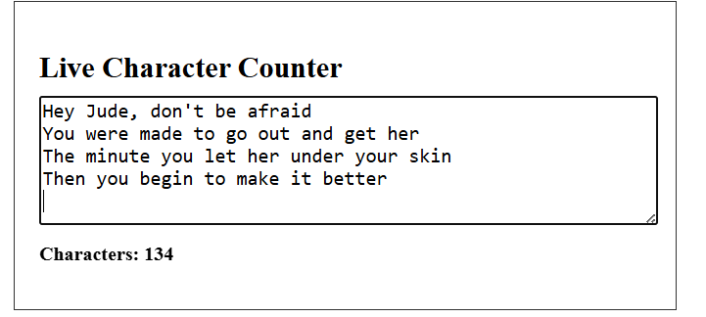

**Submitted by:**

* **Name:** Parwaaz Joshi
* **UID:** 23BIS70101