- URL: http://localhost:5000 or http://127.0.0.1:5000
👤 Default Login Credentials
- Username: admin
- Password: admin123
- Open terminal in VSCode (Ctrl + `)
- Navigate to project: cd mainframe-error-screens
- Run: python app.py
- Access: http://localhost:5000

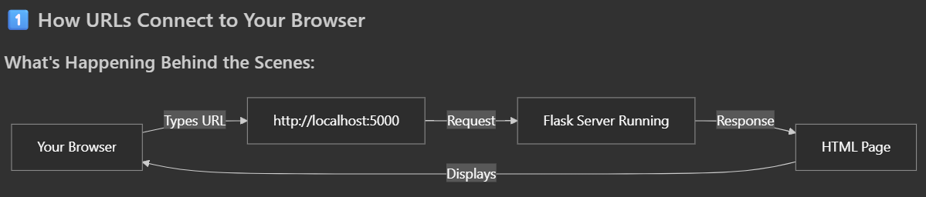

Simple Explanation:
- Flask Server = A Restaurant Kitchen
  - Your Python code (app.py) starts a "kitchen" (server)
  - It listens on "address" 0.0.0.0:5000 (like a phone number)
  - When you type http://localhost:5000, you're "calling" this kitchen
- localhost = Your Own Computer
  - localhost means "this computer"
  - 5000 is the "door number" (port)
  - Like calling your own home phone
- The Connection Process:
- Browser → "Hey, give me the page at localhost:5000"
- Flask → "Here's the login page HTML!"
Browser → Displays the beautiful login page

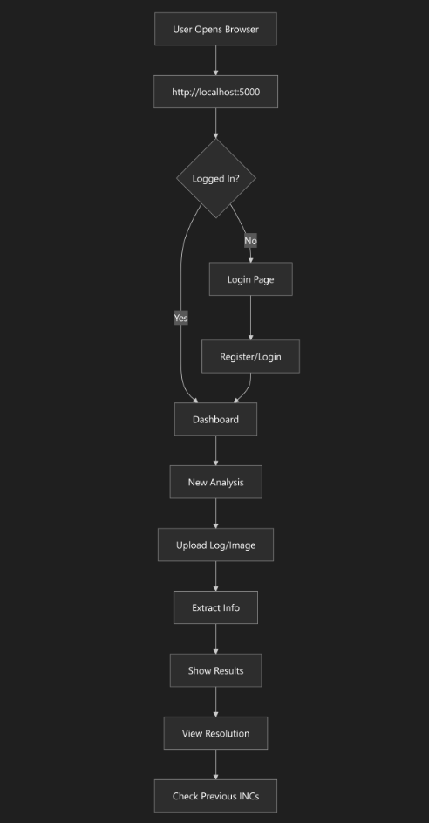
3️⃣ How Login/Password Works
Database Storage (models.py):
class User(UserMixin, db.Model):
username = db.Column(db.String(80)) # Stores username
email = db.Column(db.String(120)) # Stores email
password_hash = db.Column(db.String(255)) # Stores ENCRYPTED password

What Happens:
- You fill form: username, email, password
- Flask checks if username already exists
- Password is encrypted (hashed) - never stored as plain text!
- User saved to database (mainframe_assistant.db)
- You're redirected to login page
Security:
- Passwords are hashed using bcrypt (line 31 in models.py)
- Original password is never stored
- Even database admin can't see your password!
4️⃣ Complete Workflow with Code References
STEP 1: User Registration/Login
Files Involved:
- templates/auth/register.html - Registration form
- templates/auth/login.html - Login form
- app.py - Handles registration/login logic
What Happens:
1. Open browser → http://localhost:5000
2. See login page (or register if new user)
3. Enter credentials
4. Flask checks database
5. Creates session (remembers you're logged in)
6. Redirects to dashboard

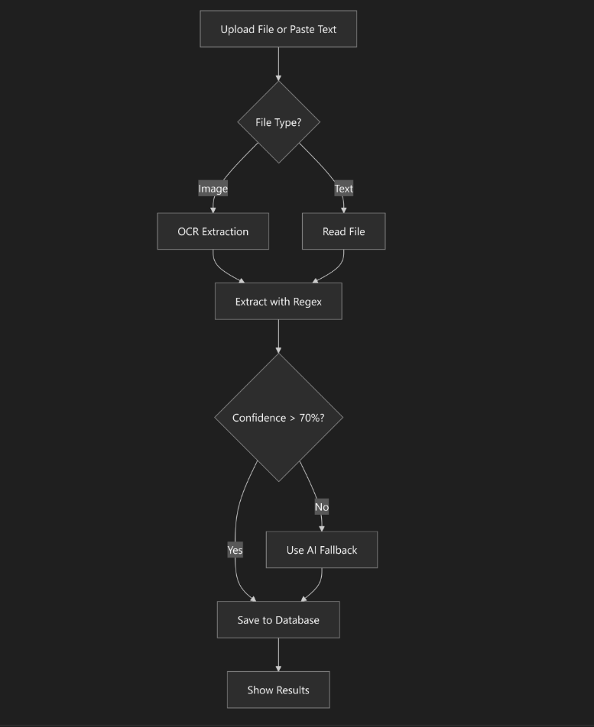

Modules Used:
- log_extractor.py - Extracts info using patterns
- ocr_processor.py - Reads text from images
- ai_fallback.py - Uses AI if regex fails
Extracts:
- JOBNAME (e.g., "DUMMYBATCH01")
- JOBID (e.g., "JOB12345")
- STATUS (e.g., "ABEND")
- RETURN CODE (e.g., "U0777")
- STEP (e.g., "STEP002")
- ERROR MESSAGE
5️⃣ Technology Stack Explained
Flask (Web Framework)
from flask import Flask
app = Flask(__name__)
app.run(host='0.0.0.0', port=5000)
- Creates web server
- Handles URLs (routes)
- Serves HTML pages
SQLAlchemy (Database)
db = SQLAlchemy()
- Stores users, analyses, INC records
- File: mainframe_assistant.db
Flask-Login (Authentication)
login_manager = LoginManager()
- Manages user sessions
- Protects pages (requires login)

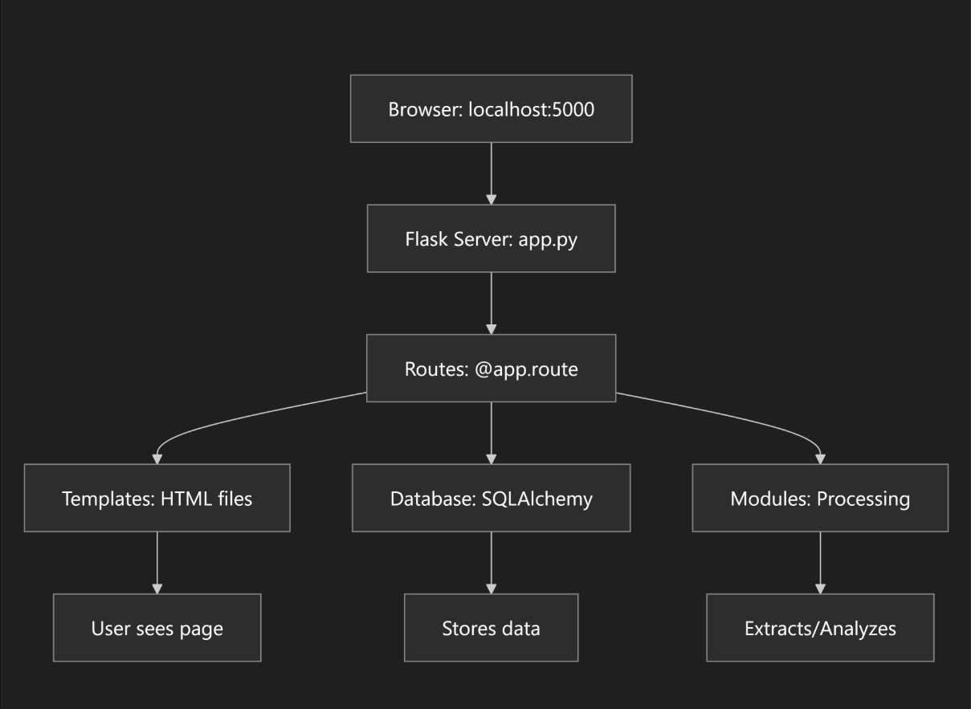

The Magic:
- You type URL → Flask receives request
- Flask checks which route matches (e.g., /login)
- Flask runs Python code for that route
- Code gets data from database if needed
- Code renders HTML template with data
- Browser displays the page

8️⃣ Why URLs Work
Configuration: config.py
app.run(host='0.0.0.0', port=5000)
- 0.0.0.0 = Listen on all network interfaces
- port=5000 = Use port 5000
- localhost:5000 = Access from same computer
- [YOUR_IP]:5000 = Access from other devices
It's like:
- Your computer = Building
- Port 5000 = Apartment number
- Flask = Person answering the door
- Browser = Visitor knocking
Your project is a web application that:
- Runs a server on your computer (Flask)
- Stores data in a database (SQLite)
- Provides web pages through browser (HTML/CSS)
- Processes mainframe logs (Python modules)
- Shows visual solutions (Generated images)

Three-Layer Analysis System
Your project uses a smart 3-tier approach to analyze mainframe logs:

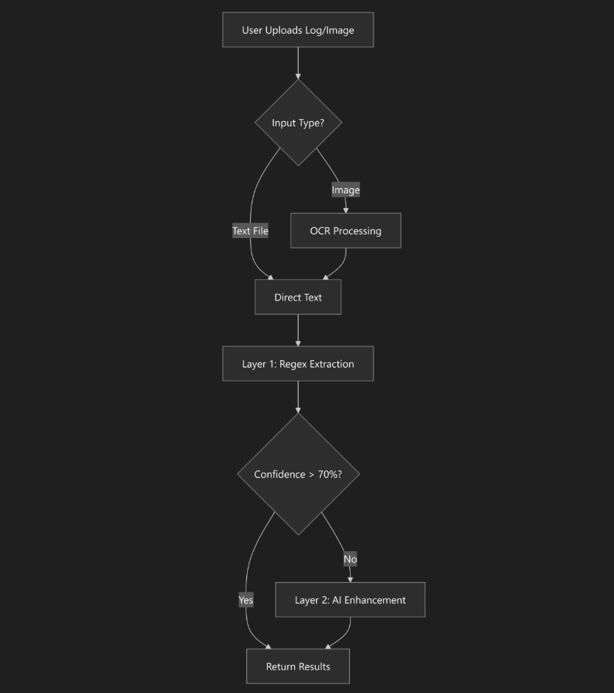

Layer 1: Regex Pattern Matching (Primary Method)
File: log_extractor.py
How It Works:
No AI model needed! Uses Regular Expressions (Regex) - pattern matching rules.
# Example patterns from the code:
PATTERNS = {
'jobname': [
r'JOBNAME\s*=\s*([A-Z0-9]+)', # Matches: JOBNAME=DUMMYBATCH01
r'IEF236I\s+ALLOC\.\s+FOR\s+([A-Z0-9]+)', # Matches IEF messages
],
'return_code': [
r'RETURN_CODE\s*=\s*([A-Z0-9]+)', # Matches: RETURN_CODE=U0777
r'ABEND\s*=\s*([SU][0-9A-F]{3,4})', # Matches: ABEND=S0C7
]
}
Step-by-Step Process:
- Receives log text (lines 94-118)
- Searches for patterns using regex (lines 120-179)
- Prioritizes error lines - looks for lines with "ABEND", "FAILED" (lines 136-144)
- Extracts 6 fields:
  - JOBNAME
  - JOBID
  - STATUS
  - RETURN_CODE
  - STEP
  - ERROR
- Calculates confidence (line 177):
- confidence = fields_found / total_fields
# Example: Found 5 out of 6 fields = 83% confidence
Layer 2: AI Enhancement (Fallback)
File: ai_fallback.py
When It Activates:
Only when regex confidence < 70% (line 242 in app.py)
Model Used:
OpenAI GPT-3.5-Turbo (line 54 in ai_fallback.py)
response = self.client.chat.completions.create(
model="gpt-3.5-turbo", # ← The AI model
messages=[...],
temperature=0.1, # Low temperature = more precise
max_tokens=500
)
How It Works:
- Creates a prompt (lines 83-122):
- "Analyze this mainframe log and extract:
- 1. JOBNAME
- 2. JOBID
- 3. STATUS
- 4. RETURN_CODE
- 5. STEP
- 6. ERROR

- Respond in JSON format..."
- Sends to OpenAI API (line 53)
- Receives JSON response:
- {
- "jobname": "TESTBATCH99",
- "jobid": "JOB54321",
- "status": "ABEND",
- "return_code": "S0C7",
- "step": "CALC001",
- "error": "Numeric data exception"
- }
- Parses and validates (lines 124-166)
Hybrid Mode:
Best of both worlds! (lines 179-212)
def enhance_extraction(regex_data, log_content):
# Use regex results where available
# Use AI to fill missing fields
# Merge both results
Example:
- Regex found: JOBNAME, STATUS, RETURN_CODE
- Regex missed: JOBID, STEP, ERROR
- AI fills in the missing 3 fields
- Final result: All 6 fields complete!

Layer 0: OCR Processing (For Images)
File: ocr_processor.py
Technology Used:
Tesseract OCR - Open-source text recognition engine
Process:
Screenshot Image
Tesseract OCR
Extract Text
Clean & Format
Pass to Regex Layer
How It Works:
- Receives image (terminal screenshot)
- Preprocesses image (lines 105-134):
  - Converts to grayscale
  - Increases contrast
  - Removes noise
- Runs OCR (line 66):
- text = pytesseract.image_to_string(image, config=custom_config)
- Cleans extracted text (lines 81-103):
  - Removes extra whitespace
  - Removes empty lines
  - Formats properly
- Validates output (lines 168-185):
  - Checks for mainframe keywords
  - Ensures minimum text length

Why This Approach?
1. Fast & Free (Regex)
- No API calls needed
- Instant results
- Works offline
- Handles 80%+ of cases
2. Smart Fallback (AI)
- Only used when needed
- Handles complex/unusual logs
- Costs money (OpenAI API)
- Optional (works without it)
3. Flexible Input (OCR)
- Accepts screenshots
- No manual typing needed
- Handles images from terminals
- Regex (Primary) - Pattern matching, no AI needed
- OpenAI GPT-3.5 (Fallback) - Only when regex confidence < 70%
- Tesseract OCR (Optional) - For image inputs

