**LIVE VIDEO STREAMS- React application using Redux**

A react application to create, edit, delete and view live stream videos using OBS with OAuth Sign In

**Pre-requisite to run this in local server:**

Start the JSON server from <https://github.com/joshi22neha/streams/tree/main/api>: npm start

Start the RTMP server from <https://github.com/joshi22neha/streams/tree/main/rtmpserver>: npm start

STREAM LIST: <http://localhost:3000/>

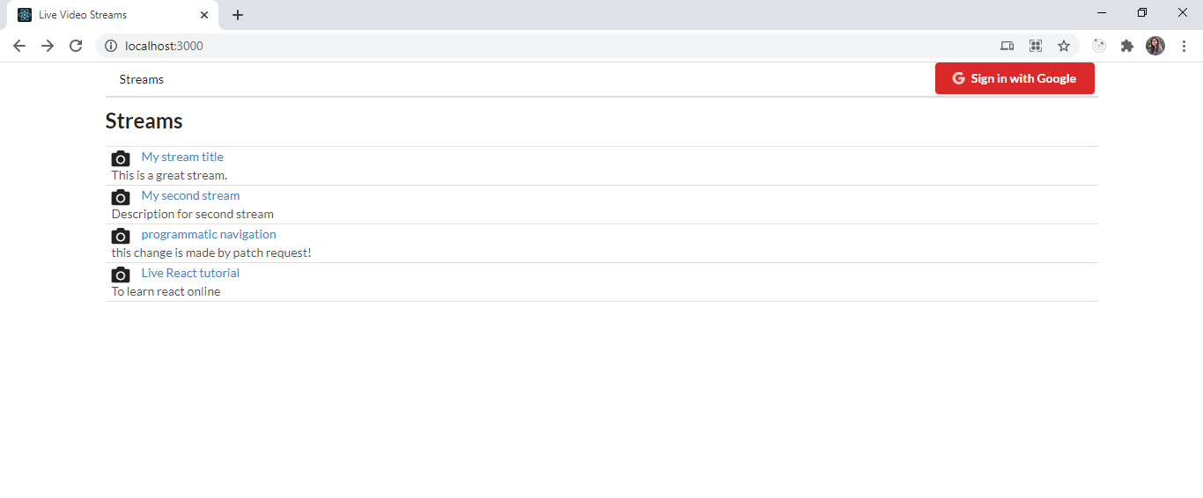

SIGN IN WITH GOOGLE: EDIT/DELETE stream access is given to user who has created that stream

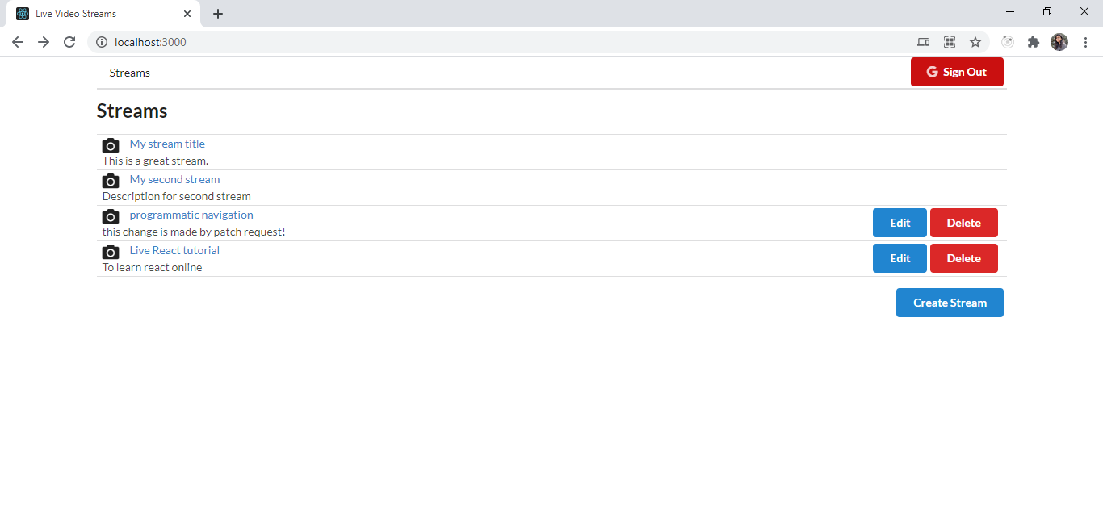

CREATE STREAMS: <http://localhost:3000/streams/new> – Create Stream option is only displayed when signed in

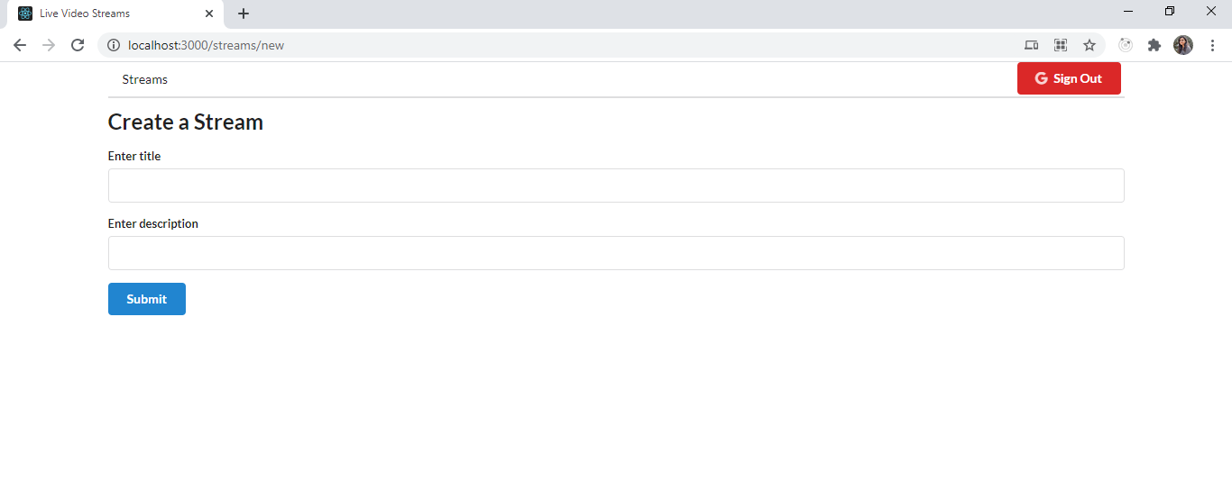

EDIT A STREAM: <http://localhost:3000/streams/edit/4> (4 is stream id)

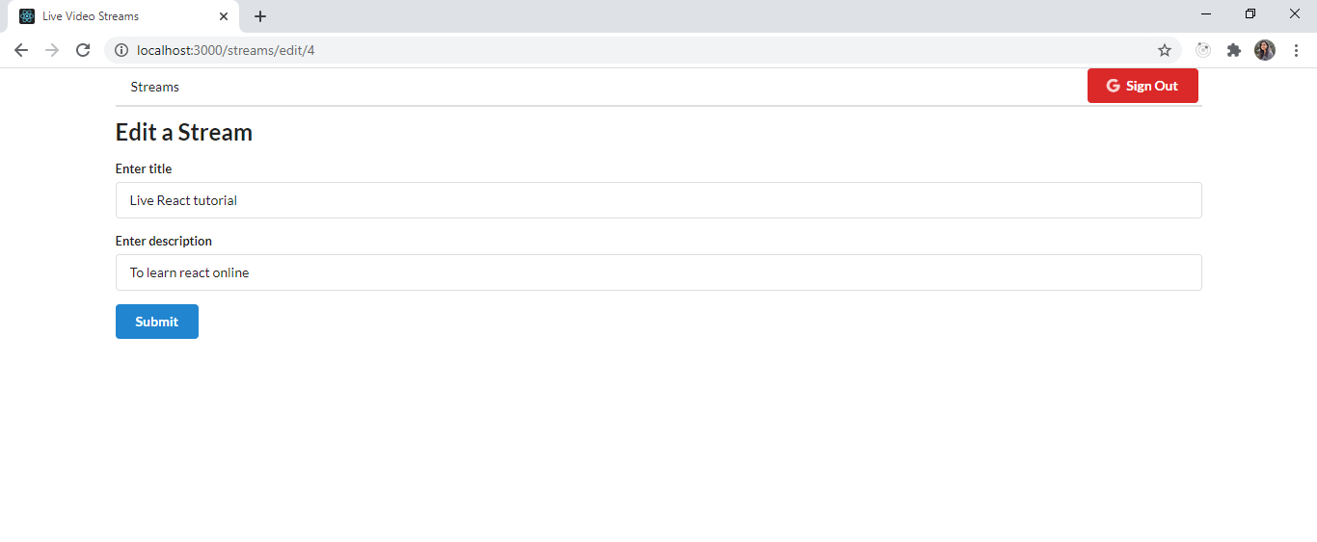

DELETE STREAM: <http://localhost:3000/streams/delete/4>

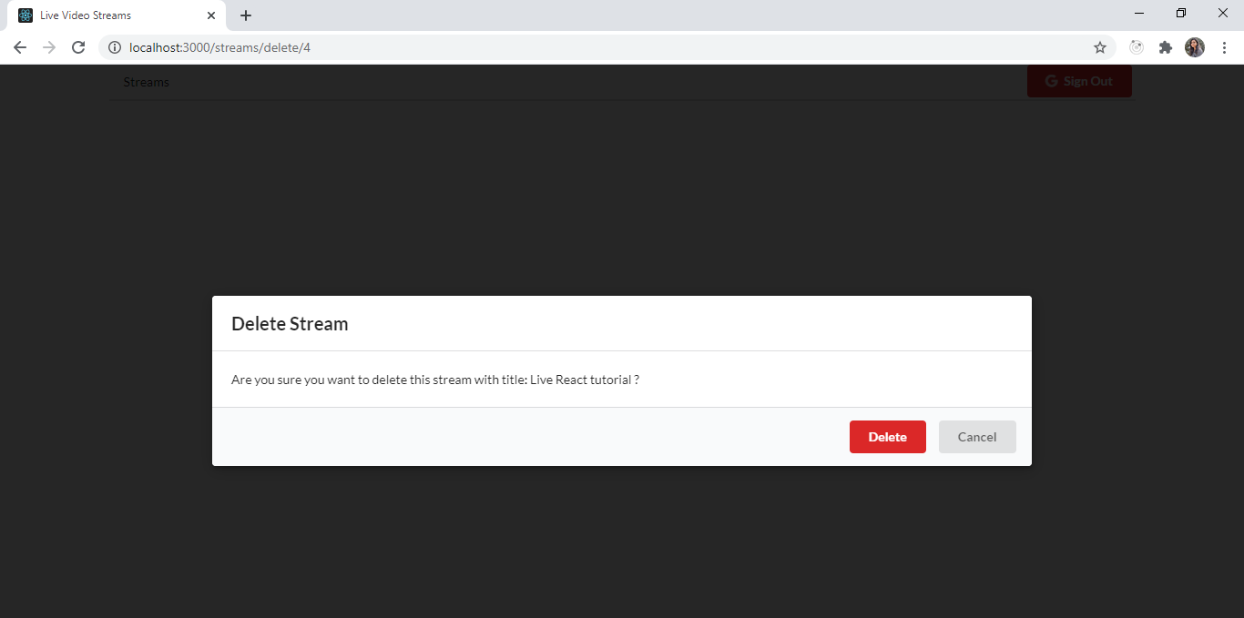

**Please follow below steps in order to host live streaming video through OBS:**

1. Open OBS studio
2. Create Scene -> Add Display Capture and Audio Input Capture.
3. Go to settings -> stream
4. select custom stream under service
5. Under Server, write rtmp-server address (rtmp://localhost/live)
6. Under Stream Key, give your streaming video id.
7. Click on start streaming

VIEW STREAM: <http://localhost:3000/streams/4>

