Mastercard Gateway Test App
Hosted Checkout — Payment Page — Application User Guide
Version 1.0.0

Executive Summary
This document is a step-by-step guide for Sales and CTS (Customer Technical Support) teams to validate this payment scenario in the Mastercard Gateway MTF (Merchant Test Facility) environment.
The Payment Page is the standard Hosted Checkout redirect flow with no configuration UI. The merchant creates a checkout session and redirects the shopper to the gateway-hosted Payment Page, where payment is completed and the shopper is returned to the merchant. This walkthrough illustrates a card payment with 3-D Secure V2; PayPal, Google Pay and Apple Pay are also available on the same page.
Step-by-Step Flow
Step 1: Start the checkout
On the merchant page, review the order and select Proceed to Checkout.
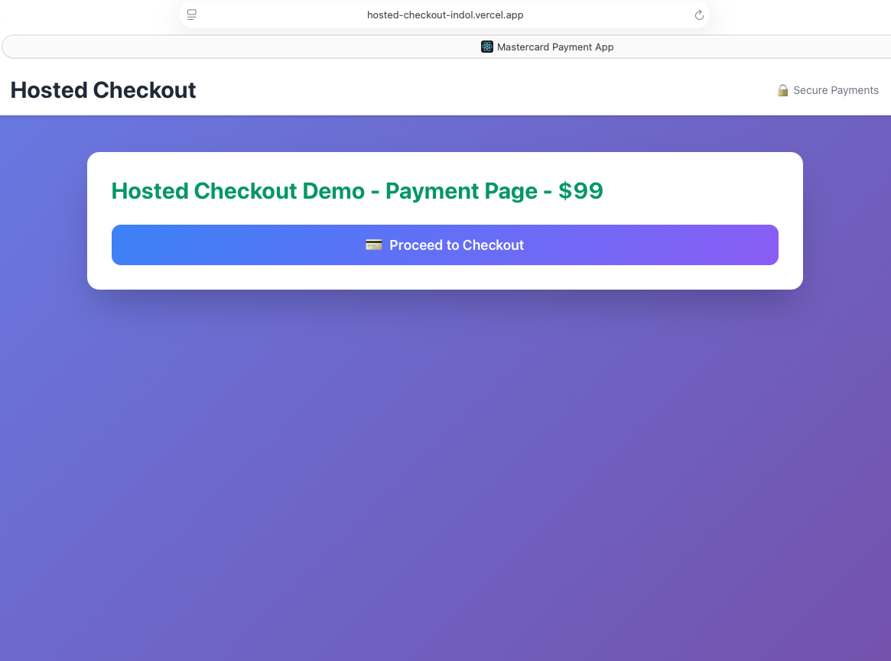
Merchant page — Hosted Checkout Demo (Payment Page); select Proceed to Checkout.
Step 2: Choose a payment method
The shopper is redirected to the gateway-hosted Payment Page, which presents the available payment options (Credit/Debit card, PayPal, Google Pay, Apple Pay).
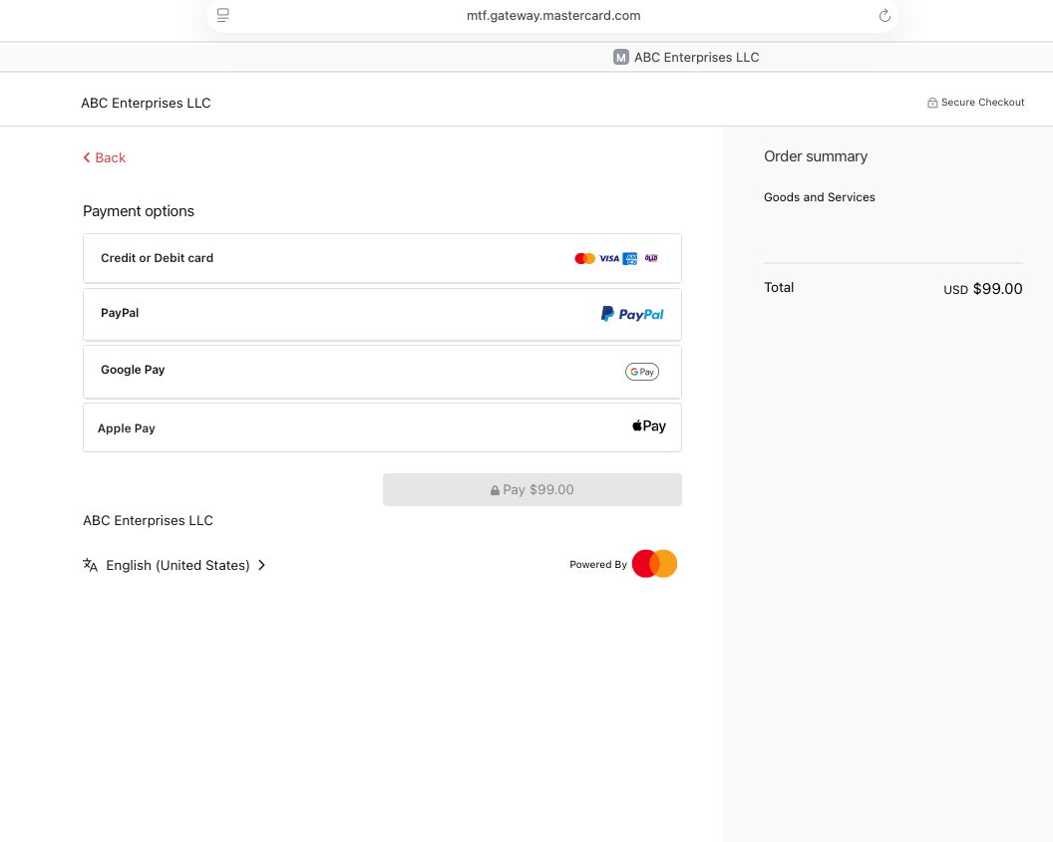
Redirect to the gateway-hosted Payment Page — available payment options.
Step 3: Enter card details and pay
Select Credit or Debit card, complete the fields (cardholder name, card number, expiry date, security code), then select Pay. Example MTF test card: 5123 4500 0000 0008, expiry 01/39, security code 100.
Notice: “The next screen you see may be payment card verification through your card issuer.”
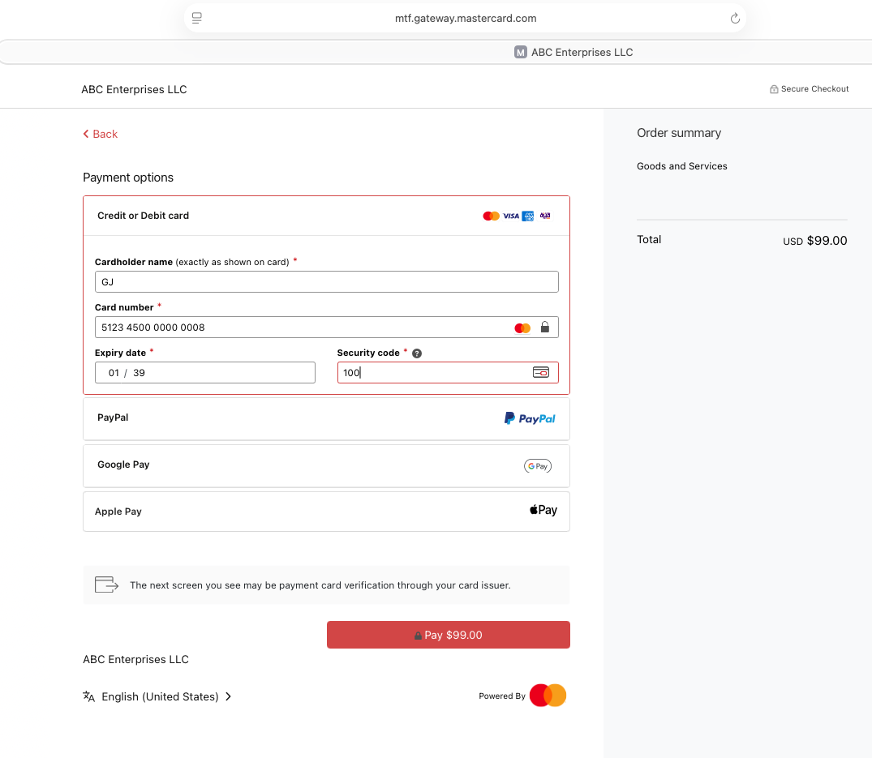
Credit or Debit card selected and details entered; select Pay.
Step 4: Complete 3-D Secure authentication
In MTF the ACS Emulator for 3DS V2 appears. Select the authentication result — for a successful flow choose “(Y) Authentication/Account Verification Successful” — then Submit.
Important: This emulator screen appears only in test environments. In production the shopper completes real issuer authentication.
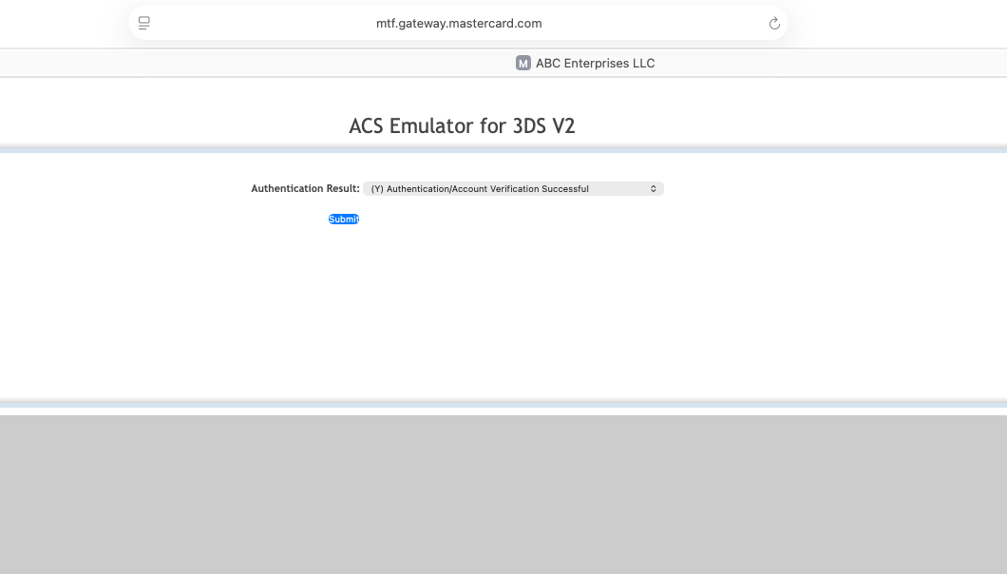
3-D Secure V2 — ACS Emulator authentication result, then Submit.
Step 5: Confirmation
The shopper is returned to the merchant receipt page, which confirms the order with the amount, Order ID, Transaction ID, status and technical details (session and checkout versions).
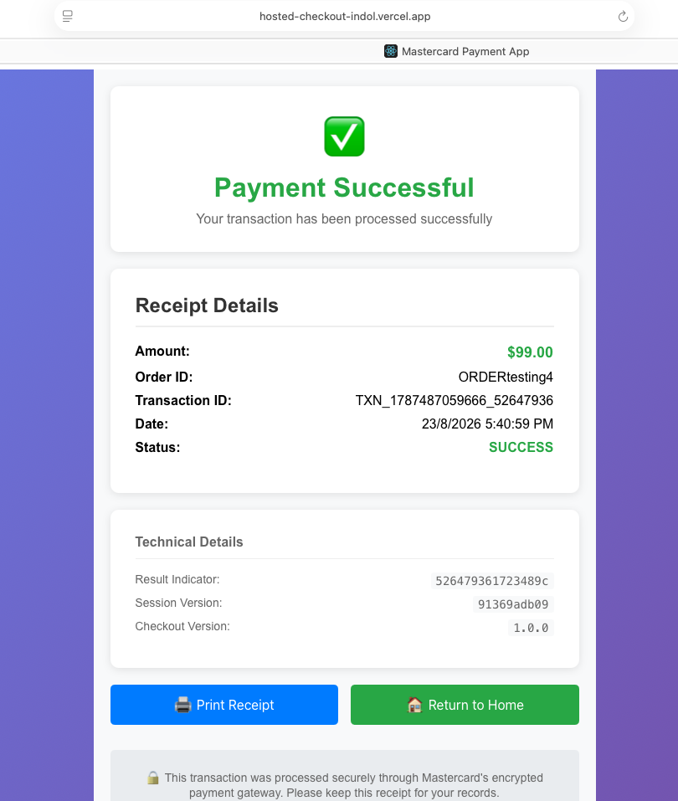
Merchant receipt — Payment Successful with transaction and technical details.
Questions & Feedback
For any queries or improvements, reach out to Gaurav.joshi@mastercard.com

