Mastercard Gateway Test App
Hosted Session + 3DS — Configurable — Application User Guide
Version 1.0.0

Executive Summary
This document is a step-by-step guide for Sales and CTS (Customer Technical Support) teams to validate this payment scenario in the Mastercard Gateway MTF (Merchant Test Facility) environment.
In a Hosted Session integration, the merchant renders its own payment form but the card data is captured directly into a gateway-hosted session (so the merchant never handles raw card data on its server). The session is then used to complete the payment with 3-D Secure authentication. This demo is fully configurable — merchant credentials, gateway URL and currency can be set, and an API Call Log shows the underlying gateway requests.
Configuration
Step 1: Configure the gateway and merchant
On the Merchant Configuration screen, set the Gateway Settings (Backend API URL, Gateway URL, API Version, Default Currency) and Merchant Information (Merchant ID, API username/password, merchant name and URL). Use Load Default Test Credentials for a quick start, then Save Configuration and Test Connection to confirm connectivity.
Tip: Your configuration is stored locally in your browser and never sent to any server except the Mastercard Gateway. Use integration/test credentials only.
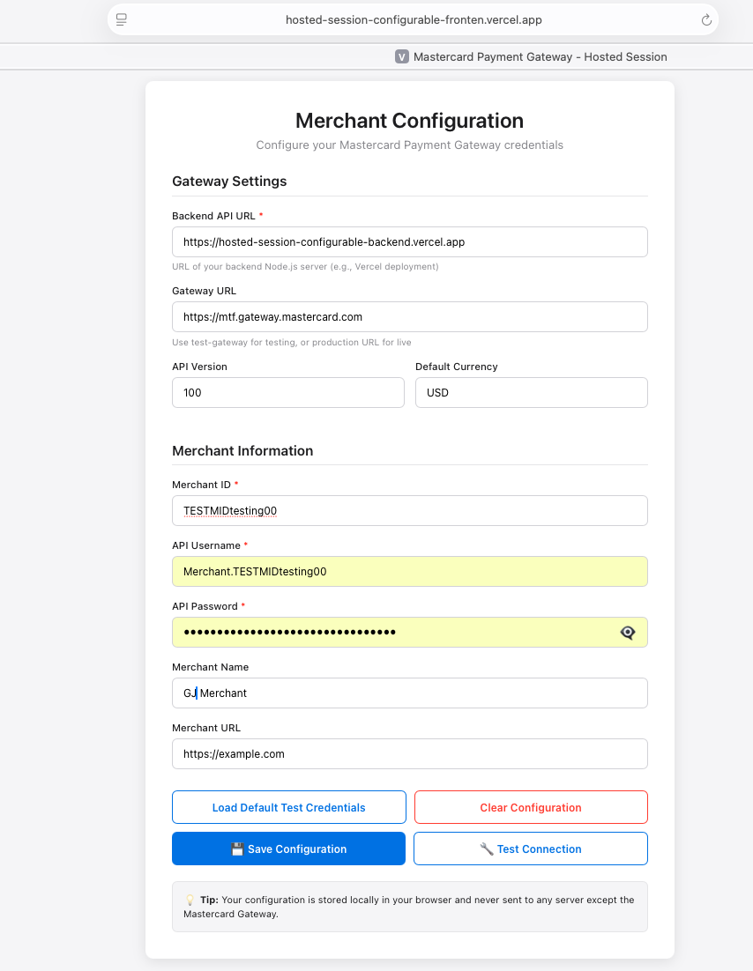
Merchant Configuration — gateway settings and merchant credentials; Save Configuration / Test Connection.
Step-by-Step Flow
Step 2: Start from the cart
Review the shopping cart (items, subtotal, tax and total) and select Proceed to Payment.
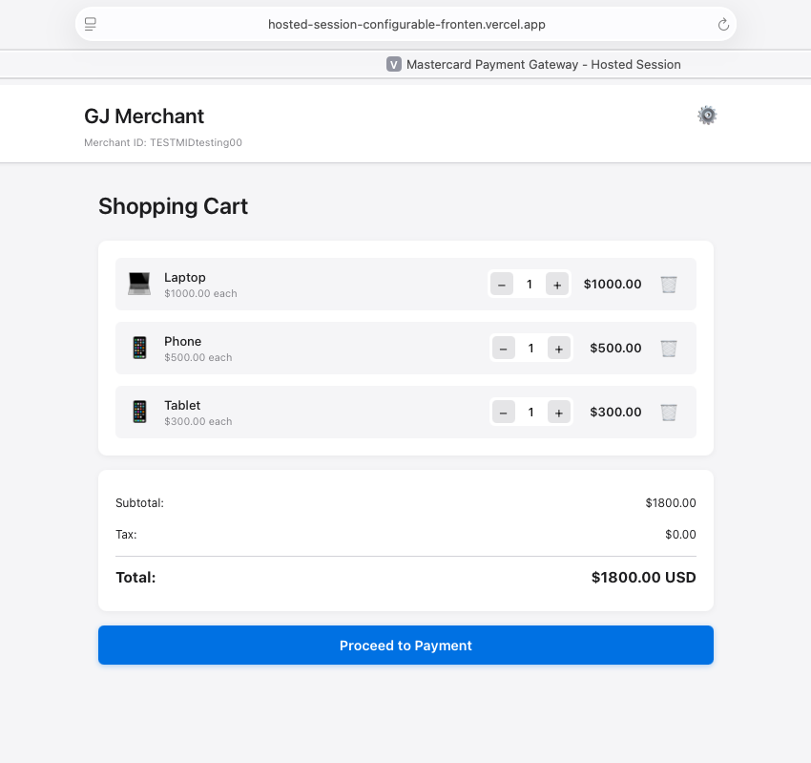
Shopping cart — review items and select Proceed to Payment.
Step 3: Enter card details in the Hosted Session form
The checkout shows the Session Information (Session ID, Order ID, Transaction ID) and the Payment Details form. Enter the card number, expiry month/year, security code and cardholder name, then select Pay. Example MTF test card: 5123 4500 0000 0008, expiry 01/39, security code 100.
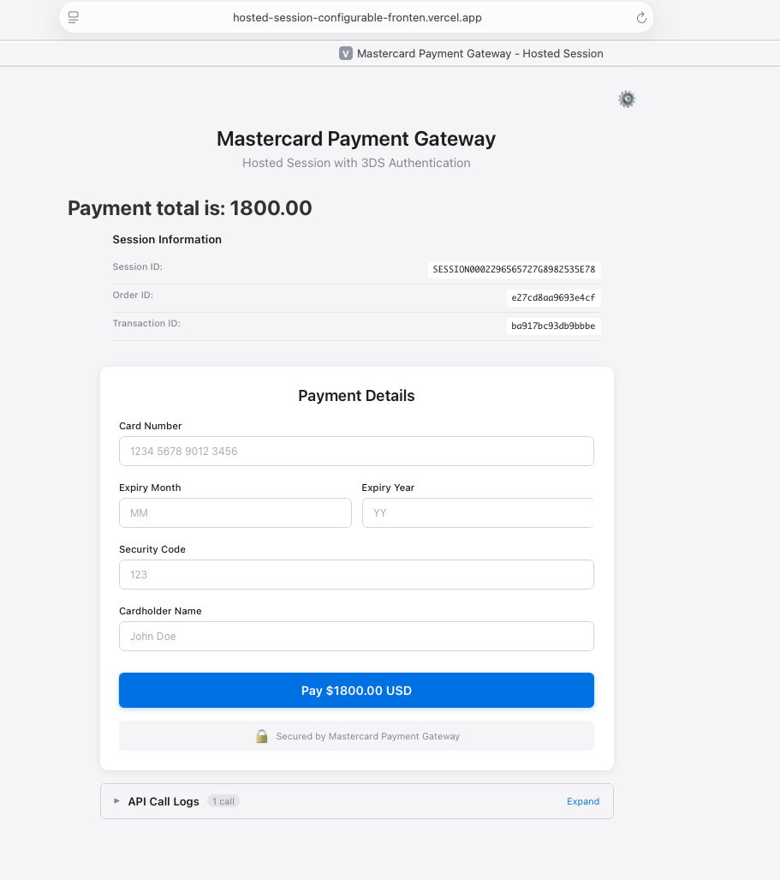
Hosted Session checkout — session details and the payment form.
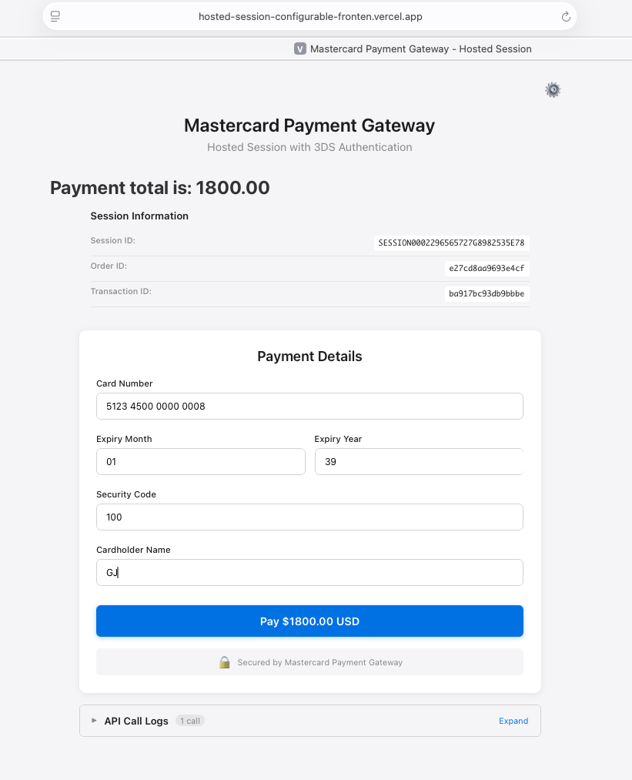
Card details entered directly on the merchant page; select Pay.
Step 4: Complete 3-D Secure authentication
The 3-D Secure challenge appears (ACS Emulator for 3DS V2). Select the authentication result and confirm; the demo processes the authentication and continues automatically.
Important: This emulator screen appears only in test environments. In production the shopper completes real issuer authentication.
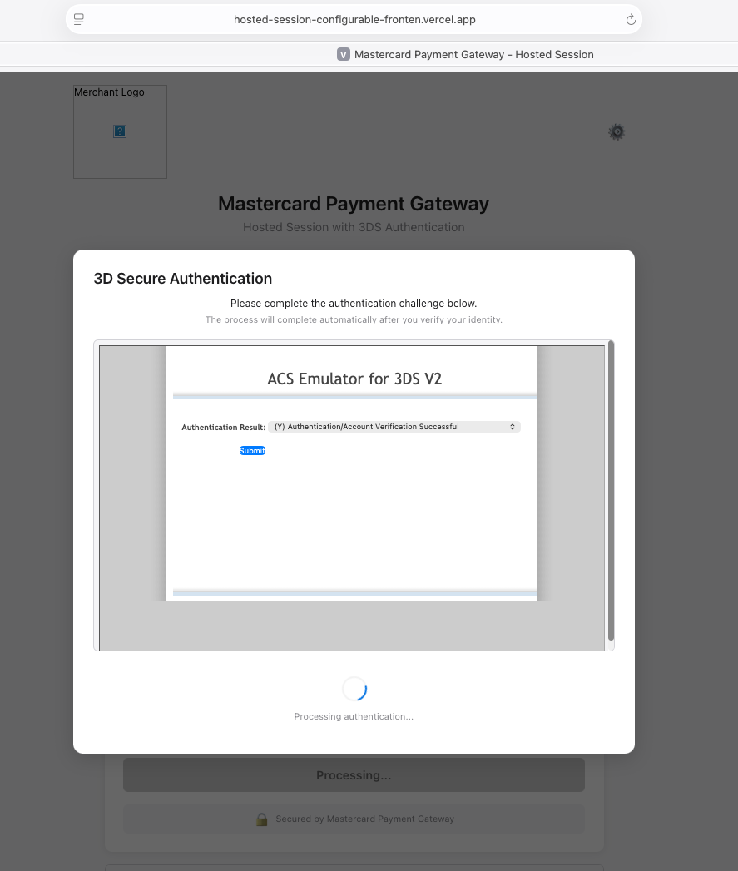
3-D Secure authentication — ACS Emulator for 3DS V2.
Step 5: Confirmation
The Payment Successful screen shows the Transaction Details — Order ID, Transaction ID, Amount, Status, Gateway Code (e.g. APPROVED), Gateway Recommendation (e.g. PROCEED) and the 3DS Authentication result (AUTHENTICATION_SUCCESSFUL). Use View Full Response or the API Request Logs to inspect the underlying gateway calls, or start a New Transaction.
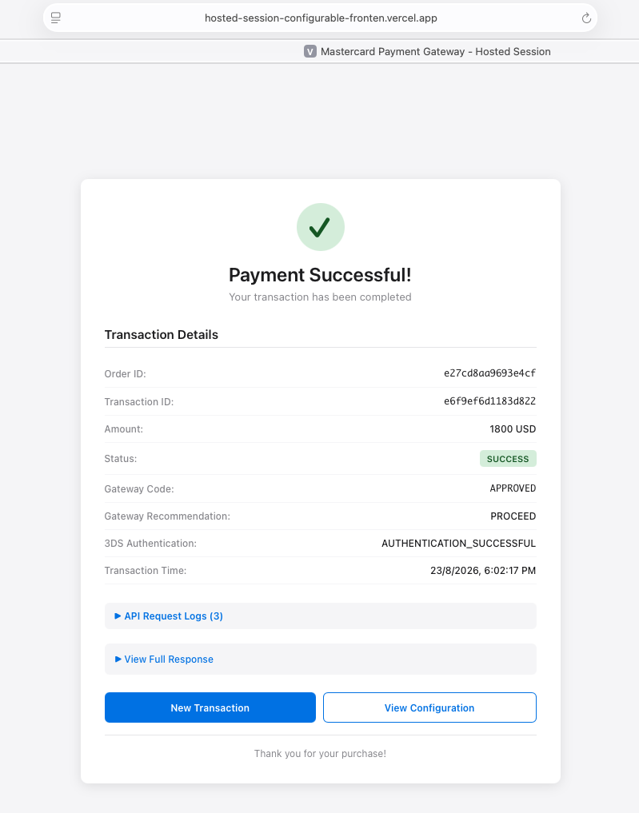
Payment Successful — transaction details, gateway code and 3DS result, with API request logs.
Questions & Feedback
For any queries or improvements, reach out to Gaurav.joshi@mastercard.com

