Mastercard Gateway Test App
Hosted Checkout — Card Payment — Application User Guide
Version 1.0.0

Executive Summary
This document is a step-by-step guide for Sales and CTS (Customer Technical Support) teams to validate this payment scenario in the Mastercard Gateway MTF (Merchant Test Facility) environment.
In Hosted Checkout (HCO), the Mastercard Gateway hosts the payment interaction. The merchant creates a checkout session (INITIATE_CHECKOUT) and the shopper keys the card on the gateway-hosted Payment Page, so the merchant never handles raw card data. This flow demonstrates a card payment with 3-D Secure V2 authentication.
Prerequisites
Merchant configuration: a valid MTF Merchant ID, API password, and gateway base URL are set (see the configuration guide).
Test card: an MTF test card, e.g. 5123 4500 0000 0008, expiry 01/39, security code 100.
Step-by-Step Flow
Step 1: Select Credit or Debit card
On the hosted Payment Page, choose Credit or Debit card to reveal the card entry fields (cardholder name, card number, expiry date, security code).
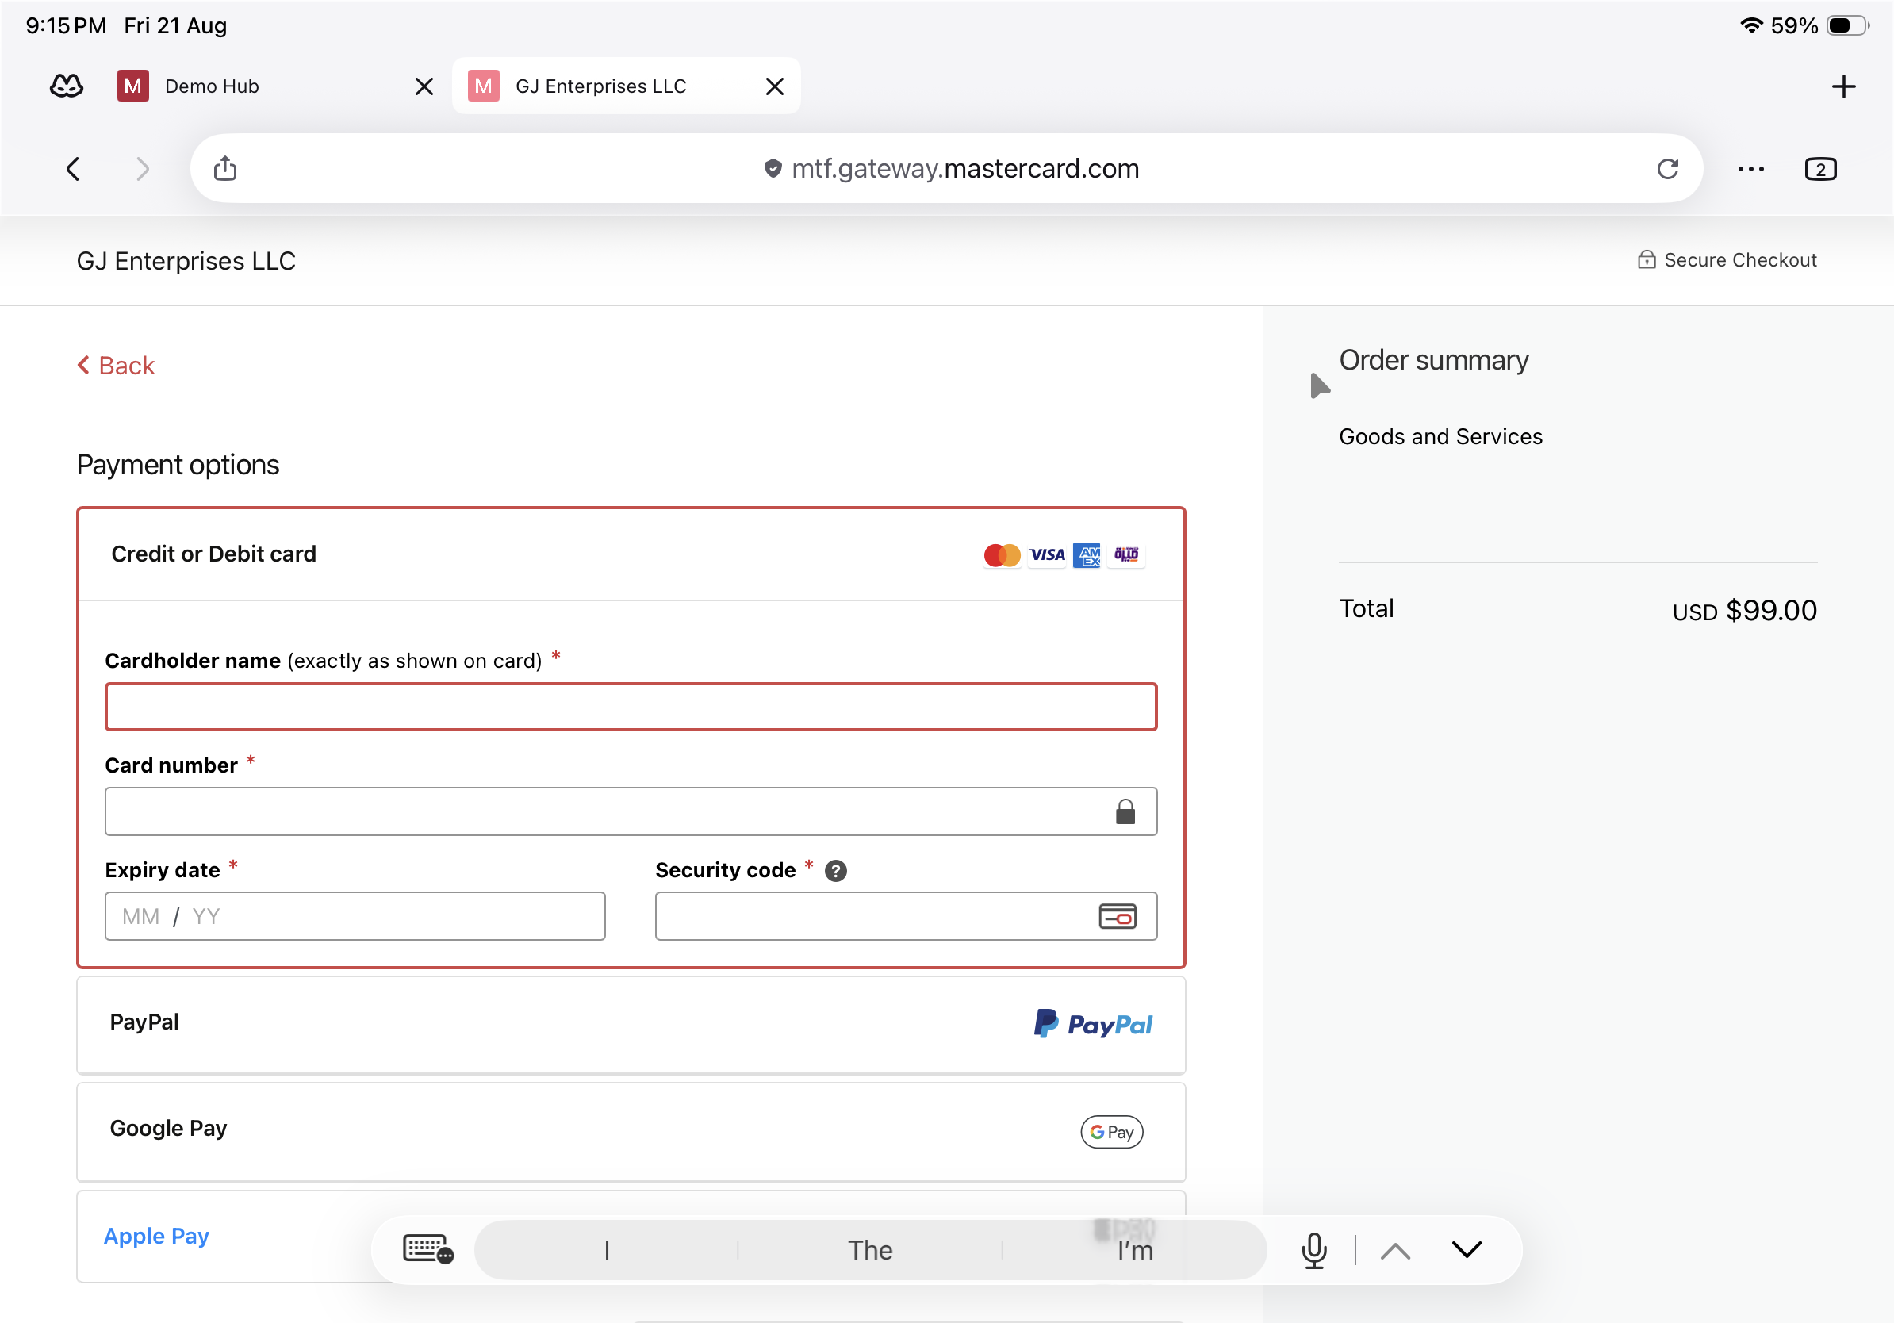
Hosted Payment Page — Credit or Debit card selected with empty fields.
Step 2: Enter the card details
Complete all fields. The gateway detects the card scheme automatically as the number is typed.
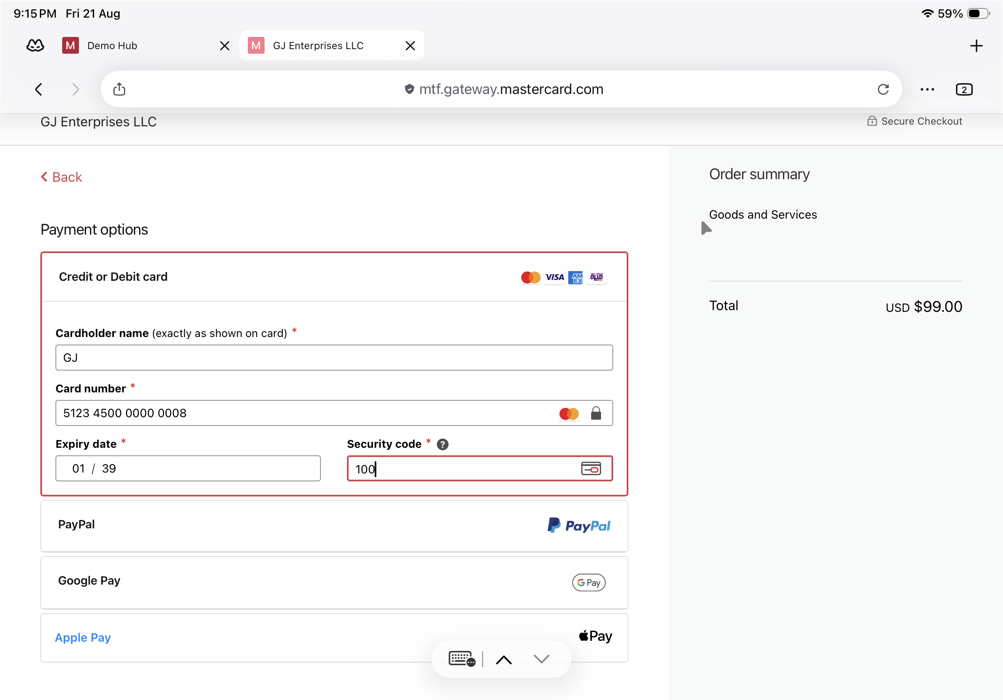
Card details entered — cardholder name, card number, expiry date, security code.
Step 3: Submit the payment
A notice indicates the next screen may be card verification through the issuer. Select Pay to continue.
Notice: “The next screen you see may be payment card verification through your card issuer.”
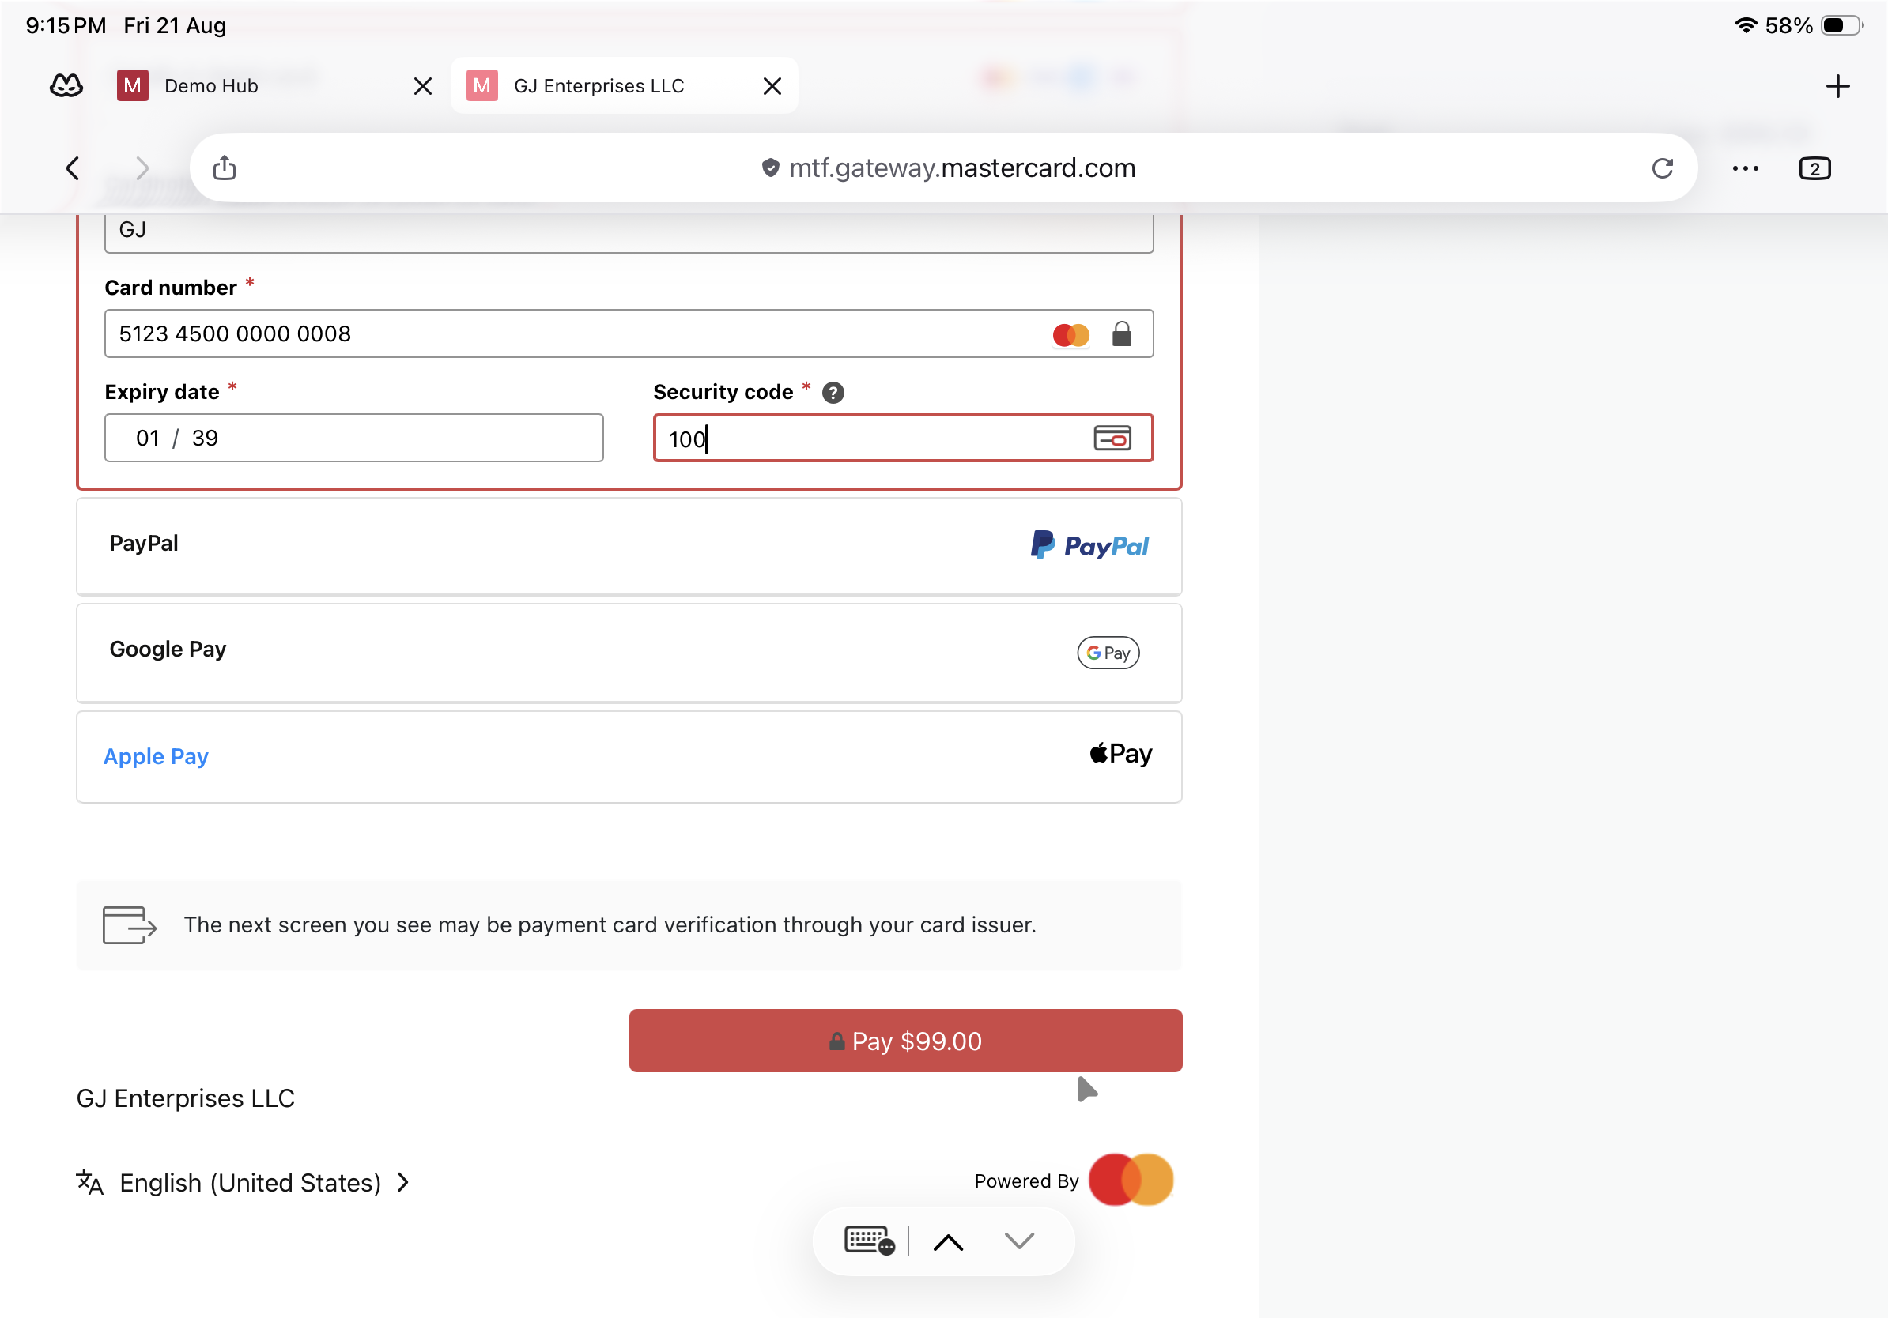
Issuer-verification notice shown; select Pay to proceed.
Step 4: Complete 3-D Secure authentication
In MTF the ACS Emulator for 3DS V2 appears. Select the authentication result — for a successful flow choose “(Y) Authentication/Account Verification Successful” — then Submit.
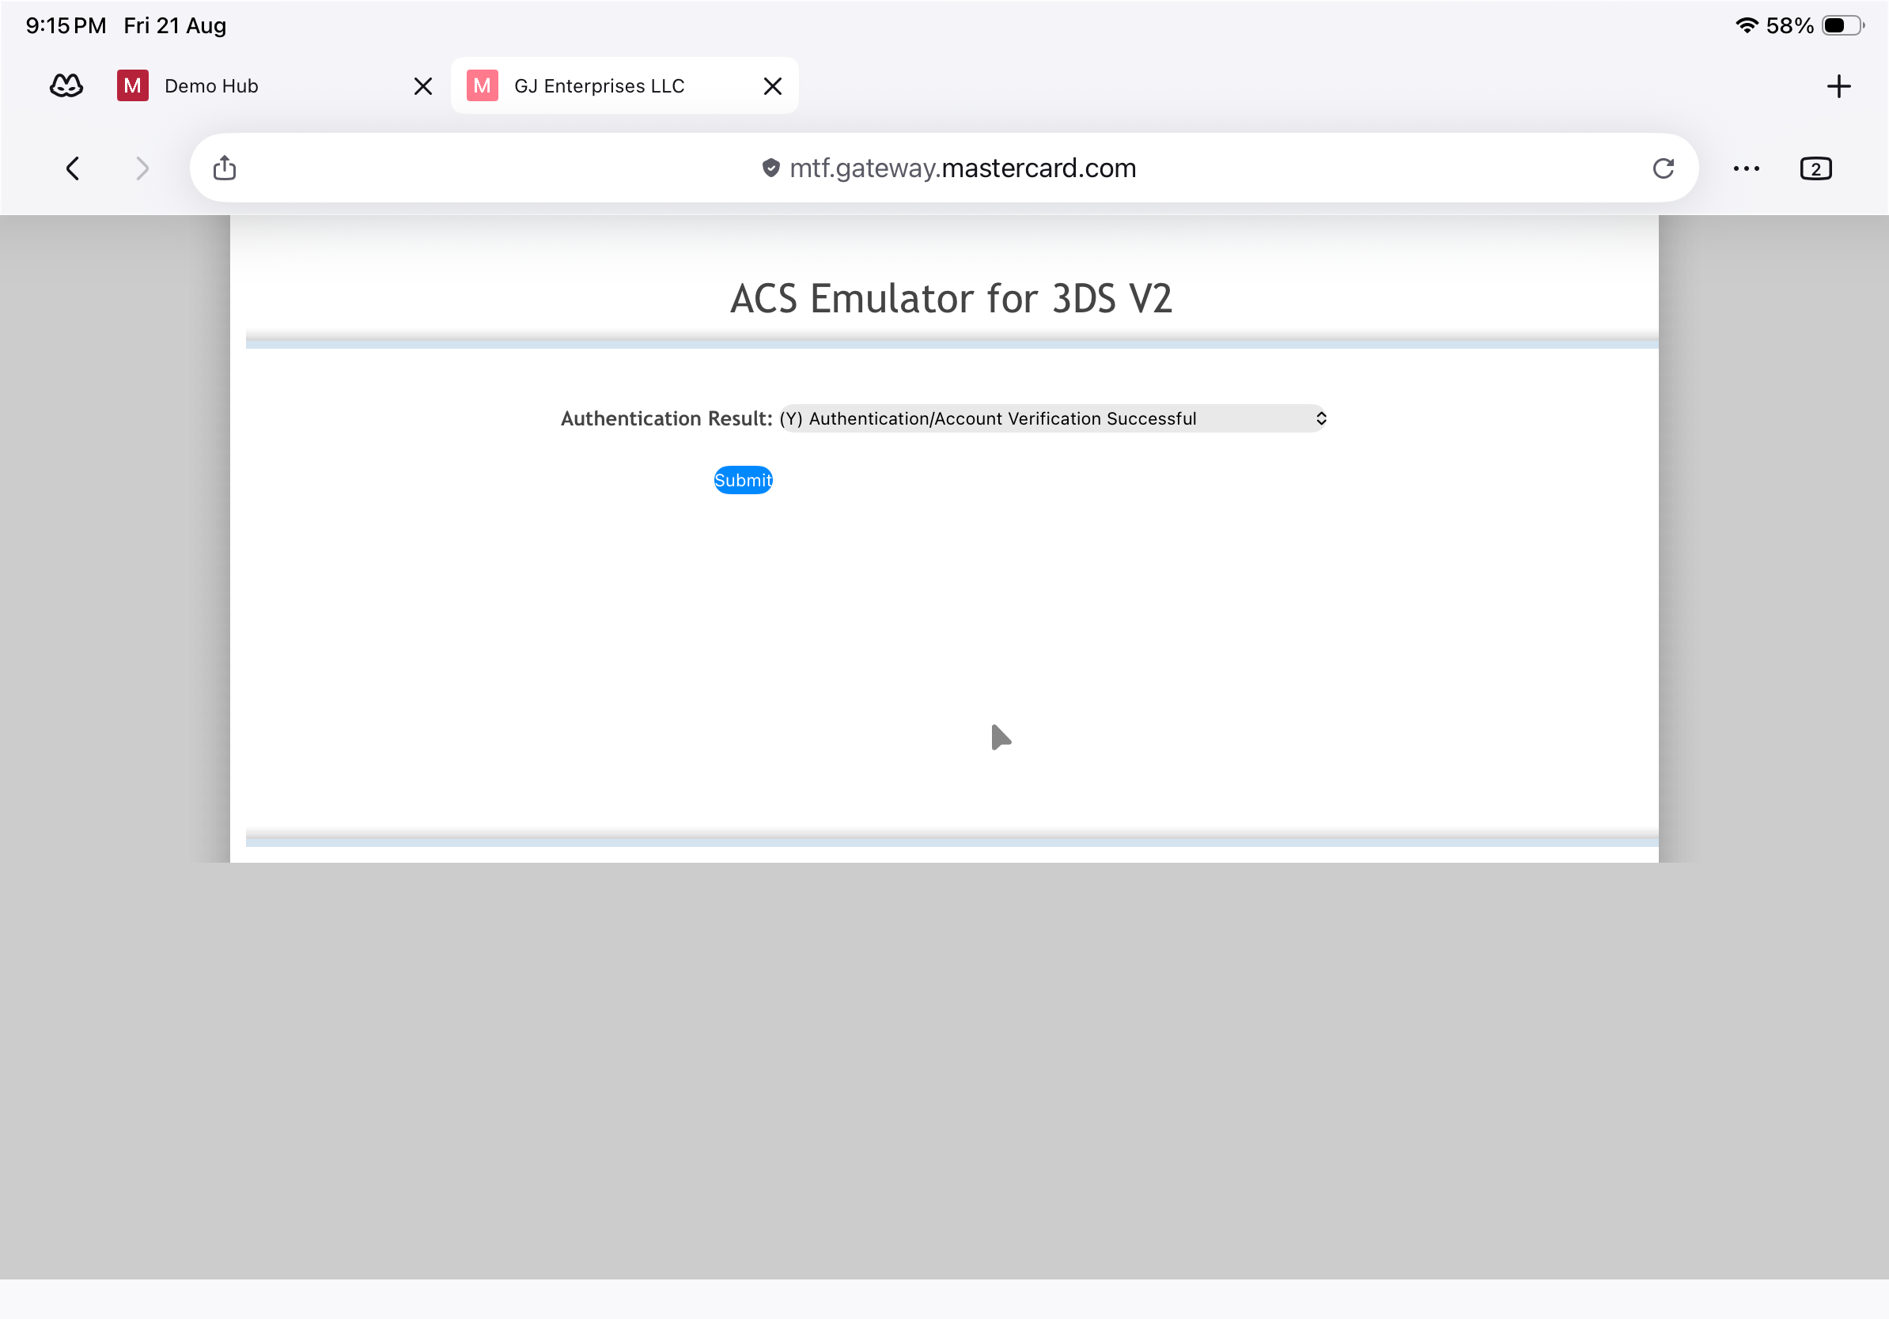
3-D Secure V2 — ACS Emulator authentication result, then Submit.
Important: This emulator screen appears only in test environments. In production the shopper completes real issuer authentication.
Questions & Feedback
For any queries or improvements, reach out to Gaurav.joshi@mastercard.com

