Mastercard Gateway Test App
Hosted Checkout — Click to Pay — Application User Guide
Version 1.0.0

Executive Summary
This document is a step-by-step guide for Sales and CTS (Customer Technical Support) teams to validate this payment scenario in the Mastercard Gateway MTF (Merchant Test Facility) environment.
This flow demonstrates Click to Pay (secure remote commerce) on the gateway-hosted Payment Page. The shopper identifies with their email, verifies with a one-time code, and pays with a card saved in their Click to Pay wallet.
Configuration
Step 1: Set API credentials and review the payload
Open the configuration screen (gear icon). On the API Configuration tab set the Merchant ID, API username/password, API Base URL, and API Version; optionally set a Webhook Forwarding URL. The Advanced JSON tab exposes the full INITIATE_CHECKOUT payload.
customerEmail: MANDATORY — requires the shopper email, which drives the Click to Pay lookup.
order.notificationUrl — the HTTPS endpoint the gateway calls with webhook notifications.
Important: API credentials are stored locally in your browser and sent to the demo backend only to call the gateway. Use integration/test credentials only.
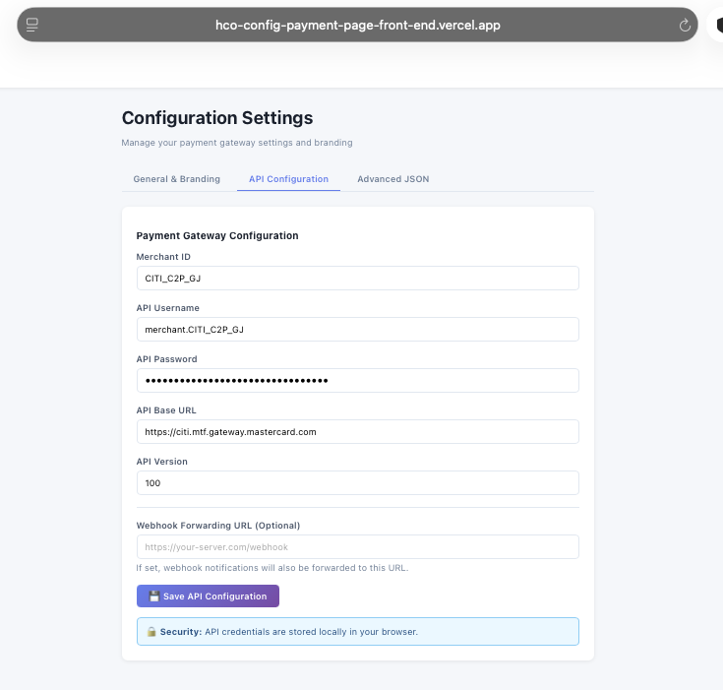
Configuration → API Configuration — merchant credentials and gateway endpoint.
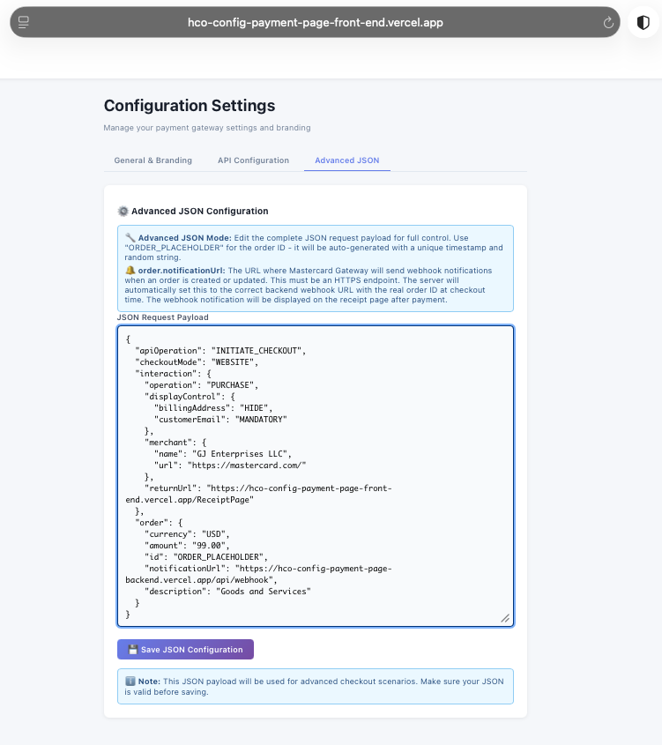
Configuration → Advanced JSON — the INITIATE_CHECKOUT request payload.
Step-by-Step Flow
Step 2: Start the checkout
From the merchant cart, review the items and select Checkout with Hosted Page.
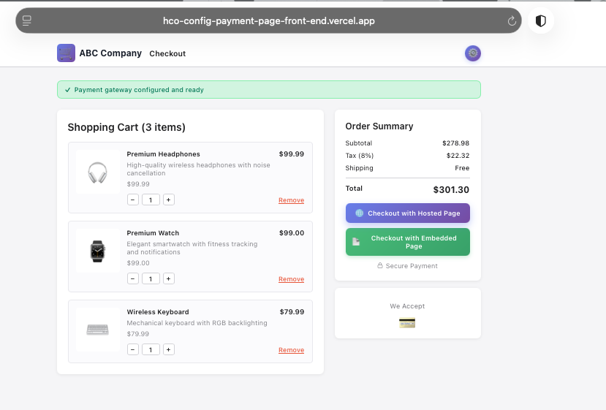
Merchant cart — review items and choose Checkout with Hosted Page.
Step 3: Identify the shopper
On the hosted Customer information screen, enter the email address to use a saved Click to Pay card (or choose to pay with another card).
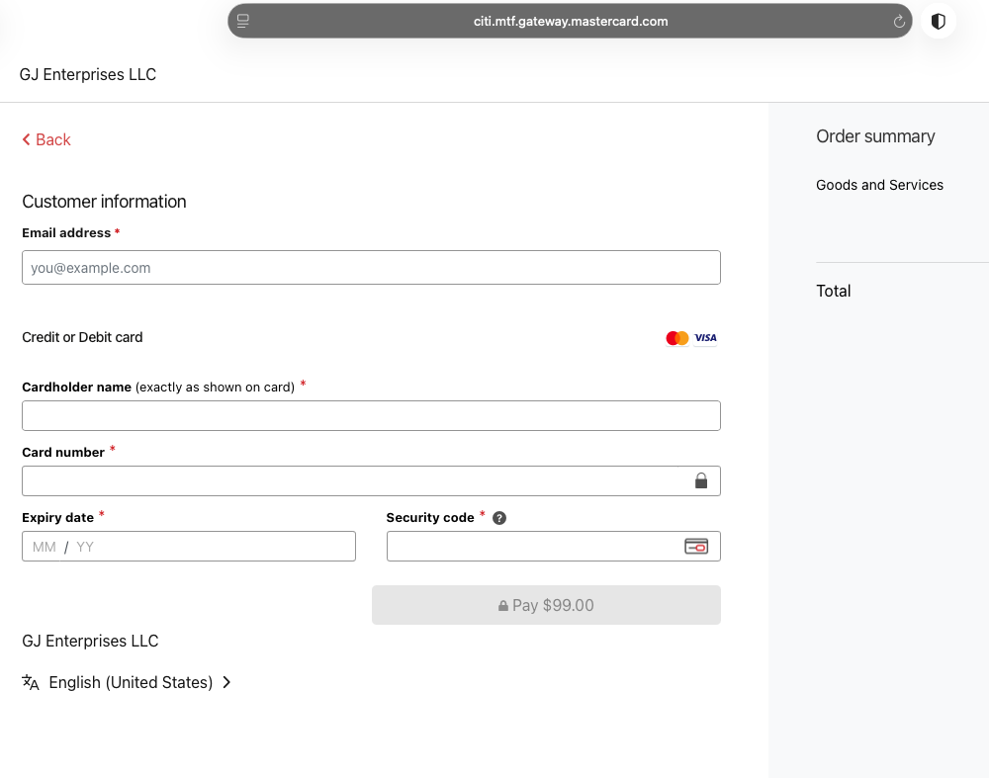
Hosted page — Customer information; enter email to use Click to Pay.
Step 4: Confirm with the one-time code
Click to Pay locates the shopper’s cards and sends a one-time code to the registered mobile number. Enter the code and select Continue.
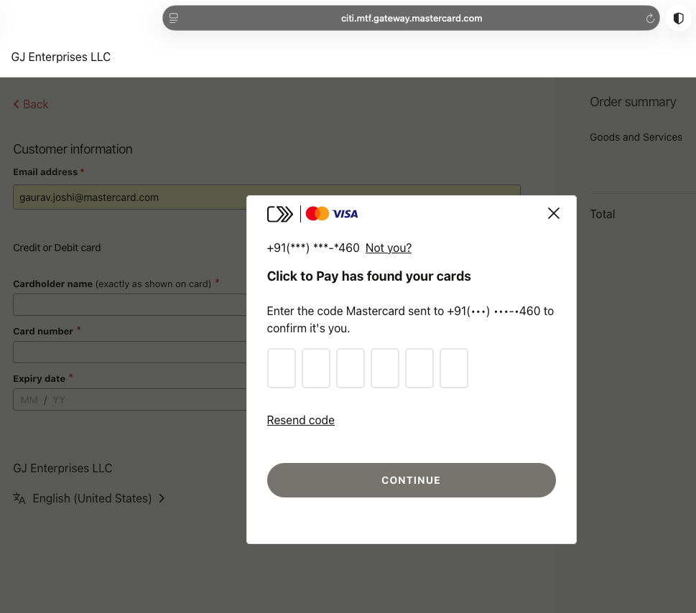
Click to Pay one-time-code prompt.
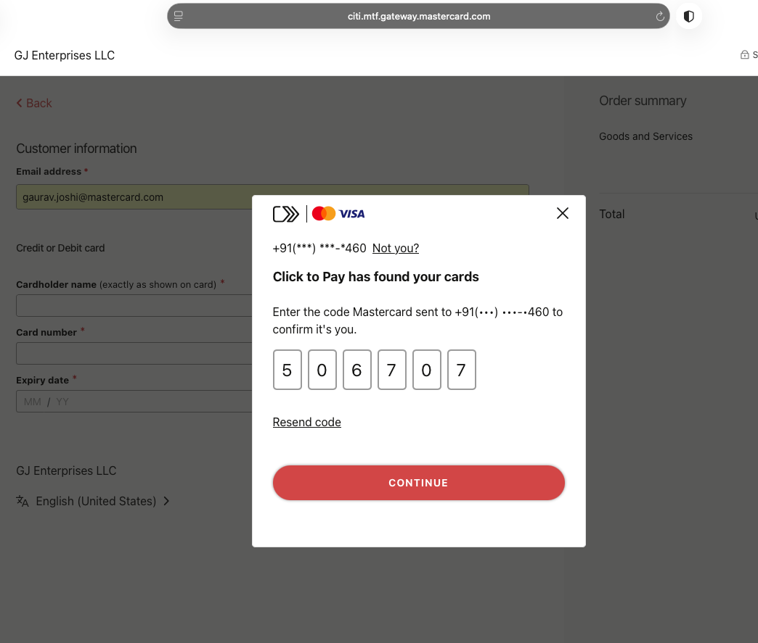
Enter the one-time code and select Continue.
Step 5: Select a card
Choose a card from the Click to Pay wallet and select Pay with Click to Pay.
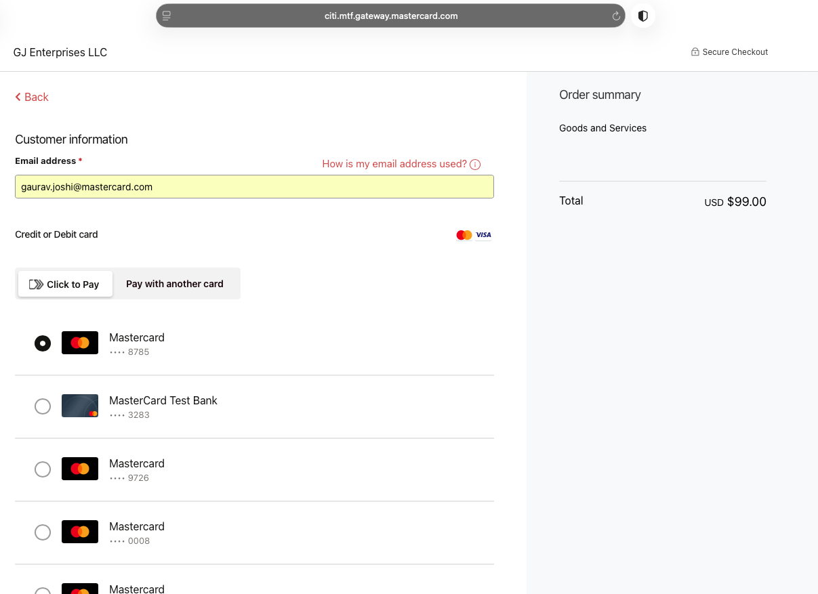
Click to Pay recognised — email shown with saved cards (Click to Pay vs. another card).
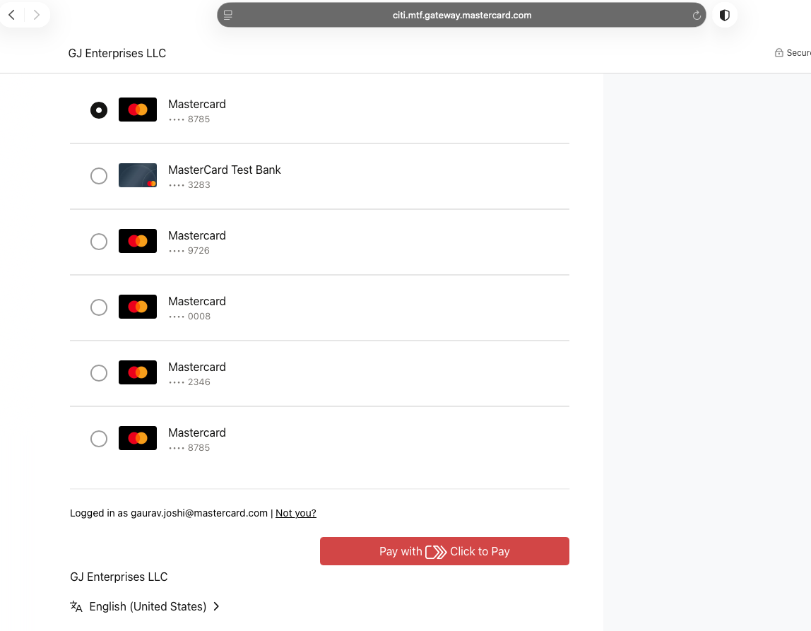
Select a card from the wallet, then Pay with Click to Pay.
Step 6: Review and pay
Review the payment in the Click to Pay sheet, then confirm on the gateway Order review and pay.
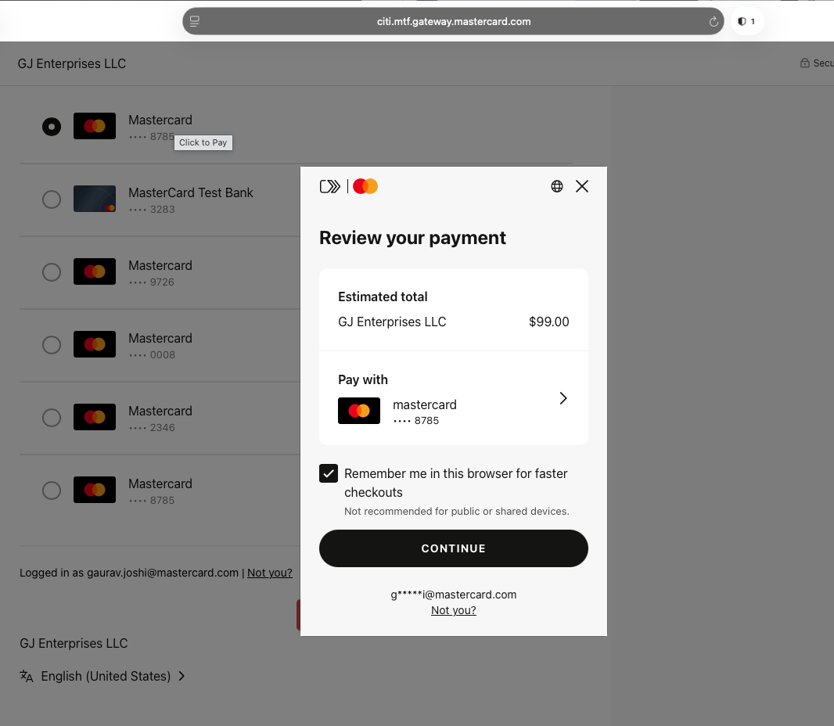
Review your payment in the Click to Pay sheet.
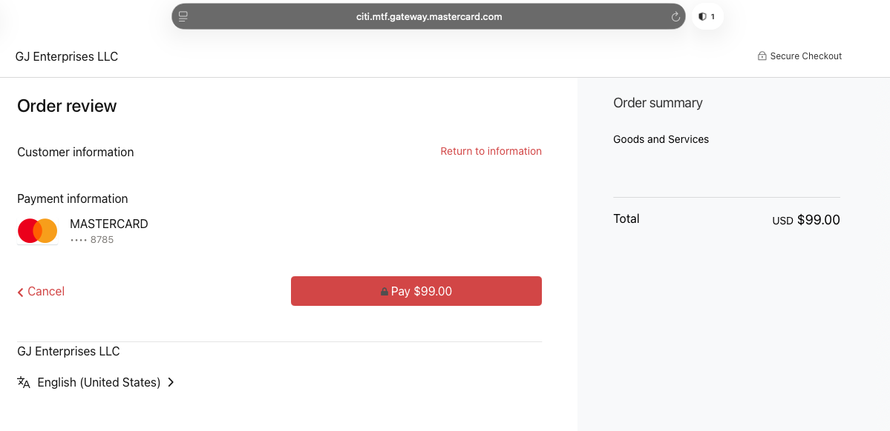
Gateway Order review — confirm the selected card and Pay.
Step 7: Receipt and webhook confirmation
The receipt confirms the order with Transaction Details (Status CAPTURED, Transaction ID, gateway Recommendation, Session/Checkout versions). The Webhook Delivery Log shows notifications delivered to the configured notificationUrl.
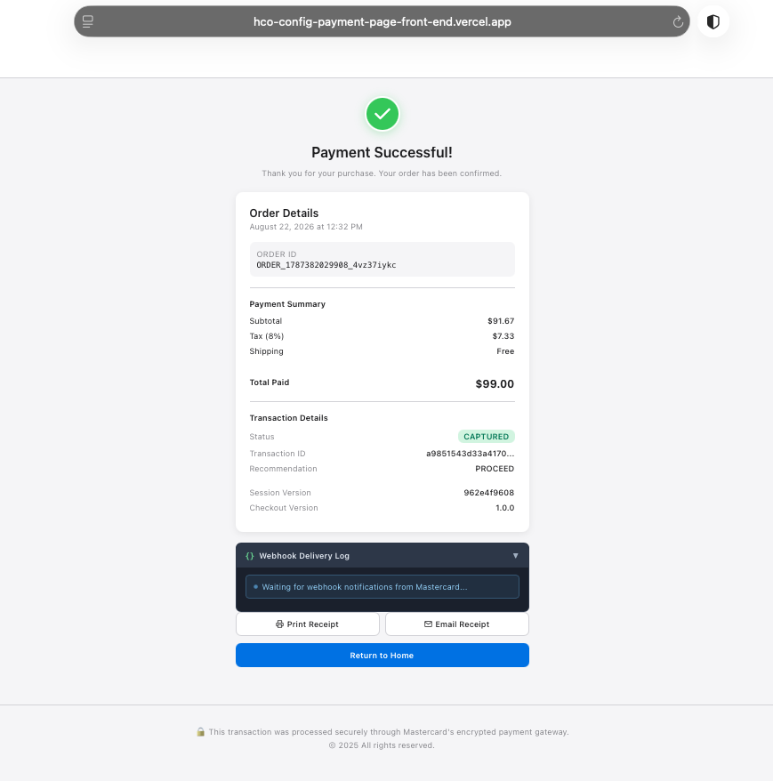
Receipt — Status CAPTURED, transaction details, and the Webhook Delivery Log.
Questions & Feedback
For any queries or improvements, reach out to Gaurav.joshi@mastercard.com

