Mastercard Gateway Test App
Click to Pay — Hosted Session — Application User Guide
Version 1.0.0

Executive Summary
This document is a step-by-step guide for Sales and CTS (Customer Technical Support) teams to validate this payment scenario in the Mastercard Gateway MTF (Merchant Test Facility) environment.
This flow demonstrates a Click to Pay (secure remote commerce) checkout built on a Mastercard Gateway Hosted Session. The shopper identifies with their email, verifies with a one-time code, and pays with a card saved in their Click to Pay wallet. A Network Console traces the gateway API calls behind the transaction.
Configuration
Step 1: Point the demo at your gateway MID
Open Configuration Settings and provide the Merchant ID, API username/password, API Base URL and API Version, then Save Configuration.
Note: API credentials are stored locally in your browser and sent to the demo backend to call the gateway. Use integration/test credentials only.
Step-by-Step Flow
Step 2: Start the checkout and enter email
The Click to Pay screen shows the Amount, Gateway, Order ID and Session ID. Enter the email address and select Continue with Email (or choose a saved / new card).
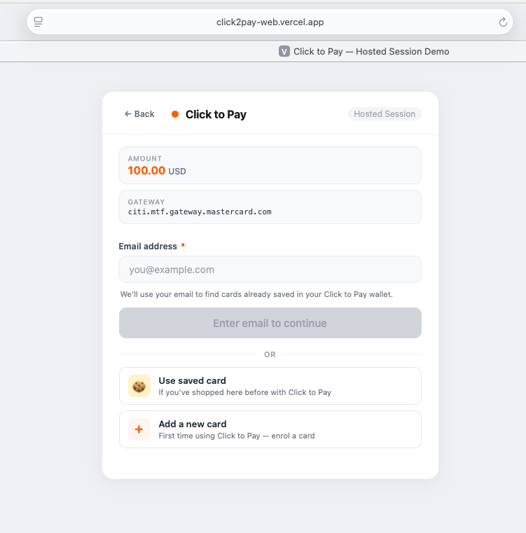
Click to Pay (Hosted Session) — session details; enter email to continue.
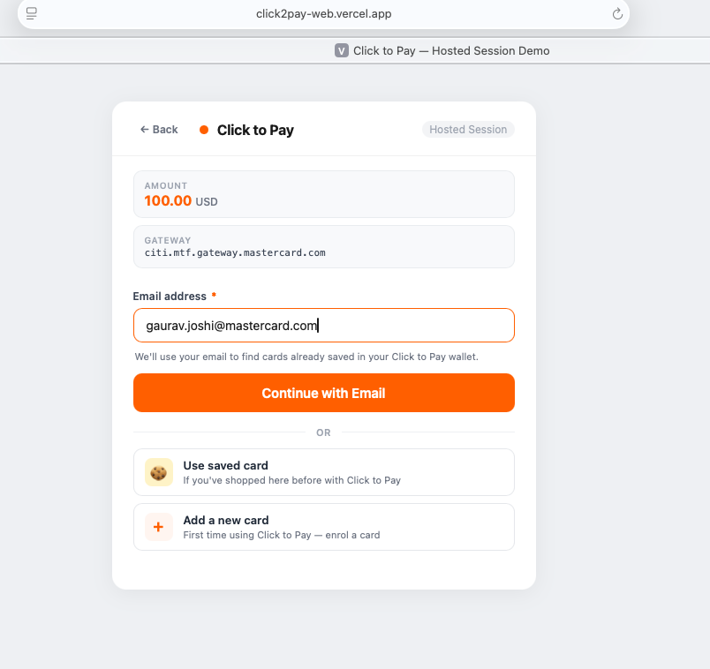
Email entered — Continue with Email (or use a saved / new card).
Step 3: Look up cards and verify
Select Lookup / Checkout with existing card. Click to Pay finds saved cards and sends a one-time code to the registered mobile number; enter the code and Continue.
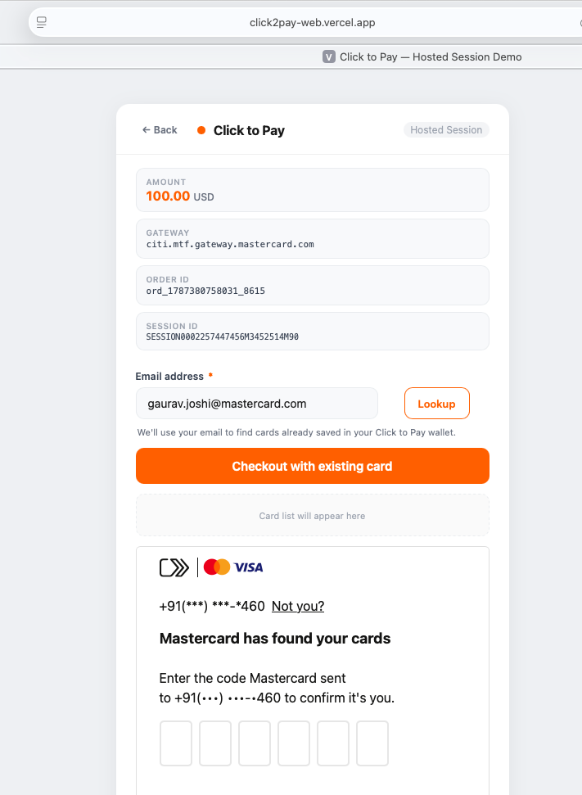
Look up existing cards; Click to Pay sends a one-time code.
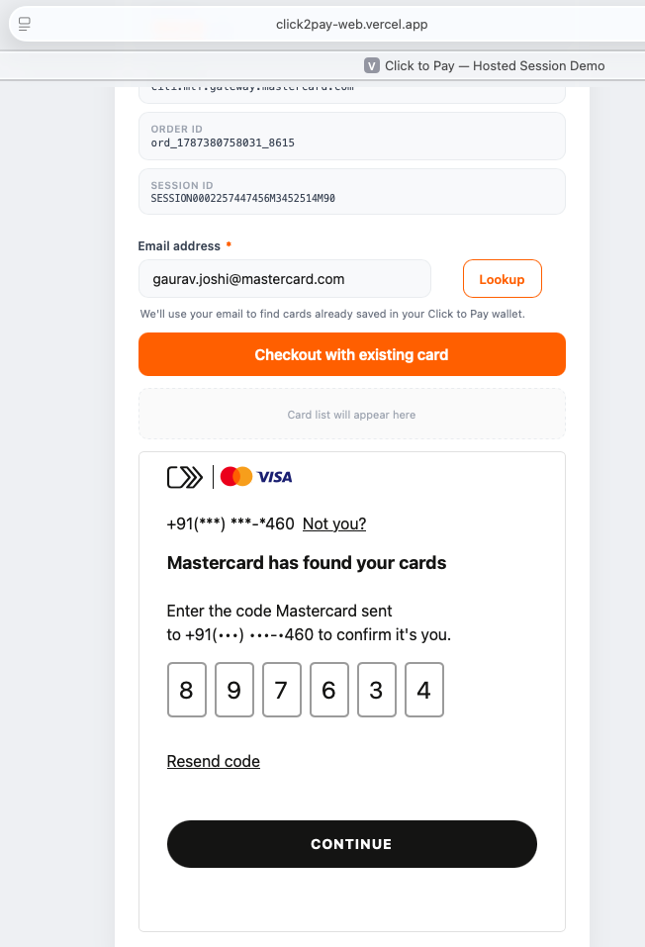
Enter the one-time code and select Continue.
Step 4: Select a card and review
Choose a card from the wallet and review the payment (optionally “remember me in this browser for faster checkouts”).
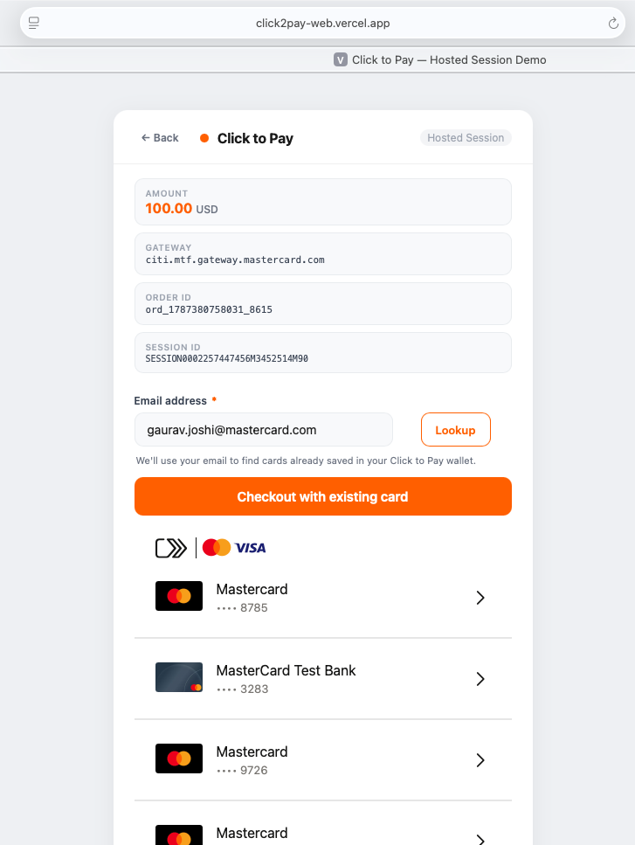
Select a card from the Click to Pay wallet.
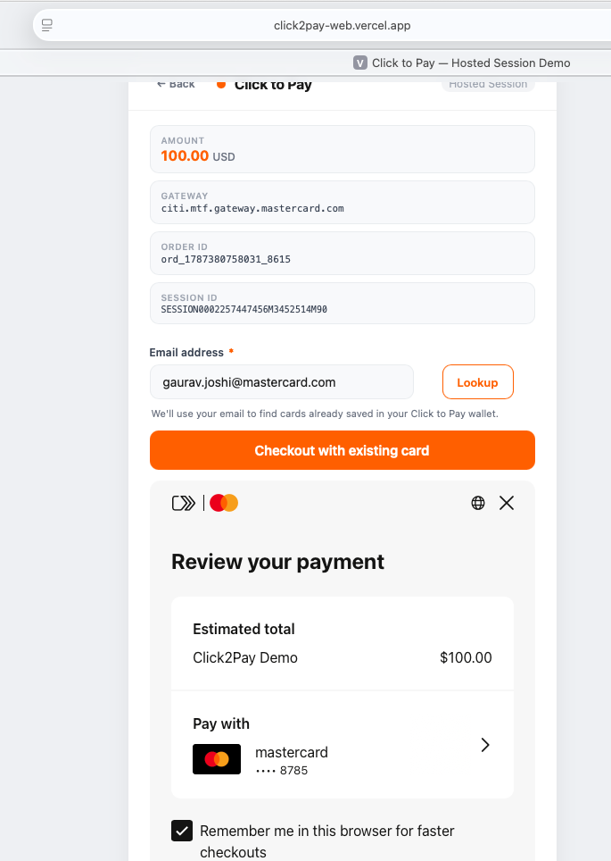
Review your payment (optionally remember this browser).
Step 5: Confirmation
The demo shows Payment Approved with the amount, Order ID and gateway code (e.g. APPROVED). The Network Console traces the sequence: Create Session → Update Session (attach amount + order id) → Payment Options Inquiry → Link Wallet to Session → Charge the Card (PAY).
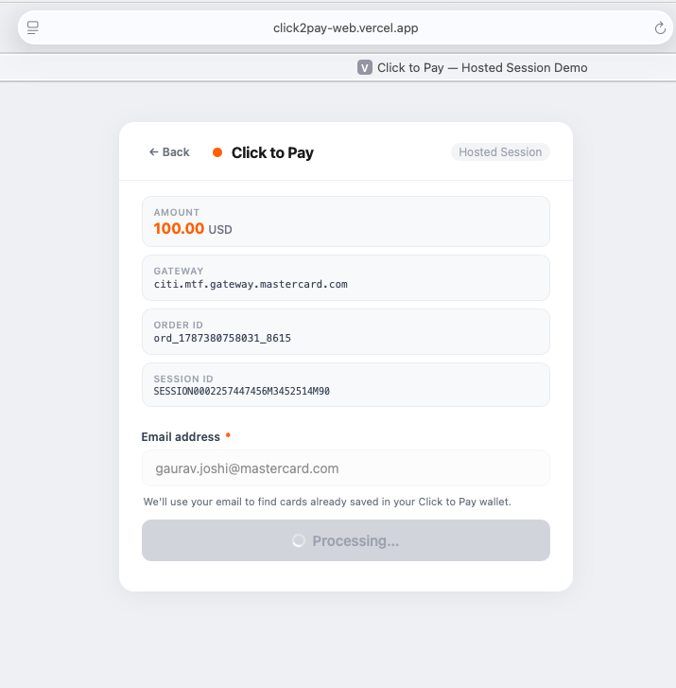
Processing the payment.
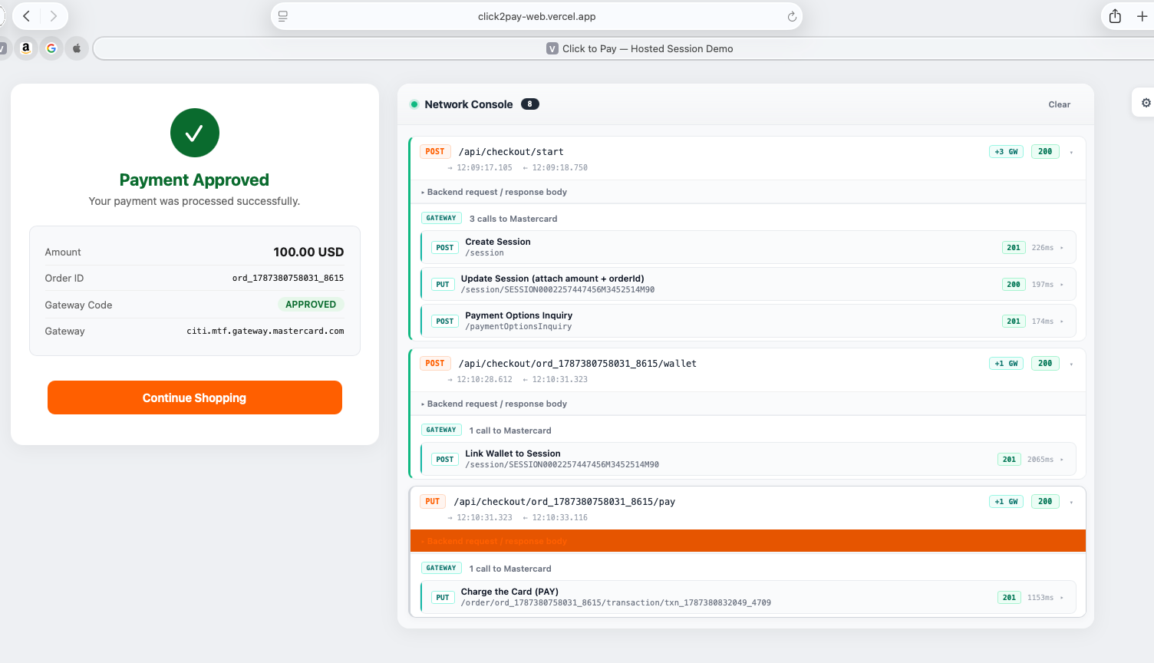
Payment Approved — gateway code and the Network Console call trace.
Note: The Network Console is a useful teaching aid — it shows the exact gateway API sequence behind a Hosted Session Click to Pay transaction.
Questions & Feedback
For any queries or improvements, reach out to Gaurav.joshi@mastercard.com

